[Morocco (arcgis.com)](https://storymaps.arcgis.com/stories/ba4ba2d1715b47238414b1ae8785db23) 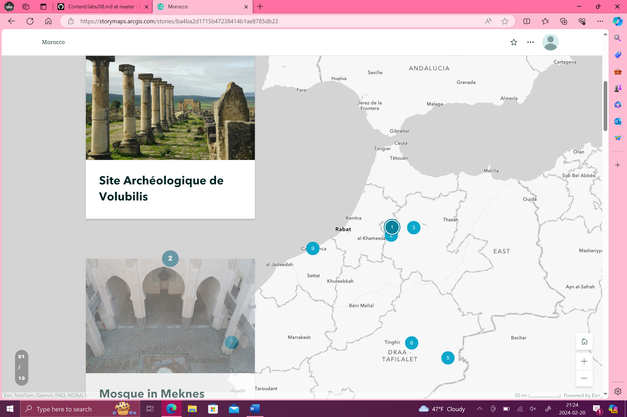

[Texas A&M (arcgis.com)](https://storymaps.arcgis.com/stories/23a7b47be2324264930e0adcb9086819) 