CSE565 Design of Experiments

Yu Chang  
ychan175@asu.edu

1. **Software Specification**

Software Rendering Performance Test: To evaluate the impact of different rendering settings on software rendering performance.

* 1. Rendering Resolution: 5 levels: 720p, 1080p, 1440p, 4K, 8K
  2. Anti-aliasing Mode: 5 levels: None, FXAA, MSAA x2, MSAA x4, MSAA x8
  3. Graphics Effects Level: 5 levels: Low, Medium, High, Very High, Ultra
  4. Texture Quality: 3 levels: Low, Medium, High
  5. Shadow Effects: 3 levels: None, Low, High

1. Tool: Python library: allpairspy 2.5.1

<https://github.com/thombashi/allpairspy>

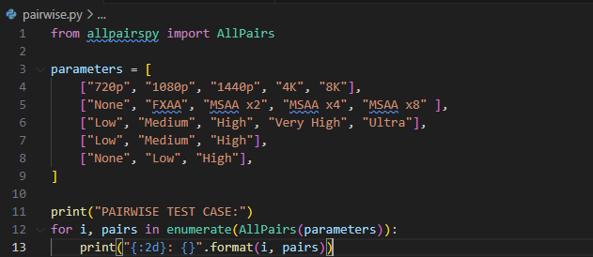

1. Test cases

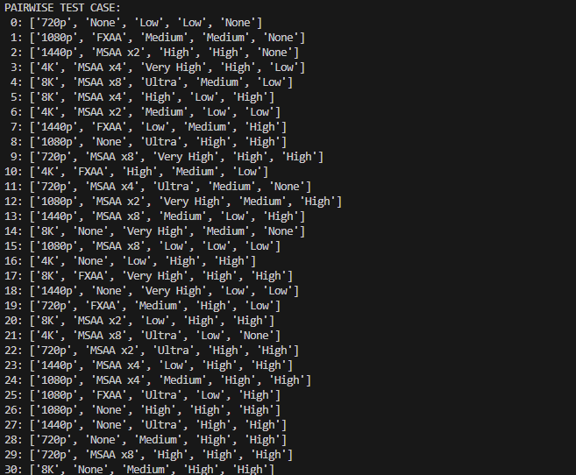

1. References

D. Ongari, "Awesome Design of Experiments," GitHub repository, [Online]. Available: <https://github.com/danieleongari/awesome-design-of-experiments>. [Accessed: Nov. 2, 2024].

C. Licumu, "pyDOE2," GitHub repository, [Online]. Available: <https://github.com/clicumu/pyDOE2>. [Accessed: Nov. 2, 2024].

"AutoOED Documentation," [Online]. Available: <https://autooed.readthedocs.io/en/latest/>. [Accessed: Nov. 2, 2024].

T. Bash, "allpairspy," GitHub repository, [Online]. Available: <https://github.com/thombashi/allpairspy>. [Accessed: Nov. 2, 2024].