CSE565 Structural Based Testing

Yu Chang  
ychan175@asu.edu

1. **Control Flow Coverage**
   1. Tool: Coverage.py 7.6.7 <https://coverage.readthedocs.io/en/latest/index.html>
   2. Coverage.py provides 1. Branch/ Decision coverage and 2. Statement Coverage.
   3. Test cases: binarySearchTest.py and binarySearchTestImproved.py.
   4. First set of test cases’ result

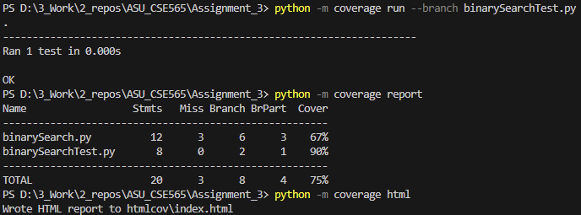

* 1. Second set of test cases’ result

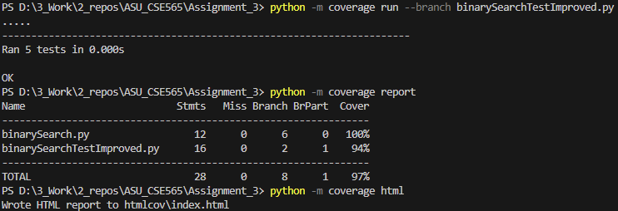

* 1. Coverage.py is easy to set up and operate, offering a variety of report formats, but it lacks a GUI.
  2. Other report format screen shots: binarySearchTestHTML.png and binarySearchTestImprovedHTML.png

1. **Static Source Code Analysis**
   1. Tool: Pylint 3.3.1 <https://www.pylint.org/>
   2. Pylint provides 1. Static code analysis, 2. Code style check, 3. Code quality metrics, etc.
   3. Analysis result

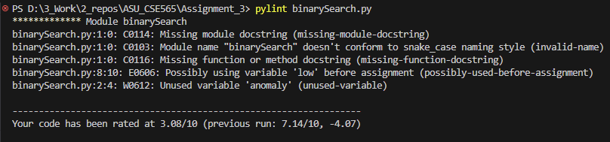

* 1. Pylint offer comprehensive code analysis, but it may generate a large number of reports.

1. **Reference**
   1. Codecov, "The best code coverage tools by programming language," Codecov Blog. [Online]. Available: https://about.codecov.io/blog/the-best-code-coverage-tools-by-programming-language/. [Accessed: Nov. 15, 2024].
   2. Coverage.py, "Coverage.py documentation," Read the Docs. [Online]. Available: https://coverage.readthedocs.io/en/7.6.7/index.html. [Accessed: Nov. 15, 2024].
   3. Python Package Index (PyPI), "Coverage," PyPI. [Online]. Available: https://pypi.org/project/coverage/. [Accessed: Nov. 15, 2024].
   4. YouTube, "Best code coverage tools," [Online]. Available: https://www.youtube.com/watch?v=KcEeorf8dNQ. [Accessed: Nov. 15, 2024].
   5. Codacy, "Python static analysis tools," Codacy Blog. [Online]. Available: https://blog.codacy.com/python-static-analysis-tools. [Accessed: Nov. 15, 2024].
   6. Reddit, "What Python code analysis tools are you using?" Reddit. [Online]. Available: https://www.reddit.com/r/Python/comments/xef3u2/what_python_code_analysis_tools_are_you_using/?rdt=44834. [Accessed: Nov. 15, 2024].
   7. Pylint, "Pylint: Python static code analysis," [Online]. Available: https://www.pylint.org/. [Accessed: Nov. 15, 2024].
      1. Mypy, "Mypy: Optional static typing for Python," [Online]. Available: https://mypy-lang.org/. [Accessed: Nov. 15, 2024].