CSE565 Reliability Prediction Tools

Yu Chang  
ychan175@asu.edu

1. **Tool 1: SFRAT**
   1. The Software Failure and Reliability Assessment Tool (SFRAT) is a software reliability modeling tool designed to estimate and predict the reliability of a software system. It creates reliability growth curves and provides tools for visualization and modeling to aid decision-making.
   2. SFRAT accepts the following input
      1. Inter-failure Times: Failure Number (FN), Interval Time (IF), and Total Time (FT). It is applicable to models such as Moranda's Geometric Model and Jelinski-Moranda Model.

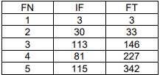

* + 1. Failure Counts: Test Time (T), Failures in Interval (FC), and Cumulative Failures (CFC). It is applicable to models such as Inflection S-Shape Model.

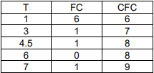

* 1. SFRAT analyzes failure data trends and applies data to various reliability models for failure predictions and evaluating model performance.
  2. All models provided by SFRAT are reliability growth models, which assume that fixing defects improves reliability over time without introducing new issues. Some other models, like Jelinski-Moranda Model, assume that the number of errors is fixed.

1. **Tool 2: SMERFS Cubed**
   1. SMERFS Cubed is the newest evolution of Statistical Modeling and Estimation of Reliability Functions for Systems. It allows the user to do hardware, software, and/or total systems reliability analyses.
   2. SMERFS includes 11 models, of which six models use the time between error occurrences as input data and five models use the number of errors detected per testing period. SMERFS Cubed adds 6 models for Hardware Reliability Analysis and 2 models for System Reliability Assessment.
   3. SMERFS provides preliminary model analysis to identify suitable candidate models, and can also perform model fitting and assess model adequacy.
   4. Similar to SFRAT, many models assume that failure rates are homogeneous or follow specific trends over time.
2. **Using tool: SFRAT**
   1. Goel-Okumoto model assumes that fixing defects improves reliability over time without introducing new issues, while the Jelinski-Moranda model assume that the number of errors is fixed.
   2. **Input data**

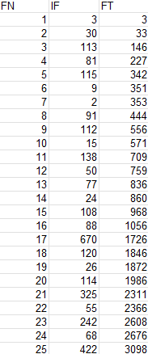 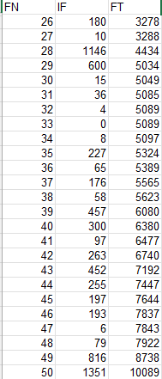 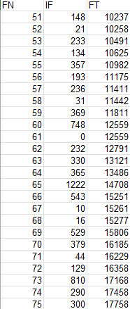

* 1. **Result**

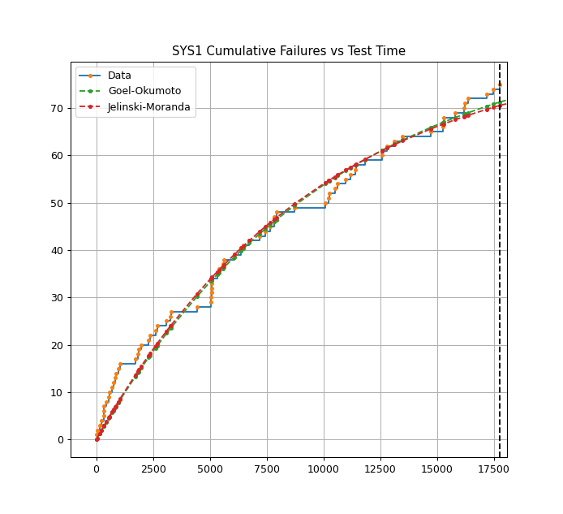

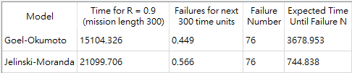

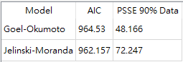

1. **References**

1 L. Fiondella, "Research on Software Reliability," [Online]. Available: https://lfiondella.sites.umassd.edu/research/software-reliability/. [Accessed: Dec. 1, 2024].

2 NASA, "Software Reliability Assessment Tools," NASA Technical Report, 2019. [Online]. Available: https://ntrs.nasa.gov/api/citations/20190002488/downloads/20190002488.pdf. [Accessed: Dec. 1, 2024].

3 L. Fiondella, "SFRAT User Guide," GitHub Repository, [Online]. Available: https://github.com/LanceFiondella/DSSL-Resources/blob/main/SFRAT/SFRAT_user_guide.pdf. [Accessed: Dec. 1, 2024].

4 L. Fiondella, "SFRAT: Software Reliability Assessment Tool," GitHub Repository, [Online]. Available: https://github.com/LanceFiondella/SFRAT. [Accessed: Dec. 1, 2024].

5 "SMERFS: Statistical Modeling and Estimation of Reliability Functions for Systems," Slingcode, [Online]. Available: https://www.slingcode.com/smerfs/. [Accessed: Dec. 1, 2024].

6 "SMERFS Overview," Slingcode, [Online]. Available: https://www.slingcode.com/smerfs/overview.php. [Accessed: Dec. 1, 2024].

7 "SMERFS Comparison," Slingcode, [Online]. Available: https://www.slingcode.com/smerfs/compare.php. [Accessed: Dec. 1, 2024].