SEGi UNIVERSITY
Faculty of Engineering, Built Environment, and Information Technology (FOEBEIT)
AUGUST 2026
WIRELESS AND MOBILE NETWORK
Final Assignment
Wireless Network Setup and Security Configuration
Using Cisco Packet Tracer
Prepared by:
Takrim Noor Hamim
Student ID: SUKD2501817

Introduction
A small company is expanding its office and requires a secure wireless network for both employees and guests. This report documents the design, configuration, and testing of a wireless network built in Cisco Packet Tracer that satisfies the following company requirements: secure WPA2-encrypted access for employees, a separate wireless network for guests, automatic IP address assignment for all devices, working internet connectivity for all users, and verified end-to-end wireless connectivity. The report also documents a troubleshooting exercise performed on a laptop that initially failed to connect to the wireless network, and provides answers to the theoretical questions set at the end of the assignment.

Network Topology
The network was built around a Linksys WRT300N wireless router, configured with the hostname OfficeWiFi, acting as the default gateway and DHCP server for the entire LAN. The devices used in the topology are:
- 1 × Wireless Router (WRT300N) — hostname OfficeWiFi
- 1 × 2960-24TT Switch — connects all wired segments
- 1 × secondary Access Point (labelled "Guest Wifi") — broadcasts the guest SSID
- 2 × PCs (PC0, PC1) — wired employee workstations
- 2 × Laptops (Laptop0, Laptop1) — wireless employee devices
- 1 × Smartphone (Smartphone0) — wireless guest device
- 1 × Cloud (Cloud1) — represents the ISP/Internet connection, attached to the router's WAN interface (0/0) via Ethernet6
- 1 × Cable Modem (Cable Modem0) — bridges the coaxial ISP-side link (Cloud1) to the Ethernet link on InternetServer
- 1 × Server (InternetServer) — represents an external/ISP-side host, reached via Cable Modem0 and Cloud1
The router's LAN interface was assigned the IP address 192.168.10.1 with subnet mask 255.255.255.0 (192.168.10.0/24), which serves as the default gateway for every device on the network. A single DHCP scope was enabled on the router with the range 192.168.10.100 – 192.168.10.150, allowing up to 51 clients to be served automatically. All devices in the topology — wired PCs, wireless laptops, and the smartphone — are configured to obtain their addresses via DHCP rather than static addressing, which satisfies the requirement that devices should receive IP addresses automatically.
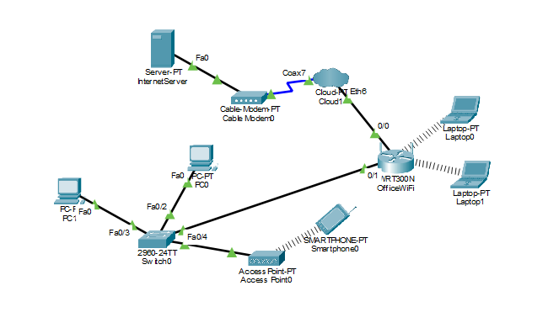
Figure 1: Final network topology built in Cisco Packet Tracer.

Part A: Basic Network Setup
For this part, all the required devices (router, switch, secondary access point, PCs, laptops, smartphone, cloud, cable modem and server) were added to the Packet Tracer workspace and connected using the appropriate wired links. The wireless router was then configured with the hostname OfficeWiFi and given the LAN IP address 192.168.10.1/24, which acts as the default gateway for the whole network.
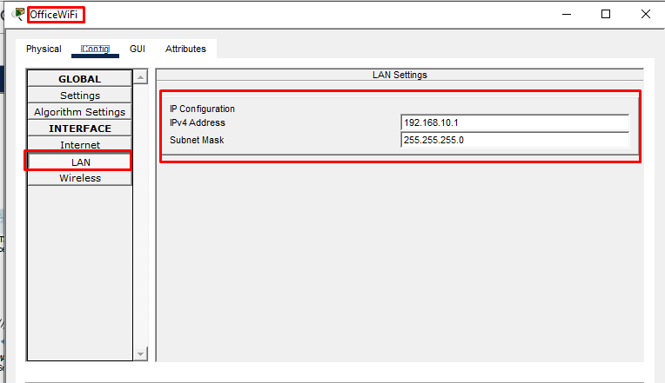
Figure 2: Router LAN IP configuration (192.168.10.1/24).

Part B: Configure Employee WiFi
Next, the employee wireless network was set up on the OfficeWiFi router. An SSID named StaffNet was created and secured with WPA2-PSK using the passphrase Staff@123. DHCP was enabled on the router so that employee devices receive their IP address automatically, using the range 192.168.10.100 – 192.168.10.150.
Both wireless networks use WPA2-PSK authentication with AES encryption, in line with the requirement that employees must connect securely using WPA2 encryption. The guest network was configured to the same WPA2-PSK/AES standard, using a separate passphrase, so that a guest credential cannot be used to access the staff network.
SSID | Purpose | Authentication | Passphrase / Encryption
StaffNet | Employees (wireless) | WPA2-PSK | Staff@123 / AES
GuestNet | Guests (wireless) | WPA2-PSK | Guest@123 / AES

DHCP configuration: Start IP Address 192.168.10.100, Range 192.168.10.100 – 192.168.10.150, Maximum Users 51, Subnet Mask 255.255.255.0. This single scope, hosted on the OfficeWiFi router, serves wired and wireless clients on both SSIDs, since the secondary access point operates purely as a Layer-2 bridge and does not run its own DHCP service.
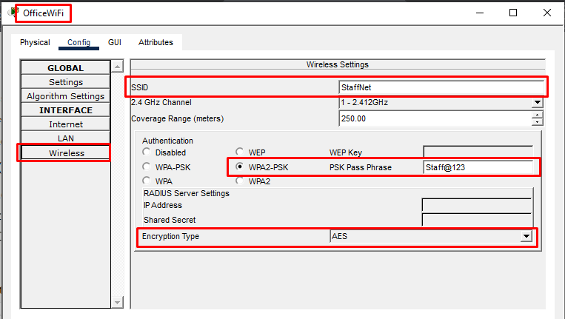
Figure 3: StaffNet SSID and WPA2-PSK security configuration on OfficeWiFi.
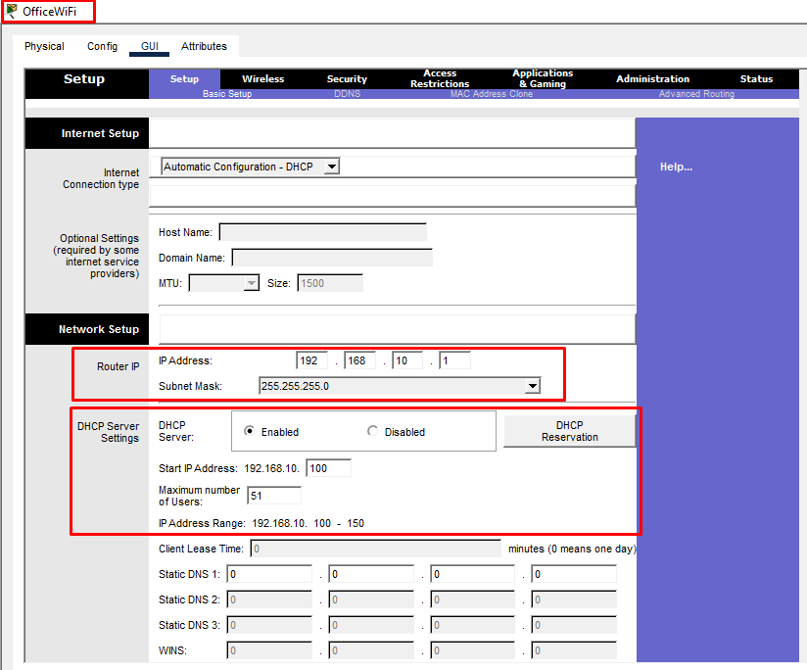
Figure 4: DHCP server configuration on OfficeWiFi (Start IP 192.168.10.100, Range 100–150).

Part C: Configure Guest WiFi
A separate guest network was then configured. Since the OfficeWiFi router can only broadcast one SSID, a second access point (labelled "Guest Wifi") was connected to the same switch and set up with its own SSID, GuestNet, secured with WPA2-PSK using the passphrase Guest@123. This access point shares the same 192.168.10.0/24 network and the same DHCP scope as the router, so guest devices still receive an IP address automatically, just like employee devices, while staying on a separate SSID and password from StaffNet.
The Linksys WRT300N router used in this design broadcasts only one SSID per radio. Since the company requires two logically separate wireless networks (StaffNet for employees and GuestNet for guests) with independent authentication credentials, a second Access Point was connected to the same switch and configured to broadcast the GuestNet SSID. Both access points remain on the same 192.168.10.0/24 LAN and share the router's single DHCP scope, so guest and staff devices still receive addresses automatically from the same pool while authenticating against different SSIDs and passphrases.
This design mirrors common small-office practice, where a consumer-grade router that supports only a single SSID is supplemented with an additional access point to provide a separate guest SSID while sharing the same LAN infrastructure.
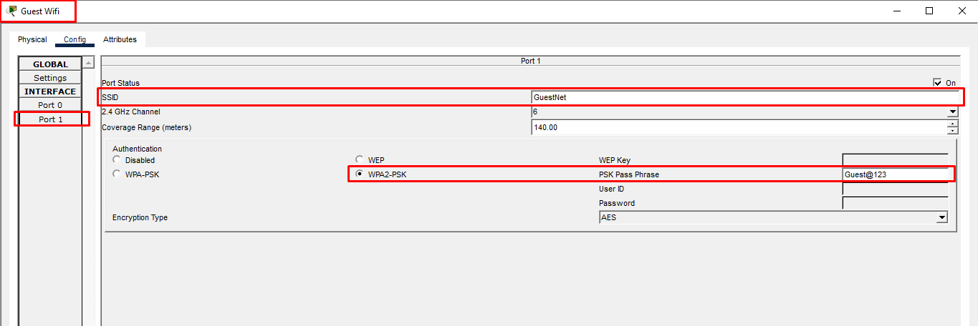
Figure 5: GuestNet SSID and WPA2-PSK configuration on the secondary Access Point ("Guest Wifi").

Part D: Wireless Device Configuration
Laptop0 and Laptop1 were configured to connect to StaffNet, and Smartphone0 was configured to connect to GuestNet, as required by the assignment. Each device was set to obtain its IP configuration automatically via DHCP. The full connection sequence — installing the wireless adapter, selecting the SSID, entering the WPA2 passphrase, and confirming a successful association — is documented below for Laptop0; the remaining devices followed the same procedure and are documented with their resulting DHCP-assigned IP configuration.

Laptop0 — Full Connection Sequence (StaffNet)

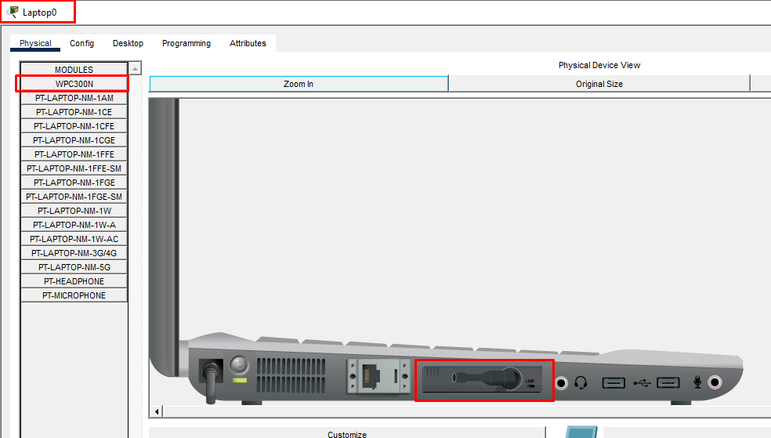
Figure 6: WPC300N wireless adapter installed on Laptop0.

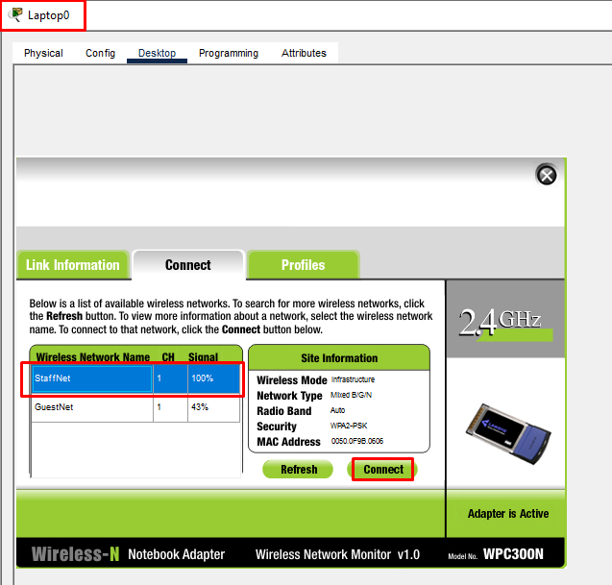
Figure 7: Laptop0 selecting the StaffNet SSID.
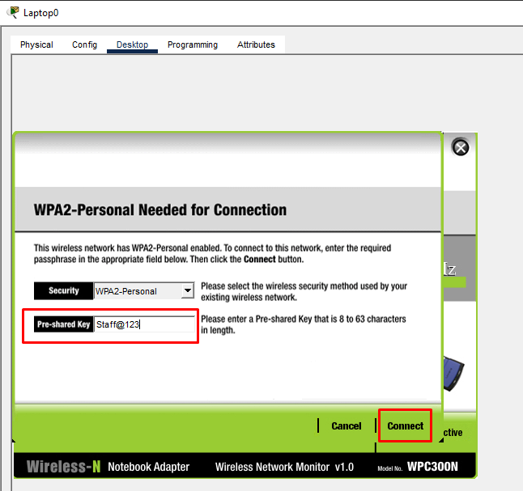
Figure 8: Entering the WPA2-Personal pre-shared key (Staff@123) for StaffNet.

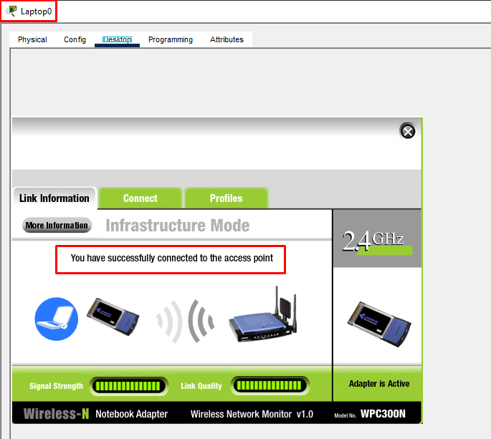
Figure 9: Laptop0 successfully connected to the access point.
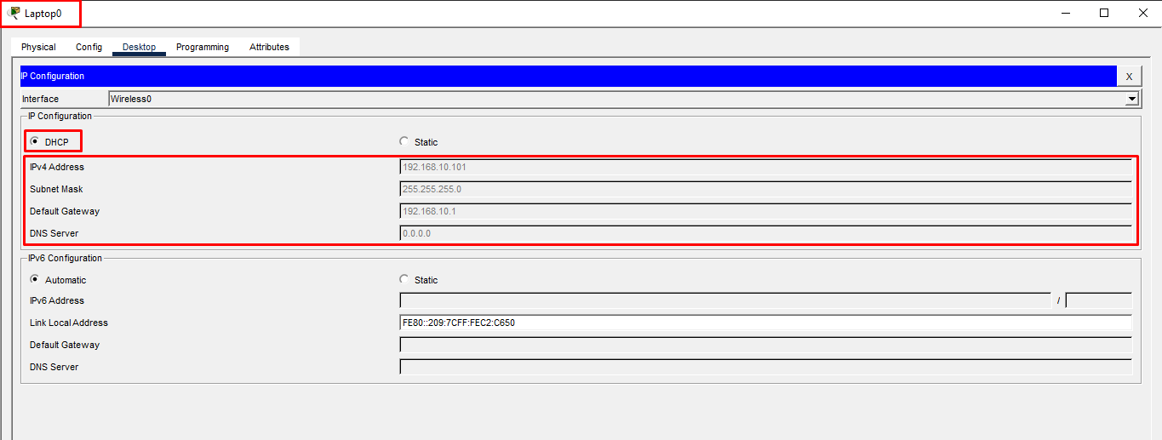
Figure 10: Laptop0 IP configuration obtained automatically via DHCP (192.168.10.101).

Laptop1 (StaffNet), Smartphone0 (GuestNet), PC0 and PC1 (wired)
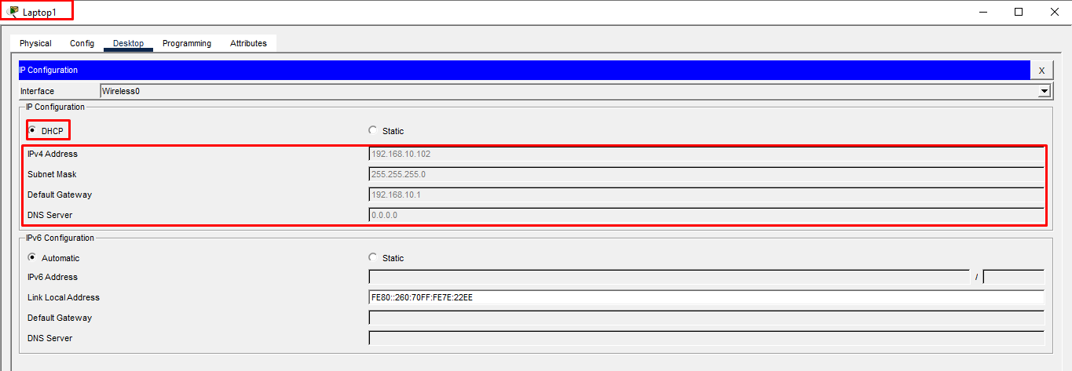
Figure 11: Laptop1 IP configuration obtained automatically via DHCP (192.168.10.102).

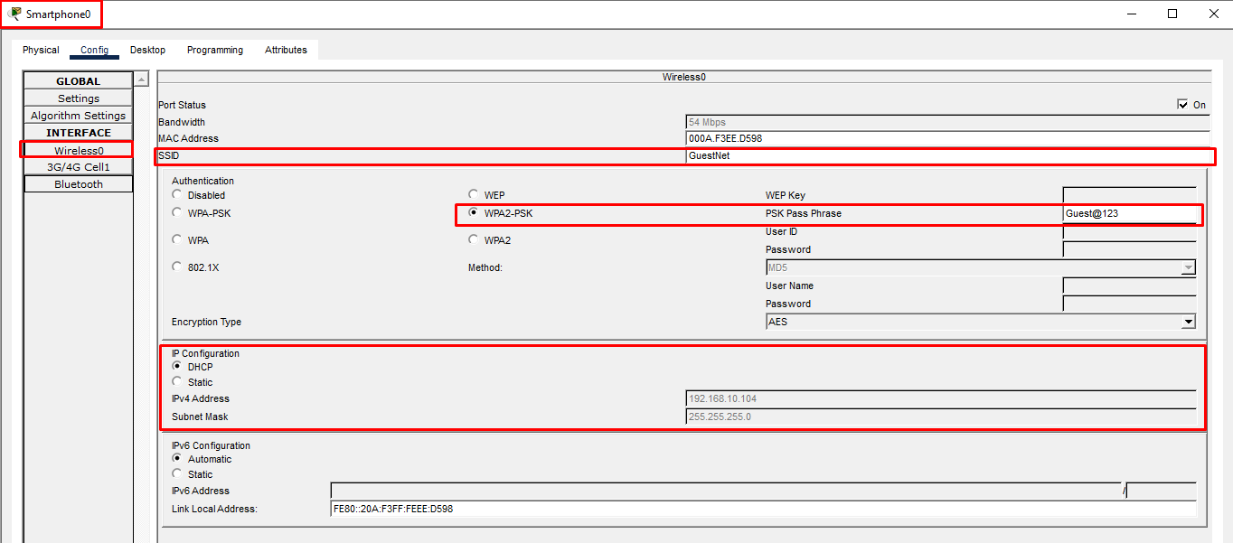
Figure 12: Smartphone0 wireless configuration — connected to GuestNet using WPA2-PSK (Guest@123).
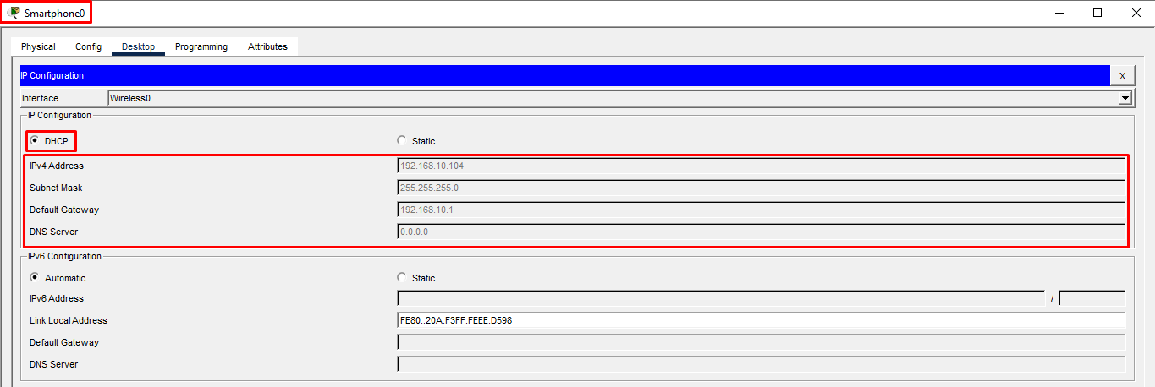
Figure 13: Smartphone0 IP configuration obtained automatically via DHCP (192.168.10.104).

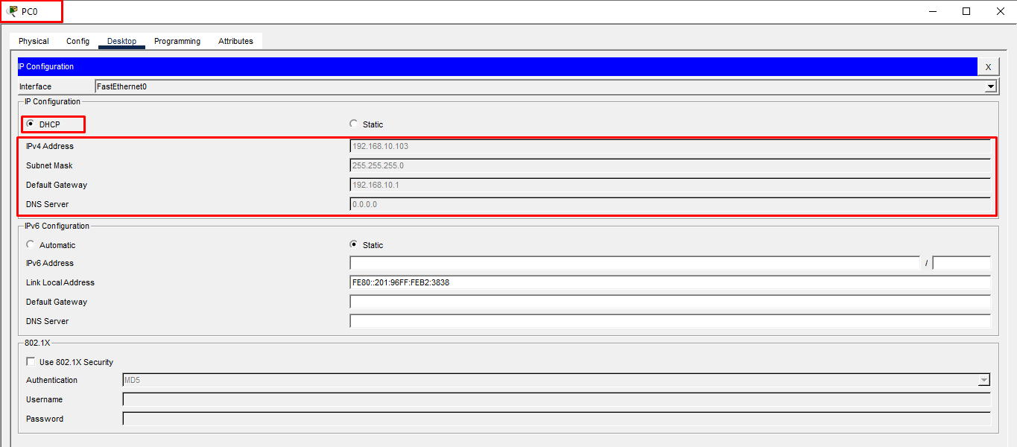
Figure 14: PC0 (wired) IP configuration obtained automatically via DHCP (192.168.10.103).

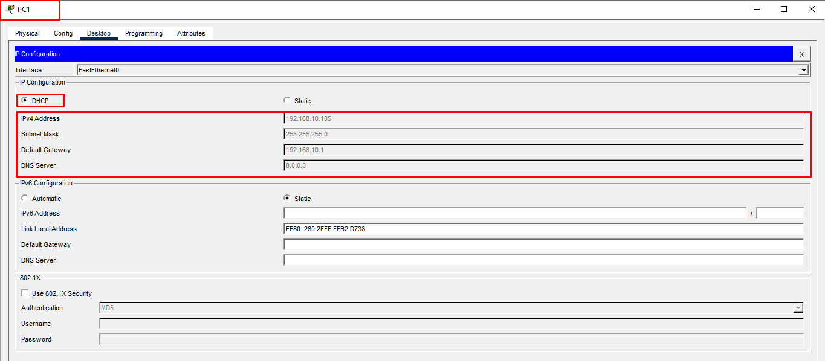
Figure 15: PC1 (wired) IP configuration obtained automatically via DHCP (192.168.10.105).

Part E: Connectivity Testing
Connectivity was verified in two ways: (1) PDU (ping) tests between pairs of devices across the wired and both wireless segments, confirmed successful in the Packet Tracer simulation panel, and (2) command-line ping tests from PC0, Smartphone0, and Laptop0 to the router's gateway address (192.168.10.1), confirming that every segment — wired, StaffNet, and GuestNet — can reach the default gateway with 0% packet loss.

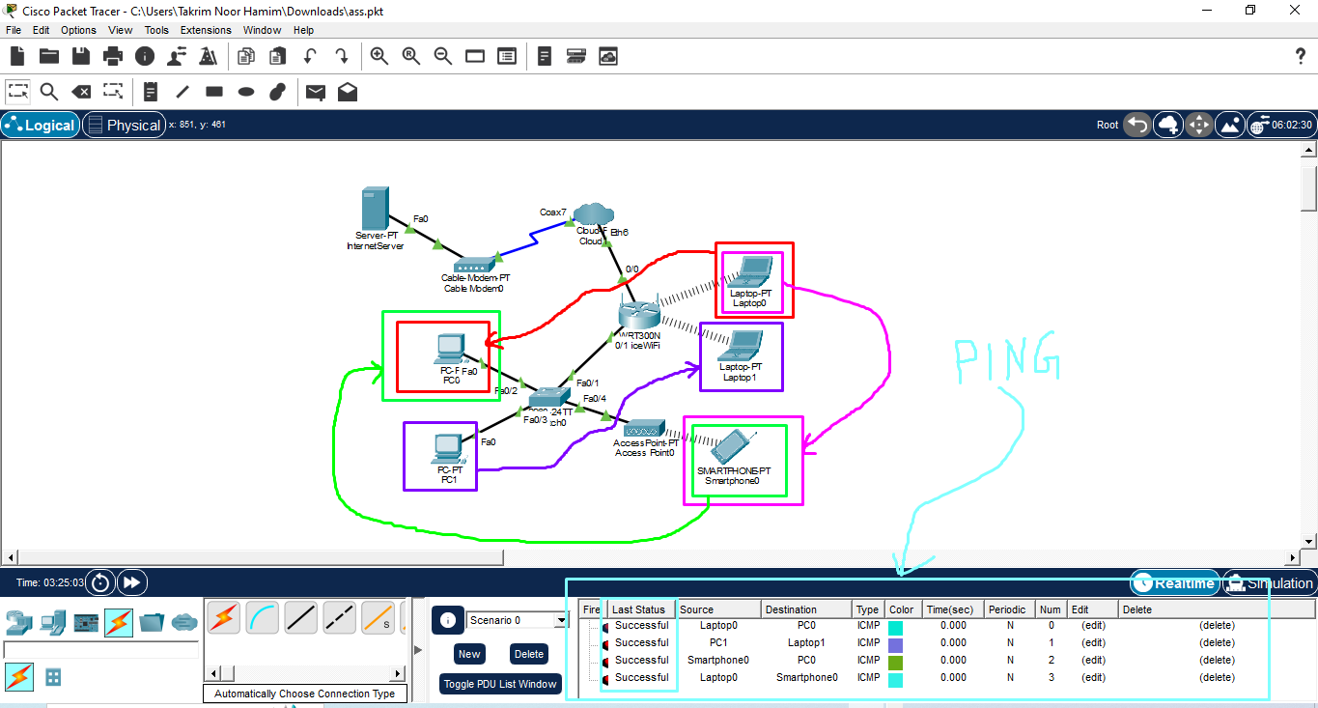
Figure 16: Successful PDU (ping) tests between PC0, PC1, Laptop0, Laptop1, and Smartphone0 across the network.

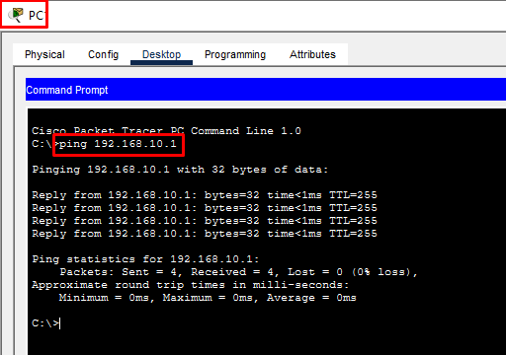
Figure 17: Ping test from PC0 to the router gateway (192.168.10.1) — successful, 0% loss.
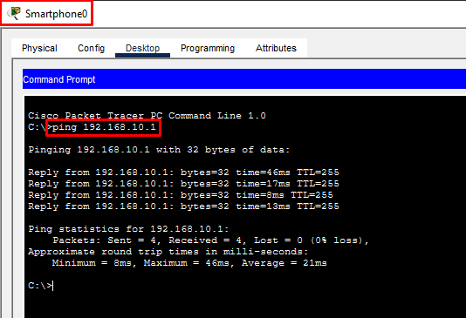
Figure 18: Ping test from Smartphone0 (GuestNet) to the router gateway — successful, 0% loss.

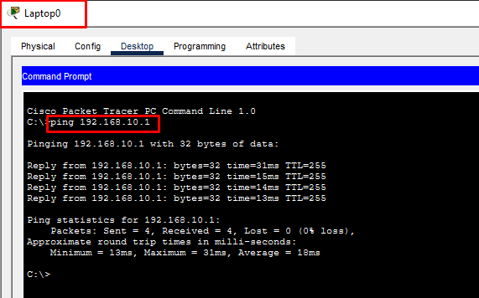
Figure 19: Ping test from Laptop0 (StaffNet) to the router gateway — successful, 0% loss.

Regarding internet connectivity: rather than relying only on gateway reachability as indirect evidence, a dedicated Server-PT (InternetServer) was placed behind Cloud1 to represent an external, ISP-side host, giving a concrete, pingable destination beyond the local network. InternetServer connects to a Cable Modem (Cable Modem0) over Ethernet, and the modem in turn connects to Cloud1's Coaxial7 port; on Cloud1, both Ethernet6 (facing the router) and the Cable Modem link were configured on the same "Cable" provider network and bridged together under Config → Connections → Cable, so that traffic passes Router → Cloud1 → Cable Modem0 → InternetServer exactly as it would over a real cable ISP link.
The router's WAN interface (0/0) was configured with a static IP address of 100.64.0.1/24, and InternetServer was assigned the corresponding address 100.64.0.2/24 on the same subnet, reachable across the Router → Cloud1 → Cable Modem0 → InternetServer path, as shown in Figures 22 and 23.

Internet Connectivity Verification

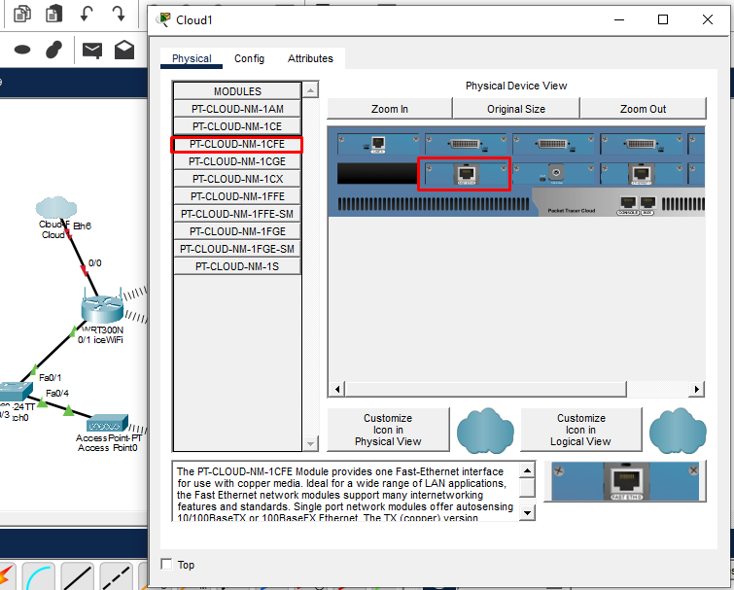
Figure 20: Cloud1 equipped with the PT-CLOUD-NM-1CFE Ethernet module, providing the Ethernet6 interface used for the ISP-side link.

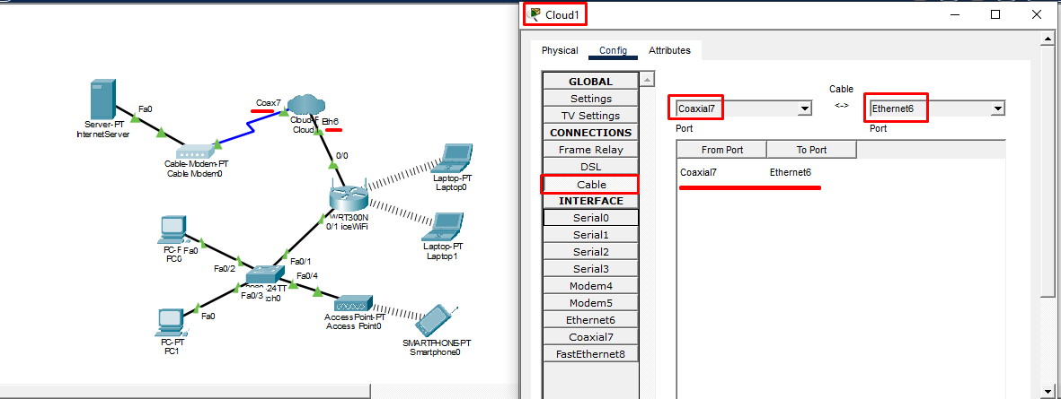
Figure 21: Cloud1 Config → Connections → Cable bridge linking Coaxial7 (Cable Modem side) with Ethernet6 (router side).
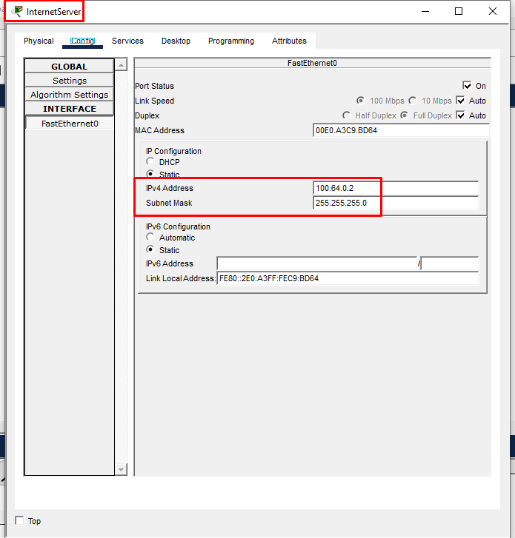
Figure 22: InternetServer static IP configuration (100.64.0.2/24) representing the external ISP-side host.

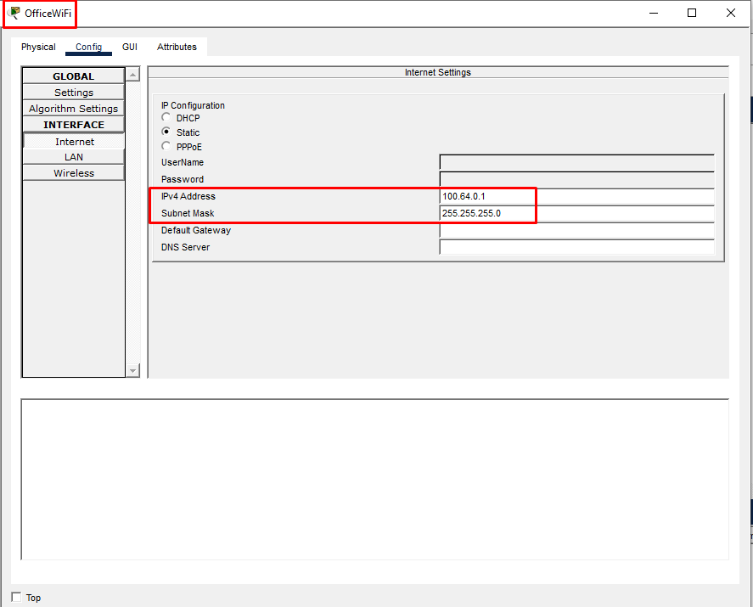
Figure 23: OfficeWiFi WAN interface static IP configuration (100.64.0.1/24).
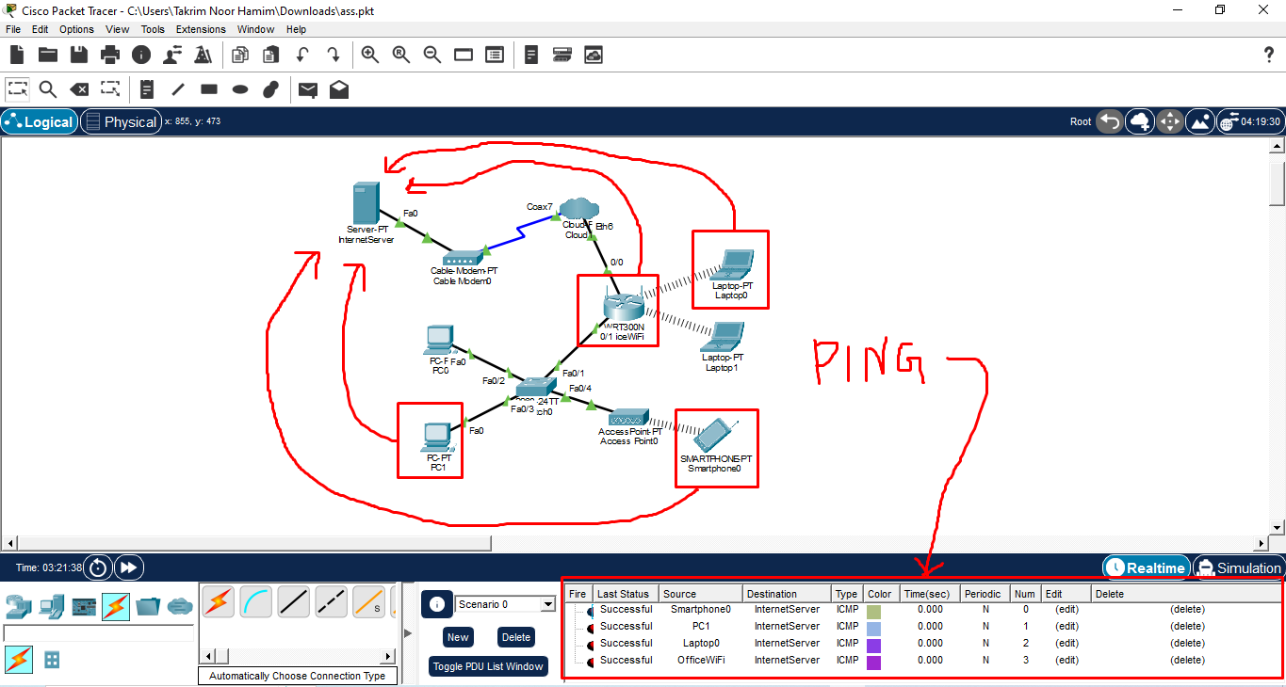
Figure 24: PDU (ping) tests from Smartphone0, PC1, Laptop0, and OfficeWiFi to InternetServer — all successful across the simulation panel.

With this link established, command-line ping tests were carried out from a device on each of the three network segments — StaffNet, GuestNet, and the wired LAN — targeting the external host address 100.64.0.2, in order to verify that all users have working internet connectivity as required by the assignment.
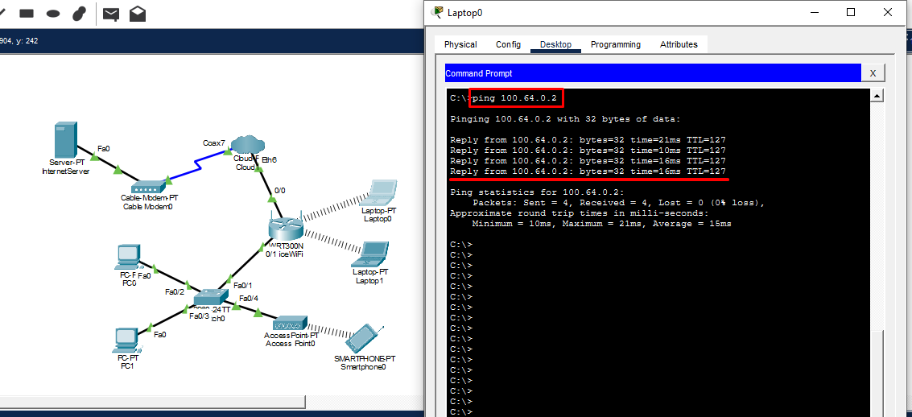
Figure 25: Ping test from Laptop0 (StaffNet) to the external host (100.64.0.2) — successful, 0% loss.
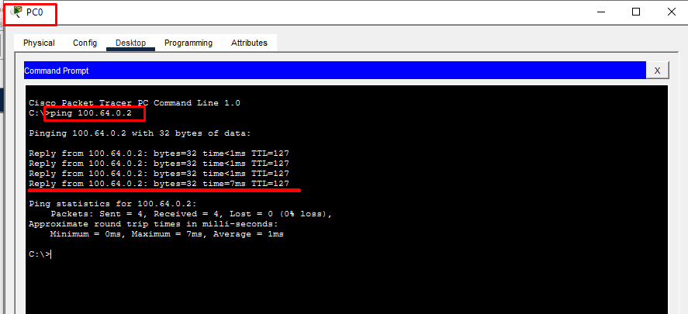
Figure 26: Ping test from PC0 (wired) to the external host (100.64.0.2) — successful, 0% loss.

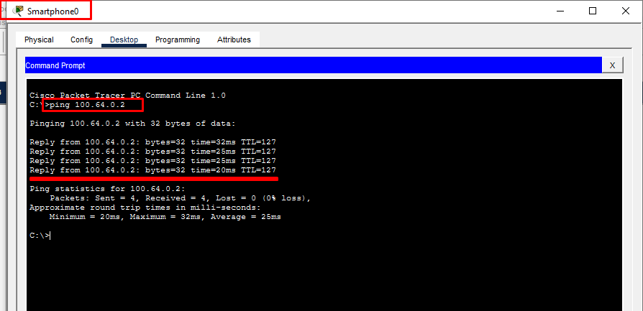
Figure 27: Ping test from Smartphone0 (GuestNet) to the external host (100.64.0.2) — successful, 0% loss.
All three segments successfully reached 100.64.0.2 with 0% packet loss (Figures 25–27), confirming that internet connectivity is correctly routed and available for every user on the network, whether connected via StaffNet, GuestNet, or a wired port.

Troubleshooting Task
Problem: During connectivity testing, Laptop0 was found unable to connect to the wireless network.

Step 1 — Identify the Issue
Reviewing Laptop0's wireless Connect screen showed that it was attempting to associate with the GuestNet SSID instead of its assigned StaffNet SSID, and that the pre-shared key supplied was Staff@123 — the StaffNet passphrase — which does not match GuestNet's passphrase (Guest@123). This combination of wrong SSID and mismatched credential caused the connection attempt to fail, with the Link Information screen reporting "No association with access point" and the adapter shown as Inactive.
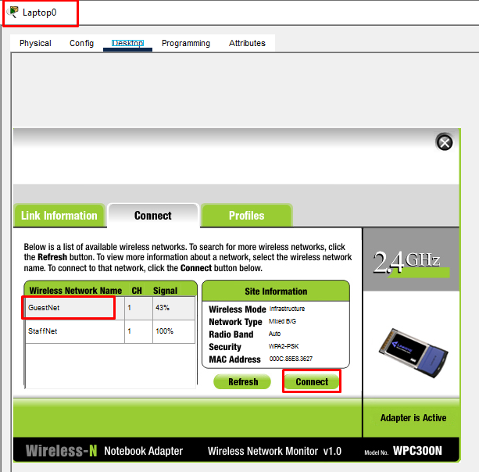
Figure 28: Laptop0 mistakenly attempting to connect to GuestNet instead of StaffNet.
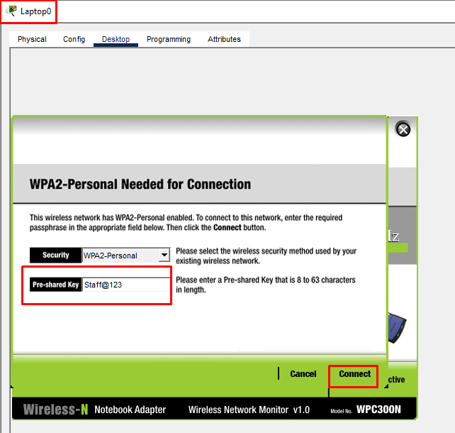
Figure 29: Incorrect pre-shared key (StaffNet's key) entered against the GuestNet SSID.

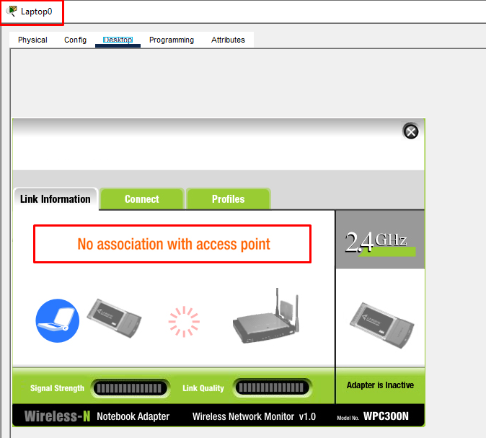
Figure 30: Resulting failure: "No association with access point", adapter Inactive.

Step 2 — Correct the Configuration
The fix was to open Laptop0's Connect screen again, select the correct SSID (StaffNet) from the list of available networks, and enter the correct WPA2-Personal pre-shared key (Staff@123).
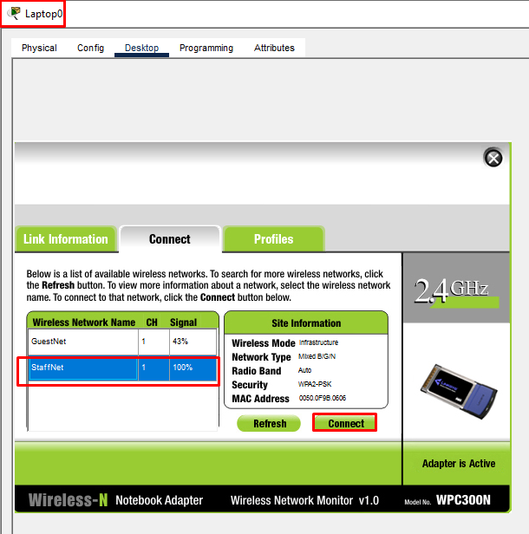
Figure 31: Correct SSID (StaffNet) selected after re-diagnosing the issue.

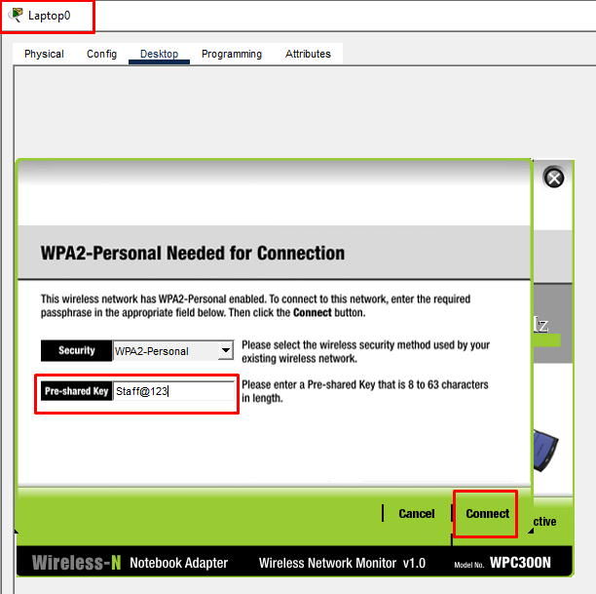
Figure 32: Correct WPA2 pre-shared key (Staff@123) entered for StaffNet.

Step 3 — Verify the Fix
After reconnecting, the Link Information screen reported "You have successfully connected to the access point," with the adapter status Active and full signal strength / link quality. Laptop0 subsequently obtained the IP address 192.168.10.101 via DHCP with default gateway 192.168.10.1 (see Figure 10), and a follow-up ping to the gateway completed successfully with 0% packet loss (see Figure 19), confirming the issue was fully resolved.
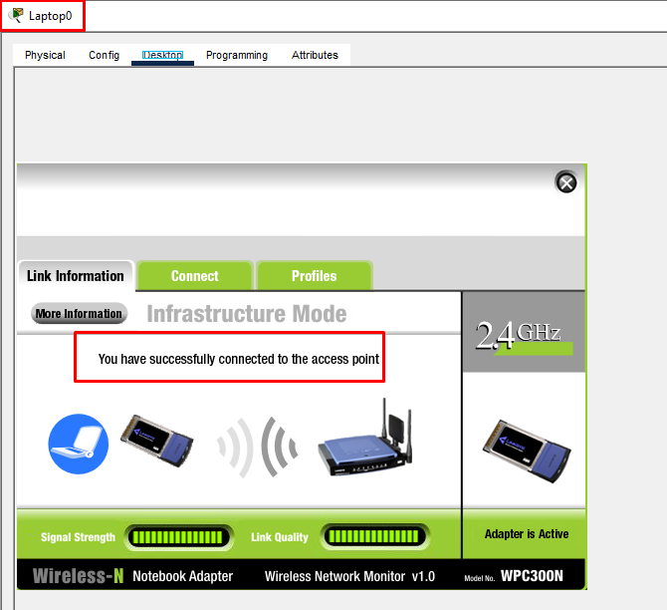
Figure 33: Laptop0 successfully reconnected to the access point after the fix.

This exercise corresponds to two of the possible issues listed in the assignment brief — an incorrect SSID selection and an incorrect password — and demonstrates a standard wireless troubleshooting workflow: check the SSID the client is associated with, verify the authentication credential being used, correct both, and confirm success at the association, DHCP, and IP-connectivity layers in turn.

Conclusion
The completed network successfully meets the company's specified requirements. Employees are provided with secure wireless access through the StaffNet SSID using WPA2-PSK/AES encryption, while guests connect through a separate GuestNet SSID broadcast by a secondary access point. All wired and wireless devices obtain their IP configurations automatically from a single DHCP scope, and network connectivity has been successfully verified through both Packet Tracer PDU simulations and command-line ping tests. In addition, the simulated connectivity issue on Laptop0 was correctly identified, resolved, and verified, demonstrating a systematic approach to wireless network troubleshooting. Overall, this project demonstrates practical skills in wireless network design, security configuration, DHCP deployment, connectivity verification, and troubleshooting using Cisco Packet Tracer.

Answers to Questions

Question 1
A company notices that employees can connect to Wi-Fi, but many users experience frequent disconnections. Analyse three possible technical reasons and describe how you would troubleshoot the issue.
Three likely technical causes are: (1) Channel congestion and RF interference — overlapping 2.4 GHz channels between nearby access points, or interference from microwaves, Bluetooth devices, and cordless phones, can cause repeated retransmissions and dropped associations. (2) Insufficient coverage or AP overload — clients at the edge of an AP's range experience weak signal and frequent re-association, and an AP serving too many simultaneous clients can also drop or de-prioritise connections once it reaches its capacity. (3) DHCP or authentication issues — an undersized DHCP pool or a very short lease time can cause clients to lose their IP address and appear to disconnect, while authentication timeouts (e.g., a slow RADIUS server in enterprise WPA2-Enterprise setups) can also repeatedly kick users off.
To troubleshoot, I would first reproduce the pattern: check whether disconnections cluster around specific access points, times of day, or locations, which points to interference or overload rather than a single misconfigured device. A wireless site survey or spectrum scan would confirm channel congestion and signal strength at the affected locations. I would then check the AP logs for de-authentication reasons, review the DHCP scope size and lease duration against the number of active clients, and, where available, check for firmware updates, since driver/firmware bugs are a common but easy-to-rule-out cause. Testing with a single client moved close to the AP helps isolate whether the fault is RF-related or configuration-related.

Question 2
A network administrator wants to choose between Wi-Fi 5 and Wi-Fi 6 for a new office deployment. Evaluate which technology is more suitable and explain your decision based on user capacity, speed, and future requirements.
For a new office deployment, Wi-Fi 6 (802.11ax) is generally the more suitable choice. In terms of user capacity, Wi-Fi 6 introduces OFDMA and uplink/downlink MU-MIMO, which allow an access point to serve multiple clients within the same channel time slot rather than serving them sequentially; this materially improves performance in dense office environments with many simultaneous laptops, phones, and IoT devices, which Wi-Fi 5 (802.11ac) handles less efficiently. In terms of speed, Wi-Fi 6 offers a higher theoretical maximum throughput per client and, more importantly, more consistent real-world throughput under load, because of its improved spectral efficiency (1024-QAM) and better scheduling.
Looking at future requirements, Wi-Fi 6 also supports Target Wake Time, which reduces power consumption for battery-operated IoT devices, and pairs naturally with WPA3, giving a stronger security baseline than Wi-Fi 5's typical WPA2 deployment. Client devices (laptops, smartphones) shipped from roughly 2020 onward increasingly support Wi-Fi 6 natively, so the technology is no longer bleeding-edge, and choosing it avoids a near-term forced upgrade. The main argument for Wi-Fi 5 would be lower upfront hardware cost in a very small, low-density office with no near-term growth plans; however, for a company that is expanding — as described in this assignment's scenario — the capacity and longevity advantages make Wi-Fi 6 the more suitable long-term choice.

Question 3
Create a troubleshooting plan for users who report: "The Wi-Fi signal is strong, but the internet is slow." Your plan should include possible causes, testing methods, and solutions.
Possible causes: signal strength (bars) reflects only the radio link between the device and the access point, not the actual data throughput, so a strong signal can coexist with a slow internet experience. Likely causes include: WAN/ISP-side bandwidth bottleneck or an ISP outage/congestion; too many devices sharing the same internet connection at peak times; interference or channel congestion reducing effective throughput despite a strong signal bar reading; outdated router firmware or a misconfigured/absent QoS policy allowing one device to consume most of the bandwidth; DNS resolution delays making browsing feel slow even when raw throughput is fine; and bufferbloat, where a saturated upstream link causes high latency and jitter under load.
Testing methods: run a speed test on a device connected directly by Ethernet to the router and compare it with a speed test over Wi-Fi, to determine whether the bottleneck is the WAN connection itself or the wireless link; run a ping/traceroute to a reliable external host to check for latency and packet loss; check the router's admin page for the number of connected devices and per-device bandwidth usage; perform a Wi-Fi channel scan to check for congestion from neighbouring networks; and test at different times of day to see if slowness correlates with peak usage.
Solutions: if the WAN link itself is confirmed slow, contact the ISP or upgrade the plan; if wireless-side interference is the cause, switch to a less congested channel or move to the 5 GHz band; if too many devices are competing for bandwidth, configure QoS/traffic shaping to prioritise business-critical traffic; update router firmware; and where a specific device is monopolising bandwidth, apply per-device bandwidth limits or investigate it for unwanted background updates or malware.

Question 4
"Wi-Fi will eventually replace Ethernet completely." Do you agree or disagree? Discuss your opinion with technical evidence.
I disagree that Wi-Fi will completely replace Ethernet. While Wi-Fi has clearly become the dominant access method for mobile and portable client devices — laptops, phones, tablets — several technical factors mean wired Ethernet is likely to remain necessary for specific roles rather than disappear.
First, latency and consistency: Ethernet offers deterministic, very low latency with negligible jitter, because it is a dedicated, interference-free physical medium, whereas Wi-Fi shares a contested wireless medium subject to interference, collisions, and variable signal quality; this matters for applications such as competitive gaming, video production, VoIP/video conferencing at scale, and industrial control systems. Second, raw bandwidth ceiling: wired standards such as 10GbE, 25GbE, and 100GbE are well-established in data centres and server rooms, and wired connections between switches, servers, and access points (backhaul) will remain necessary even in a "wireless-first" office, since every access point still needs a wired uplink to the switch and, ultimately, to the router. Third, reliability and security: a physical cable cannot be intercepted or jammed as easily as a radio signal, and is not subject to the capacity-sharing problem inherent to a shared wireless channel.
In practice, the more realistic trajectory is coexistence rather than replacement: Wi-Fi (now Wi-Fi 6/6E/7) increasingly handles user-facing access, while Ethernet continues to carry backhaul, server, and latency-critical traffic. This is consistent with current enterprise network design, where even the most modern all-wireless office still relies on a wired core and distribution layer.

