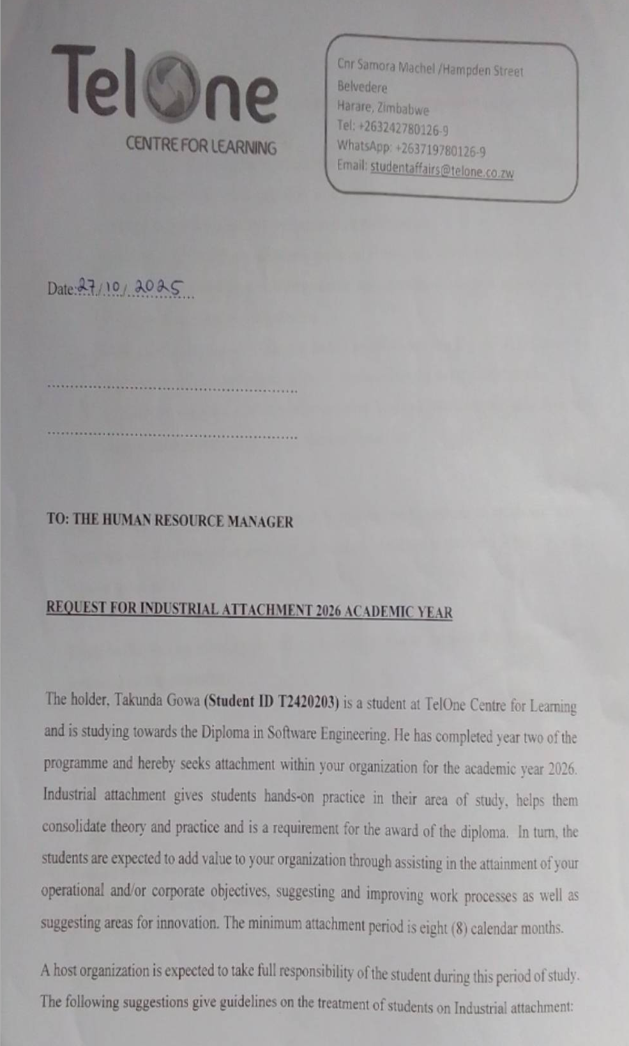
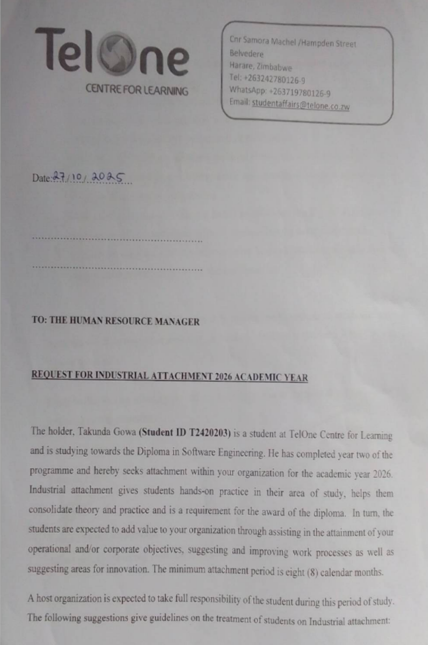
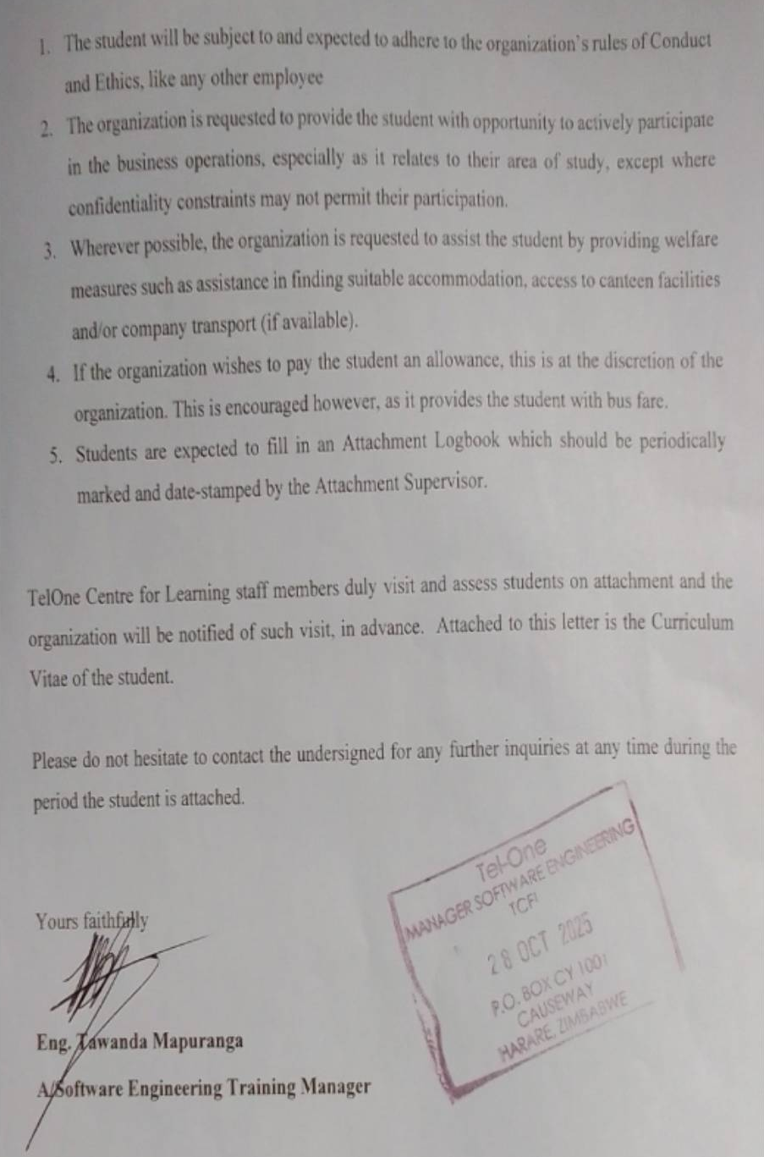

Takunda Gowa | Curriculum Vitae

 Address: 87 Blackway Harare

Phone: 078 725 9729
 Email: takundagowa@gmail.com

LinkedIn: https://www.linkedin.com/in/takunda-gowa-511369309/

GitHub: https://github.com/taku-source

Portfolio:http://127.0.0.1:5500/index.html

Profile
I am a passionate, committed, and creative Software Engineering student who enjoys building systems that solve real-world problems while gaining practical knowledge. I have strong interests in web development, graphic design, and technological innovation. I enjoy combining creativity with functionality to develop systems, websites, and designs that make everyday life easier and more efficient.
Career objectives
- Gain more experience and knowledge in the Software engineering and it technician filed to become more skilled
- Contribute to meaningful projects that solve real world problems and also to make complex or stressfull tasks be easy and enjoyable
- To be great a leader, decision maker and problems solver
- To be an asset to any organisation through excellence and ethical business practices with the willingness to learn newthings in and outside my field and also bring a wealth of essential skills that I have mastered in my years of academic studies
Personal Details
DOB: 14 May 2007
SEX: male
MARITAL STATUS: single
AGE: 18 years

Education

Telone Center for Learning (2024-2026 graduating year)

DIPLOMA in SOFTWARE ENGINEERING

Jameson High school (2020-2023)

9 Ordinary level passes including Maths, Computer science, English

HEXCO certificate

Technical Skills
Programming Languages: Python, JavaScript, C, C#, MySQL, HTML, CSS
Frameworks & Tools: Flask, SQLAlchemy, .NET Framework, GitHub
Design Tools: Canva, Photoshop
Soft Skills: Communication, Leadership, Teamwork, Creativity, Critical Thinking, Problem Solving, Time Management

Other Competencies: Technopreneurship, Innovation, and Research

Projects & Creations

mgExcel Projects – Construction Company Website
HTML | CSS | JavaScript

-Designed and developed a website to advertise and market the company’s construction services, increasing visibility and accessibility across South Africa.
Live Site: https://taku-source.github.io/mgexcel-project/

Reserve Spot – Online Appointment Booking System
Flask | SQLAlchemy | HTML | CSS | JavaScript | MySQL

-Developed a web-based system to reduce long queues for ID processing by enabling users to book, manage, and cancel appointments online. Features include admin and user dashboards with appointment limits per day.

TalkEasy – Voice Messaging Social Platform
Flask | SQLAlchemy | HTML | CSS | JavaScript

-Created a prototype of a social media platform focused on simple, voice-based communication for individuals who prefer efficient interaction.

Poster & Logo Design – Excel Learning Academy
Canva | Photoshop

-Designed a modern logo and digital posters for branding and marketing purposes. Currently developing the school’s website as part of its digital transformation.

Achievements
- Built a live construction company website (mgExcel Projects).
- Designed branding materials (logo, posters) for Excel Learning Academy.
- Created multiple web systems and prototypes solving real-world challenges.

Personal attributes
- Strong problem-solving and analytical skills
- Critical thinker and quick learner
- Excellent communication and teamwork abilities
- Self-motivated, consistent, and disciplined
- Able to adapt and collaborate with diverse teams
- Good researcher and presenter
- Focused on structure, quality, and timely results

References

MR C. UTA: +263 77 460 3969 | utanoel@gmail.com
Lecture at TELONE CENTRE FOR LEARNING :TEL:+263242780126

MR KAPARARIDZE: +263 77 329 8525
Lecture at JAMESON HIGH SCHOOL of Computer Science

MS MICHAEL: +263 77 501 2753
Lecture at TELONE CENTER FOR LEARNING:TEL:+263242780126

