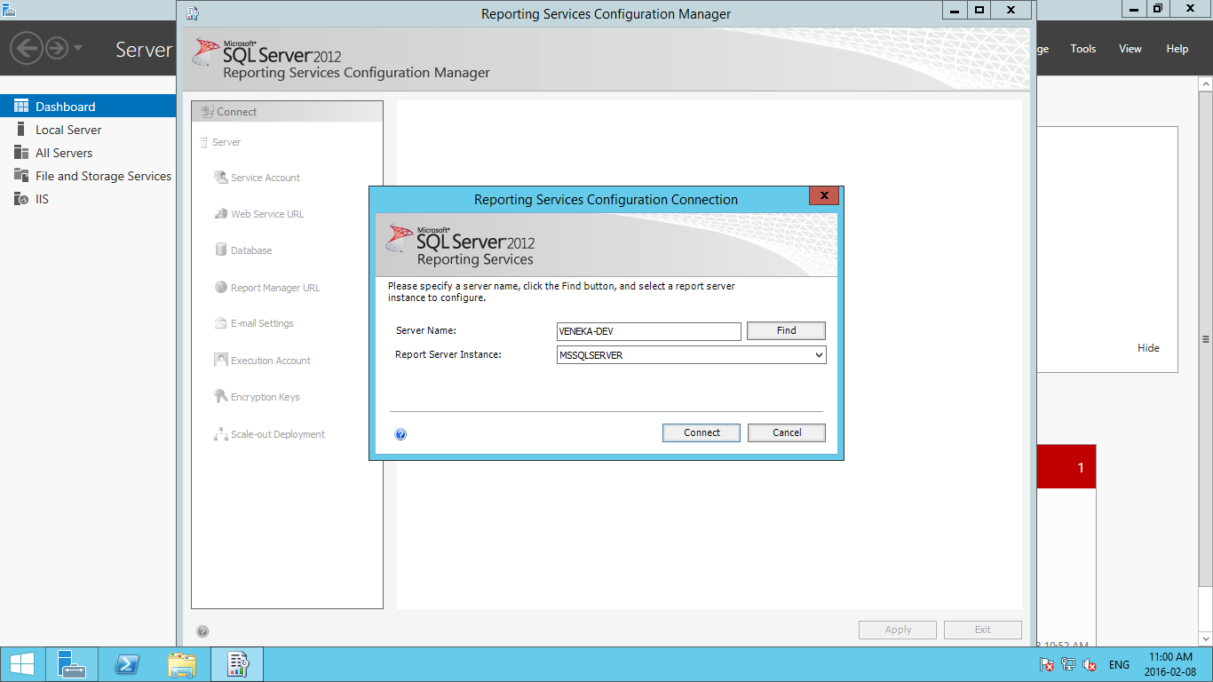

Press Connect

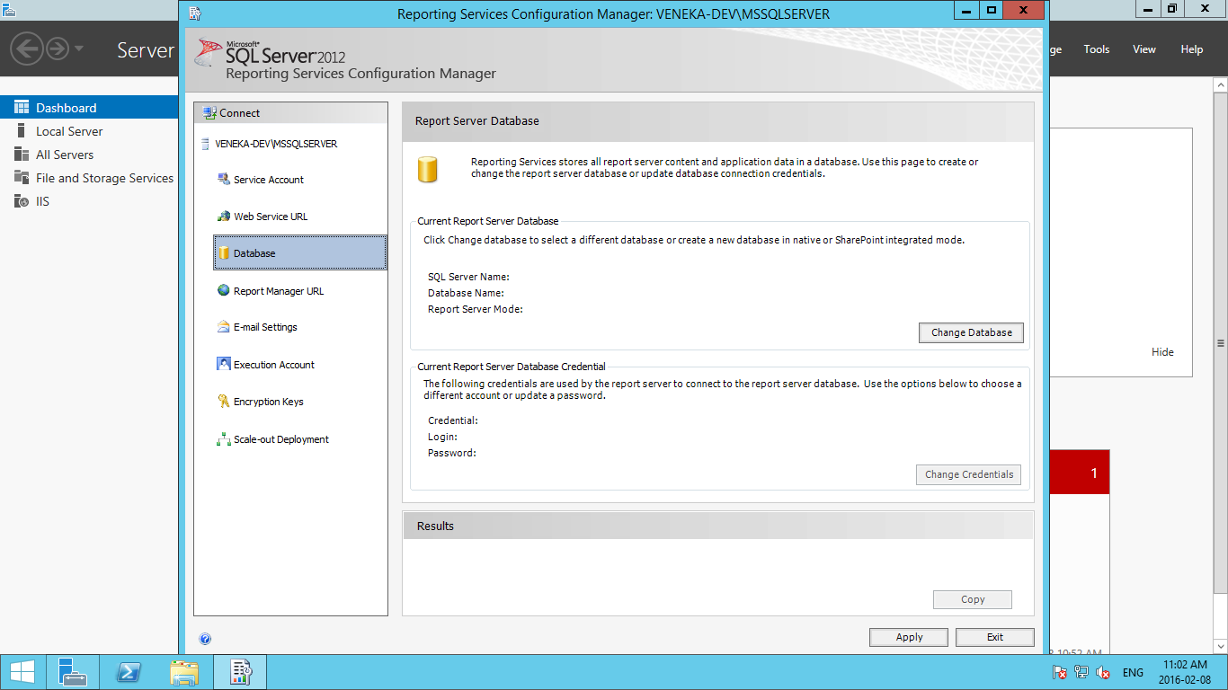

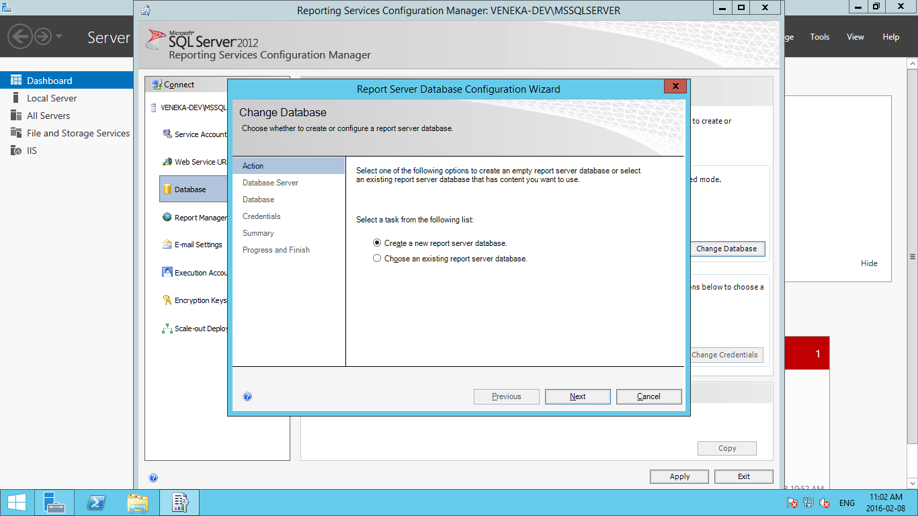

When you are configuring First Time select Create a new report server Database Click Next

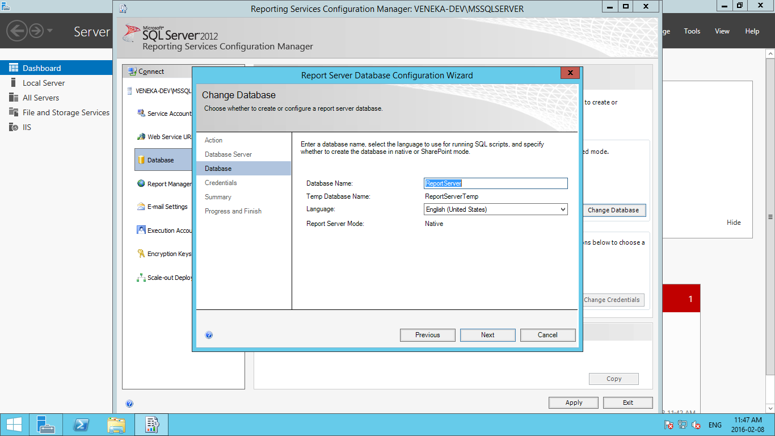

Need to Create Dummy Windows user which should have access to Reportserver

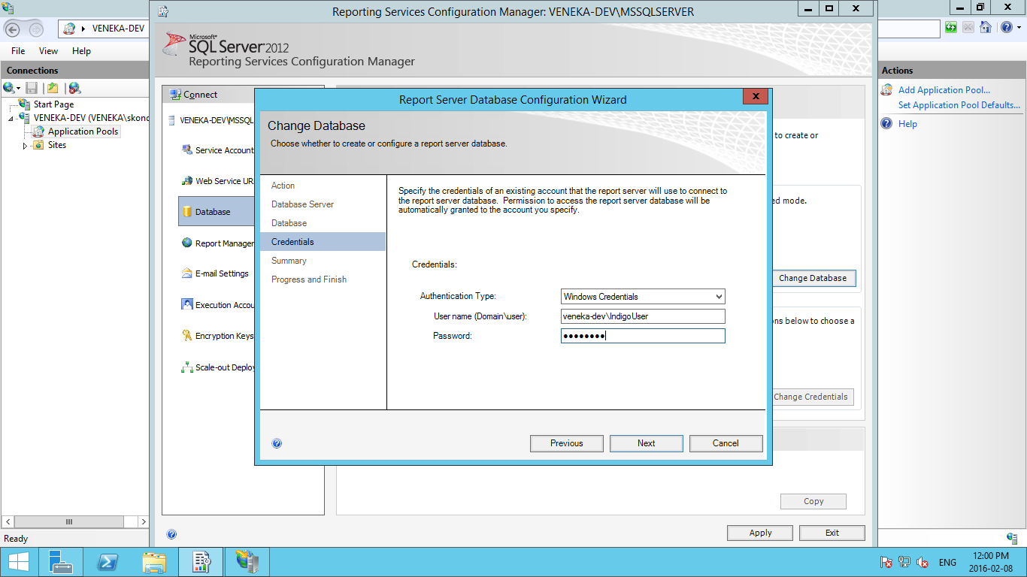

Click on Next

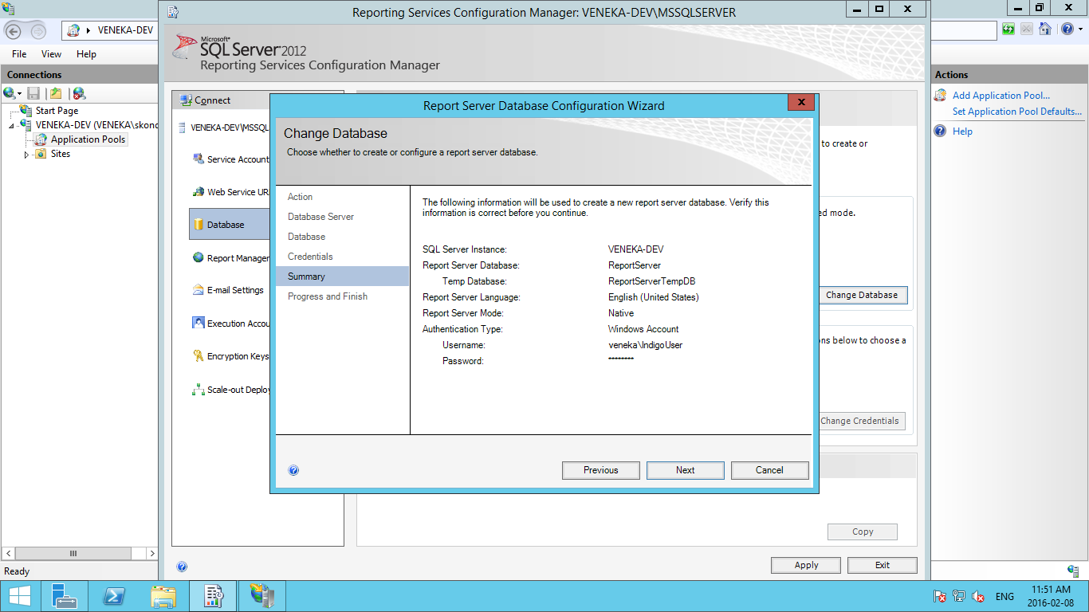

Click on Next🡪next screen click on Finish

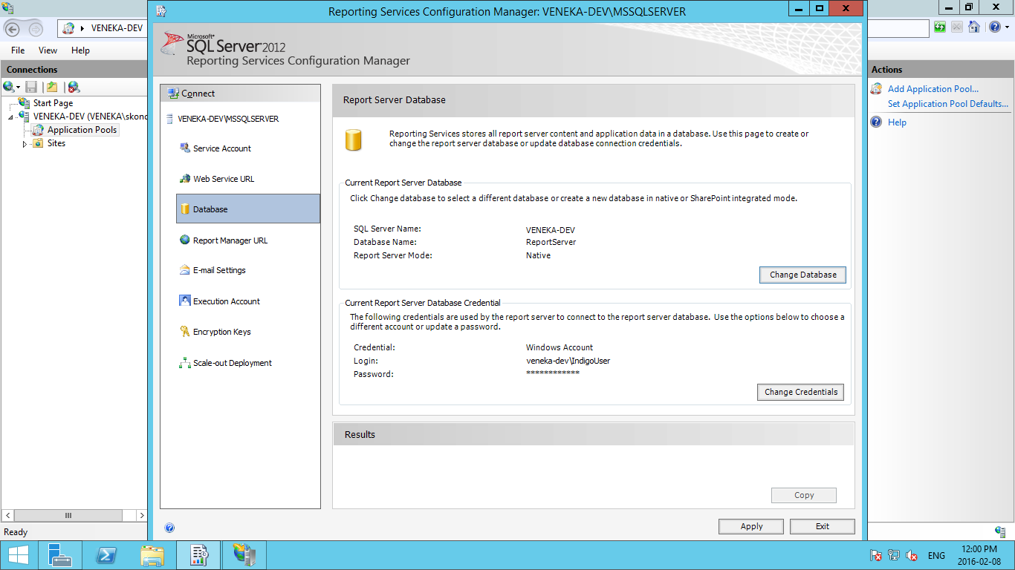

To Configure Report Server URL:

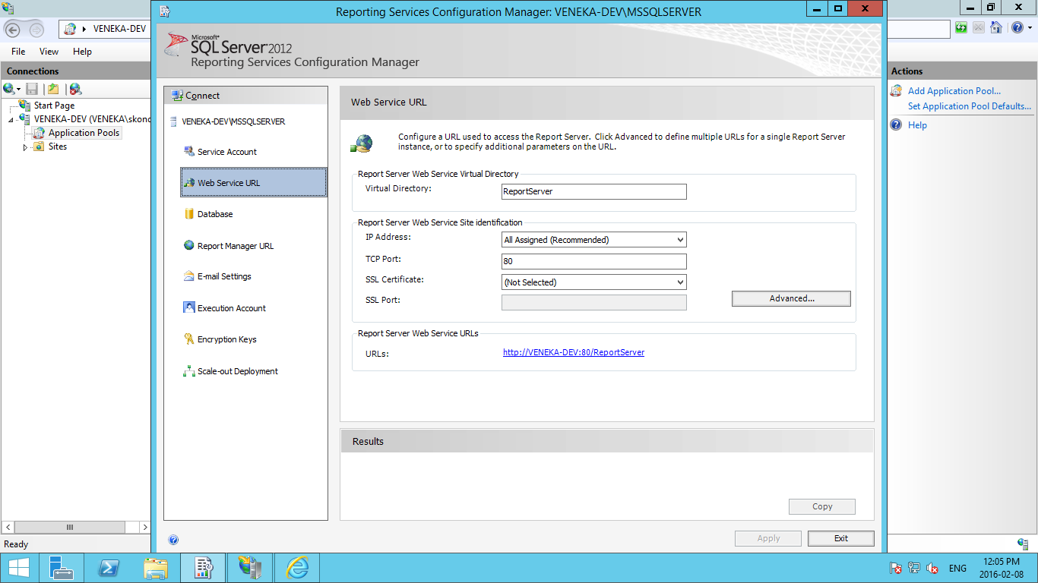

Click on Apply.

Click on Apply for First time

1. Start SQL Server Configuration Manager.
2. Expand **SQL Server Network Configuration**.
3. Select **Protocols for MSSQLSERVER.**
4. Right-click **TCP/IP**, and select **Enable**.
5. Select **SQL Server Services**.
6. Right-click **SQL Server (MSSQLSERVER)**, and select **Restart**.

**Error**  
  
The report server cannot access the private key for the service account. This key is used to decrypt the symmetric key that protects content in the report server database. This condition might occur after the password is reset for the report server service account. You must either restore a backup key or delete all encrypted content. (rsKeyStateNotValid)  
  
**Solutions**

* Open Report Services Configuration Connection
* Connect Server
* Click on **"Encryption Keys"**
* right side **"delete Encrypted Content"** delete
* Apply

Note: Please configure the connectionstring for the database using webInterface of ReportMager.

Steps to update the connectionstring using webinterface.

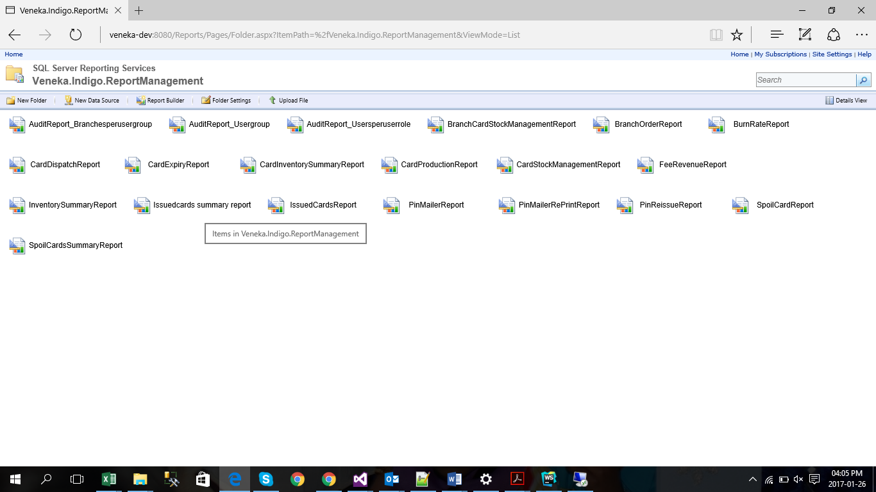

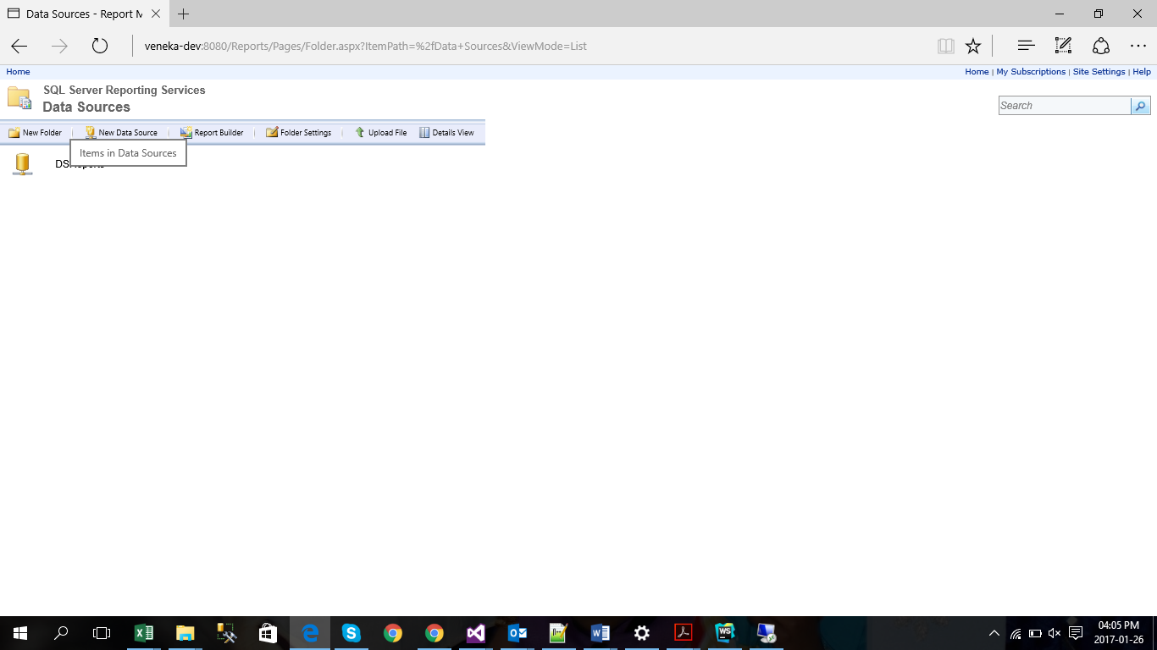

You can see datasoure click on datasource

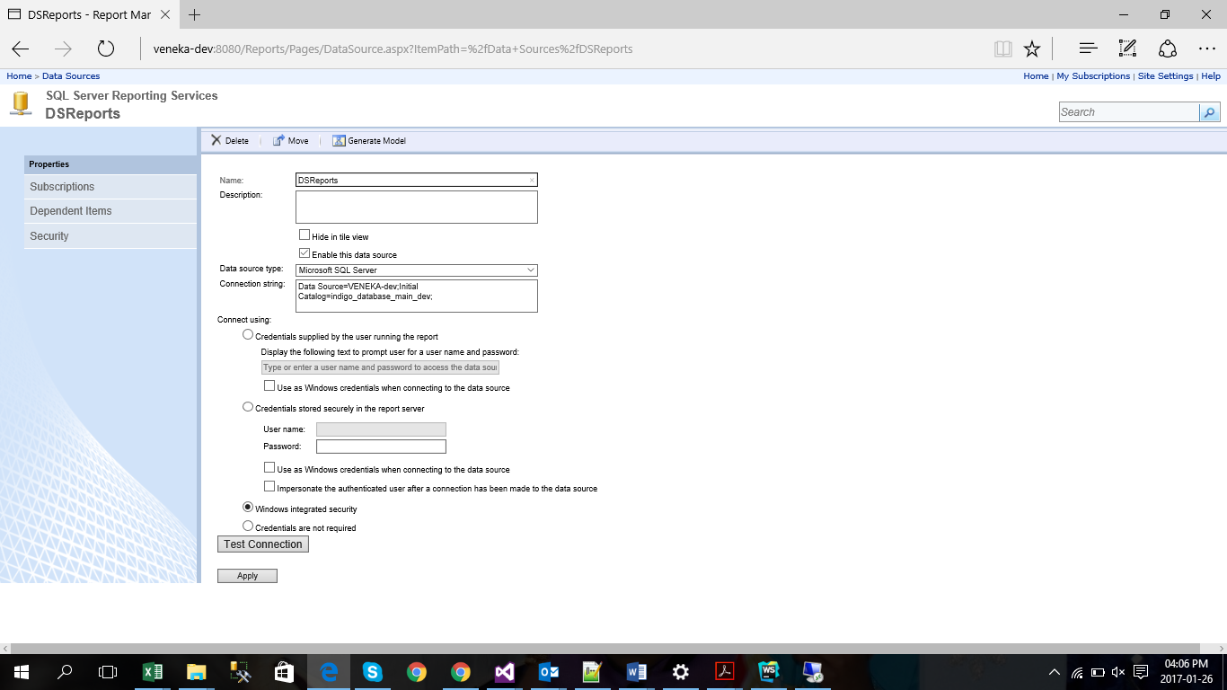

Do the configuration like above.