Requirements Specification

STUDENT NAMES :

STUDENT NUMBER: CSE24-

**1.1 Functional Specifications**

**Overview**

The banking platform is developed to enable secure and streamlined financial transactions for both personal and business users. It accommodates various service types and delivers essential banking features through an intuitive interface.

**Functional Specifications**

**Service Enrollment**

Users should be able to enroll in various financial services, including Savings, Investment, and Cheque options. The platform must support both deposits and withdrawals where permitted, and any changes made through transactions should be reflected immediately in the user's service balance.

**Transaction Records**

Users should be able to view a detailed record of all their financial transactions, including deposits, withdrawals, and interest earnings. Each entry in the log must clearly display the date and time of the transaction, the amount involved, and the specific service type associated with it.

**Interest Processing**

The platform is designed to automatically calculate and apply monthly interest to eligible services, ensuring financial accuracy and consistency. Investment services should receive a 5% interest rate, while Savings services are credited with 0.05% monthly. These interest amounts must be added directly to the corresponding service balances without requiring manual intervention.

**1.2 Non-Functional Specifications**

**Security**

All client information must be safeguarded through encryption protocols during both data storage and transmission. Passwords should be securely hashed before being stored to prevent unauthorized access. Additionally, robust access control mechanisms must be implemented to ensure that only authorized users can perform sensitive operations within the platform**.**

**Performance**

The system should deliver prompt responses to user interactions, ideally within two seconds under standard operating conditions. It must also be capable of handling multiple users accessing the system simultaneously without any noticeable drop in performance or speed.

**Usability**

The system interface should be designed for ease of use, ensuring accessibility for individuals with basic digital proficiency. Navigation must be straightforward, with clear guidance and feedback provided throughout the user experience. Additionally, the system should be fully compatible with both desktop and mobile devices to support flexible access.

**Maintainability**

The system should be built using a modular architecture and accompanied by thorough documentation to facilitate easy maintenance, updates, debugging, and future feature enhancements.

# 2. Structural UML Modelling

**2.1. System Use Case Diagram**

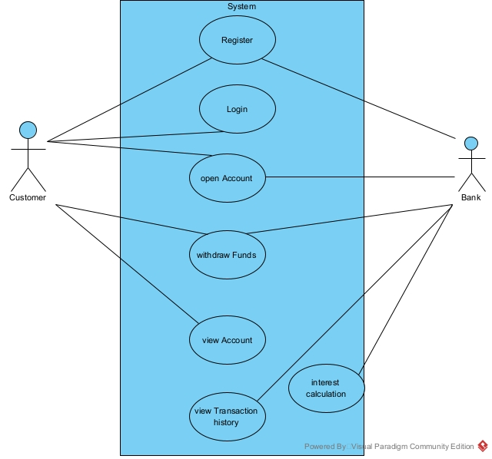

**2.2. Class diagram**

**3.** Behavioural UML Modelling)

**3.1.   Login and Deposit Sequence Diagrams:**

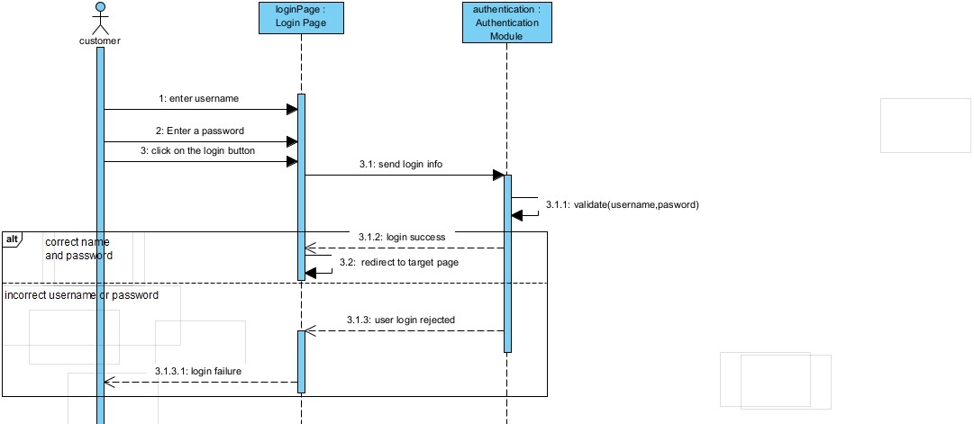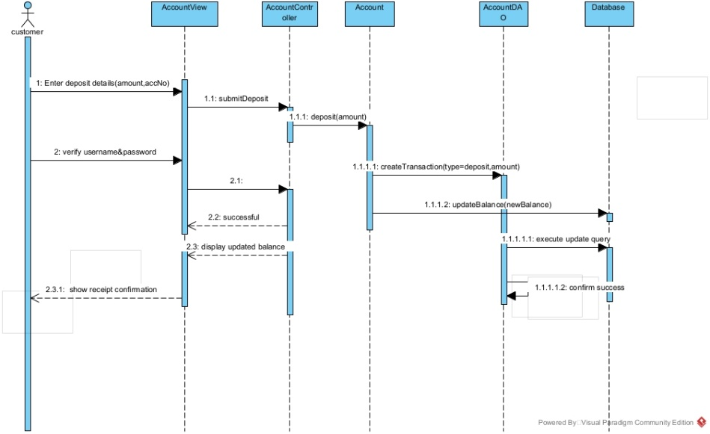

**3.2. State Diagram:**

**Meeting record appendix**

**: Interview Summary**

**Interviewer**: Kentsenao Baseki  
**Interviewee**: Students  
**Date**: 18 September 2025  
**Purpose**: To gather functional specifications for the banking platform

**Interviewer: What types of services should be supported?**  
**Interviewee***: Savings, Investment, and Cheque services, each with distinct rules for deposits, withdrawals, and interest.*

**Interviewer: Can users subscribe to more than one service?**  
**Interviewee***: Yes, users can enroll in multiple services simultaneously.*

**Interviewer: Is it important to track transactions?**  
**Interviewee***: Absolutely. Users should be able to view all past financial activities clearly.*

**Interviewer: What are the essential features the platform should offer?**  
**Interviewee***: It should support service management, and transaction tracking.*