2023-09: New NV

2023-09: New NV (NV_8 is the best. NV_3 is OK.)
Studying other NV's

NV_0 (yellow)
NV_1 (red)
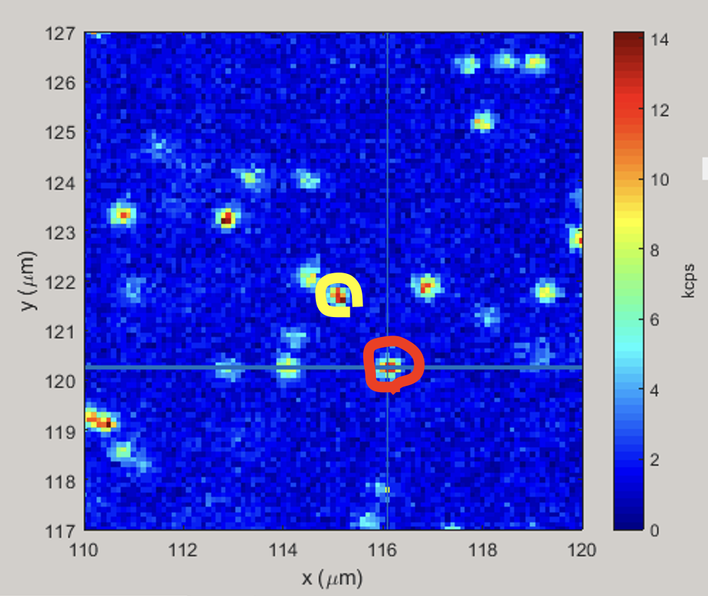

"1DExp-seq-Rabimodulated-vary-mw_freq-2023-09-16-220330" | 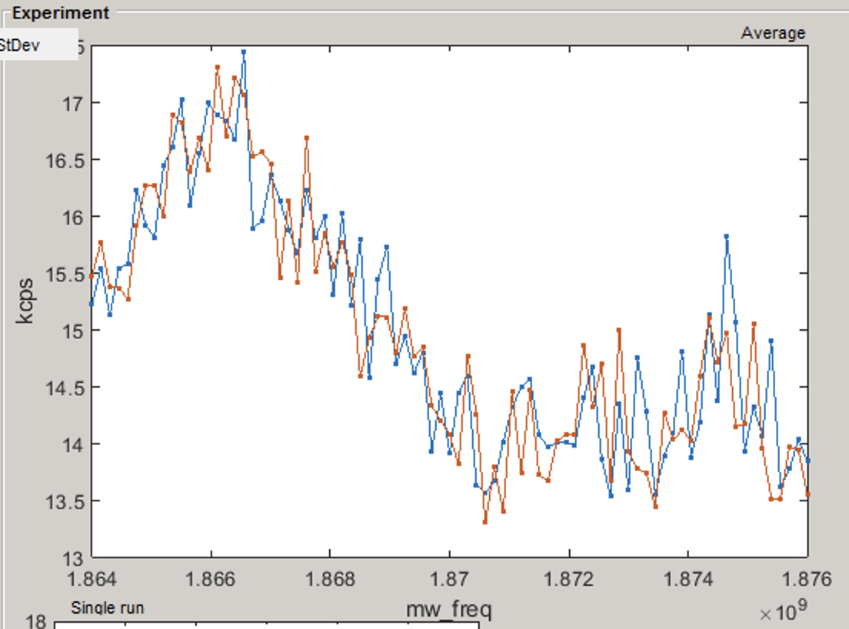

NV_0 (yellow)
NV_2 (red)
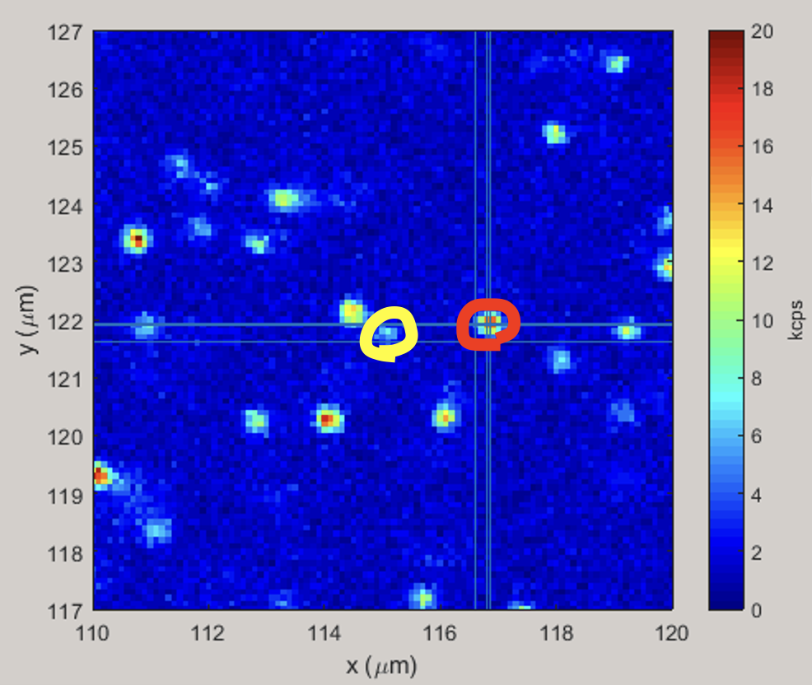

"1DExp-seq-Rabimodulated-vary-mw_freq-2023-09-16-225148" | 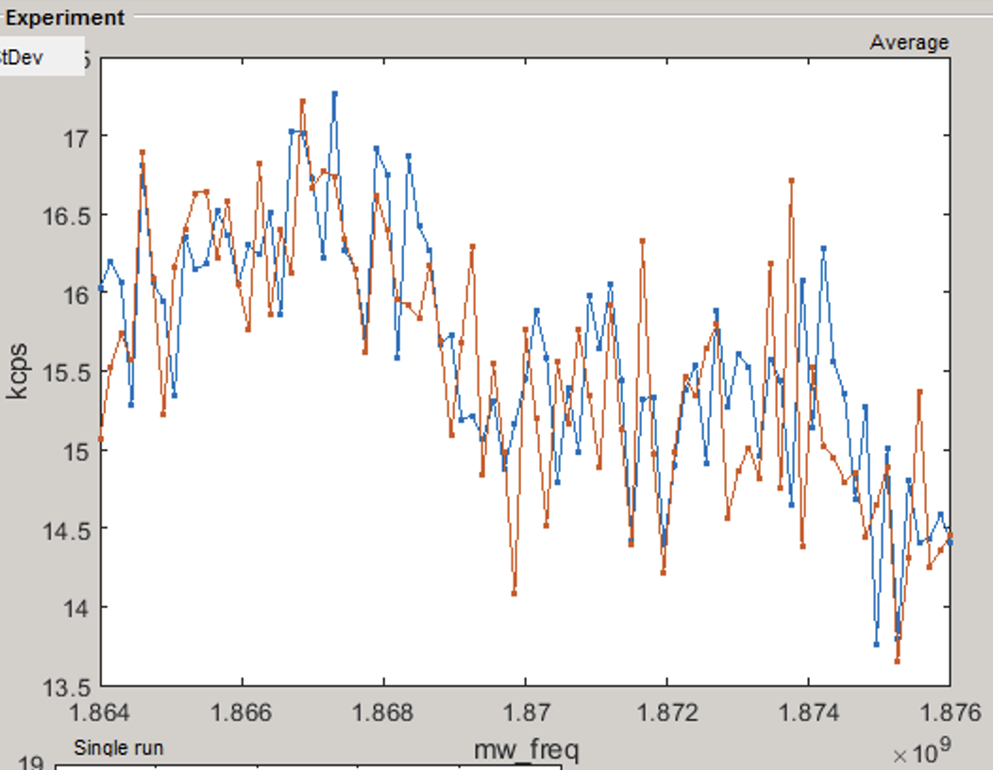

NV_0 (yellow)
NV_3 (red)
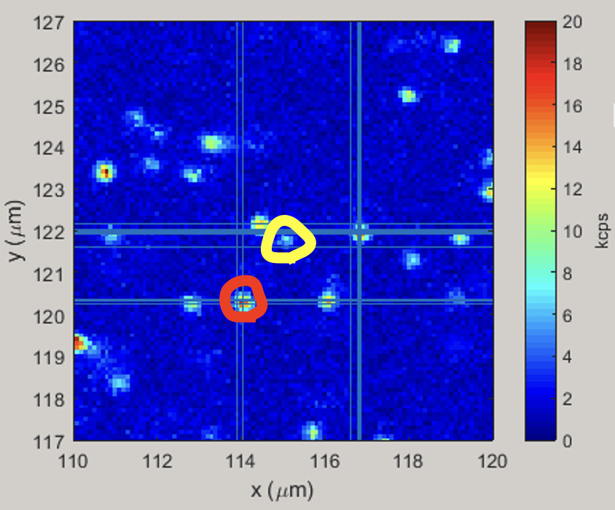

"1DExp-seq-Rabimodulated-vary-mw_freq-2023-09-16-232348"  "1DExp-seq-Rabimodulated-vary-length_rabi_pulse-2023-09-16-233044"  "1DExp-seq-ramsey-vary-tau-2023-09-16-233918"  "1DExp-seq-ramsey-vary-tau-2023-09-17-122222" | 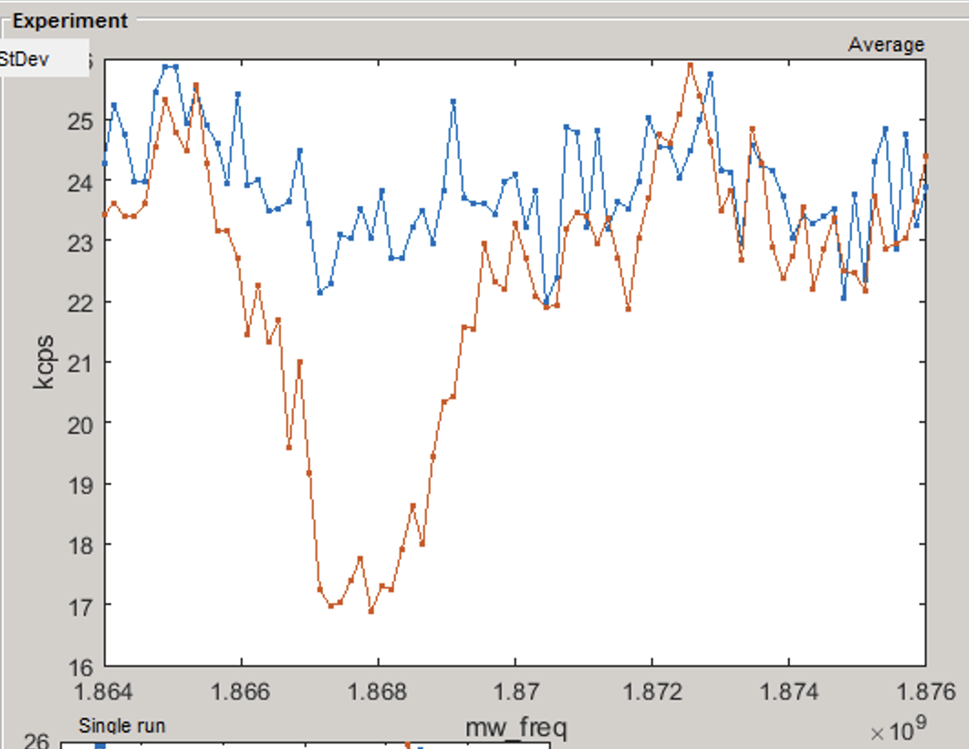  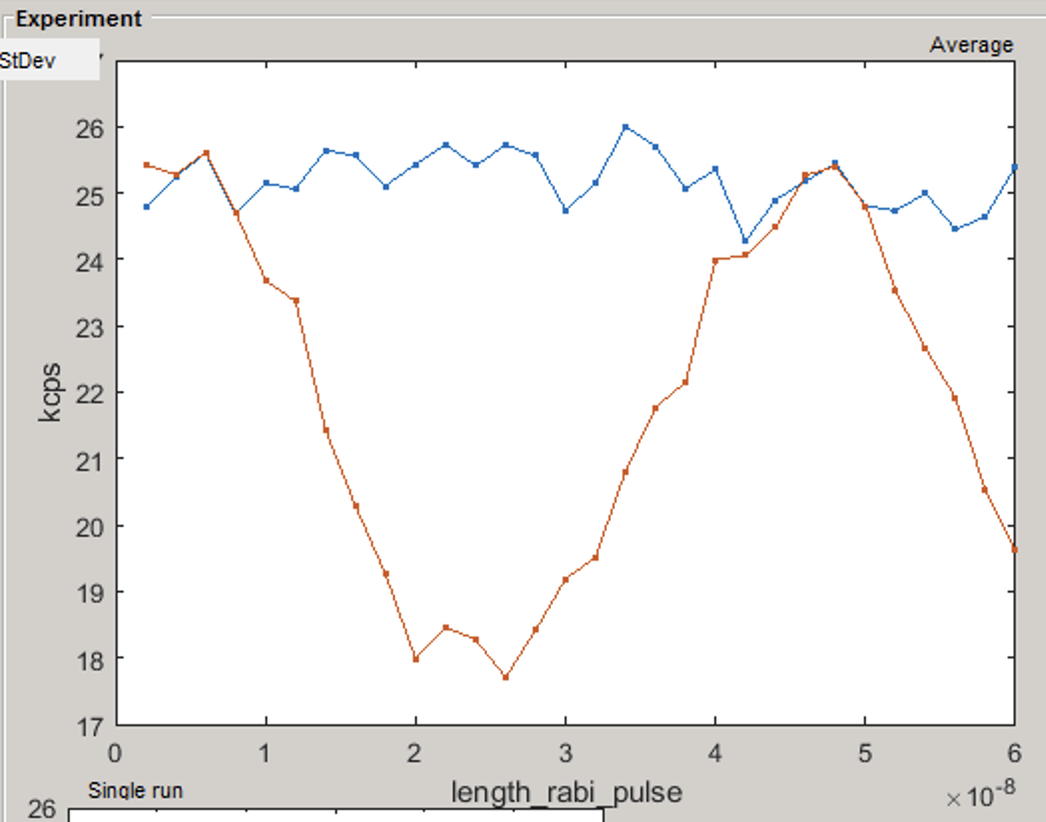  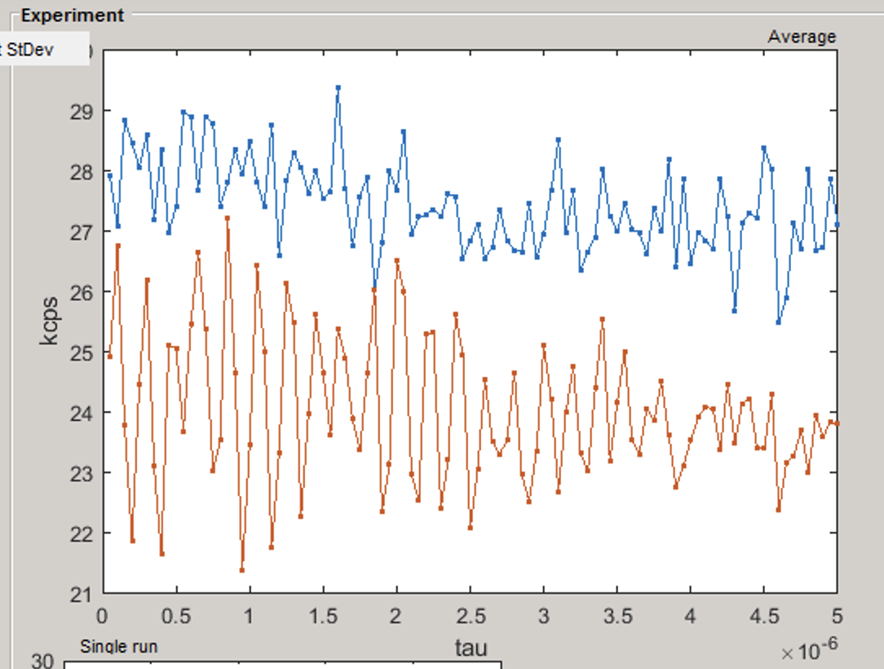  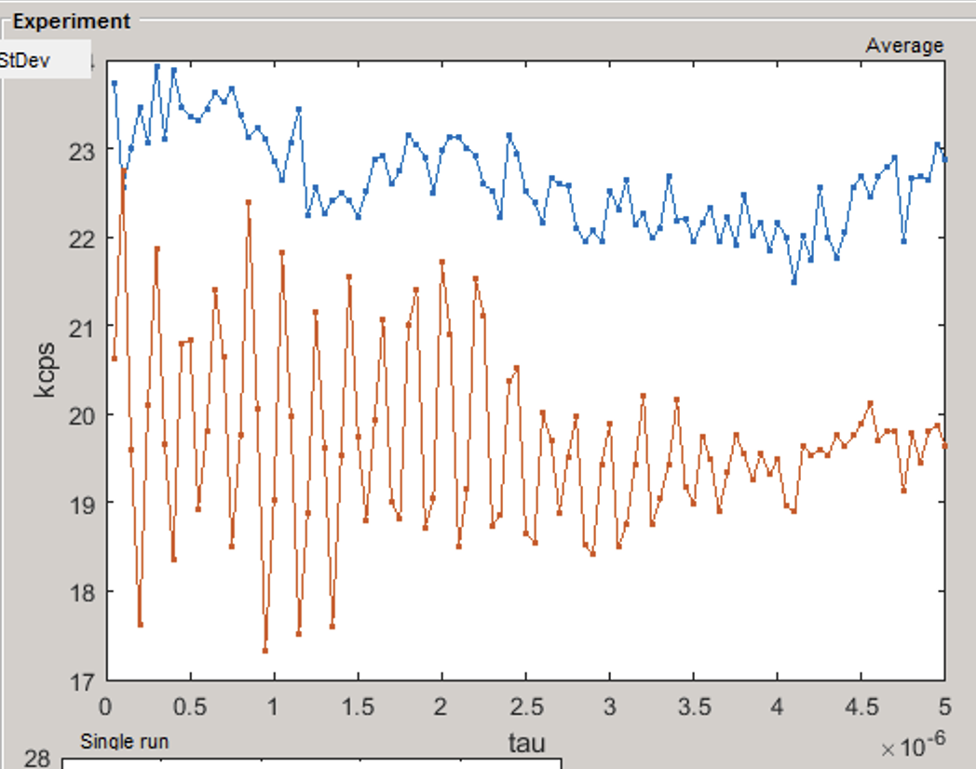  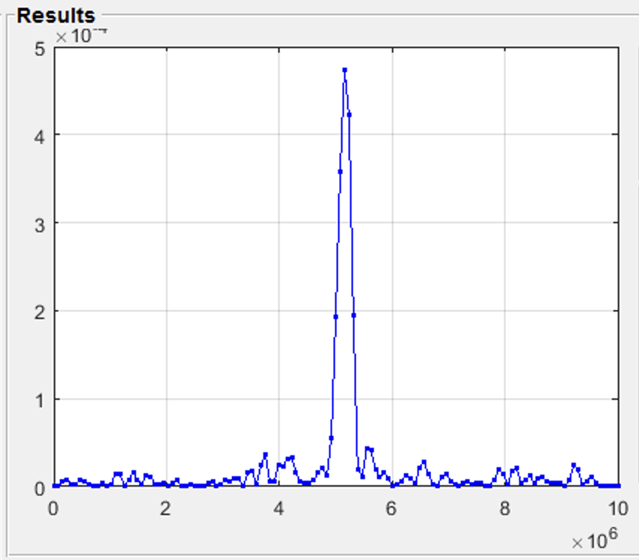

NV_0 (yellow)
NV_4 (red)
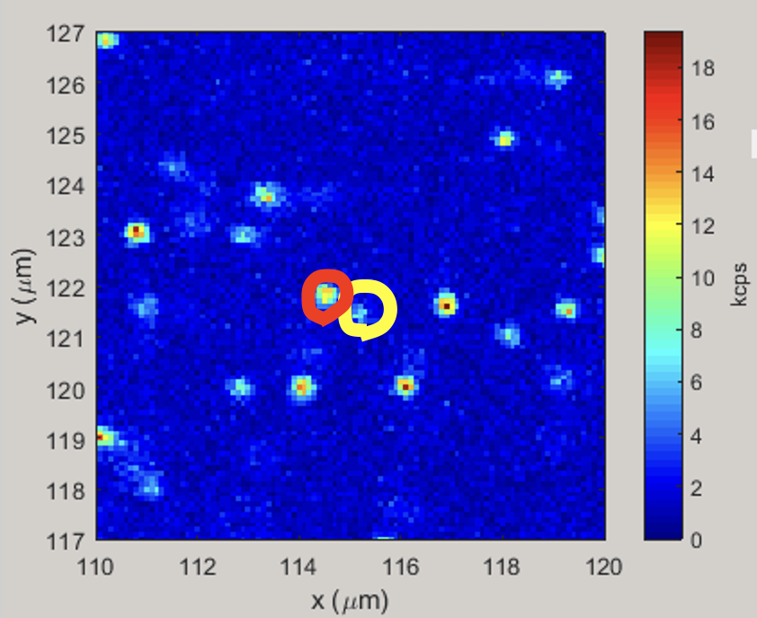

"1DExp-seq-Rabimodulated-vary-mw_freq-2023-09-17-133737" | 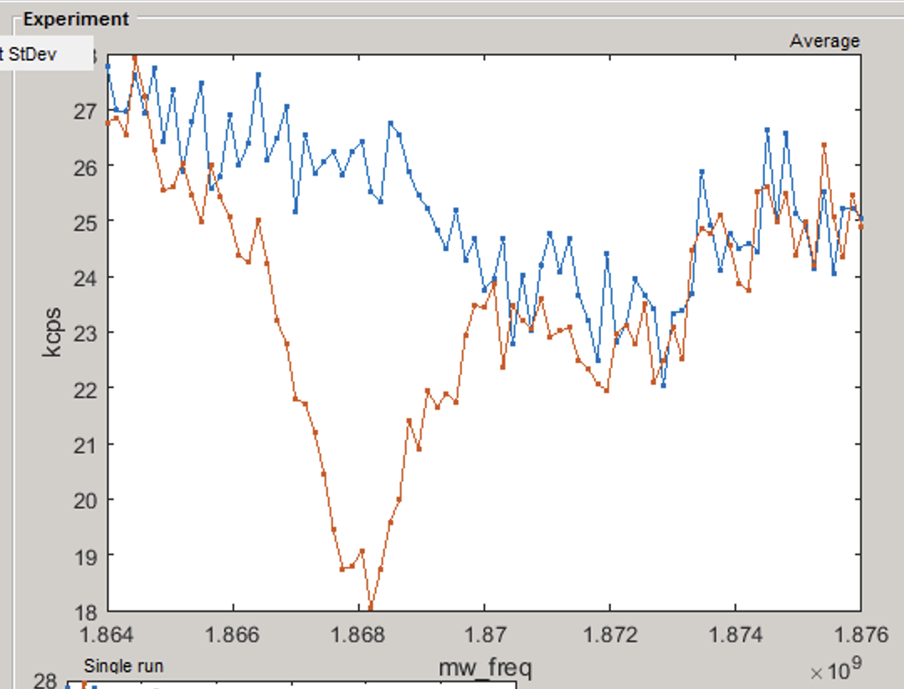  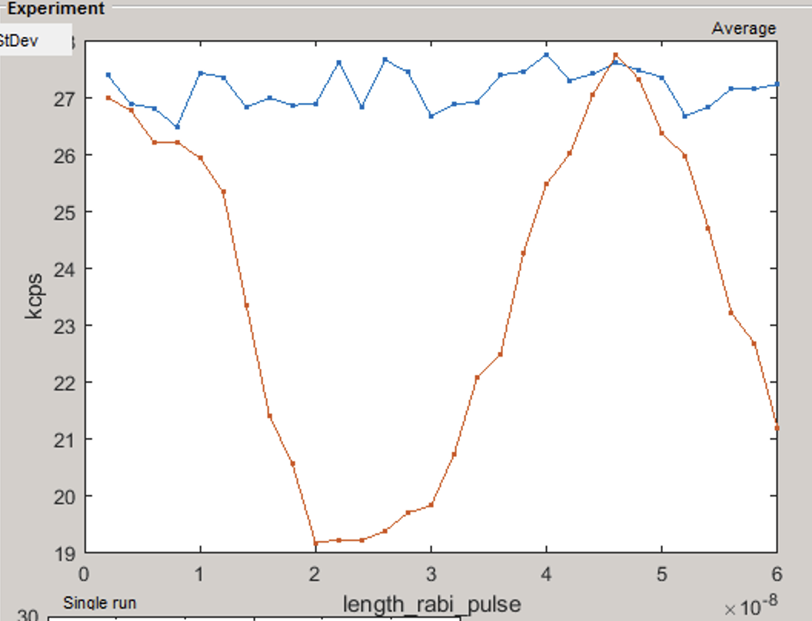  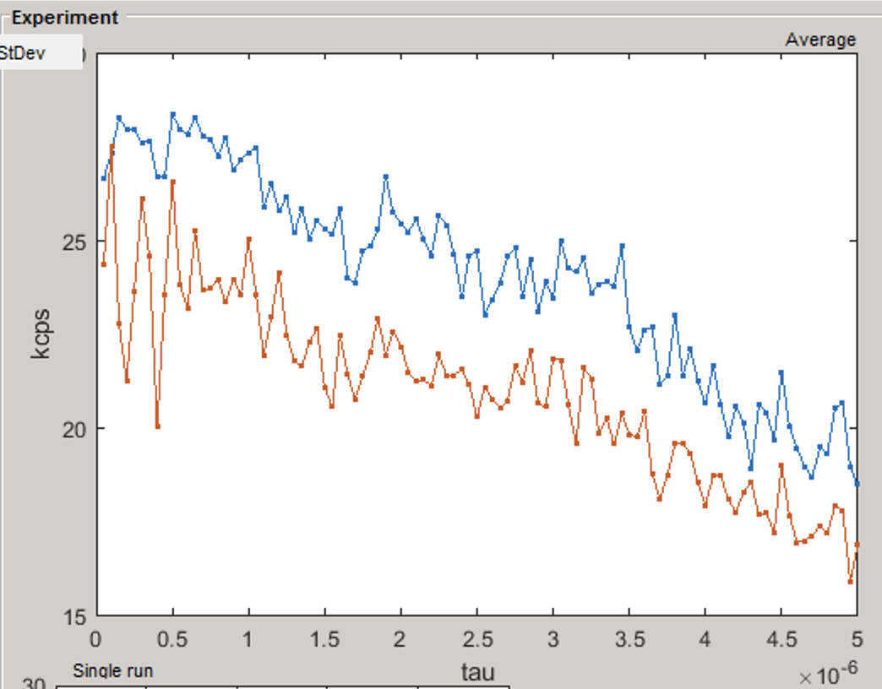  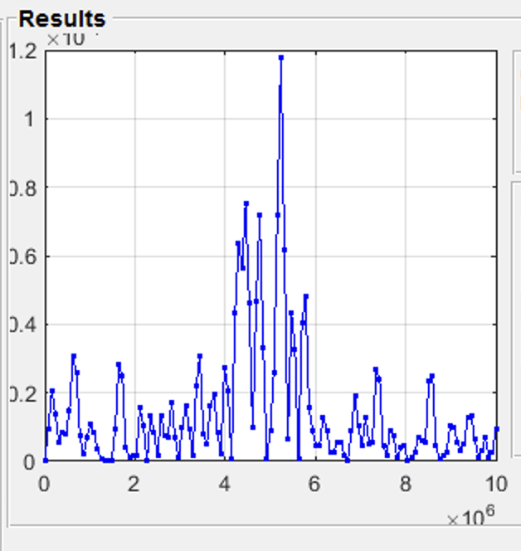

NV_4 (yellow)
NV_5 (red)

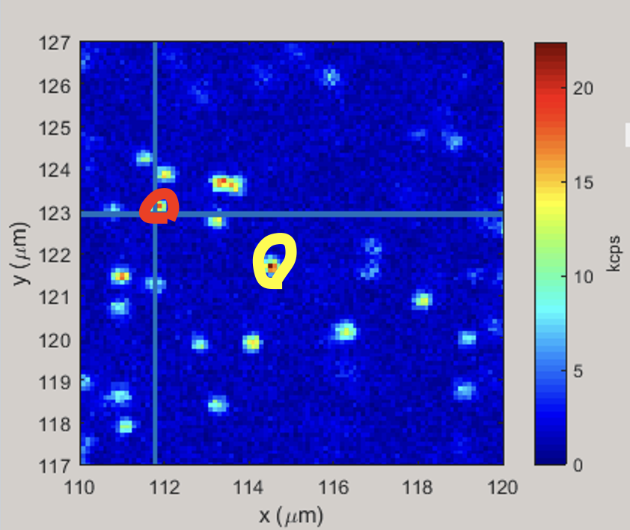

"1DExp-seq-Rabimodulated-vary-mw_freq-2023-09-17-153043" | 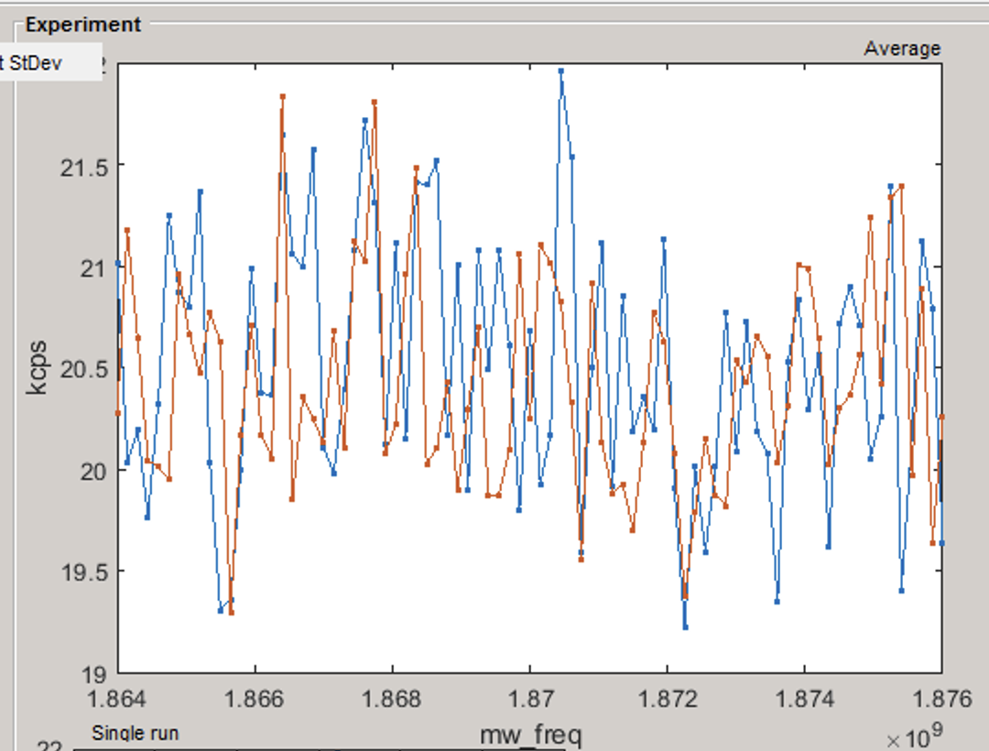

NV_0 (yellow)
NV_6 (red)
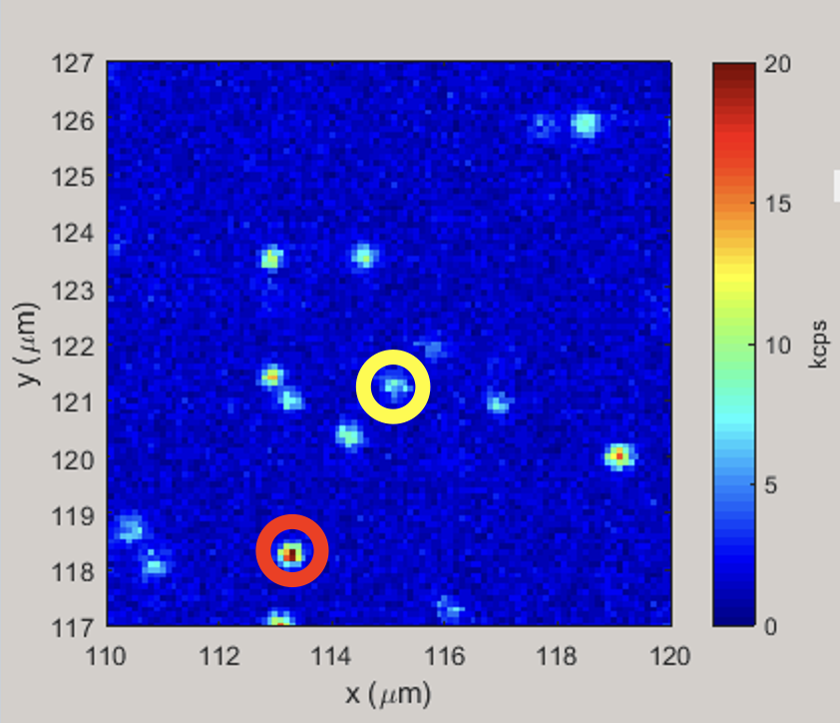

"1DExp-seq-Rabimodulated-vary-mw_freq-2023-09-17-170729" | 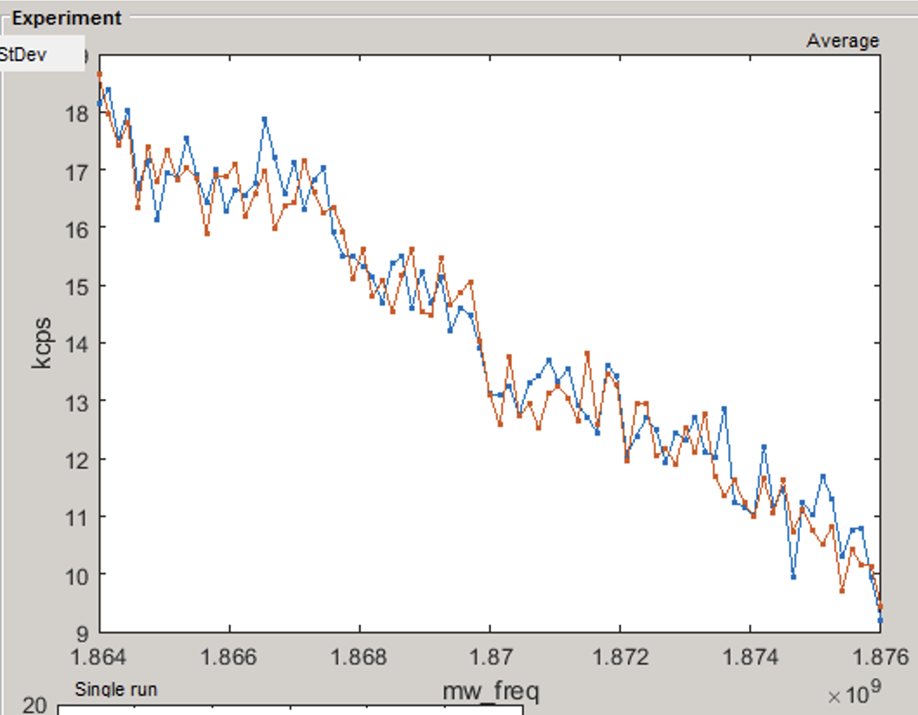

NV_0 (yellow)
NV_7 (red)
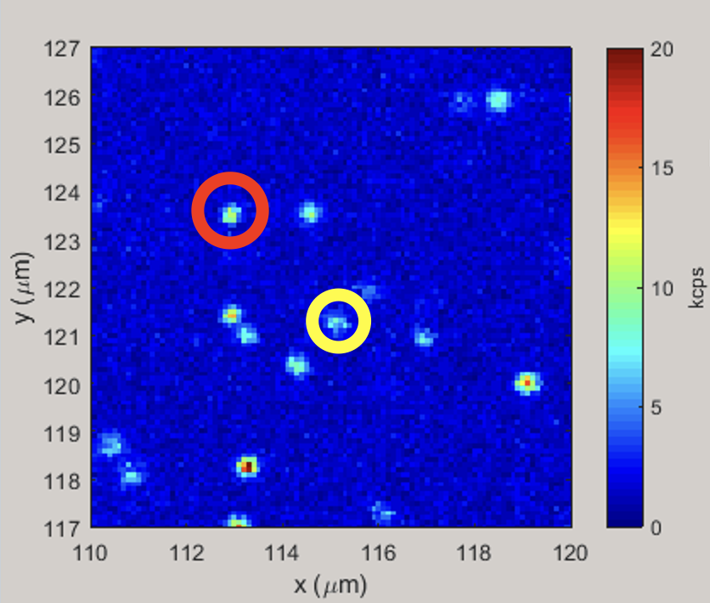

"1DExp-seq-Rabimodulated-vary-mw_freq-2023-09-17-182202"  1DExp-seq-Rabimodulated-vary-length_rabi_pulse-2023-09-17-182959  1DExp-seq-ramsey-vary-tau-2023-09-17-183901 | 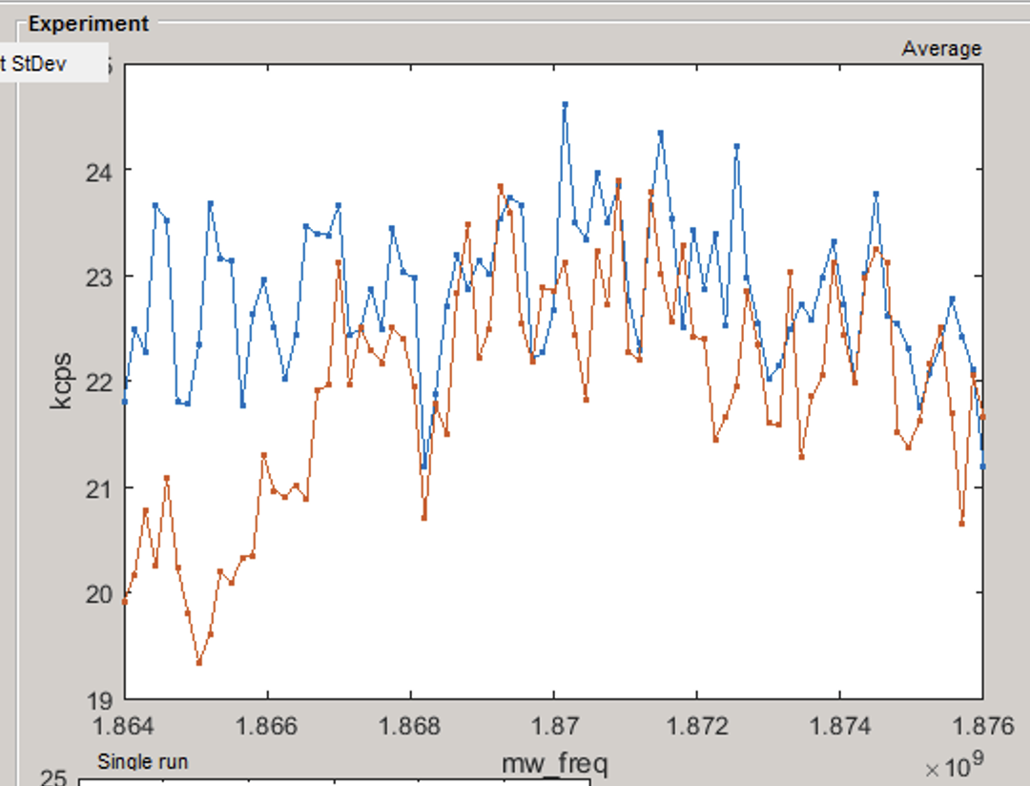  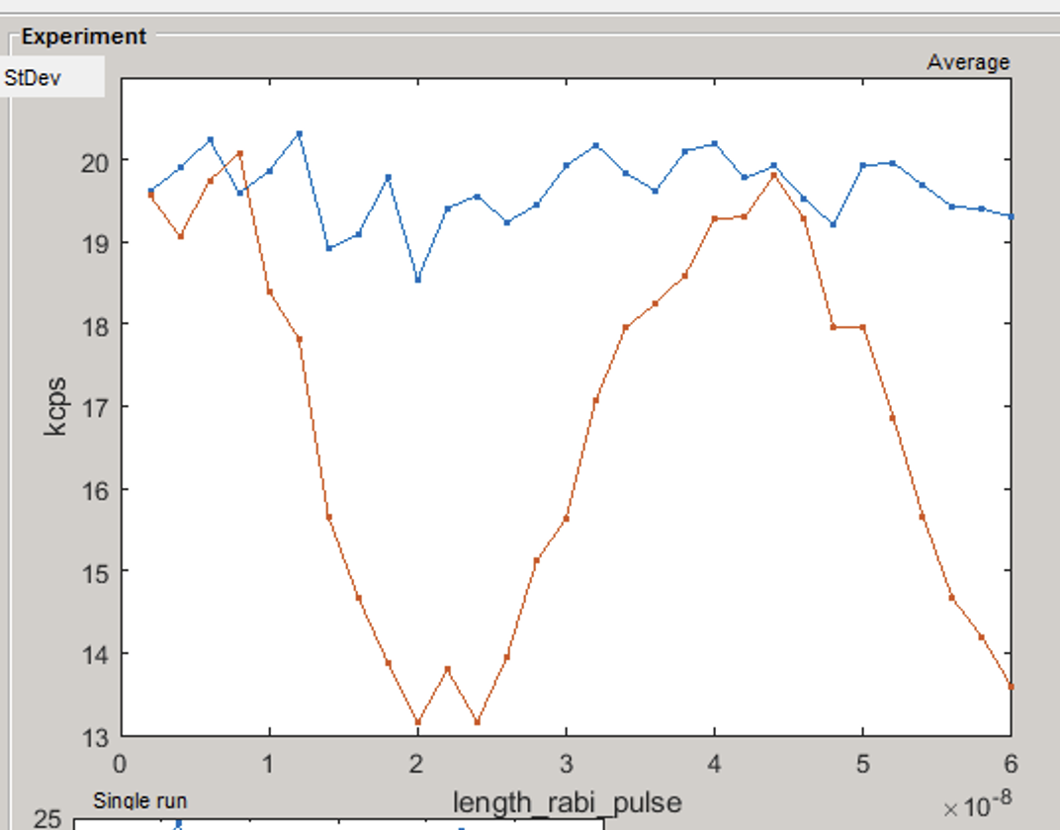  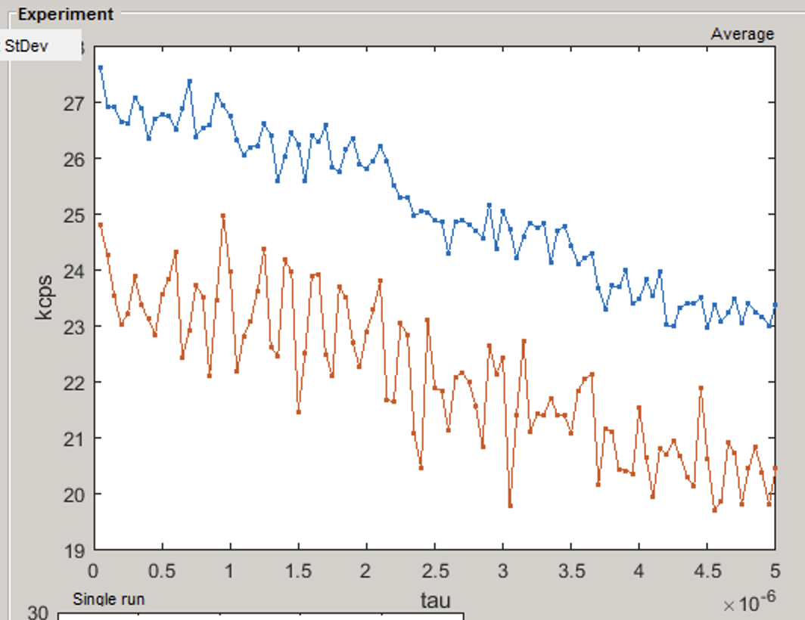  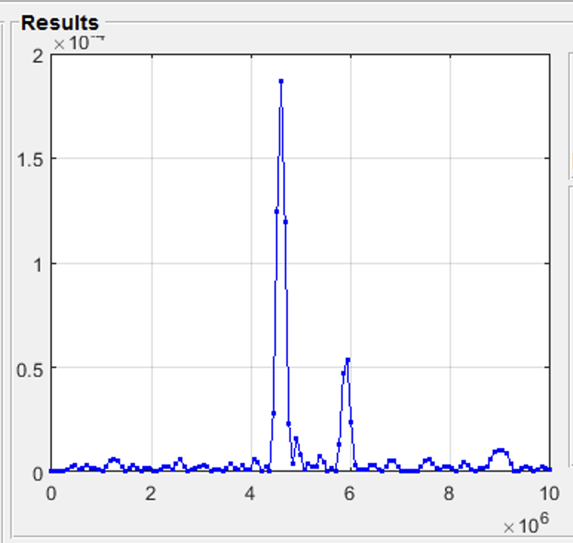

NV_0 (yellow)
NV_7 (red)
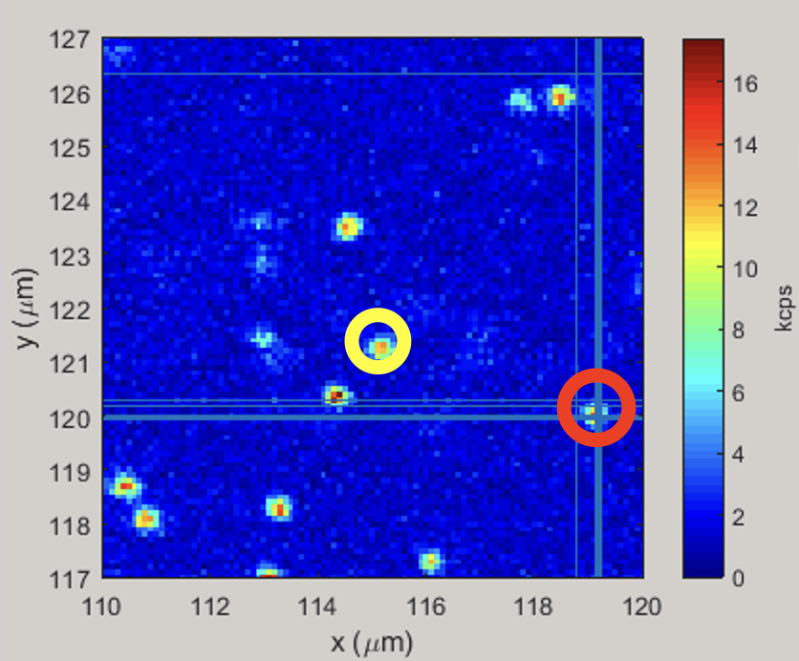

"1DExp-seq-Rabimodulated-vary-mw_freq-2023-09-17-193706" | 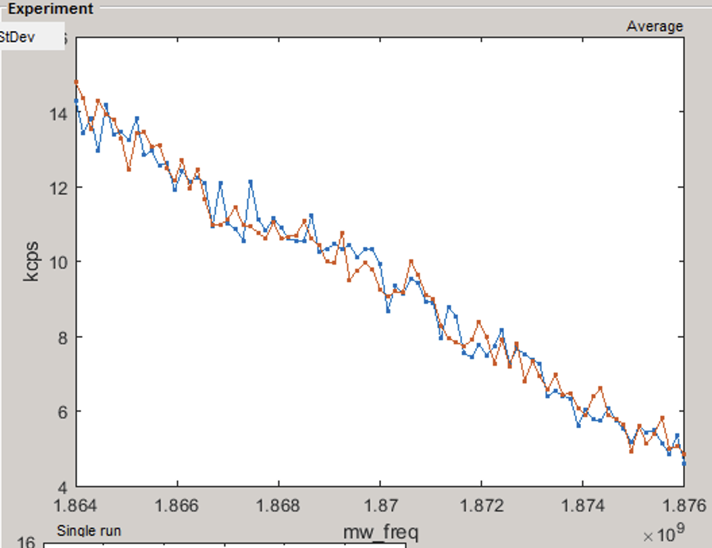

NV_0 (yellow)
NV_8 (red) (z_red < z_yellow)

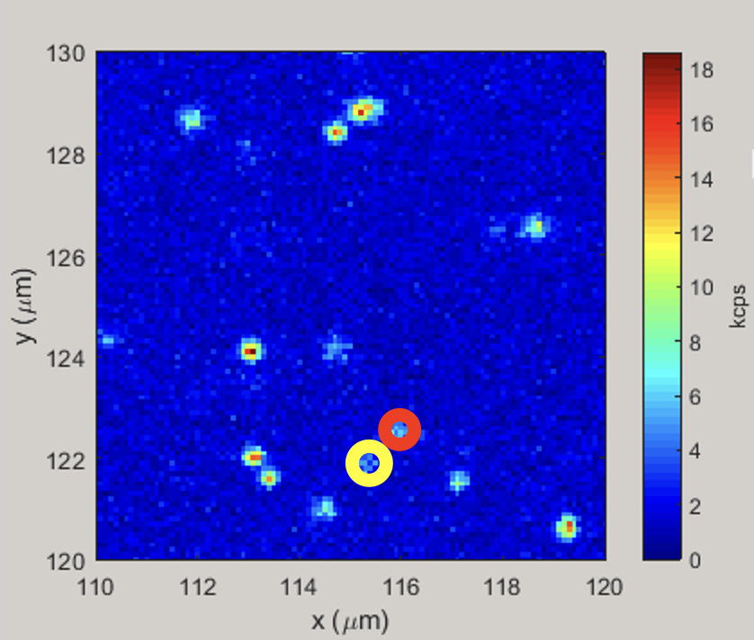

"1DExp-seq-Rabimodulated-vary-mw_freq-2023-09-17-210948"  "1DExp-seq-Rabimodulated-vary-length_rabi_pulse-2023-09-17-211624"  "1DExp-seq-ramsey-vary-tau-2023-09-17-220050" | 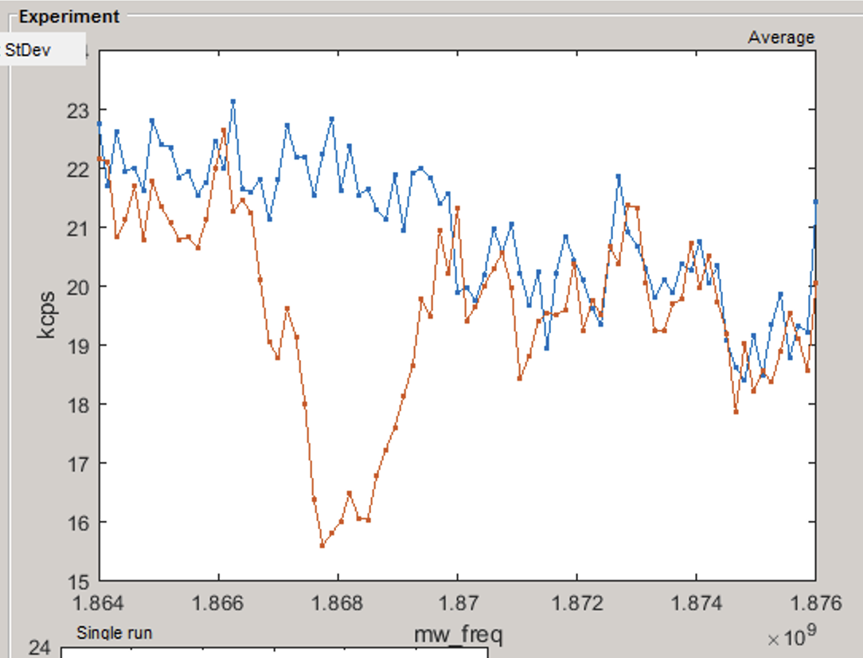  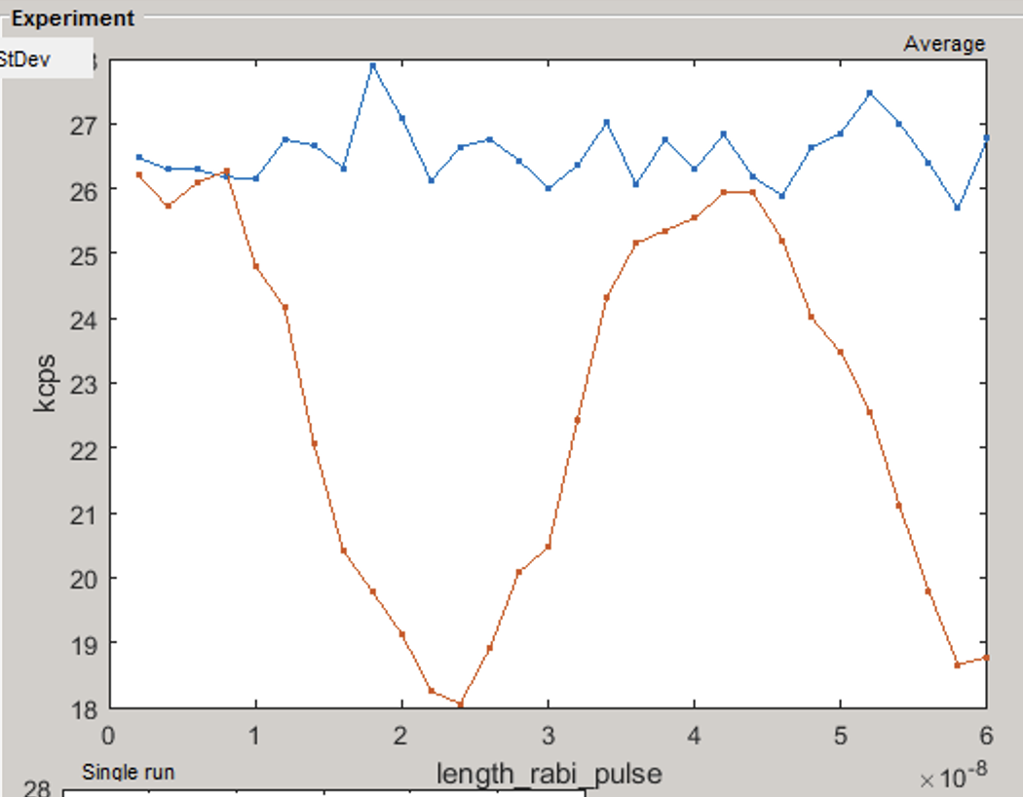  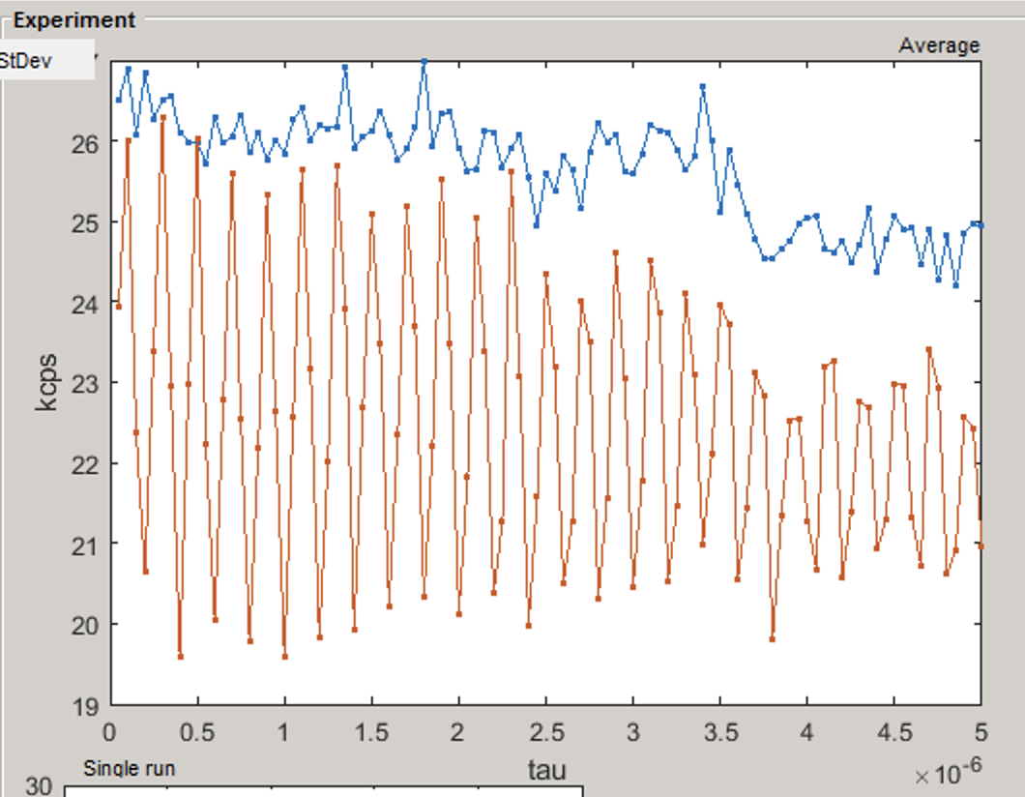  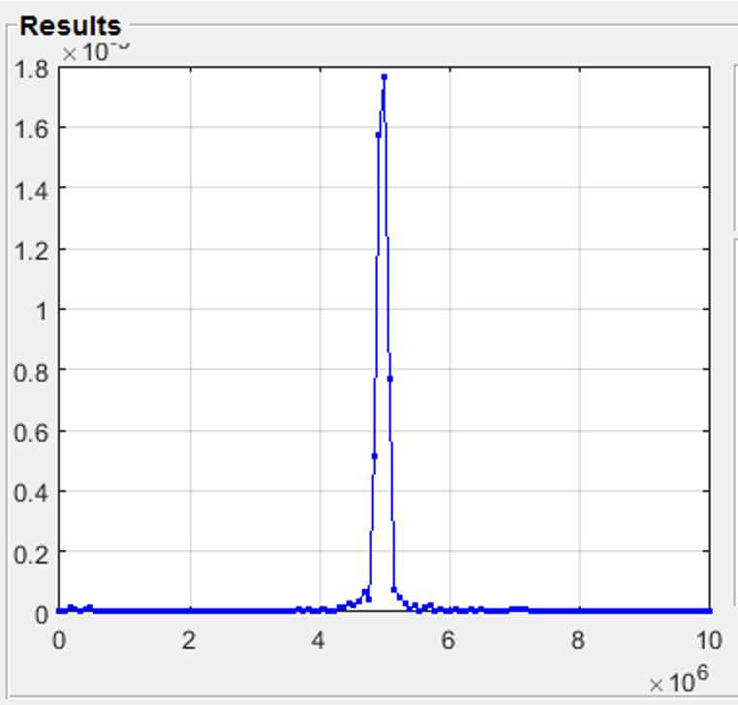

NV_0 (yellow)
NV_9 (red)

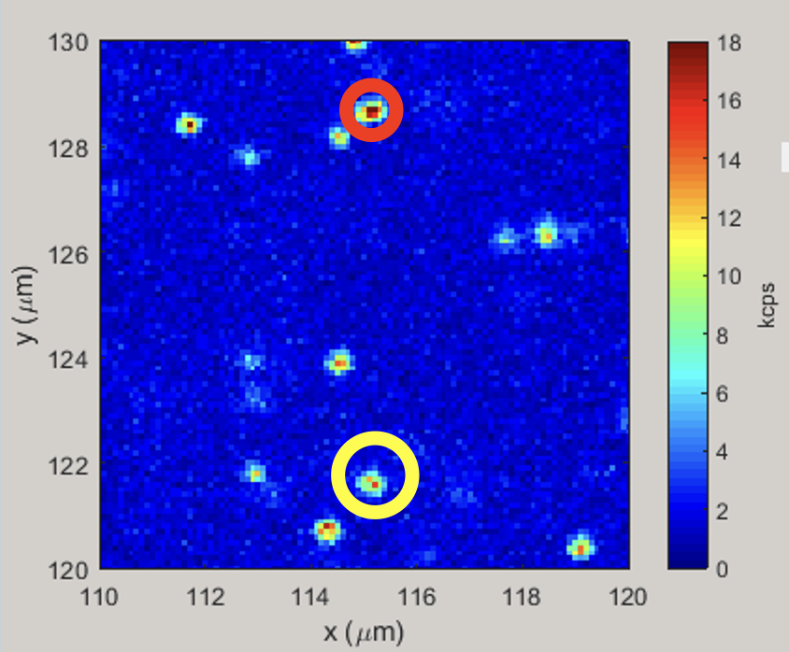

"1DExp-seq-Rabimodulated-vary-mw_freq-2023-09-18-122049" | 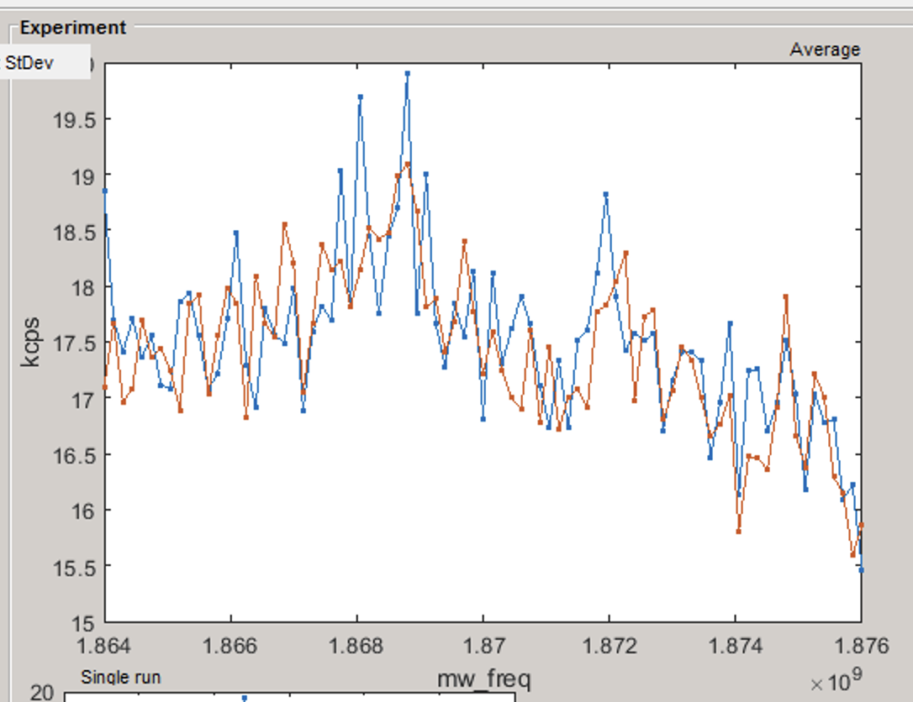

NV_0 (yellow)
NV_10 (red)

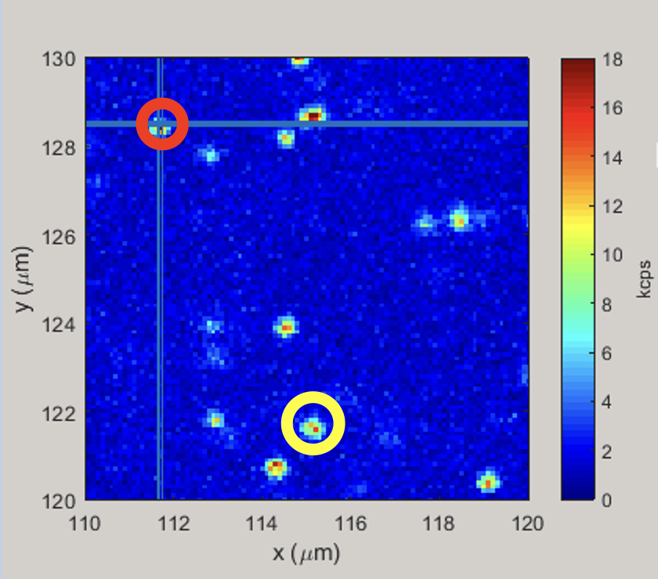
"1DExp-seq-Rabimodulated-vary-mw_freq-2023-09-18-122049" | 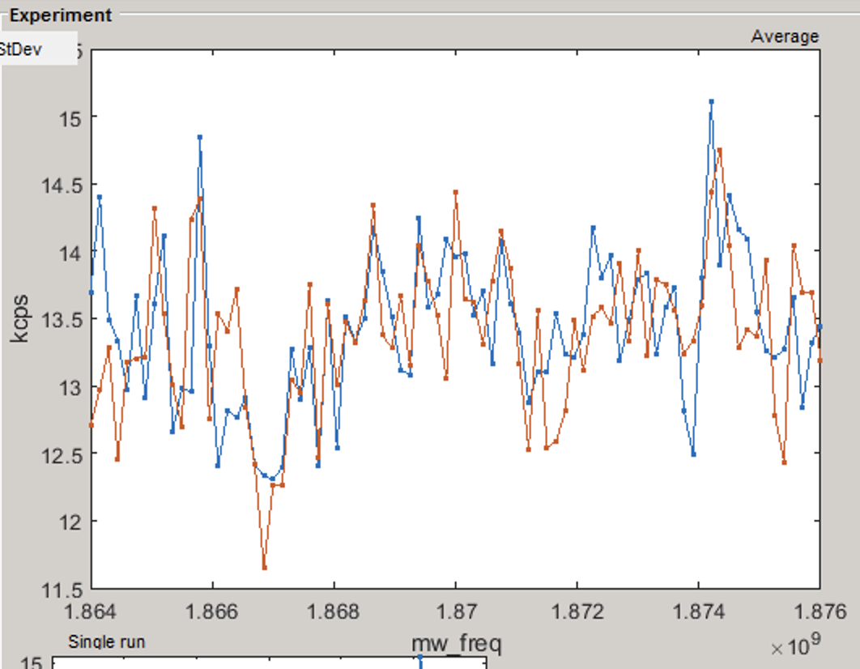

NV_0 (yellow)
NV_11 (red)
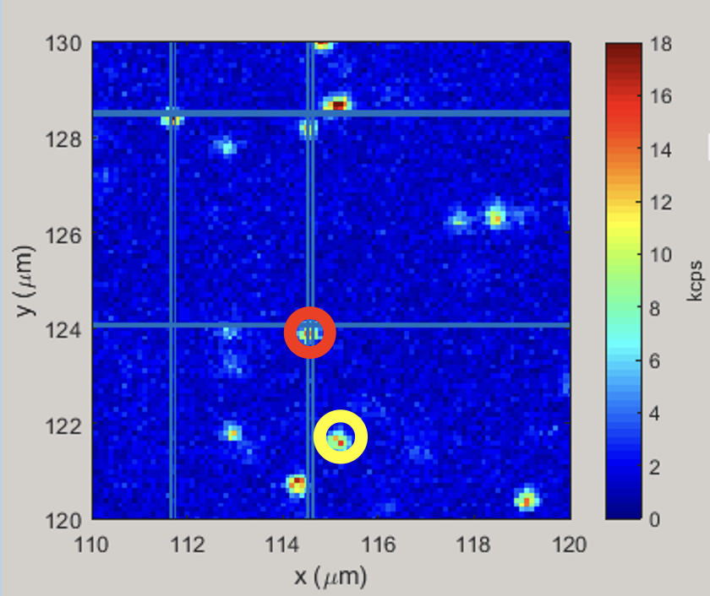

"1DExp-seq-Rabimodulated-vary-mw_freq-2023-09-18-132034" | 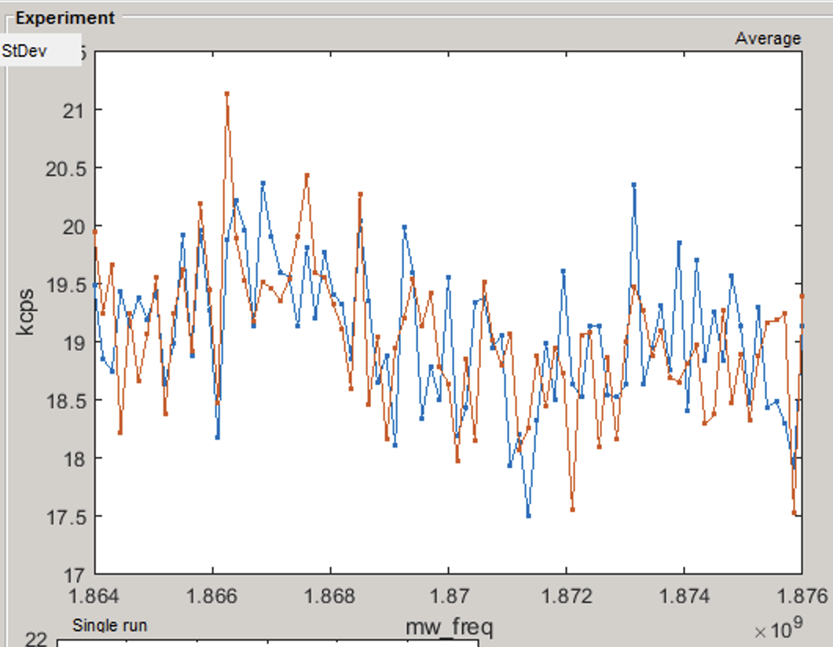

NV_0 (yellow)
NV_12 (red)
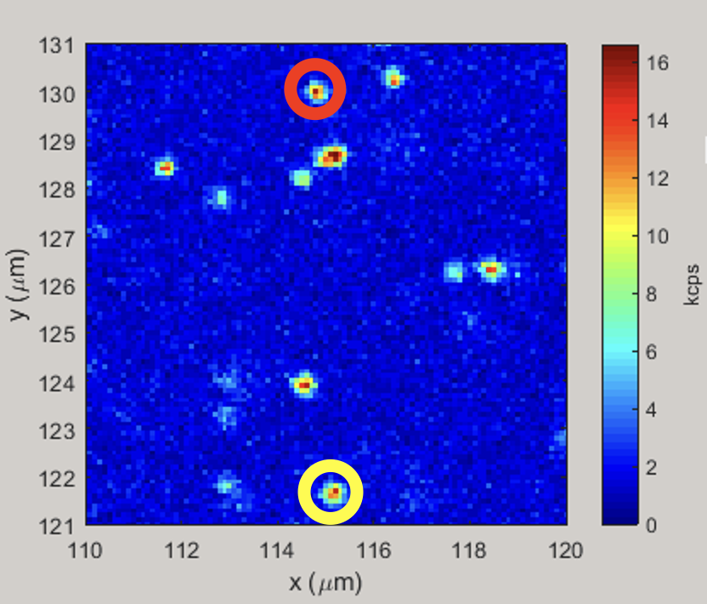

"1DExp-seq-Rabimodulated-vary-mw_freq-2023-09-18-154433" | 