What’s Concrete class ?
The simplest definition is that’s a class that is not abstract
A concrete class is a class that has an implementation for all of its methods that were inherited from abstract or implemented via interfaces. It also does not define any abstract methods of its own.

What’s Design Pattern ?
In software engineering, a design pattern is a general repeatable solution to a commonly occurring problem in software design. A design pattern isn't a finished design that can be transformed directly into code. It is a description or template for how to solve a problem that can be used in many different situations.

Creational design patterns

it’s all about class instantiation , it deals with the creation of classes and objects , it can be divided into class-creation patterns and object-creation patterns. While class creation patterns use inheritance effectively in the instantiation process . Object-creation patterns use initialization of the object effectively to get the job done.

- Abstract Factory
Creates an instance of several families of classes
- Builder
Separates object construction from its representation
- Factory Method
Creates an instance of several derived classes
- Object Pool
Avoid expensive acquisition and release of resources by recycling objects that are no longer in use
- Prototype
A fully initialized instance to be copied or cloned
- Singleton
A class of which only a single instance can exist

Factory Design Pattern:
Definition :
it defines an interface ( a contract it defines a common contract ) for creating an object but let’s sub-classes decide which class to instantiate ,
Why do we need a factory ?
In object-oriented we must instantiate an object with the new operator , factory pattern is telling us how to instantiate those objects , it’s telling us when u will about to instantiate let’s encapsulate that instantiation , so we will use a factory once we need to instantiate , we will wrap the process of new object() into factory , it wraps all the business logic of a particular class type into one place call factory
in factory design pattern we have 2 things , the thing we want to create and the thing that’s going to create the other things.
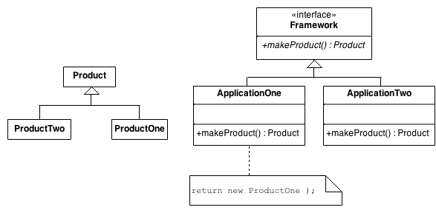
- here the product , is the things we want to create
- Framework is the main factory
- AppOne and two , is the factories that’s going to create the products
- in order to us to use polymorphism we need to be able to treat all the factories (AppOne and two) as one type , so factories must extends a single interface
- and these factories need to create things different in types , maybe productOne maybe productTwo then they must share a specific type which is the product

what’s the benefit ?
a- the instantiation is very complex , Example : maybe if we want to create an object from animal u may need computation , business logic (central way contains all the objects creation in only one place)
b- polymorphism , if you have a factory that wraps your construction and that factor is instance , then u can swap that instance at run time to become another factory

Summary
When it comes to the factory pattern, consider the use of new keyword to create a new object as harmful. The factory allows us to have a centralized location well all of our objects are created.

Implementation
- You define a base class type (or an interface), and then have any number of subclasses which implement the contract defined by the base class.
- Create a concrete classes that implements the base class
- create the factory class that will return object of the base class , with switch case on the passed parameters defined which object should I create
  - create function could be static function
- just call the factory.function_name() then use the returned object

for code look at FactoryMethod folder in design pattern
--------------------------------------------------------------------------------

-------------------------------------------------------------------------------
Builder
https://www.geeksforgeeks.org/builder-design-pattern/
Definition:
it allows us to separate the class instantiation from it representation , it’s a way for building some thing step by step , and after we build everything we saying build and it returns an instance , the builder won’t return an instance if it didn’t has all the information it needs ,
- builder is not useful if it just needed to create a builder with 3 attributes
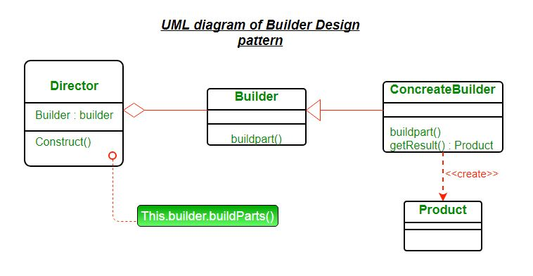
- Director: (create the product using builder interface)
  - controls the algorithm that generate the final product , it just using the passing builder object to build a specific product , but the product is determined by the concrete builder itself (Director has no idea what the product is ) , it just construct using the builder passed with a determined steps (construct function is called to build the product )
- Builder:
  - it just an interface determine all the steps that must be taken to build a product
- Concrete Builder
  - it’s the one who implements the builder interface , it’s contains the product and it contains the functionality to build the product
- Product:
it’s just the type of the object that will be generated by the builder pattern ,
don’t forgot Product is our main class the one who is doing a real functionality in the business logic , and all other classes are wrapper around him to generate the product in a series of steps

Implementation:
Consider we have a robot we need to build , we will build the robot in 2 ways
standard and modern robot
- create the product (robot)
- create the builder (RobotBuilder)
- create the concrete builders ( StandardRobotBuilder , ModernRobotBuilder)
- create the directory (RobotEngineer)
- define a RobotEngineer , and passing the desired concrete class , then call build()
- get the product , and do whatever u want here we are going to run it
for the code view look at folder BuilderDesignPattern

PROTOTYPE
Prototype allows us to hide the complexity of making new instances from the client. The concept is to copy an existing object rather than creating a new instance from scratch,
The existing object acts as a prototype and contains the state of the object. The newly copied object may change same properties only if required. This approach saves costly resources and time, especially when the object creation is a heavy process.
Consists of :
- Prototype : the actual class object that we want to copy it
- Prototype registry : the factory or the store that copy objects
- client : the one who use registry service to copy objects

Implementation
We're going to create an abstract class Shape and concrete classes extending the Shapeclass. A class ShapeCache is defined as a next step which stores shape objects in a Hashtable and returns their clone when requested.

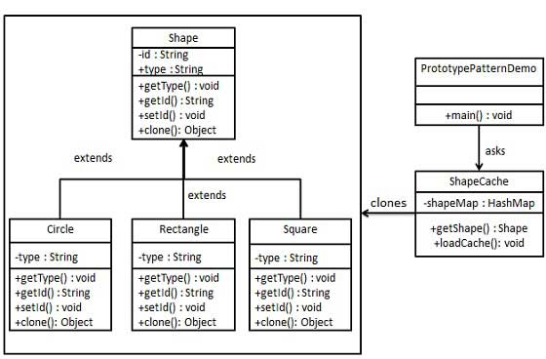
- Implement the abstract class that will be extended by multiple classes ( prototypes) , add the clone function inside it and depend on your language will select the approach to create clone method
- implement the concrete prototypes classes , that has the business logic with multiple states ( make sure to insert a unique id or name , to use it in cloning technique
- implement the Store , the class that copy object depend on specific key
for code Look at folder Prototype

Object pool
it’s a creational design pattern , used when cost of initializing an object is too high
basically it’s a container which contains amount of objects , when an object is taken from the pool, it is not available in the pool until it is put back.
Objects in the pool have a life-cycle:
- Creation
- Validation
- Destroy
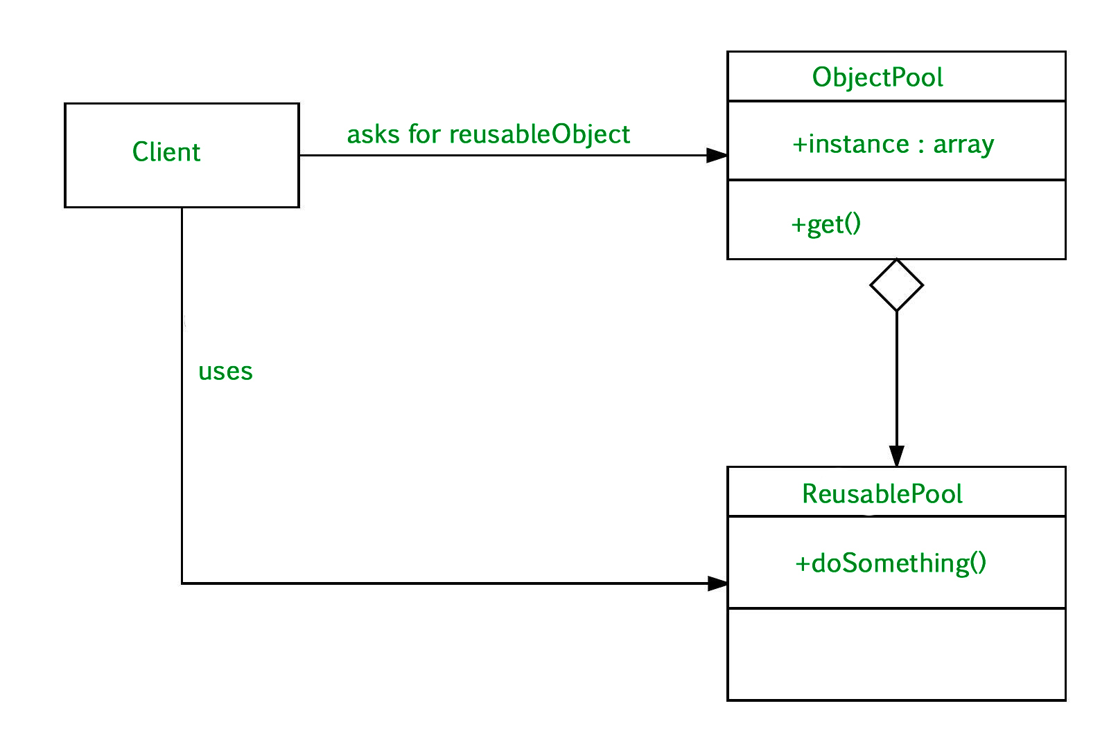
consist of :
- client : the code that will use object from the pool
- ReusablePool : the class that we need to instantiate using the object pool design pattern
- ObjectPool: The Pool class is the most important class in the object pool design pattern. ObjectPool maintains a list of available objects and a collection of objects that have already been requested from the pool.
Implementation:
- create the target class , the class that we want to instantiate
- create the class that will hold amount of objects
- use the code
for code details look at ObjectPool folder

Abstract Factory
it’s all about producing families of objects , like this factory produce a set of objects with specific type then the other factory and so on.

The first thing the Abstract Factory pattern suggests is to explicitly declare interfaces for each distinct product of the product family (e.g., chair, sofa or coffee table). Then you can make all variants of products follow those interfaces. For example, all chair variants can implement the Chair interface; all coffee table variants can implement the CoffeeTable interface, and so on.

Declare abstract-factory – an interface contains all the creation function of other families (for example, createChair, createSofa and createCoffeeTable).)

and for each family create a factory the implements the abstract factory , and it returns a specific type of family
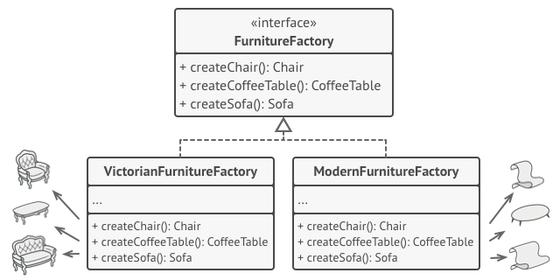
Structure
- Abstract Products
  - declare interfaces for a set of distinct but related products which make a product family ( modernChair , OldChair from family Chair )
- Concrete Products
  - various implementation for each product type
- Abstract Factory
  - interface declare a set of methods for creating each of abstract products
- Concrete Factories
  - implement the creation method of specific type of products
  - Although concrete factories instantiate concrete products, signatures of their creation methods must return corresponding abstract products. This way the client code that uses a factory doesn’t get coupled to the specific variant of the product it gets from a factory. The Client can work with any concrete factory/product variant, as long as it communicates with their objects via abstract interfaces.

How to Implement
- Define product types with it’s variant of these products
  - ( chair => (ModernChair , OldChair )
- Declare abstract product interface for each type , them implement it by the variant of these products
- Declare abstract factory interface with a set of creation functions for each product type
- Implement a set of concrete factory classes , one for each
  - ( ModernFactory , OldFactory )
- Create Factory Initialization code somewhere in the app that will initialize of of the concrete factories depend on configuration or anything ! , then any creation of the product use that factory

Example
illustrates how the Abstract Factory pattern can be used for creating cross-platform UI elements without coupling the client code to concrete UI classes, while keeping all created elements consistent with a selected operating system.
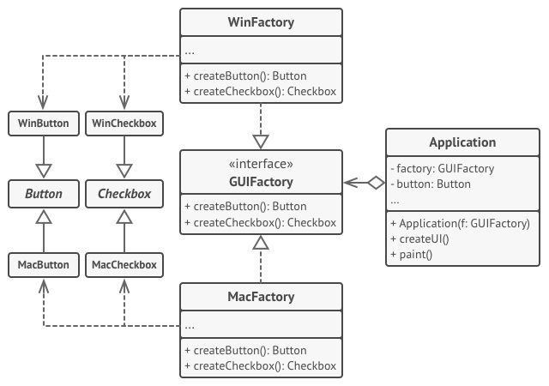
For code details look at AbstractFactory Folder in design pattern repo

Reference
https://refactoring.guru/design-patterns/abstract-factory
-------------------------------------------------------------------------------------------------------

Structural Design patterns

it’s define how each component should be constructed to defining a simple way for relationship between components , it define also how classes and objects can be combined to form larger structures
- ADAPTER
- BRIDGE
- COMPOSITE
- DECORATOR
- FACADE
- FLYWEIGHT
- PRIVATE CLASS DATA
- PROXY

DECORATOR

Definition:
Decorator pattern allow a user to add additional functionality to an existing (object or class ) without modify it’s current structure
it’s an open close principle prove
it changes the skin of an object by wrap it into another recursively
Wrapping a gift, putting it in a box, and wrapping the box.
Motivation:
sometimes we want to add responsibilities to individual objects not the entire class

Main Components To design decorator structure ?
- Component
  - Define interface for objects that can have responsibilities added dynamically
- Concrete Component
  - defines an object which additional responsibilities can be attached , the main class like (Circle , Rectangle )
- Decorator
  - the class that add the responsibilities dynamically by passing an instance of a class that has additional function need to be attached to the concrete class (concrete decorator)
- Concrete Decorator
  - adds responsibilities to the component

Implementation
let’s implement these requirements but with decorator not with the following inheritance technique
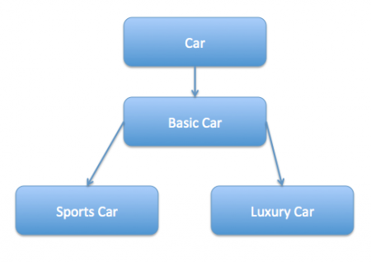

Component an interface
public interface ICar {
public void drive();
}
concrete components
public class BasicCar implements ICar {

@Override
public void drive() {
System.out.println("Car is moving");
}

}

Decorator

abstract class CarDecorator implements ICar{
protected ICar tempCar;

public CarDecorator(ICar car)
{
this.tempCar = car;
}

@Override
public void drive()
{
tempCar.drive();
}
}
concrete components
public class SportCar extends CarDecorator{

public SportCar(ICar car)
{
super(car);
}

@Override
public void drive()
{
tempCar.drive();
System.out.println(" Sport Car Moving");
}
}
//*****************************************************************************
public class MilitaryCar extends CarDecorator{

public MilitaryCar(ICar car)
{
super(car);
}

public void drive()
{
tempCar.drive();
System.out.println(" Military Car is hitting");
}}

Adapter
It’s just allows objects with incompatible interface to collaborate.
A special class that converts object so another object can understand .
an adapter wraps one of the objects to hide the complexity of conversion happening behind the scene.
The adapter gets an interface, compatible with one of the existing objects.
- Using this interface, the existing object can safely call the adapter’s methods.
- Upon receiving a call, the adapter passes the request to the second object, but in a format and order that the second object expects.
- After receiving a call , the adapter passes the request to another object in format that the other object expected.

Problem
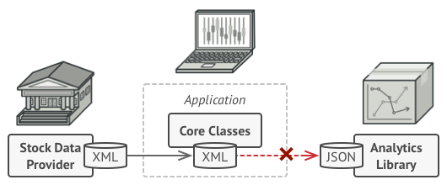
Analytics Library need Json but our core classes
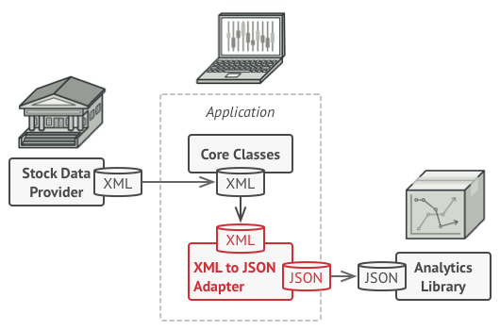

Structure
Object Adapter.
This implementation using the composition principle: the adapter implements the interface of one object and wraps the other one
- The Client Class
  - the class that contains the existing business logic
- Client Interface
  - the protocol that other classes must follow be used by the client code
- Service
  - useful class that client code can’t use directly because incompatible ( format , type , interface)
- Adapter
  - the class that able to communicate with both the client and the service , implements the client interface while wrapping the service object , receive calls from the client and translate it to calls for the service
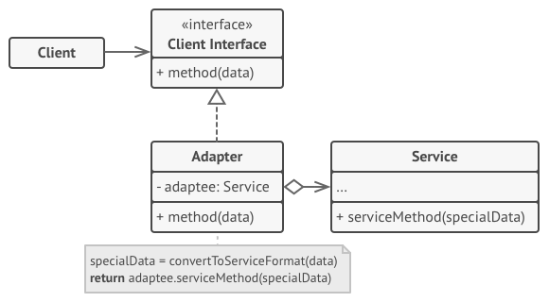

How to implement

Make sure that you have at least 2 classes with incompatible interfaces ( can’t communicate with each other)
  - Service class which is a 3-party library or a legacy code we need to communicate with
  - client class that would benefit from using service
- declare the client interface and describe how clients communicate with the service
- create the adapter class and make it follow the client interface
- add attribute to the adapter that old reference to the service . The common practice is to initialize the reference inside the constructor
- One by one, implement all methods of the client interface in the adapter class. The adapter should delegate most of the real work to the service object, handling only the interface or data format conversion.
- Client should use the adapter via client interface . This will let you change or modify the adapter without affecting the client code

Real World Example
The Adapter pattern allows you to use 3rd-party or legacy classes even if they’re incompatible with the bulk of your code. For example, instead of rewriting the notification interface of your app to support each 3rd-party service such as Slack, Facebook, SMS or (you-name-it), you can create a set of special wrappers that adapt calls from your app to an interface and format required by each 3rd-party class.

Reference
https://refactoring.guru/design-patterns/adapter

For code details see Adapter in the repo

Bridge

- it let’s you split a set of related classes into two separate hierarchies ( abstraction and implementation ) which can be modified independently from each other

- Need when we want to decoupled an abstraction from it’s implementation
- it’s switching from inheritance to composition , you extract one of the dimensions into separate class hierarchy , so the original class will have a reference of the new dimension.

Problem ?
Look at problem here.

https://refactoring.guru/design-patterns/bridge

When we apply it ?
- When we want to divide a class with similar shape , like a RedCircle and BlueCircle , but have different functionality ( both of them are Circle but different in color)
- When we want to extend a class into several independent dimensions
  - the bridge suggest that you must build a separate class hierarchy for each dimensions
  - the original class delegates the work to the object belongs to those hierarchies instead of doing everything in his own
- When we want to switch implementation at the run time

Structure
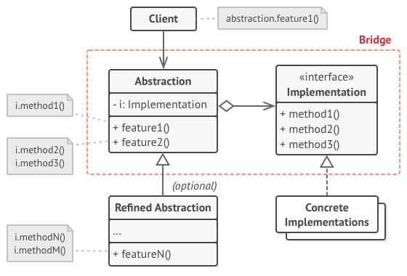
- The Abstraction
  - Provide the high level logic , and the concrete doing the low level work
- The Implementation
  - define the interface that’s common for all concrete implementation
  - an abstraction can only communicate with an implementations via method that are declare in the implementation interface
- Concrete Implementations
  - Contain the code of specific platform
- Refined Abstraction
  - Provide a low-level work with it’s parent work
- Client
  - it’s only interested in working with the abstraction
  - it’s the client job to link the abstraction object to one of implementation objects.

How to implement ?

- Identify the different dimensions in your classes , it could be (interface/abstraction , abstraction/domain , front-end/back-end)
- See what operations the client needs and define them in base abstraction class
- Determine the operations available on all platforms (interfaces), define the ones that abstraction needs in general implementation interface
- for all platforms create concrete implementation classes , but make sure they all follow the implementation interfaces
- Inside the abstraction class add a reference field for implementation type
- the client code should pass implementation object to the abstraction object and then deal with only the abstraction object
for code details look at Bridge Folder in the repo

Composite

It let’s you compose objects into tree structures and then deal with each object as if they were individual objects

Structure
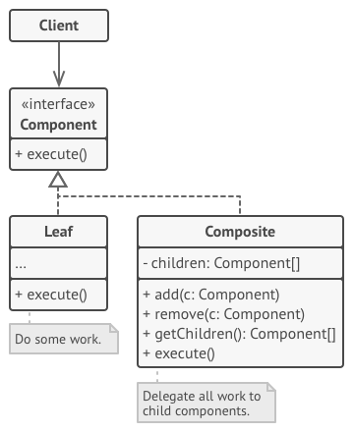

- Component (interface or abstract)
  - describe operation that commons to both simple and complex elements of the tree
- Leaf
  - is a basic element of the tree that doesn’t has sub elements
  - usually, leaf components end up doing most of the real work, since they don’t have anyone to delegate the work to.
- The Container ( Composite)
  - it’s an element that has sub elements (leaves or other containers)
  - upon receiving a request , a container delegates the work to it’s sub-elements, process intermediate result and then return the final result
- The Client
  - works with all the elements through the component interface
  - client can work in the same way with simple and complex elements

When To Use Composite
- Use it when you have to implement a tree object structure
  - it’s provides 2 type of elements simple leaves and complex containers , a container can be composed of both leaves and containers. This let’s you construct a nested recursively object structure that form a tree
- Use it when you want the client code to treat both simple and complex elements the same way
  - all the elements defined by composite interface , the client doesn’t have to worry about it’s concrete classes

How To Implement
- Make sure that your app can be represented as a tree structure , try to break it down into simple leaves and complex containers , and containers must contain both simple and complex elements
- Create the interface component with a list of methods that make sense to both the complex and the simple elements
- Create a leaf class to represent simple elements. A program can have multiple leaf classes
- Create container class to represent complex elements. In this class provide an array field for storing references to both complex and simple elements and make sure the array type is the component interface
  - when creating this container remember the container must delegate most of the work to sub-elements
- Finally define the method of add and remove in the containers
- keep in mind that the leaf classes will break the segregation principle because the method will be empty in the leaf class
for code reference a simple example found here , or look at the code in github repo
https://www.baeldung.com/java-composite-pattern

Behavioral Design Patterns

These design patterns are all about Class's objects communication. Behavioral patterns are those patterns that are most specifically concerned with communication between objects.

. Chain of responsibility
A way of passing a request between a chain of objects
- Command
Encapsulate a command request as an object
- Interpreter
A way to include language elements in a program
- Iterator
Sequentially access the elements of a collection
- Mediator
Defines simplified communication between classes
- Memento
Capture and restore an object's internal state
- Null Object
Designed to act as a default value of an object
- Observer
A way of notifying change to a number of classes
- State
Alter an object's behavior when its state changes
- Strategy
Encapsulates an algorithm inside a class
- Template method
Defer the exact steps of an algorithm to a subclass
- Visitor
Defines a new operation to a class without change

