Data Part
WLASL Dataset:
Why This Dataset?
We selected the WLASL Dataset after analyzing around 30 research papers published between 2020 and 2025. We observed that most of the studies used WLASL because it is a standard benchmark dataset in sign language recognition. It provides a large number of word-level classes, real-world video variations, and well-annotated data, which makes it suitable for training and fair comparison. Using WLASL also allows our work to be comparable with existing research results
Pie chart :
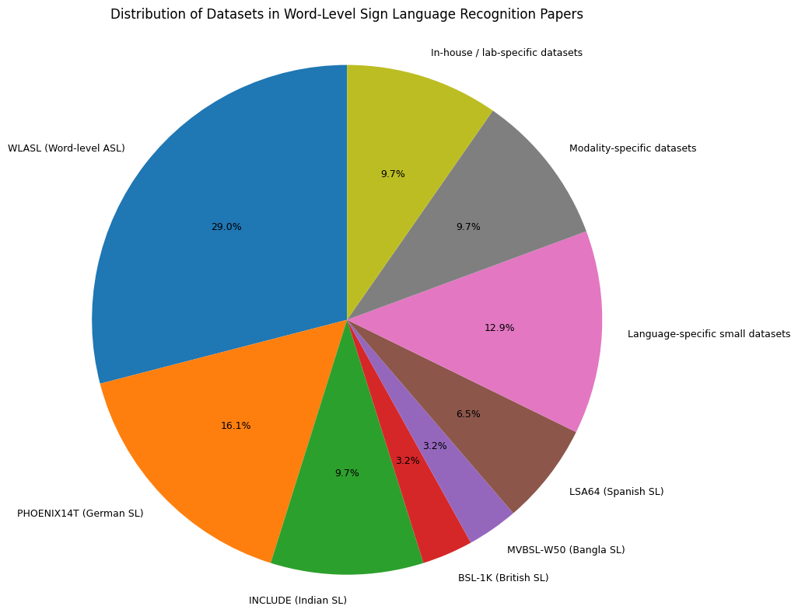
Link: https://raw.githubusercontent.com/dxli94/WLASL/refs/heads/master/start_kit/WLASL_v0.3.json
Sample json file:
[
{
"gloss": "book",
"instances": [
{
"bbox": [
385,
37,
885,
720
],
"fps": 25,
"frame_end": -1,
"frame_start": 1,
"instance_id": 0,
"signer_id": 118,
"source": "aslbrick",
"split": "train",
"url": "http://aslbricks.org/New/ASL-Videos/book.mp4",
"variation_id": 0,
"video_id": "69241"
}….

Description:
The dataset JSON is structured as a list of gloss objects, where each gloss represents a word, such as ‘book’. Each gloss contains an ‘instances’ list, where each element corresponds to a single video sample.
Each video instance includes detailed attributes such as video_id (unique identifier), URL (source of the video), signer_id (person performing the sign), and instance_id (index of that sample). It also includes frame_start and frame_end, which define the temporal segment of the video used, fps indicating frame rate, bbox specifying the spatial region of the signer, split indicating whether the sample belongs to train, validation, or test set, source specifying the dataset origin, and variation_id representing different variations of the same sign.

1️⃣ What is bbox and values like [385, 37, 885, 720]?
✅ Answer
“bbox stands for bounding box. It defines the rectangular region in the video frame where the signer is located.”
🔍 Format
[x1, y1, x2, y2]
Value | Meaning
x1 | Left coordinate
y1 | Top coordinate
x2 | Right coordinate
y2 | Bottom coordinate
👉 Example:
[385, 37, 885, 720]
Means:
- Start at pixel (385, 37)
- End at pixel (885, 720)
🎯 Use
- Crop the signer region
- Remove background noise
- Focus model on relevant area

2️⃣ What is frame_start and frame_end?
✅ Answer
“These define the temporal segment of the video that contains the actual sign.”
🔍 Example
frame_start = 1
frame_end = 50
👉 Means:
- Use frames from 1 to 50 only

❗ Special Case
frame_end = -1
👉 Means:
“Use the video till the end”

🎯 Why important?
- Removes unnecessary frames before/after sign
- Improves model accuracy
- Reduces noise

3️⃣ Difference: instance_id vs variation_id vs video_id
✅ Simple Table (Very Viva-Friendly)
Field | Meaning
video_id | Unique ID of the video file
instance_id | Index of that video within the same word
variation_id | Different style/version of the same sign

🧠 Easy Explanation
🔹 video_id
“Unique identifier for each video”

🔹 instance_id
“Counts how many samples exist for a word”
👉 Example:
- book video 1 → instance_id = 0
- book video 2 → instance_id = 1

🔹 variation_id
“Represents variations of the same sign”
👉 Example:
- Same word “book” signed slightly differently

🎯 One-line answer
“video_id identifies the video globally, instance_id identifies it within a class, and variation_id captures different styles of the same sign.”

4️⃣ What is fps (Frames Per Second = 25)?
✅ Answer
“FPS represents how many frames are displayed per second in the video.”

🔍 Example
fps = 25
👉 Means:
- 1 second = 25 frames

🎯 Why important?
- Determines motion smoothness
- Helps in frame sampling

💡 In your project
“We use FPS to understand video speed and ensure consistent temporal sampling when extracting fixed number of frames.”

🏆 Final Combined Answer (If they ask everything together)
“The dataset provides both spatial and temporal annotations. The bounding box defines the signer’s region in each frame, while frame_start and frame_end specify the exact portion of the video containing the sign. Each video is uniquely identified by video_id, with instance_id representing its index within the class and variation_id capturing different signing styles. FPS indicates the frame rate, which helps in consistent temporal processing.”

What is spatial and temporal annotation?
🟦 1. Spatial Annotation
“Physical annotation refers to where the important object (here, the signer) is located in each frame.”
🔍 In your dataset:
- Represented by: bbox
- Example: [385, 37, 885, 720]
👉 Meaning:
- It tells the model:
“Focus on this region of the frame—this is where the signer is.”

🟩 2. Temporal Annotation
“Temporal annotation refers to when the important action (the sign) happens in the video.”
🔍 In your dataset:
- Represented by: frame_start and frame_end
👉 Meaning:
- It tells the model:
“Only this part of the video contains the actual sign.”

Data collection and preprocessing:
Why we selected limited number of words?
The WLASL dataset contains around 2000 words, and even if we consider only 20 videos per word, the dataset would require approximately 140 GB of storage along with significantly high training time and computational resources. Training such a large-scale model typically requires high-end GPUs, which is not feasible on platforms like T4 GPUs. Therefore, considering resource constraints and focusing on designing an effective model architecture, By working with a smaller subset, we were able to carefully design, tune, and evaluate our architecture. The proposed pipeline is scalable, and with sufficient resources, it can be extended to a much larger vocabulary
Dataset Selection and Filtering:
We performed dataset filtering to remove underrepresented classes and ensure that each class has sufficient training samples, which helps in reducing class imbalance and improving model stability. Because of storage limitations, we filtered the dataset to include only those words with more than 21 video samples, and the selected videos were organized and stored in the raw_data directory.
Selected Words : ['all', 'before', 'black', 'book', 'candy', 'chair', 'clothes', 'computer', 'cool', 'cousin', 'deaf', 'drink', 'fine', 'finish', 'go', 'help', 'hot', 'like', 'many', 'mother', 'no', 'now', 'orange', 'table', 'thanksgiving', 'thin', 'walk', 'what', 'who', 'woman', 'year', 'yes']
Number of videos per word:
all: 19
before: 19
black: 19
book: 8
candy: 17
chair: 15
clothes: 12
computer: 20
cool: 19
cousin: 19
deaf: 19
drink: 18
fine: 18
finish: 19
go: 19
help: 17
hot: 20
like: 20
many: 20
mother: 18
no: 19
now: 20
orange: 19
table: 13
thanksgiving: 20
thin: 18
walk: 18
what: 19
who: 17
woman: 18
year: 18
yes: 19
Bar graph:
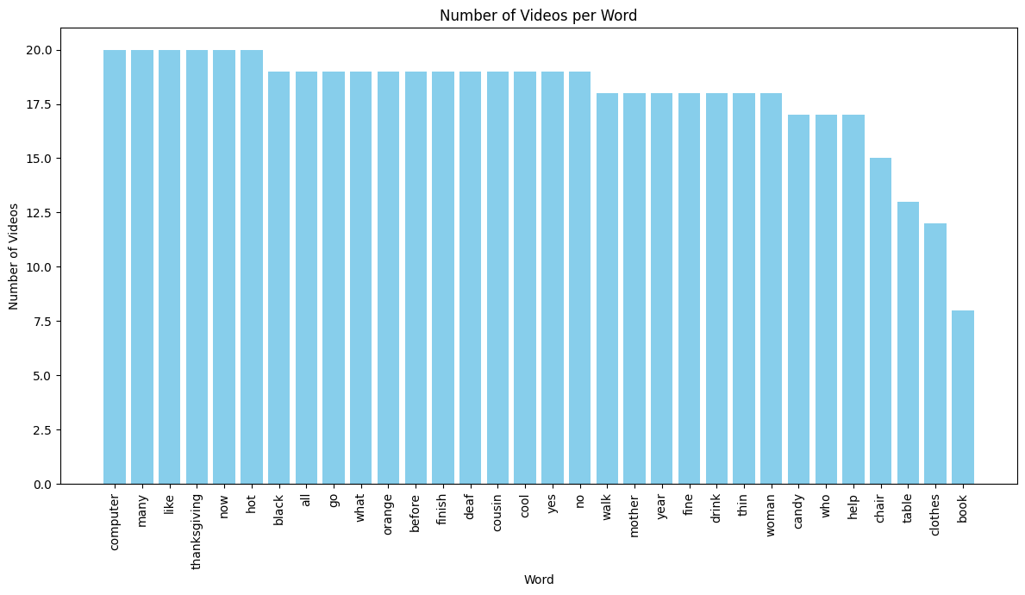

Label Encoding:
We used label encoding to convert categorical gloss labels into numerical form for model compatibility.
Video Handling and Frame Processing:
Frame Extraction
- Each video is read using OpenCV
- Frames are resized to 160 × 160
- Pixel values are normalized (0–1)
Frame Sampling (Very Important)
You ensure each video has exactly 20 frames using:
- Padding (repeat last frame) if frames are less
- Uniform sampling if frames are more
👉 Why this is important:
- Neural networks require fixed-size input
- Maintains temporal consistency across videos
👉 Viva line:
“We applied temporal normalization by sampling a fixed number of frames per video to ensure consistent input size for the model.”
Feature Extraction using MediaPipe
You use MediaPipe to extract human pose information.
From each frame, you extract:
- 33 pose landmarks (body)
- 21 landmarks per hand (max 2 hands)
Each landmark has:
- x, y, z coordinates
So per frame:
- Pose = 99 values
- Hands = 126 values
- Total features per frame ≈ 225
If landmarks are missing:
- You fill with zeros (zero padding)
👉 Why this is powerful:
- Removes background noise
- Focuses only on human motion (sign language gestures)
👉 Viva line:
“We used pose-based feature extraction to reduce dependency on background and focus only on human skeletal movement, which is more relevant for sign language recognition.”

6. Data Augmentation (Handling Small Data)
You apply augmentation on videos:
- Horizontal flip
- Brightness variation
- Small rotation
👉 This simulates:
- Different lighting conditions
- Different orientations
- Real-world variations
👉 Why needed:
- Prevents overfitting
- Improves model robustness
👉 Viva line:
“We used video-level augmentation techniques to artificially increase data diversity and improve generalization.”

7. Class Imbalance Handling (VERY IMPORTANT)
You handle imbalance in two ways:
(1) Equal Sampling
- You fix TARGET_VIDEOS = 20 per class
- If a class has fewer samples:
  - You randomly duplicate existing samples
👉 This ensures:
- Balanced dataset
- No class dominates training

(2) Extra Augmentation for Minority Classes
- If a class has < 18 videos
- You generate additional augmented samples
👉 This is smart balancing:
- Not just duplication
- Adds variation
👉 Viva line:
“We addressed class imbalance using a combination of controlled duplication and targeted augmentation for minority classes to maintain both balance and diversity.”
“Overall, our preprocessing pipeline converts raw sign language videos into structured numerical data by performing class balancing, temporal normalization, pose-based feature extraction, and augmentation. This significantly reduces noise, ensures dataset balance, and prepares the data in a format suitable for deep learning models.”

Model Training Part:
The training is split into two phases deliberately — a strategy called transfer learning with progressive unfreezing. In phase 1, a pre-trained MobileNetV2 backbone is frozen completely, and only the custom layers on top are trained. This forces the model to learn how to interpret and combine features without corrupting the already-good visual representations baked into MobileNetV2 from ImageNet. In phase 2, the top 20 layers of the backbone are unfrozen and fine-tuned at a much lower learning rate, gently adapting those features to sign language visuals without destroying them.
The model takes two inputs simultaneously for every video clip — raw RGB frames and skeleton pose data. Each input is processed through its own dedicated branch before being combined. The RGB branch passes every frame through MobileNetV2 using TimeDistributed, which applies the same CNN to each of the 16 frames independently and produces a compact 96-dimensional feature per frame. The pose branch does the same: a small dense network reduces the keypoint coordinates into a 96-dimensional vector per frame. This dual-stream design is important because neither modality alone is sufficient — RGB captures appearance and subtle hand shape, while pose captures the global motion trajectory of hands and body regardless of lighting or background variation.
Once both branches produce a (16, 96) sequence each, they are concatenated into a (16, 192) joint sequence. A MultiHeadAttention layer is then applied over the time axis. This lets the model learn which frames in the sequence are most important relative to every other frame — for example, the peak of a gesture matters more than transitional frames. The output is passed through a residual connection (Add) and LayerNormalization, which is the standard transformer-style post-attention pattern to stabilise training.
The attended sequence is then fed into a Bidirectional LSTM. The bidirectionality is key here: signs have temporal context in both directions — the beginning of a sign depends on what comes after it for disambiguation. The LSTM reads the sequence forward and backward and merges both, producing a single fixed-size vector representing the entire clip.
For regularization against overfitting, the model uses several complementary strategies: Dropout and BatchNormalization after every major sub-block, L2 kernel regularization on all dense layers, SpatialDropout1D on the fused sequence (which drops entire time steps rather than individual features, a much stronger constraint on sequence models), and recurrent_dropout inside the LSTM to prevent the hidden state from memorizing patterns.
The training uses CosineDecay learning rate scheduling, which gradually reduces the learning rate from its initial value to near zero over training — this prevents oscillation near good solutions. The optimizer is AdamW, which is Adam with weight decay, providing another route to regularization by penalizing large weights directly in the update step. clipnorm=1.0 prevents exploding gradients, which are common with recurrent layers.
Data augmentation is applied at three levels: spatial (horizontal flips, brightness and contrast jitter), temporal (dropping up to 4 frames, speed perturbation by resampling the time axis at 0.75–1.25× speed), and cross-sample (Mixup, which blends two video clips and their labels together). Mixup is particularly powerful here — it forces the model to produce smooth, probabilistic boundaries between sign classes rather than sharp, overfit decision surfaces.
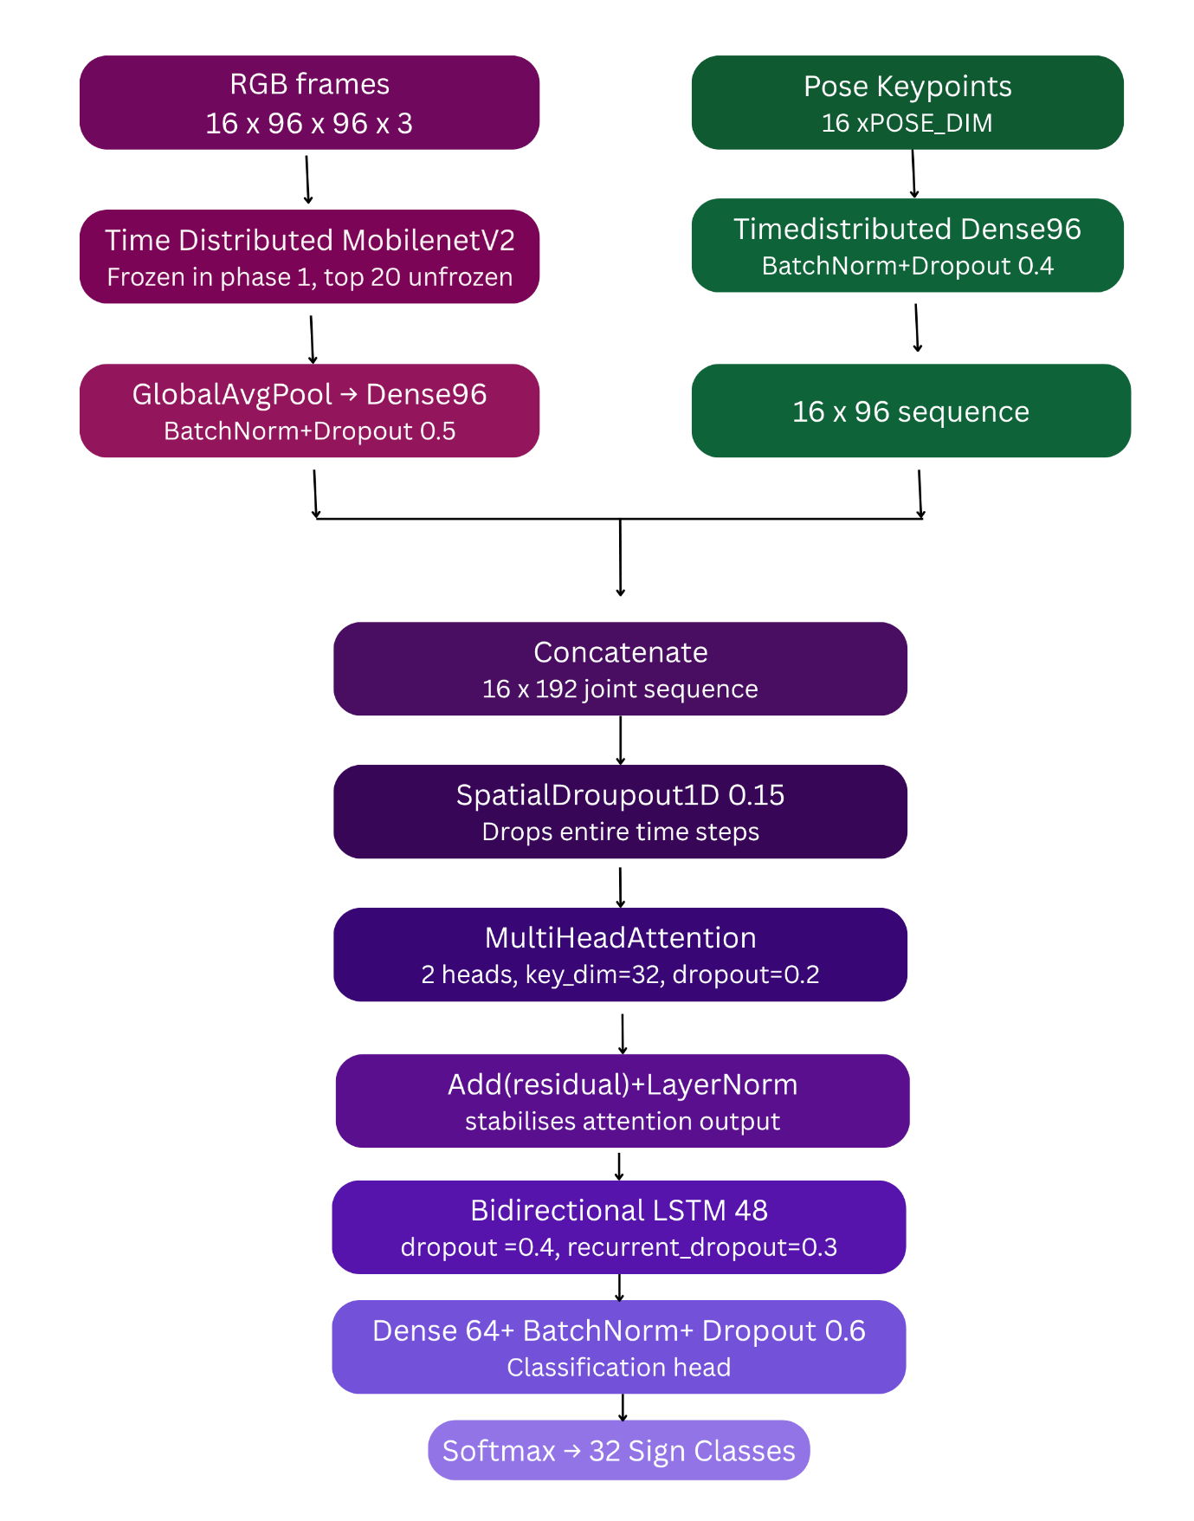
we achieved around 87% accuracy. However, this should be interpreted in the context of our experimental setup. Our dataset contains only 32 classes, which makes the classification task relatively less complex compared to large-scale datasets with hundreds or thousands of classes.
At the same time, our dataset is also smaller, so we compensated for that using transfer learning, dual-modal input (RGB + pose), and strong augmentation techniques. These design choices helped improve generalization and achieve higher accuracy compared to typical small-scale setups
We saved the trained model to use for testing and integrate with the frontend.

