
Harnessing Machine Learning for Diabetes Risk Prediction
Methodologies and Model Building in Business Data Analytics (BDA401)
5/12/2024
Final Project
Dr. Ayman Khalil
By:
Abedelrahman Al Zaatari
Ahmad Hdeib
Aisha Alawiya
Jana Ellweis
Hiba Sleiman
Tala Hareb

Business Problem:
A healthcare organization wants to improve preventive care by identifying individuals at high risk of developing diabetes. By predicting diabetes risk based on demographic, lifestyle, and medical data, the organization aims to prioritize at-risk individuals with tailored interventions, thereby reducing the prevalence of diabetes and improving overall patient outcomes.

Dataset:
https://www.kaggle.com/datasets/rcratos/diabetes-risk-prediction/data

Dataset Features:
- Age: Age of the individual.
- Gender: Gender of the individual (e.g., Male, Female).
- Polyuria: Frequent urination (Yes/No).
- Polydipsia: Excessive thirst (Yes/No).
- Sudden weight loss: Indicates sudden and unexplained weight loss (Yes/No).
- Weakness: General weakness or fatigue (Yes/No).
- Polyphagia: Excessive hunger (Yes/No).
- Genital thrush: Presence of genital thrush (Yes/No).
- Visual blurring: Blurred vision (Yes/No).
- Itching: Skin itching (Yes/No).
- Irritability: Mood irritability (Yes/No).
- Delayed healing: Delayed wound or cut healing (Yes/No).
- Partial paresis: Weakness or partial paralysis (Yes/No).
- Muscle stiffness: Muscle stiffness or tightness (Yes/No).
- Alopecia: Hair loss or baldness (Yes/No).
- Obesity: Presence of obesity (Yes/No).
- Class: Target variable indicating diabetes status (Positive/Negative).

Data Preprocessing and Preliminary Analysis:
- Data cleaning:
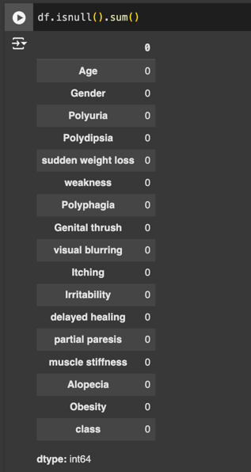
- Data Transformation:
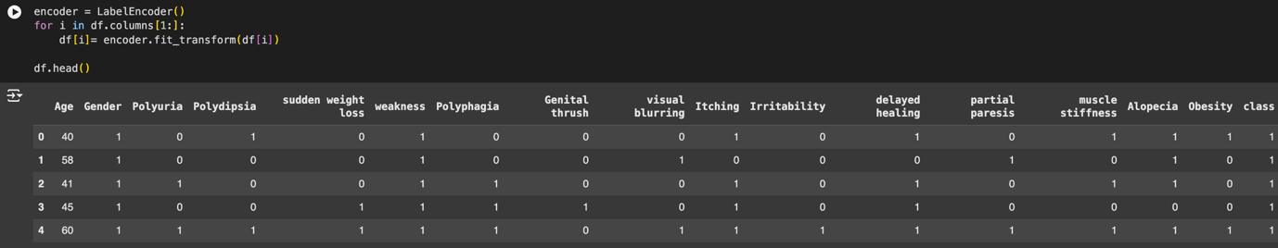

- Exploratory Data Analysis (EDA):
- Target Variable Distribution

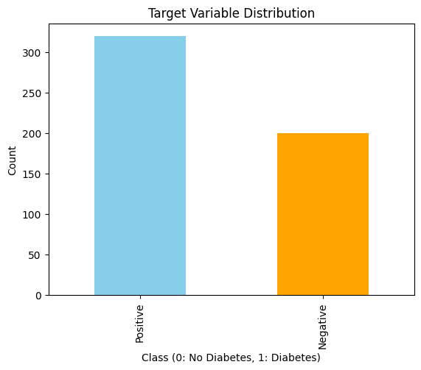
The bar chart illustrates the distribution of the target variable (class), which indicates whether an individual has diabetes (Positive) or not (Negative).
The dataset is imbalanced, with more positive cases (approximately 320) than negative cases (around 200).

Insight: The imbalance suggests that the model may need techniques like resampling (e.g., oversampling the minority class) to ensure the classifier performs well on both classes.

Relevance: The imbalance in the target variable (class) highlights that most cases in the dataset are positive for diabetes. This also suggests the need for targeted screening campaigns and preventive measures to focus on identifying diabetic individuals early.

- Polyuria vs Class

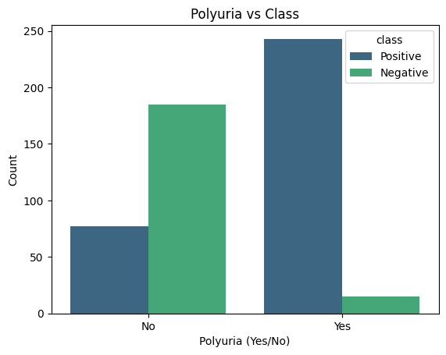
This shows the relationship between the symptom Polyuria (frequent urination) and diabetes diagnosis (class).
Most individuals with Polyuria are diabetic (Positive), while most without Polyuria are non-diabetic (Negative).
Insight: Polyuria is a strong predictor of diabetes, as a significant proportion of positive cases exhibit this symptom. This reinforces the importance of this feature in the model's predictions.
Relevance: The strong correlation between Polyuria (frequent urination) and diabetes provides a clear signal for risk prediction. This symptom is easily identifiable in patients, making it an accessible feature for early diagnosis.

- Age Distribution
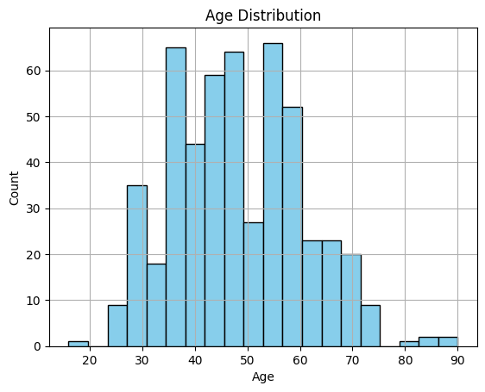
This histogram represents the distribution of ages in the dataset.
The age range is from approximately 20 to 90 years, with most individuals between 40 and 60 years old.
Insight: The dataset has a normal age distribution, with the majority of cases occurring in middle-aged individuals. Older individuals may have a higher risk of diabetes, which could make Age an important feature for predictions.
Relevance: The age distribution shows that middle-aged and older individuals are more likely to have diabetes, aligning with known risk factors. This insight can guide the prioritization of screening efforts toward higher-risk age groups.

Selecting the Best ML Model Type:
Based on the goal of predicting diabetes risk (positive/negative), the problem is best suited for Supervised Learning.

Justification to why Supervised Learning:
- Target Variable: The dataset has a clear target variable (class), which labels individuals as "Positive" (diabetes) or "Negative" (no diabetes).
- Objective: Predict specific outcomes (whether an individual is at risk of diabetes) based on the provided features.
- Learning Type: Supervised Learning is appropriate since labeled data is available to train the model.

Algorithm Selection and Justification:

Random Forest: An ensemble model that improves accuracy by combining multiple decision trees.
Why?
- Handles Mixed Data Types:
  - Works effectively with both categorical (e.g., Polyuria, Polydipsia) and numerical features (e.g., Age) without extensive preprocessing.
- Reduces Overfitting:
  - Uses an ensemble of decision trees, averaging results to improve generalization and robustness against overfitting.
- Identifies Key Features:
  - Provides feature importance scores, highlighting the most influential factors for diabetes risk, aiding in actionable healthcare decisions.
- Captures Complex Relationships:
  - Models non-linear relationships between features and the target variable, which is crucial in healthcare datasets.
- Better Alternative to Other Models:
  - Logistic Regression assumes linear relationships, which may not capture the complexity of non-linear patterns in the dataset, such as interactions between symptoms like Polyuria and Polydipsia.
  - Decision trees are prone to overfitting, especially with categorical features and small datasets, reducing their ability to generalize.
  - Gradient Boosting provides strong performance but requires extensive tuning, which isn't ideal for a dataset of this size and complexity.

Implementation in Google Colab:
https://colab.research.google.com/drive/1fsFcWuWbuP89xJO-xaIh-fajN9bcLu54?usp=sharing

Model Training and Evaluation:

- Feature and Target Selection:
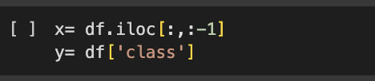

- Data splitting: Splits the data into:
  - Training Set: 80% of the data, used to train the model.
  - Test Set: 20% of the data, used to evaluate the model's performance.

- Model Initialization and Training:
  - Initializes a Random Forest model with 10 decision trees.
  - Trains the Random Forest model using the training data (x_train and y_train).
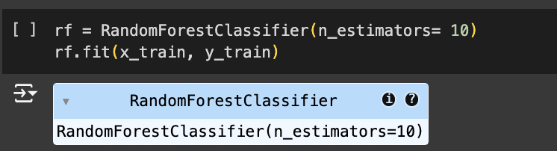

- Optimization using cross-validation.
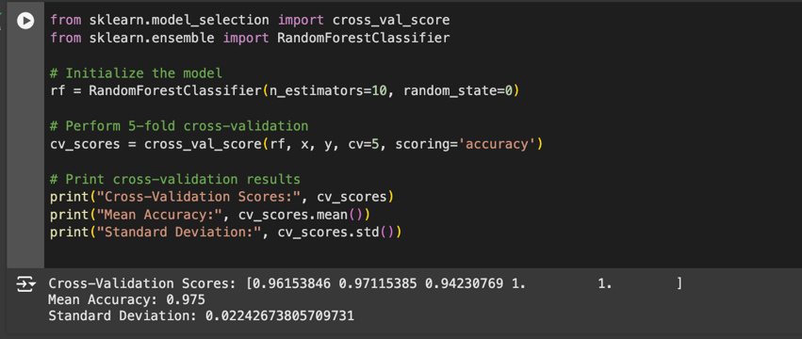
Cross-Validation Scores:
- [0.96153846, 0.97115385, 0.94230769, 1.0, 1.0]
These represent the accuracy scores for each of the 5 folds in cross-validation.

Accuracy remains consistently high across all folds, ranging from 94.2% to 100%, indicating the model generalizes well.
- Mean Accuracy: 0.975 (97.5%)
The average accuracy across all folds. This reflects the model's overall performance and confirms its reliability.
- Standard Deviation: 0.0224 (2.24%)
This low standard deviation shows that the accuracy is stable and consistent across the folds, meaning the model isn't highly sensitive to different subsets of data.

Performance Assessment:
- The trained Random Forest model (rf) generates predictions (y_pred) for the test dataset (x_test).
- Then it compares the predicted values (y_pred) to the actual test labels (y_test) and computes evaluation metrics.
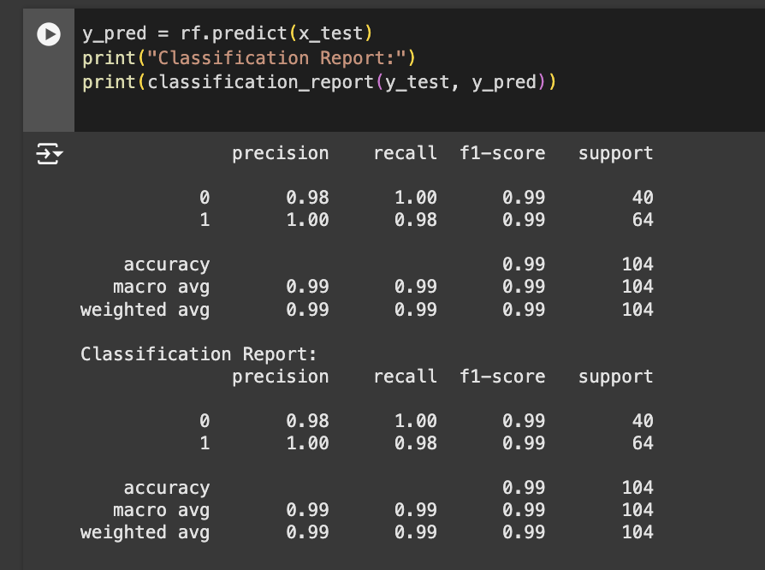

Confusion Matrix:
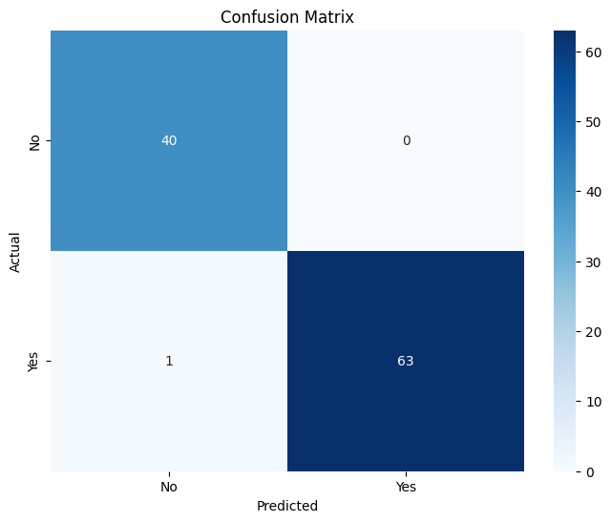
Axes:
- X-axis (Predicted): The predictions made by the model (No, Yes for diabetes status).
- Y-axis (Actual): The actual labels in the dataset (No, Yes for diabetes status).
Cells:
  - Top-left (True Negatives - TN): 40
    - The model correctly predicted "No" for 40 individuals who actually do not have diabetes.
  - Top-right (False Positives - FP): 0
    - The model did not incorrectly predict "Yes" for any individual who does not have diabetes.
  - Bottom-left (False Negatives - FN): 1
    - The model incorrectly predicted "No" for 1 individual who actually has diabetes.
  - Bottom-right (True Positives - TP): 63
    - The model correctly predicted "Yes" for 63 individuals who actually have diabetes

Analysis and Interpretations:
Feature importance: Feature importance helps identify which features contribute the most to the Random Forest model's predictions. Random Forest inherently calculates feature importance as part of its training process.
Code:
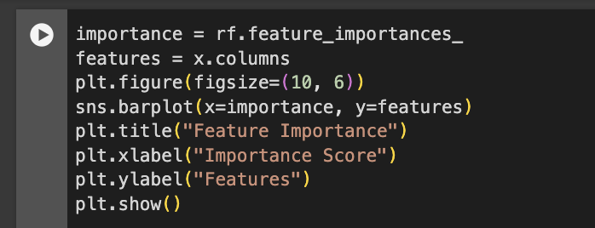
Result:
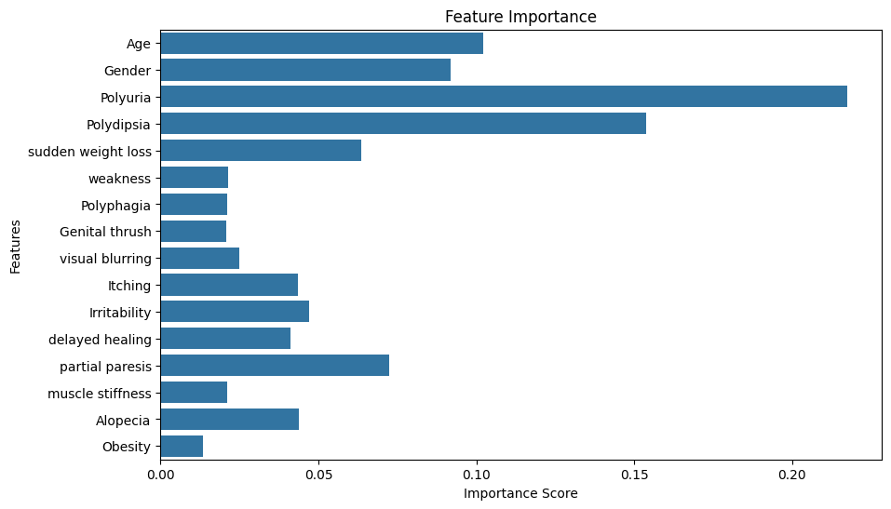
- Most Important Features:
  - Polyuria (Frequent urination): Strongly correlated with diabetes.
  - Polydipsia (Excessive thirst): A key clinical indicator.
- Moderately Important Features:
  - Age: Reflects increased diabetes risk with age.
  - Sudden Weight Loss: Critical indicator often linked to diabetes onset.
- Less Important Features:
  - Weakness, Genital Thrush, and Itching contribute but have lower impact.
- Negligible Features:
  - Obesity: Unexpectedly low importance, possibly due to dataset characteristics or feature interactions.

Business Recommendations and Decision-Making
Translating Insights:
- The Random Forest model identified key features like Polyuria, Polydipsia, Age, and Sudden Weight Loss as the most important predictors of diabetes risk.
- The imbalance in the target variable suggests that most cases are diabetic, emphasizing the need for tailored preventive measures.
- Recommendations:
  - Symptom-Based Screening:
    - Use key features like Polyuria and Polydipsia to develop targeted screening tools.
    - Implement symptom checklists in healthcare centers to identify high-risk individuals early.
  - Age-Focused Outreach:
    - Prioritize individuals aged 40-60 for awareness campaigns and regular health checkups, as this age group shows the highest concentration of diabetes cases.
Decision Making:
- Healthcare Campaigns:
  - Launch campaigns emphasizing early warning signs like Polyuria and Polydipsia.
  - Distribute educational materials explaining the importance of these symptoms and their link to diabetes.
- Resource Allocation:
  - Direct resources to high-risk demographics, such as middle-aged and older individuals, to maximize early detection.
- Preventive Programs:
  - Create lifestyle programs tailored to individuals with symptoms like Sudden Weight Loss to reduce the risk of diabetes development.
  - Offer dietary consultations and exercise plans to pre-diabetic individuals identified through the model.
Impact Analysis:
- Improved Early Detection:
  - By focusing on key symptoms and at-risk demographics, early detection rates can significantly increase, allowing timely interventions.
- Reduced Healthcare Costs:
  - Early interventions can lower long-term treatment costs by preventing diabetes-related complications.
- Enhanced Patient Outcomes:
  - Tailored interventions based on the model’s predictions can lead to better health outcomes and improved patient satisfaction.
- Operational Efficiency:
  - Allocating resources to high-risk individuals minimizes unnecessary screenings and maximizes healthcare impact.

