
Harnessing Machine Learning for Diabetes Risk Prediction

Machine Learning
Final Project
Dr. Abbas Rammal
By:
Ibrahim Mabrouki
Mahmoud Sidani
Tala Hareb

Table of Contents
1. Collecting Data
• Dataset
• Dataset Features
2. Preparing the Data
• Data Info
• Data Cleaning
• Checking for Null Values
• Checking for Duplicates
• Outliers Detection and Handling
• Data Visualization
• Shuffling
• Class Distribution
• Heat Map
• Data Transformation
• Splitting
3. Choosing Our Model
• Selecting ML Model Type
• Algorithm Selection
4. Training Our Model
• Implementation
• Feature Importance
5. Testing
6. Performance Assessment
• Before Cleaning
• After Cleaning

7. Fine-Tuning
• SMOTE
• ROC Curve
• Cross-Validation
8. Trying Different Models
• Logistic Regression
• Decision Tree Classifier
• Voting Classifier
9. Business Recommendations and Decision-Making

Business Problem:
A healthcare organization wants to improve preventive care by identifying individuals at high risk of developing diabetes. By predicting diabetes risk based on demographic, lifestyle, and medical data, the organization aims to prioritize at-risk individuals with tailored interventions, thereby reducing the prevalence of diabetes and improving overall patient outcomes.

1. Collecting Data:

Dataset:
https://www.kaggle.com/datasets/rcratos/diabetes-risk-prediction/data

Dataset Features:
- Age: Age of the individual.
- Gender: Gender of the individual (e.g., Male, Female).
- Polyuria: Frequent urination (Yes/No).
- Polydipsia: Excessive thirst (Yes/No).
- Sudden weight loss: Indicates sudden and unexplained weight loss (Yes/No).
- Weakness: General weakness or fatigue (Yes/No).
- Polyphagia: Excessive hunger (Yes/No).
- Genital thrush: Presence of genital thrush (Yes/No).
- Visual blurring: Blurred vision (Yes/No).
- Itching: Skin itching (Yes/No).
- Irritability: Mood irritability (Yes/No).
- Delayed healing: Delayed wound or cut healing (Yes/No).
- Partial paresis: Weakness or partial paralysis (Yes/No).
- Muscle stiffness: Muscle stiffness or tightness (Yes/No).
- Alopecia: Hair loss or baldness (Yes/No).
- Obesity: Presence of obesity (Yes/No).
- Class: Target variable indicating diabetes status (Positive/Negative).

2. Preparing the Data:
- Data Info:

df.head()

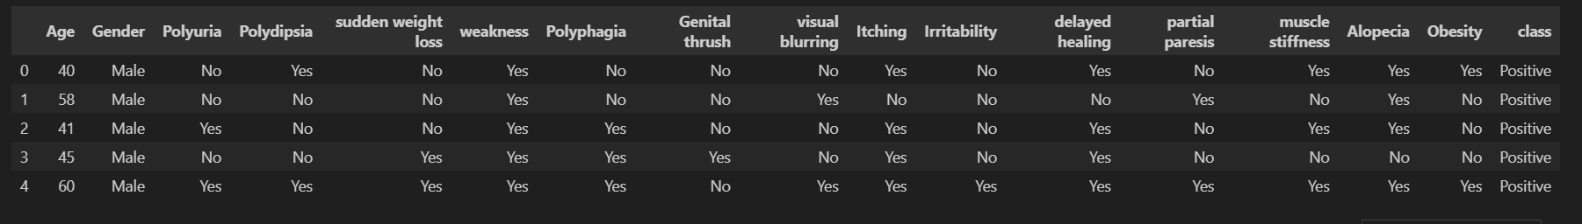

From the initial inspection of the dataset, we noticed that the first few rows predominantly display positive cases, indicating the need to shuffle the data for a balanced representation before splitting.

df.info()

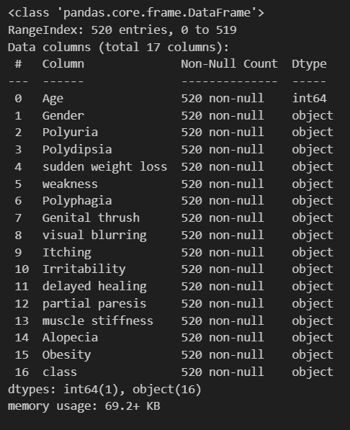
Additionally, the data contains several columns with object types, which will need to be transformed into numerical values for effective analysis.

- Data cleaning:

checking for null values:

df.isnull().sum()
cases:

for Numerical attributes
- when the number of the missing value is low we can study the central tendency of the data if
- the standard deviation is low(which means that the variability of between the data is normal
- we find the mean and assign it to the missing value otherwise we find the mode which is not affected by deviation(it is not affected by the outlier).

- when we have high number of missing values and the column or the row is not essential we might just drop the rows

for Categorical attributes:

- The missing values can be filled using the mode (most frequent value).
- If there are significant missing values, the data can be dropped.

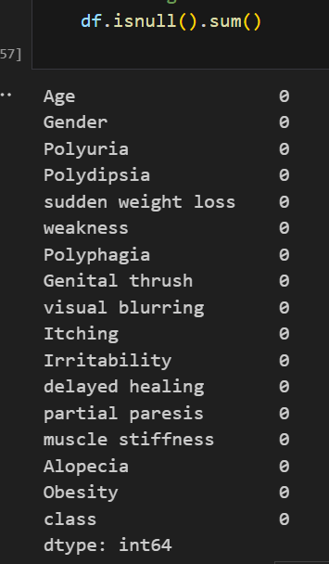
We did not have missing data in our dataset.

Checking for duplicates:
We identified duplicate rows in the dataset and provided a summary of the duplicates along with their counts.
# Count occurrences of each row
duplicates_count = df[df.duplicated(keep=False)] # Select all rows that are duplicates
duplicates_summary = duplicates_count.value_counts().reset_index(name='Count')

# Display duplicates with their counts
if not duplicates_summary.empty:
print("Duplicate rows and their counts:")
display(duplicates_summary)
else:
print("No duplicate rows found.")
# here required the duplicates removal

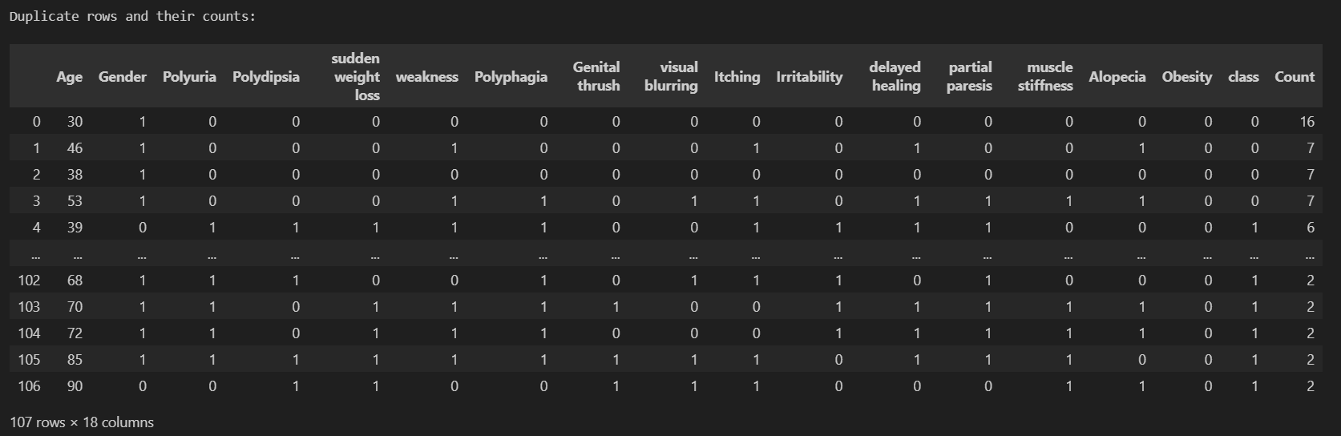Deleting the duplicates:
After identifying the duplicates, we removed them while retaining the first occurrence of each duplicate to ensure data consistency.
# Print the number of rows before removing duplicates
print(f"Number of rows before removing duplicates: {df.shape[0]}")

# Remove duplicate rows, keeping only the first occurrence
df_cleaned = df.drop_duplicates(keep='first').copy()

# Print the number of rows after removing duplicates
print(f"Number of rows after removing duplicates: {df_cleaned.shape[0]}")

# Display the cleaned dataset
df_cleaned.head()

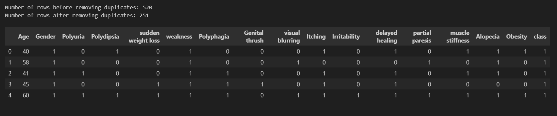

Outliers Detection and handling:
We identified outliers in the dataset using boxplots for numeric attributes, highlighting extreme values that deviate significantly from the rest.

# Create boxplots for each numeric column
numeric_columns = df_cleaned.select_dtypes(include=['number']).columns # Select only numeric columns

# Loop through each numeric column and create a boxplot
for column in numeric_columns:
plt.figure(figsize=(8, 5))
sns.boxplot(x=df[column])
plt.title(f"Boxplot of {column}")
plt.show()

#here requires the removing of the outlier

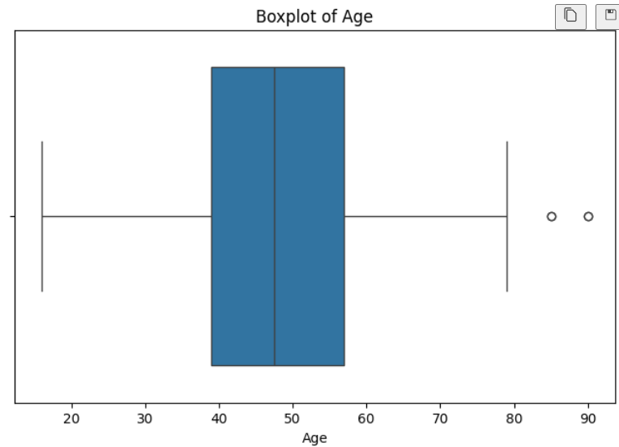
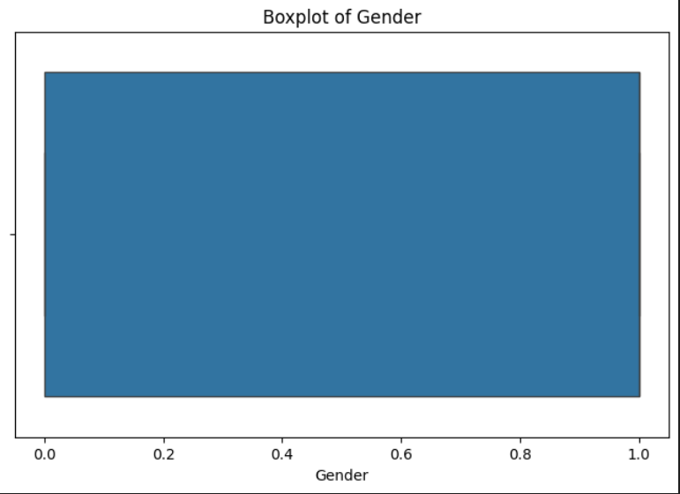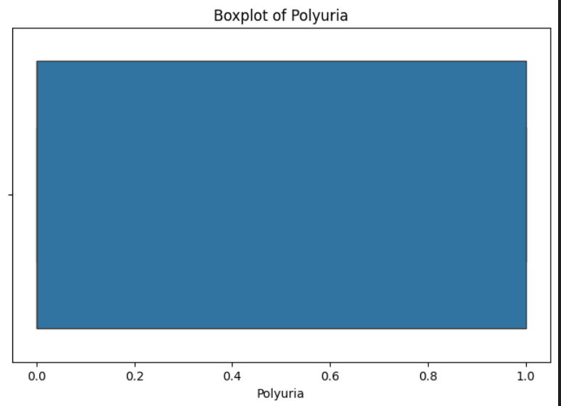
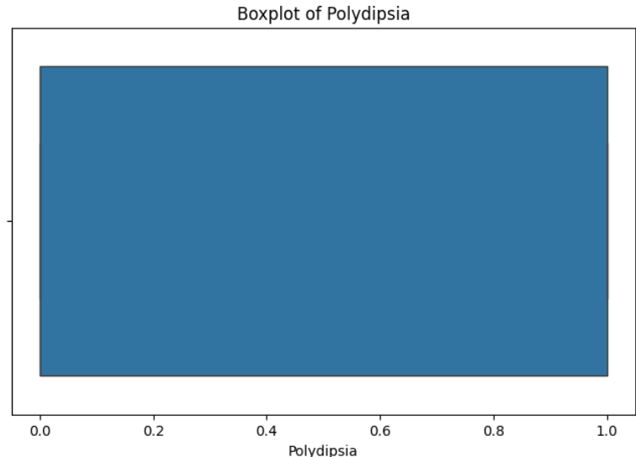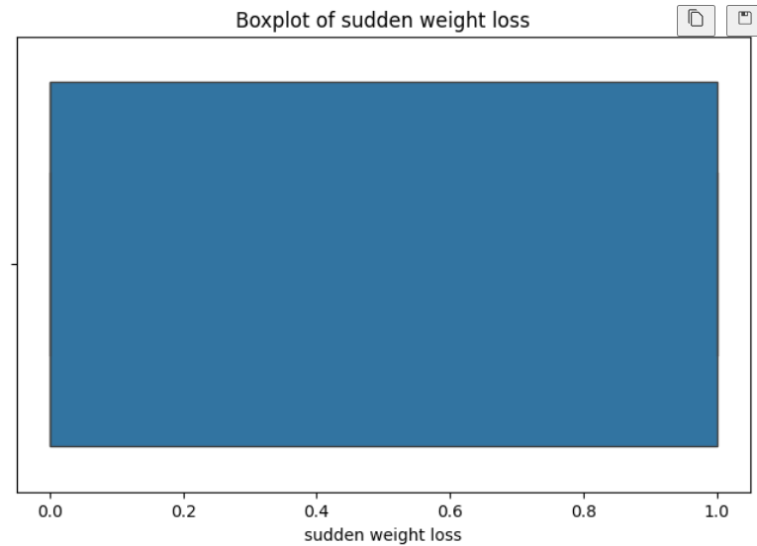
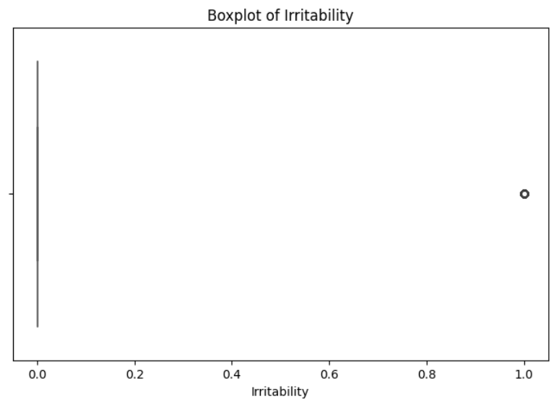 …ect

After identifying outliers in the dataset, we preserve the dataset size by avoiding row removal and instead use methods like regression or clipping to handle the outliers. Regression involves finding the attribute most correlated with the outlier's attribute, building a regression model to estimate a better value, while clipping replaces values below the lower bound with the lower bound and values above the upper bound with the upper bound.

We will use regression with binary attributes and clipping with numeric ones.

In our dataset, the `Age` attribute contains outliers, and since it is numeric and operates within ranges, clipping is the preferred approach for handling these outliers.

Q1 = df_cleaned['Age'].quantile(0.25)
Q3 = df_cleaned['Age'].quantile(0.75)
IQR = Q3 - Q1
lower_bound = Q1 - 1.5 * IQR
upper_bound = Q3 + 1.5 * IQR

print(f"Lower Bound for Age: {lower_bound}, Upper Bound for Age: {upper_bound}")

# Clip Age values to handle outliers
df_cleaned['Age'] = df_cleaned['Age'].clip(lower=lower_bound, upper=upper_bound)

# Verify the changes
print("Summary statistics for Age after handling outliers:")
print(df_cleaned['Age'].describe())

# Plot the updated boxplot for Age
plt.figure(figsize=(8, 5))
sns.boxplot(x=df_cleaned['Age'])
plt.title("Boxplot of Age After Removing Outliers")
plt.show()

After addressing the outliers in the "Age" attribute, we recalculated the summary statistics to confirm the changes.

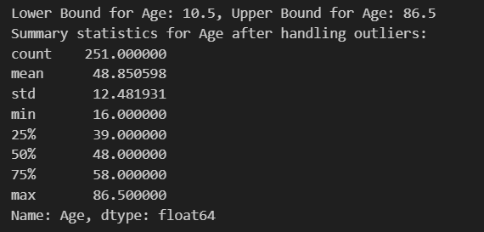

The updated boxplot illustrates that the extreme values have been clipped, bringing all data points within the defined lower and upper bounds (10.5 and 86.5, respectively). This ensures the dataset is now more consistent and suitable for further analysis without losing significant information.

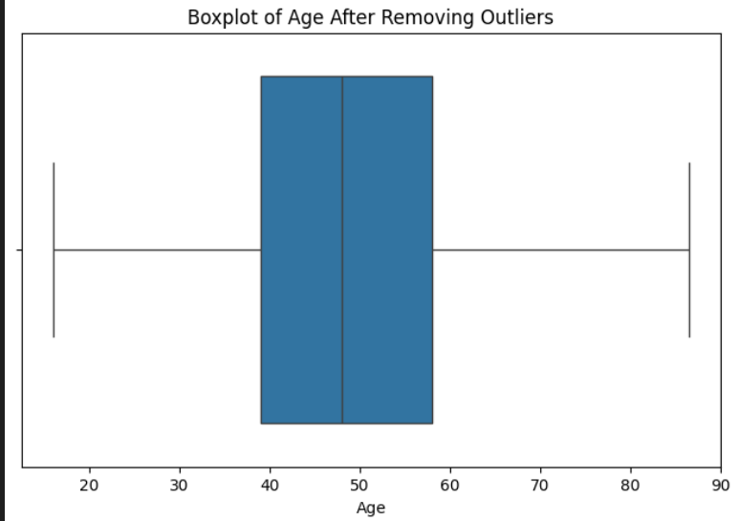

for the binary columns (Obesity, Irritabbility and Genital thrush)
we will use the logistic regression

they were identified and corrected using a systematic approach:
- Detection: A function was implemented to identify outliers by checking for invalid values in the binary columns.
- Correction: Logistic regression was applied to predict and replace the outliers based on the patterns observed in the non-outlier data.
- Verification: Boxplots for the binary columns were generated post-correction to confirm the integrity of the dataset.

from sklearn.linear_model import LogisticRegression
import seaborn as sns
import matplotlib.pyplot as plt

# Define a function to detect outliers in binary columns
def detect_outliers_binary(df, column):
# Outliers for binary columns are values other than 0 or 1
return (df[column] != 0) & (df[column] != 1)

# Define a function to handle binary outliers using Logistic Regression
def handle_binary_outliers_with_regression(df, target_column):
# Detect outliers in the target column
outliers = detect_outliers_binary(df, target_column)

# Check if there are any outliers
if outliers.sum() == 0:
print(f"No outliers detected in column '{target_column}'. Skipping...")
return

# Prepare training data (non-outlier rows)
predictors = df.drop(columns=[target_column]) # Drop target column for predictors
target = df[target_column]
predictors_non_outliers = predictors[~outliers] # Non-outlier predictors
target_non_outliers = target[~outliers] # Non-outlier target values

# Train logistic regression on non-outlier data
log_reg = LogisticRegression()
log_reg.fit(predictors_non_outliers, target_non_outliers)

# Predict values for outliers
predictors_outliers = predictors[outliers] # Outlier predictors
if predictors_outliers.empty:
print(f"No valid predictors for outliers in column '{target_column}'. Skipping...")
return

predicted_values = log_reg.predict(predictors_outliers)

# Replace outlier values with predicted values
df.loc[outliers, target_column] = predicted_values

# List of binary columns with outliers to fix
binary_columns = ['Obesity', 'Irritability', 'Genital thrush']

# Apply logistic regression-based outlier handling for each binary column in df_cleaned
for column in binary_columns:
print(f"Fixing outliers for {column}...")
handle_binary_outliers_with_regression(df_cleaned, column)

# Display the updated dataset
print("Binary outliers handled.")
print(df_cleaned[binary_columns].head())

# Plot the boxplots for each binary column after handling outliers
for column in binary_columns:
plt.figure(figsize=(8, 5))
sns.boxplot(x=df_cleaned[column])
plt.title(f"Boxplot of {column} After Handling Outliers")
plt.show()

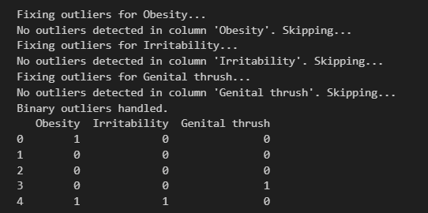

After handling binary outliers, the final shape of the cleaned dataset was:
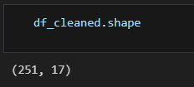

- Data Visualization

Shuffling:
In this code, we are shuffling the dataset to ensure the data is randomized before splitting it into training and testing sets.
This helps prevent the issue of class domination in the testing set, ensuring a fair evaluation of the model.

# View the first 5 rows before shuffling
print("Before shuffling:")
display(df.head())

# Shuffle the DataFrame
shuffled_df = df.sample(frac=1, random_state=42).reset_index(drop=True)

# View the first 5 rows after shuffling
print("\nAfter shuffling:")
display(shuffled_df.head())

The before and after views of the data confirm the successful randomization of the rows.

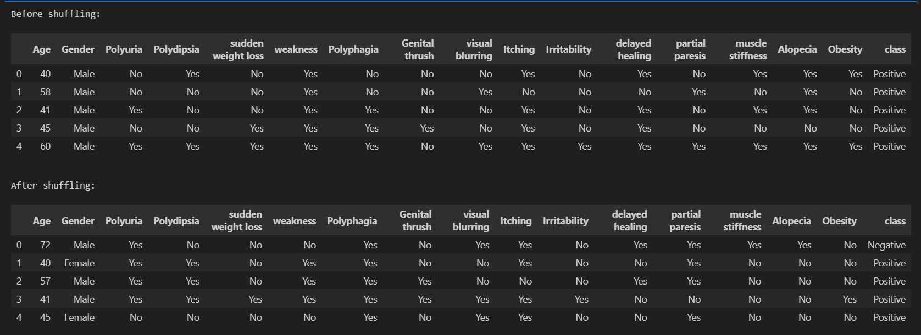

Class distribution:
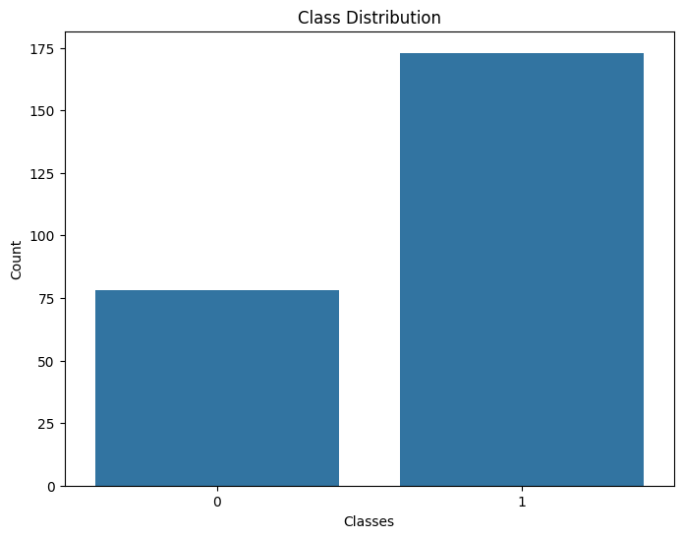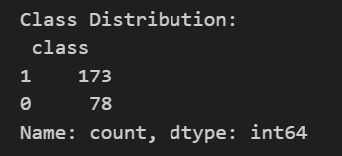
The class distribution plot shows an imbalance in the dataset, with 173 instances of class 1 and 78 instances of class 0.
Heat map :
numeric_columns = df.select_dtypes(include=['number']).columns
df[numeric_columns] = df[numeric_columns].fillna(df[numeric_columns].mean())

# Encode categorical variables (if needed)
from sklearn.preprocessing import LabelEncoder
encoder = LabelEncoder()
for col in df.select_dtypes(include=['object']).columns:
df[col] = encoder.fit_transform(df[col])

# Compute the correlation matrix
corr_matrix = df.corr()

# Display the heatmap
plt.figure(figsize=(10, 8))
sns.heatmap(corr_matrix, annot=True, cmap='coolwarm')
plt.title("Correlation Heatmap")
plt.show()

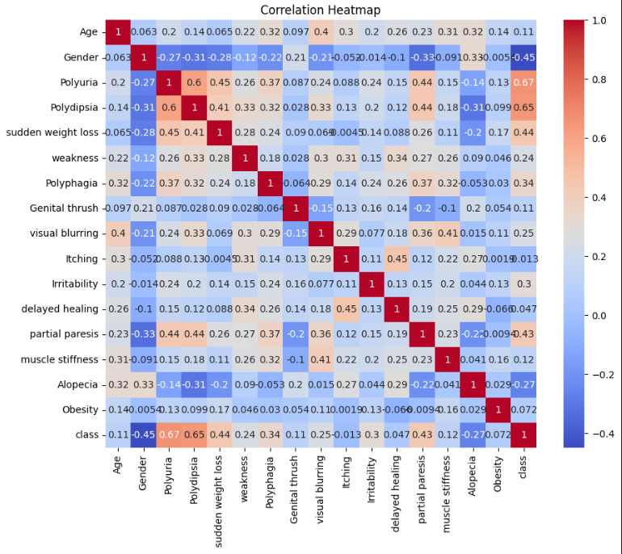
The heatmap shows the strongest correlations with the target class are Polyuria (0.67) and Polydipsia (0.65). These features are key predictors and should be prioritized during model training. The other correlations are relatively low, suggesting no redundant data.

Since tree-based models select features based on their contribution to reducing impurity during splits, rather than their correlation, there is no need to drop or merge any attributes.

- Data Transformation:

To prepare the dataset for ML algorithms, categorical variables were transformed into numerical values using LabelEncoder, which assigns a unique numerical value to each category in a column.

encoder = LabelEncoder()
for i in df_cleaned.columns[1:]:
df_cleaned[i]= encoder.fit_transform(df_cleaned[i])

df_cleaned.head()

This ensures all features are represented numerically, making them compatible with machine learning models.
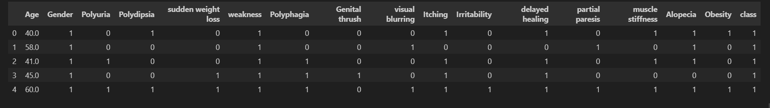

- Splitting:

x= df_cleaned.iloc[:,:-1]
y= df_cleaned['class']
x_train, x_test, y_train, y_test = train_test_split(x,y, train_size=0.8,random_state= 0)

The first two lines separate the features (x) and the target variable (y) from the dataset, with x containing all columns except the last and y containing the 'class' column. The data is then split into training (80%) and testing (20%) sets.

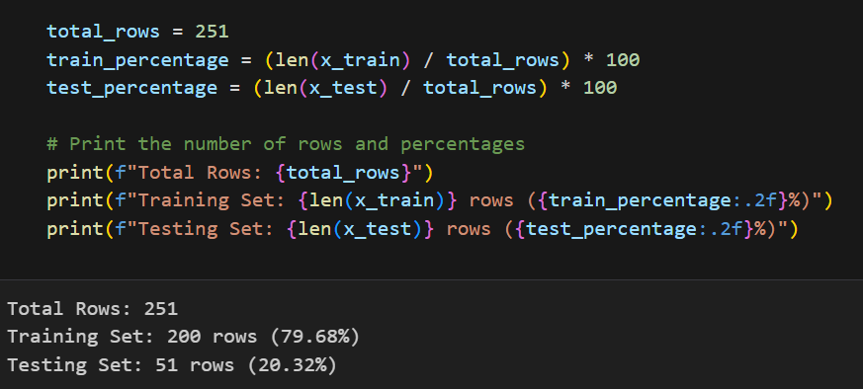

- Choosing our model :

Selecting the Best ML Model Type:
Based on the goal of predicting diabetes risk (positive/negative), the problem is best suited for Supervised Learning.

Justification to why Supervised Learning:
- Target Variable: The dataset has a clear target variable (class), which labels individuals as "Positive" (diabetes) or "Negative" (no diabetes).
- Objective: Predict specific outcomes (whether an individual is at risk of diabetes) based on the provided features.
- Learning Type: Supervised Learning is appropriate since labeled data is available to train the model.

Algorithm Selection and Justification:

Random Forest: An ensemble model that improves accuracy by combining multiple decision trees.
Why?
- Handles Mixed Data Types:
  - Works effectively with both categorical (e.g., Polyuria, Polydipsia) and numerical features (e.g., Age) without extensive preprocessing.
- Reduces Overfitting:
  - Uses an ensemble of decision trees, averaging results to improve generalization and robustness against overfitting.
- Identifies Key Features:
  - Provides feature importance scores, highlighting the most influential factors for diabetes risk, aiding in actionable healthcare decisions.
- Captures Complex Relationships:
  - Models non-linear relationships between features and the target variable, which is crucial in healthcare datasets.
- Other algorithms we will try:
  - Logistic Regression assumes linear relationships, which may not capture the complexity of non-linear patterns in the dataset, such as interactions between symptoms like Polyuria and Polydipsia.
  - Decision trees are prone to overfitting, especially with categorical features and small datasets, reducing their ability to generalize.
  - Voting Classifier provides strong performance but requires extensive tuning, which isn't ideal for a dataset of this size and complexity.

4- Training the model:

- Feature and Target Selection:
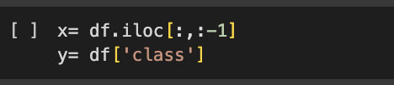

- Data splitting: Splits the data into:
  - Training Set: 80% of the data, used to train the model.
  - Test Set: 20% of the data, used to evaluate the model's performance.

- Model Initialization and Training:
  - Initializes a Random Forest model with 10 decision trees.
  - Trains the Random Forest model using the training data (x_train and y_train).
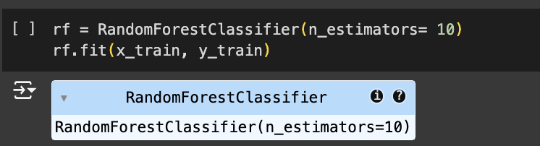

Radom Forest visualization
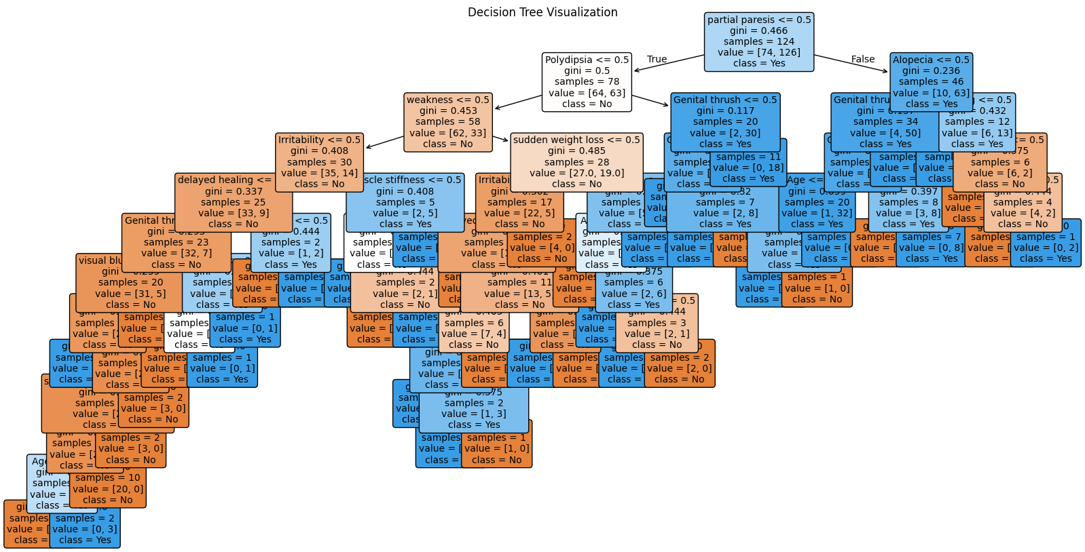

Feature Importance:

The feature importance plot highlights the contribution of each feature to the model's predictions, with Polyuria, Polydipsia, and Age emerging as the most significant predictors, offering valuable insights into the factors driving the model's decision-making process.

importance = rf.feature_importances_
features = x.columns
plt.figure(figsize=(10, 6))
sns.barplot(x=importance, y=features)
plt.title("Feature Importance")
plt.xlabel("Importance Score")
plt.ylabel("Features")
plt.show()

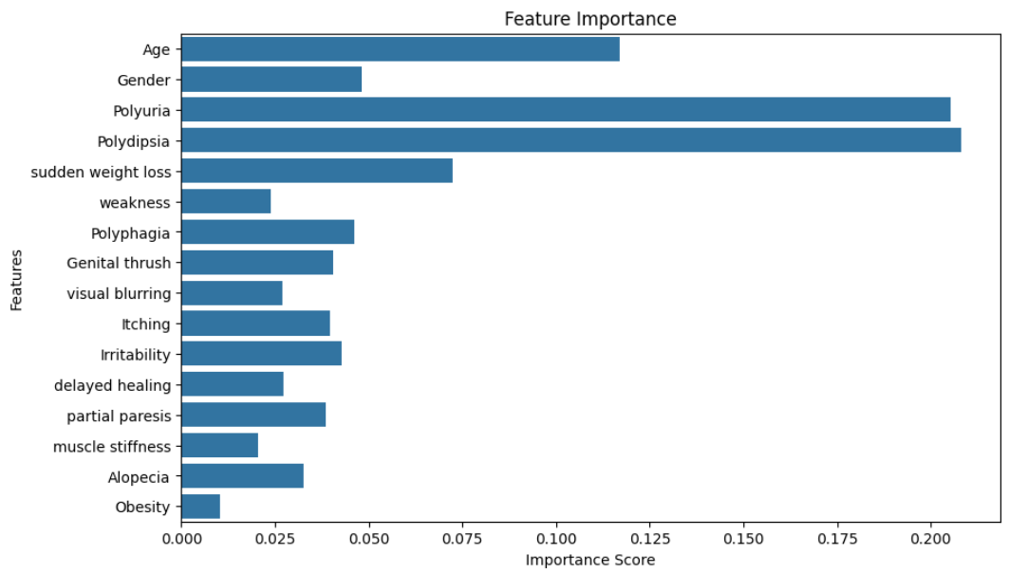

The feature importance plot highlights Polyuria, Polydipsia, and Age as the most significant contributors to the target class. This suggests these features have the highest predictive power.

Further exploratory data analysis (EDA) focusing on these key features, such as their relationship with the class variable, can provide deeper insights into their influence

- Polyuria vs Class

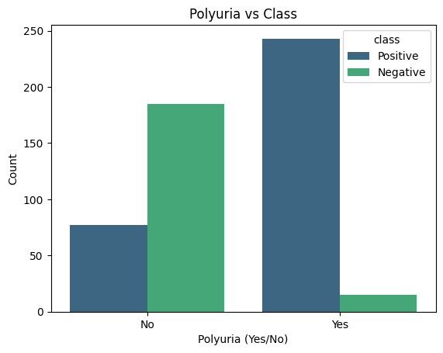
This shows the relationship between the symptom Polyuria (frequent urination) and diabetes diagnosis (class).
Most individuals with Polyuria are diabetic (Positive), while most without Polyuria are non-diabetic (Negative).
Insight: Polyuria is a strong predictor of diabetes, as a significant proportion of positive cases exhibit this symptom. This reinforces the importance of this feature in the model's predictions.
- Age Distribution
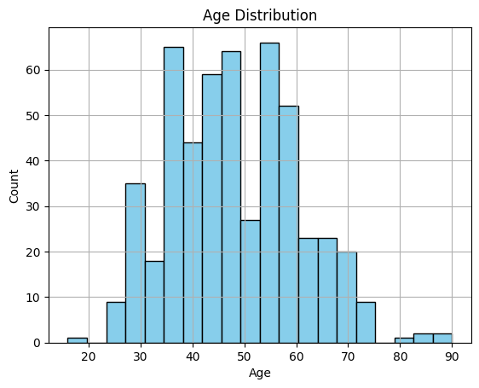
This histogram represents the distribution of ages in the dataset.
The age range is from approximately 20 to 90 years, with most individuals between 40 and 60 years old.
Insight: The dataset has a normal age distribution, with the majority of cases occurring in middle-aged individuals. Older individuals may have a higher risk of diabetes, which could make Age an important feature for predictions.

5-Performance Assessment:

Before cleaning:
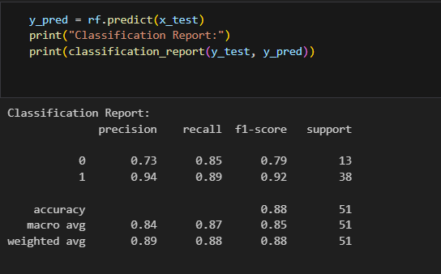

# Assuming y_test and y_pred are already defined
conf_matrix = confusion_matrix(y_test, y_pred)

# Plotting the confusion matrix
plt.figure(figsize=(8, 6))
sns.heatmap(conf_matrix, annot=True, fmt='d', cmap="Blues", xticklabels=["No", "Yes"], yticklabels=["No", "Yes"])
plt.title("Confusion Matrix")
plt.xlabel("Predicted")
plt.ylabel("Actual")
plt.show()
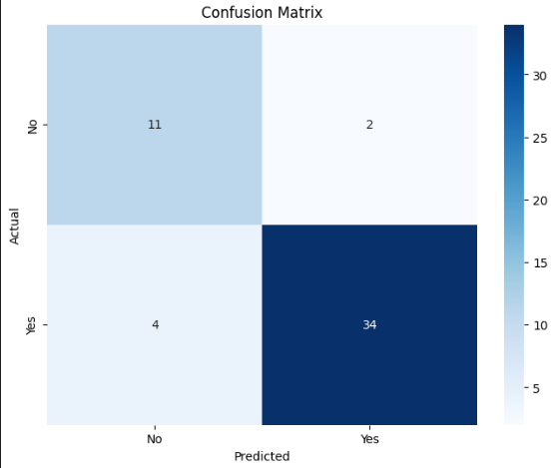
Before cleaning the data, the model's performance was not optimal, as shown by the classification report. While the overall accuracy was decent at 88%, there were noticeable false positives and false negatives. For instance, in the confusion matrix, 2 instances of class 0 were incorrectly predicted as 1 (false positives), and 4 instances of class 1 were incorrectly predicted as 0 (false negatives). This highlights the need for data cleaning and preprocessing to improve precision, recall, and overall model performance.

After cleaning:

After cleaning we had over fitting due to class imbalance
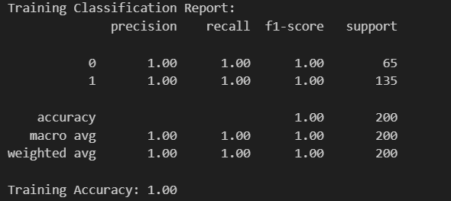

- Fine Tuning

We studied this imbalance

# Verify the distribution of classes in each split
print("Original class distribution:")
print(y.value_counts())

print("\nTraining set class distribution:")
print(y_train.value_counts())

print("\nTesting set class distribution:")
print(y_test.value_counts())
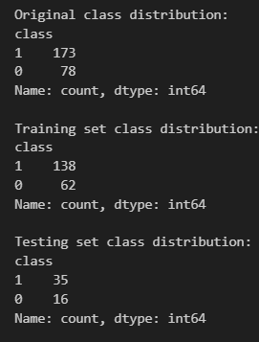

Optimized it using SMOTE

To address the class imbalance in the dataset (173 instances of class 1 vs. 78 instances of class 0), we used SMOTE (Synthetic Minority Oversampling Technique) to balance the data. SMOTE generates synthetic samples for the minority class, ensuring equal representation of both classes in the training data.

from imblearn.over_sampling import SMOTE

smote = SMOTE(random_state=0)
x_train_balanced, y_train_balanced = smote.fit_resample(x_train, y_train)

print("Class distribution after SMOTE:\n", y_train_balanced.value_counts())

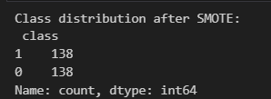

New Optimized performance:

After applying SMOTE, the class distribution became balanced with 138 instances of each class, significantly improving the training dataset's quality. The model was retrained using the balanced data.
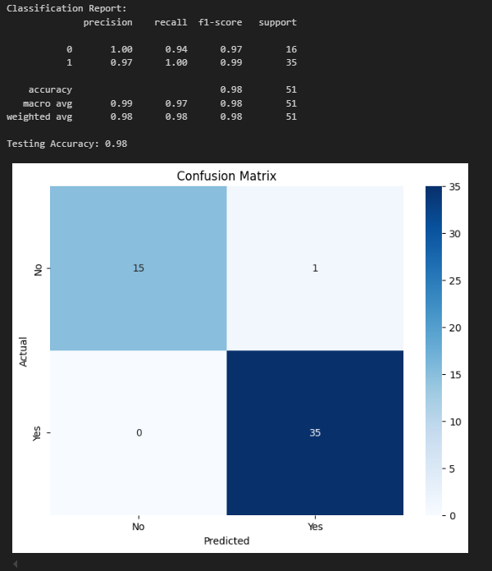

New Optimized Performance: The balanced dataset resulted in a noticeable improvement in model performance:
- The testing accuracy increased to 98%.
- Precision, recall, and F1-scores for both classes were nearly perfect.
- The confusion matrix shows minimal misclassifications, with only 1 false positive and 0 false negatives.

ROC Curve
To study the tradeoffs we visualized ROC (Receiver Operating Characteristic) Curve and the AUC (Area Under the Curve)

- The ROC curve shows the trade-off between the True Positive Rate (TPR) and False Positive Rate (FPR) at various thresholds.
- The AUC score quantifies the model's ability to distinguish between classes (1 being perfect, 0.5 being random).

y_pred_proba = rf.predict_proba(x_test)[:, 1] # Assuming 'rf' is your Random Forest model

# Compute ROC curve and AUC score
fpr, tpr, thresholds = roc_curve(y_test, y_pred_proba) # False Positive Rate, True Positive Rate
roc_auc = auc(fpr, tpr) # Area Under the Curve

# Plot the ROC curve
plt.figure(figsize=(8, 6))
plt.plot(fpr, tpr, color='blue', label=f'ROC Curve (AUC = {roc_auc:.2f})')
plt.plot([0, 1], [0, 1], color='gray', linestyle='--') # Dashed diagonal line (random classifier)
plt.xlabel('False Positive Rate')
plt.ylabel('True Positive Rate')
plt.title('Receiver Operating Characteristic (ROC) Curve')
plt.legend(loc='lower right')
plt.grid()

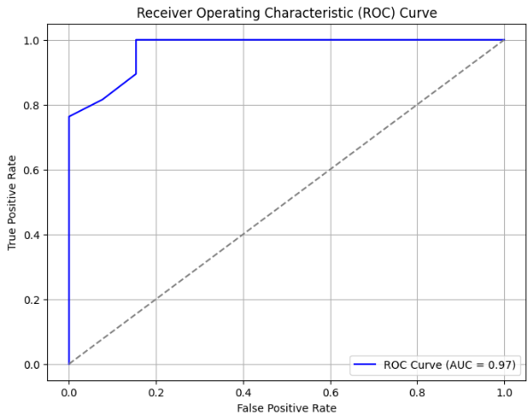
The ROC curve is plotted, and its proximity to the top-left corner signifies strong model performance. The dashed diagonal line represents a random classifier for comparison.

Then we re plotted the ROC Curve to highlight specific threshold points to provide more detailed insights into the model's performance.

# Compute ROC curve and AUC score
fpr, tpr, thresholds = roc_curve(y_test, y_pred_proba)
roc_auc = auc(fpr, tpr)

# Plot the ROC curve
plt.figure(figsize=(10, 6))
plt.plot(fpr, tpr, color='blue', label=f'ROC Curve (AUC = {roc_auc:.2f})')
plt.plot([0, 1], [0, 1], color='gray', linestyle='--', label="Random Classifier") # Dashed diagonal line
plt.scatter(fpr, tpr, color='red', label='Threshold Points') # Highlight TPR and FPR points

# Highlight a specific point on the curve (example: midpoint)
highlight_index = len(fpr) // 2 # Example: Highlighting the middle point
plt.scatter(fpr[highlight_index], tpr[highlight_index], color='green', s=100, label='Highlighted Point')
plt.annotate(
f'TPR={tpr[highlight_index]:.2f}, FPR={fpr[highlight_index]:.2f}',
(fpr[highlight_index], tpr[highlight_index]),
textcoords="offset points",
xytext=(-30, 10),
ha='center',
color='green'
)

# Add axis labels, title, and legend
plt.xlabel('False Positive Rate (FPR)')
plt.ylabel('True Positive Rate (TPR)')
plt.title('ROC Curve with TPR and FPR Highlighted')
plt.legend(loc='lower right')
plt.grid()

# Show the plot
plt.show()

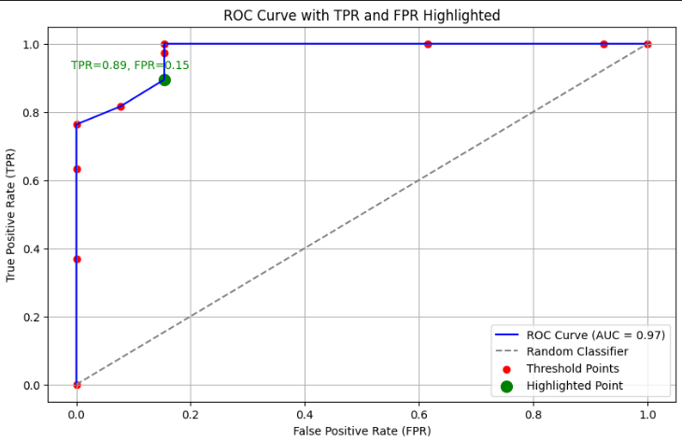
The ROC curve demonstrates excellent model performance with an AUC of 0.97, indicating a strong ability to distinguish between classes. The curve rises sharply towards the top-left corner, reflecting a high True Positive Rate (TPR) and low False Positive Rate (FPR). The highlighted point (TPR=0.89, FPR=0.15) shows the model balances accuracy well at this threshold, making it a potentially optimal decision point. Overall, the model significantly outperforms a random classifier, as seen by its distance from the diagonal line.

Optimization using cross-validation:
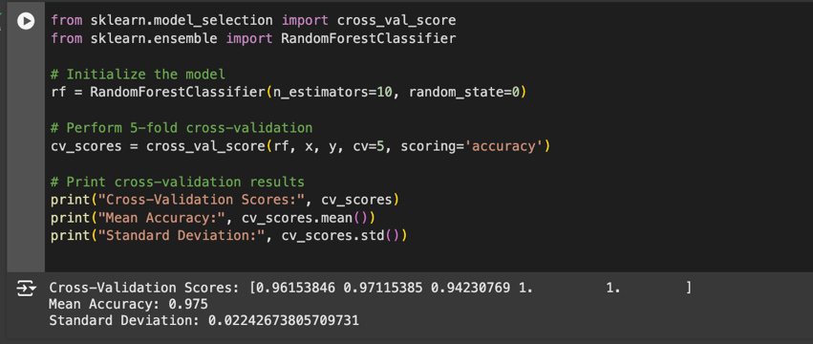

Cross-Validation Scores:
- [0.96153846, 0.97115385, 0.94230769, 1.0, 1.0]
These represent the accuracy scores for each of the 5 folds in cross-validation.
Accuracy remains consistently high across all folds, ranging from 94.2% to 100%, indicating the model generalizes well.
- Mean Accuracy: 0.975 (97.5%)
The average accuracy across all folds. This reflects the model's overall performance and confirms its reliability.
- Standard Deviation: 0.0224 (2.24%)
This low standard deviation shows that the accuracy is stable and consistent across the folds, meaning the model isn't highly sensitive to different subsets of data.

Trying different models:

LogisticRegression
from sklearn.ensemble import VotingClassifier

# Initialize individual models
logistic_model = LogisticRegression()
decision_tree_model = DecisionTreeClassifier()
random_forest_model = RandomForestClassifier()

# Combine the models into a VotingClassifier (using soft voting)
ensemble_model = VotingClassifier(
estimators=[
('Logistic Regression', logistic_model),
('Decision Tree', decision_tree_model),
('Random Forest', random_forest_model)
],
voting='soft' # Use soft voting to average probabilities
)

# Train the ensemble model on the training data
ensemble_model.fit(x_train, y_train)

# Make predictions on the test set
y_pred = ensemble_model.predict(x_test)

# Evaluate the model
print("Classification Report:")
print(classification_report(y_test, y_pred))

# Calculate and print accuracy
test_accuracy = accuracy_score(y_test, y_pred)
print(f"Testing Accuracy: {test_accuracy:.2f}")

# Confusion Matrix
conf_matrix = confusion_matrix(y_test, y_pred)
plt.figure(figsize=(8, 6))
sns.heatmap(conf_matrix, annot=True, fmt='d', cmap="Blues", xticklabels=["No", "Yes"], yticklabels=["No", "Yes"])
plt.title("Confusion Matrix")
plt.xlabel("Predicted")
plt.ylabel("Actual")
plt.show()

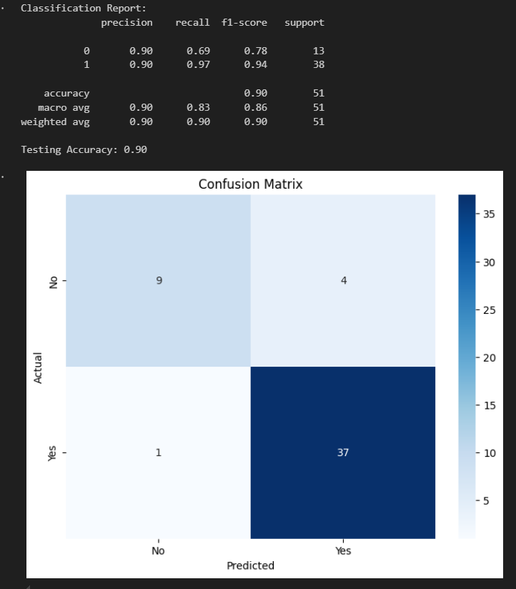
The Result above refers to the report and the confusion matrix Before the SMOT. The model showed to be biased toward the majority class, which is class 1, resulting in lower recall (0.69) for the minority class. Also, the overall accuracy was 90%. The accuracy still less than that in the Random Forest model after regression consequently we could not achieve higher accuracy.

After SMOTE Logistic Regression:

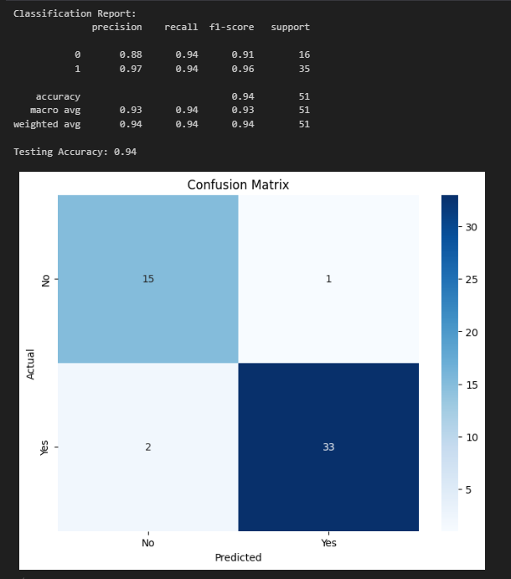

The above result refers to logistic regression model, but after using SMOT. It is obvious that addressing the class imbalance led to improvement in the recall (0.94) and the F1-score for the minority class as well as enhancing the overall accuracy 94%. In general, Random Forest did better than Logistic regression.

DecisionTreeClassifier

# Initialize the Decision Tree Classifier
decision_tree_model = DecisionTreeClassifier()

# Train the model on the training data
decision_tree_model.fit(x_train, y_train)

# Make predictions on the test set
y_pred = decision_tree_model.predict(x_test)

# Evaluate the model
print("Classification Report:")
print(classification_report(y_test, y_pred))

# Calculate and print accuracy
test_accuracy = accuracy_score(y_test, y_pred)
print(f"Testing Accuracy: {test_accuracy:.2f}")

# Confusion Matrix
conf_matrix = confusion_matrix(y_test, y_pred)
plt.figure(figsize=(8, 6))
sns.heatmap(conf_matrix, annot=True, fmt='d', cmap="Blues", xticklabels=["No", "Yes"], yticklabels=["No", "Yes"])
plt.title("Confusion Matrix")
plt.xlabel("Predicted")
plt.ylabel("Actual")
plt.show()

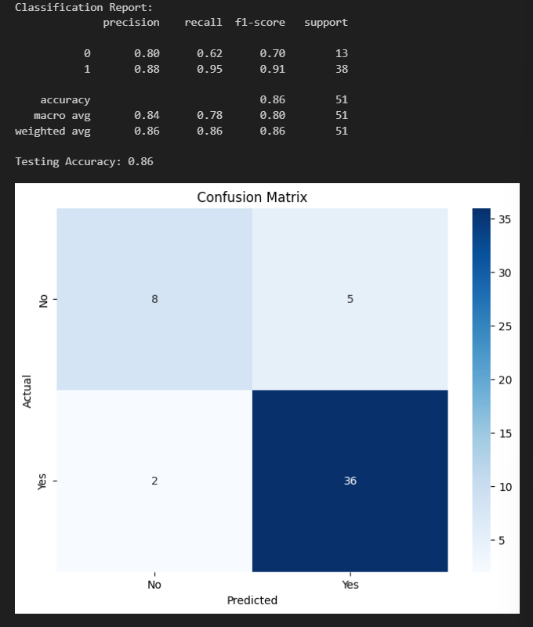

Before SMOTE: The model struggled with the minority class (class 0), showing a recall of 0.62 and an F1-score of 0.70 for class 0, with an overall accuracy of 86%. This indicates a bias towards the majority class.

After SMOTE:

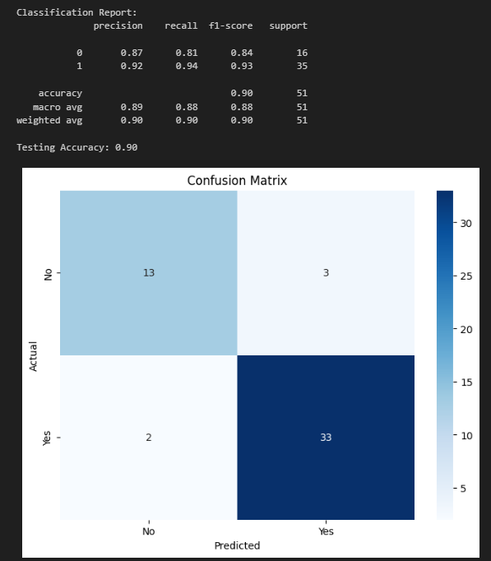

The application of SMOTE significantly improved the model's performance for the minority class, increasing the recall to 0.81 and the F1-score to 0.84 for class 0, and the overall accuracy rose to 90%. This demonstrates that balancing the data improved the model's ability to generalize across both classes.

Similarly to what we concluded previously it seems that Random Forest is performing better in taking decisions.

Voting Classifier:
from sklearn.ensemble import VotingClassifier

# Initialize individual models
logistic_model = LogisticRegression()
decision_tree_model = DecisionTreeClassifier()
random_forest_model = RandomForestClassifier()

# Combine the models into a VotingClassifier (using soft voting)
ensemble_model = VotingClassifier(
estimators=[
('Logistic Regression', logistic_model),
('Decision Tree', decision_tree_model),
('Random Forest', random_forest_model)
],
voting='soft' # Use soft voting to average probabilities
)

# Train the ensemble model on the training data
ensemble_model.fit(x_train, y_train)

# Make predictions on the test set
y_pred = ensemble_model.predict(x_test)

# Evaluate the model
print("Classification Report:")
print(classification_report(y_test, y_pred))

# Calculate and print accuracy
test_accuracy = accuracy_score(y_test, y_pred)
print(f"Testing Accuracy: {test_accuracy:.2f}")

# Confusion Matrix
conf_matrix = confusion_matrix(y_test, y_pred)
plt.figure(figsize=(8, 6))
sns.heatmap(conf_matrix, annot=True, fmt='d', cmap="Blues", xticklabels=["No", "Yes"], yticklabels=["No", "Yes"])
plt.title("Confusion Matrix")
plt.xlabel("Predicted")
plt.ylabel("Actual")
plt.show()

The VotingClassifier is an ensemble learning technique that combines the predictions of multiple individual models (e.g., Logistic Regression, Decision Tree, and Random Forest) to improve overall performance. By leveraging soft voting, it averages the predicted probabilities of each model, leading to a more robust and accurate classification, particularly in scenarios where individual models have complementary strengths.
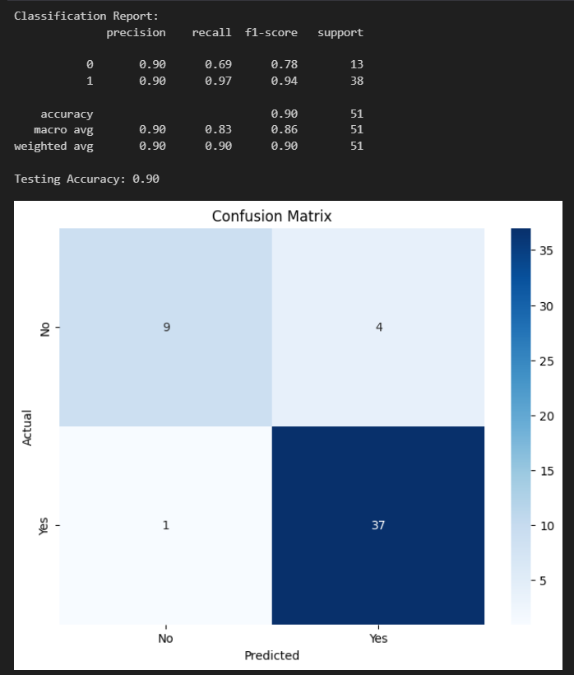

Before SMOTE: The classifier had a recall of 0.69 and an F1-score of 0.78 for the minority class (class 0), with an overall accuracy of 90%, showing a moderate bias toward the majority class.

After SMOTE:
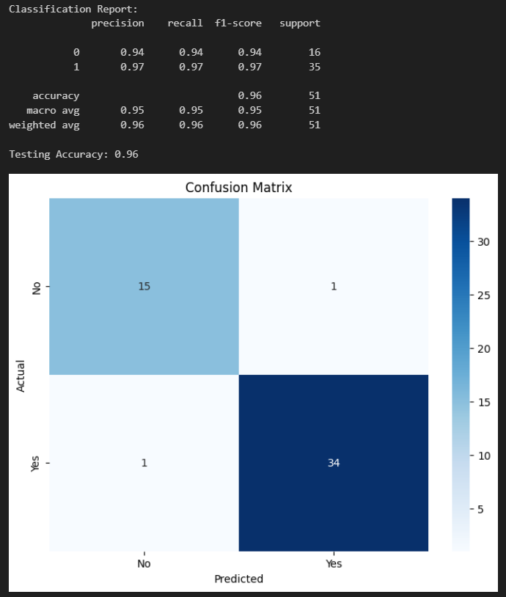

After SMOTE: The performance improved significantly, with the minority class achieving a recall of 0.94 and an F1-score of 0.94, and the overall accuracy increasing to 96%, indicating a better balance in predictions for both classes.

Similarly to what we concluded previously it seems that Random Forest is performing better in taking decisions.

Conclusion: random forest yielded the best results

Testing :

Done on the website using Flask.

Business Recommendations and Decision-Making
Translating Insights:
- The Random Forest model identified key features like Polyuria, Polydipsia, Age, and Sudden Weight Loss as the most important predictors of diabetes risk.
- The imbalance in the target variable suggests that most cases are diabetic, emphasizing the need for tailored preventive measures.
- Recommendations:
  - Symptom-Based Screening:
    - Use key features like Polyuria and Polydipsia to develop targeted screening tools.
    - Implement symptom checklists in healthcare centers to identify high-risk individuals early.
  - Age-Focused Outreach:
    - Prioritize individuals aged 40-60 for awareness campaigns and regular health checkups, as this age group shows the highest concentration of diabetes cases.

