## Assignment 3: AJAX calls and updating front end content with AJAX

**19F-0245**  **Talal Ahmed**  **CS-5A**

**Weather App using AJAX**

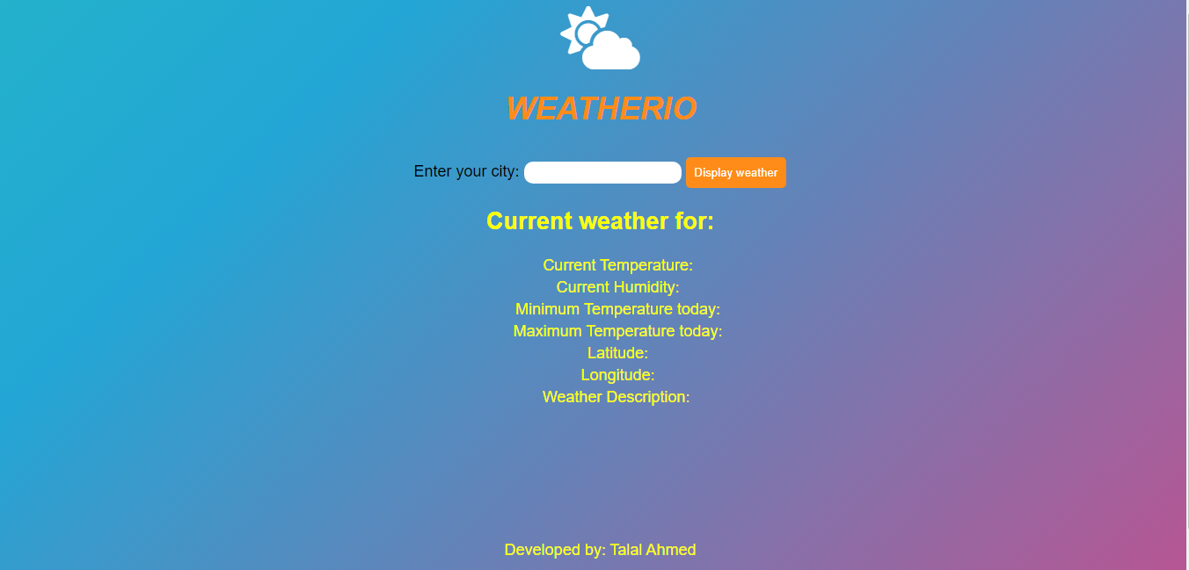

Search for any city in the world. The data is retrieved from openweathermap using AJAX and jqueries and is displayed in real time.

**Searching for a city:**

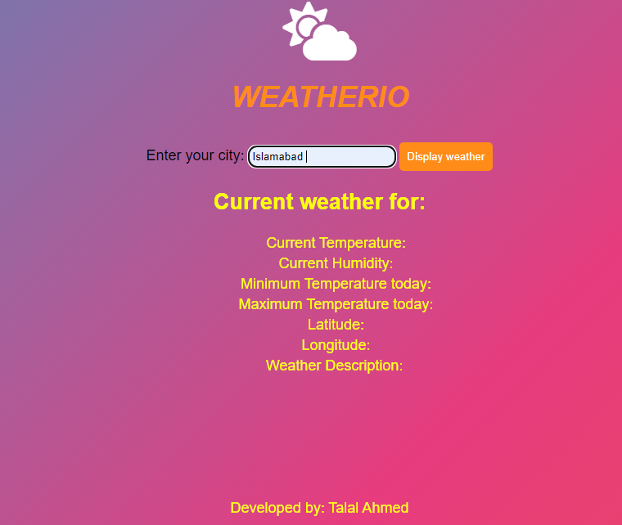

**Weather and other details are displayed after searching:**

