GIT

|  |  |
| --- | --- |
| git init | Initialize local git repository |
| git add <file> | Adds files to indexes |
| git staus | Check status of working tree |
| git add filename.txt |  |
| git push | Push to remote repository |
| git pull | pull latest from remote repository |
| git clone | clone repository into a new directory |
| (download link) | git-scm.com/download/win |
| touch test.docx | creates a new file |
| git config --global user.name ‘rajib’ |  |
| git config --global user.email ‘rajib@rajib.com’ |  |
| git add test.docx |  |
| git add *.docx | will add any docx file to git |
| git add . |  |
| git commit -m 'change1’  git add .  git commit –m ‘change2’ |  |
| git add sample.docx | add file to git |
| git status |  |
| git rm --cached sample.docx | to remove file from git |
|  |  |

|  |  |
| --- | --- |
| creates/initialize a new Git repository | git init |
| inspects the contents of the working directory and staging area | git status |
| adds files from the working directory to the staging area | git add filename.txt |
| adding all file in directory to staging | git add . |
|  | git add scenen-3.txt scene-7.txt |
| shows the difference between the working directory and the staging area | git diff |
|  | git commit –m ‘first change’ |
| commits can be viewed with git log | git log |
|  |  |
|  | git show HEAD |
| will restore the file in your working directory to look exactly as it did when you last made a commit. | git checkout HEAD scene-5.txt |
|  | git reset HEAD filename |
|  | git reset 1234567 |

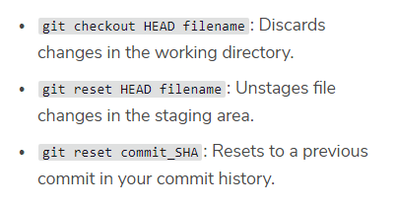

GIT BRANCH

|  |  |
| --- | --- |
| to answer the question: “which branch am I on?” | git branch |
| To create a new branch | git branch new_branch |
| You can switch to the new branch with | git checkout branch_name |
| All the commands you do on master, you can also do on this branch. |  |
| merging the branch into master with | git merge branch_name |
| After the branch has been integrated into master, it has served its purpose and can be deleted. | git branch -d branch_name |

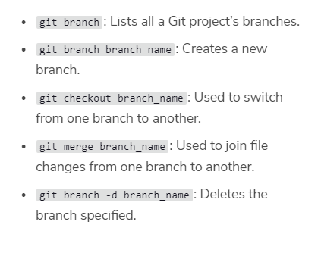

|  |  |
| --- | --- |
| Undo changes not stagged | git checkout -- trial.txt  git checkout trial.txt |
| undo commited changes | git revert 81129e33f7252182e2bb4d08159b57914cf7ecc2 |

From Youtube Git tutorial

|  |  |
| --- | --- |
| to add an already created repository to git hub | git remote add origin https://github.com/psychpixles/practice.git  git push -u origin master |
|  | git remote set-url --add --push origin <https://github.com/psychpixles/test.git> |
| to clone from github website | git clone <https://github>.com/psychpixles/test.git |
|  | <https://stackoverflow.com/questions/14290113/git-pushing-code-to-two-remotes> |
| to show status | git status |
| add a specifc file to staging area | git add test.txt |
| to add all file to staging area | git add . |
| to commit change in local hardware, m means message | git commit –m ‘fist version of hungry code’ |
| to show log of all your commit history | git log |
| to push the code to github website it will ask for password and user id for the first time | git push |
| [NOT WORKING] | git difftool HEAD |
|  |  |
|  |  |

best way is add the repository in git hub

then

git clone url to local computer

Reverting and Resetting Code Changes

|  |  |
| --- | --- |
|  |  |
| first atleast one commit required |  |
| Undo Uncommited changes | git checkout -- readme.txt |
| undo uncommited changes all files | git checkout -- . |
| undo commited changes | git revert 01002a74e977841b11f02e2b56c733f6ae257a13 |
| to quit from the menu | :q |
| dont’t use it .. as i dont understand this | git reset --hard 732c016a91de0d03c0c8b9992aa4be2f94fc8d91 |

Branches In Git

|  |  |
| --- | --- |
| list all the branch | git branch |
| create a new branch named newbranch | git branch newbranch |
| to make a branch active | git checkout newbranch |
| finding problem here_ first checkout to master branch | git merge newbranch |
|  | git merge –abort |
| create a new branch and checkout to it in one command | git checkout -b dummy |
| delete a branch | git branch –d dummy |
|  |  |

head referes to the most recent commit