Step 2: Fancy Command Test Report
fancy-grep.js | IT-207-003 | Fall 2026

1. Fancy Command Specification
Purpose. The fancy-grep.js program combines grep and head. It searches one file for a pattern, prints up to a selected number of matching lines, and reports the total number of matching lines.
Command syntax. node fancy-grep.js <pattern> <number> <file>
Expected behavior. The user provides a search pattern, a nonnegative result limit, and a filename. The program reads the file, finds every line containing the pattern, prints only the requested number of matching lines, and then displays the total number of matches.

Expected edge-case behavior
- No matches: The program prints no matching lines and reports Total matches: 0.
- Limit larger than the result set: The program prints every available match without failing.
- Limit of 0: The program prints no matching lines but still reports the total number of matches.
- Invalid limit or missing input: The program displays its usage message and exits with a nonzero status.

2. Testing
I tested fancy-grep.js by running it against 3 different search patterns and I also ran the entire automated testing suite.
Test | Command | Expected output | Actual output
1 | node fancy-grep.js a 2 sample.txt | apple  banana  Total matches: 4 | apple  banana  Total matches: 4  PASS
2 | node fancy-grep.js ap 5 sample.txt | apple  apricot  Total matches: 2 | apple  apricot  Total matches: 2  PASS
3 | node fancy-grep.js orange 3 sample.txt | Total matches: 0 | Total matches: 0  PASS
Automated result. After performing my manual testing I ran npm test. The results indicated that All tests passed.

Terminal screenshot
Figure 1. Manual Fancy Command tests and the automated test result.
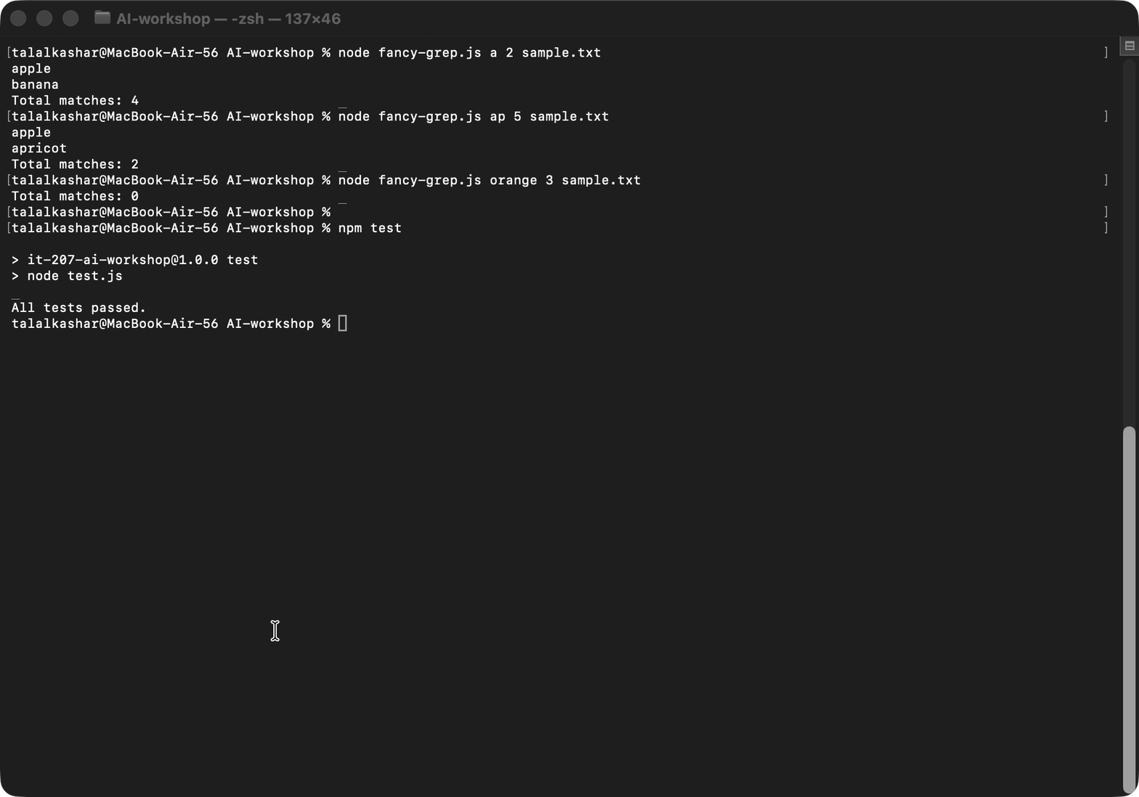

3. Testing Reflection
Through manual testing I found that my Fancy Command worked as expected with a normal limit, a limit greater than the amount of matches, and a matchless pattern. I did not find any functional errors from these tests. These tests did reveal that I should have tested more boundaries than just what is considered normal input. Following testing, I created additional automated test cases for a limit of 0 and for a nonnumeric limit. A limit of zero confirmed the program prints no matching lines yet reports the correct number of matches. The nonnumeric test case confirmed the program prints the usage message and exits with a code other than zero.
I used AI to help me recognize scenarios involving no matches, fewer matches than expected, an empty file, a limit of 0, and invalid input. I then manually ran the scenarios, compared the expected output with the actual output, and created additional automated tests based on the outcomes.

Changes made after testing
- Added an automated test for a result limit of 0.
- Added an automated test for a nonnumeric limit and the expected usage error.
- Documented the normal behavior and edge cases in the project README.

AI assistance
AI assisted me in learning the original Linux commands, planning the Fancy Command, suggesting testing options, and identifying potential edge cases. To verify that the suggested ideas were valid, I ran the Linux commands, reviewed my Node.js code, manually checked the output from each command, and tested the programs using automated tests.

Project link
https://github.com/talalkashar/AI-workshop

