TILE CATALOG
Premium Porcelain - Discounted Stock

April 2026 Edition

77 SKUs - All prices in Qatari Riyal (QAR)
Price formula: Discounted unit x 1.20 shipping x 1.40 margin
Sources: PI No. Q16885 + Q-16870 - Generated 24 April 2026

Catalog Overview
This catalog lists 77 SKUs across 34 series, totaling 147,305.55 square meters of available inventory with an aggregate stock value of QAR 7,243,811. The average selling price is QAR 47.53 per m2.

Stock by Series
Series | SKUs | Qty (m2) | Avg Price (QAR) | Stock Value (QAR)
ISMR | 3 | 18,144.00 | 62.16 | 1,127,831
ISBR | 2 | 11,917.44 | 62.16 | 740,788
CTSE | 4 | 12,960.00 | 45.91 | 574,112
TVCR | 3 | 9,230.40 | 55.94 | 565,275
BLIC | 11 | 9,813.96 | 56.48 | 555,689
MBLT | 2 | 8,014.86 | 55.77 | 490,446
ICMR | 6 | 9,251.82 | 49.39 | 456,947
STVO | 4 | 6,245.10 | 49.39 | 308,445
ZCRR | 1 | 4,694.40 | 62.16 | 291,804
CARA | 3 | 5,205.06 | 49.39 | 257,078
CTVP | 3 | 3,680.64 | 62.16 | 228,789
1400 | 1 | 9,901.80 | 21.84 | 216,255
RLMB | 3 | 4,857.28 | 34.61 | 174,447
800 | 2 | 8,090.00 | 18.48 | 149,503
CTAG | 1 | 2,064.96 | 62.16 | 128,358
AMMB | 2 | 2,103.68 | 51.24 | 123,944
CYTR | 1 | 1,785.24 | 68.88 | 122,967
VSMB | 1 | 1,840.32 | 62.16 | 114,394
RPCT | 1 | 1,581.12 | 49.39 | 78,092
PNTO | 2 | 1,563.30 | 49.39 | 77,211
ZFUM | 1 | 3,504.60 | 21.84 | 76,540
CPPD | 1 | 725.76 | 68.88 | 49,990
LGBC | 2 | 1,226.88 | 36.96 | 45,345
VSME | 2 | 993.60 | 43.51 | 43,232
VYST | 2 | 937.44 | 43.51 | 40,788
OPFC | 1 | 720.90 | 49.39 | 35,605
700 | 1 | 1,444.55 | 21.84 | 31,549
FCOT | 1 | 1,275.34 | 21.84 | 27,853
7001 | 2 | 1,062.22 | 21.84 | 23,199
FLOC | 1 | 665.28 | 31.75 | 21,123
SRSE | 4 | 557.28 | 36.96 | 20,597
LTYC | 1 | 546.48 | 31.75 | 17,351
PSVE | 1 | 365.76 | 43.51 | 15,914
RTTD | 1 | 334.08 | 36.96 | 12,348

Product Catalog
All 77 SKUs with photos. Prices in Qatari Riyal (QAR).

Photo | Product | Specifications | Stock | Price (QAR)
WHITE | A14R1400-WH0.M0R  14-14000 WHITE-RT | Size: 30.00 X 60.00 CM  Series: 1400  Color: WHITE | 9,901.80  m2 | 21.84  per m2
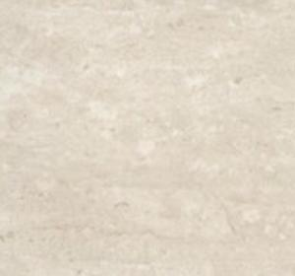 | A07R700-WH0.M0U  07-700 WHITE-UR | Size: 41.60 X 41.60 CM  Series: 700  Color: WHITE | 1,444.55  m2 | 21.84  per m2
 | A07R7001-LBE.G0U  07-7001 LIGHT BEIGE-UR | Size: 41.60 X 41.60 CM  Series: 7001  Color: LIGHT BEIGE | 688.54  m2 | 21.84  per m2
 | A07R7001-LBE.G0U  07-7001 LIGHT BEIGE-UR | Size: 41.60 X 41.60 CM  Series: 7001  Color: LIGHT BEIGE | 373.68  m2 | 21.84  per m2
WHITE | A20R800-WH0.G0U  20-800 WHITE-UR | Size: 20.00 X 20.00 CM  Series: 800  Color: WHITE | 4,621.00  m2 | 18.48  per m2
WHITE | A20R800-WH0.G0U  20-800 WHITE-UR | Size: 20.00 X 20.00 CM  Series: 800  Color: WHITE | 3,469.00  m2 | 18.48  per m2
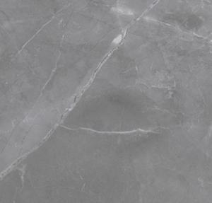 | A05GAMMB-LIG.N0X0P  05-AMANI MARBLE LIGHT GREY-NPL | Size: 80.00 X 80.00 CM  Series: AMMB  Color: LIGHT GREY | 312.32  m2 | 40.32  per m2
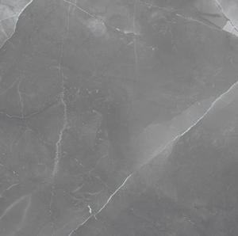 | A22GAMMB-LIG.N0X5P  22-AMANI MARBLE LIGHT GRAY-PL-TH: 9 | Size: 120.00 X 120.00 CM  Series: AMMB  Color: LIGHT GREY | 1,791.36  m2 | 62.16  per m2
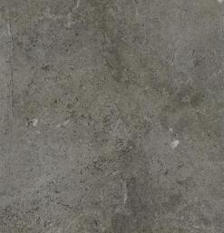 | A93GBLIC-GRY.A6X5R  93-BALTICO GRAY LS R10-RT-TH:9MM | Size: 90.00 X 180.00 CM  Series: BLIC  Color: GRAY | 443.88  m2 | 49.39  per m2
 | A93GBLIC-GRY.A6X5R  93-BALTICO GRAY LS R10-RT-TH:9MM | Size: 90.00 X 180.00 CM  Series: BLIC  Color: GRAY | 518.40  m2 | 49.39  per m2
 | A93GBLIC-GRY.A6X5R  93-BALTICO GRAY LS R10-RT-TH:9MM | Size: 90.00 X 180.00 CM  Series: BLIC  Color: GRAY | 2,120.58  m2 | 49.39  per m2
 | A93GBLIC-GRY.A6X5R  93-BALTICO GRAY LS R10-RT-TH:9MM | Size: 90.00 X 180.00 CM  Series: BLIC  Color: GRAY | 775.98  m2 | 49.39  per m2
 | A93GBLIC-GRY.A6X5R  93-BALTICO GRAY LS R10-RT-TH:9MM | Size: 90.00 X 180.00 CM  Series: BLIC  Color: GRAY | 1,380.24  m2 | 49.39  per m2
 | A93GBLIC-GRY.A6X5R  93-BALTICO GRAY LS R10-RT-TH:9MM | Size: 90.00 X 180.00 CM  Series: BLIC  Color: GRAY | 280.26  m2 | 49.39  per m2
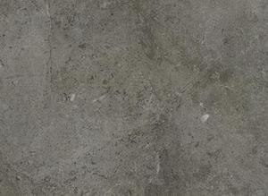 | A93GBLIC-GRY.A6X5R  93-BALTICO GRAY LS R10-RT-TH:9MM | Size: 90.00 X 180.00 CM  Series: BLIC  Color: GRAY | 670.68  m2 | 68.88  per m2
 | A93GBLIC-GRY.A6X5R  93-BALTICO GRAY LS R10-RT-TH:9MM | Size: 90.00 X 180.00 CM  Series: BLIC  Color: GRAY | 670.68  m2 | 68.88  per m2
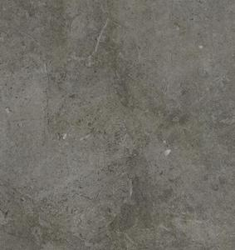 | A93GBLIC-GRY.A6X5R  93-BALTICO GRAY LS R10-RT-TH:9MM | Size: 90.00 X 180.00 CM  Series: BLIC  Color: GRAY | 1,185.84  m2 | 68.88  per m2
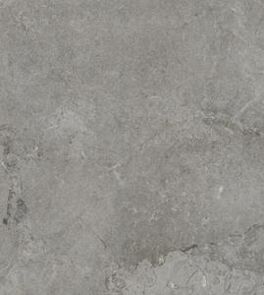 | A93GBLIC-LIG.A6X5R  93-BALTICO LIGHT GREY LS R10-RT:9MM | Size: 90.00 X 180.00 CM  Series: BLIC  Color: LIGHT GREY | 1,114.56  m2 | 68.88  per m2
 | A93GBLIC-GRY.A6X5R  TFG 93·BALTICO GRAY LS R10-RT-TH:9MM | Size: 90.00 X 180.00 CM  Series: BLIC  Color: GRAY | 652.86  m2 | 49.39  per m2
 | A93GCARA-GRY.M0X5R  93-CARARA GRAY-RT-TH :9MM | Size: 90.00 X 180.00 CM  Series: CARA  Color: GRAY | 2,151.36  m2 | 49.39  per m2
 | A93GCARA-GRY.M0X5R  93-CARARA GRAY-RT-TH:9MM | Size: 90.00 X 180.00 CM  Series: CARA  Color: GRAY | 526.50  m2 | 49.39  per m2
 | A93GCARA-GRY.M0X5R  93-CARARA GRAY·RT-TH:9MM | Size: 90.00 X 180.00 CM  Series: CARA  Color: GRAY | 2,527.20  m2 | 49.39  per m2
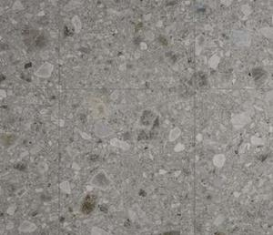 | A93GCPPD-GRG.M0X5R  93-CEPPO D ISEO GREIGE-RT 9MM | Size: 90.00 X 180.00 CM  Series: CPPD  Color: GREIGE | 725.76  m2 | 68.88  per m2
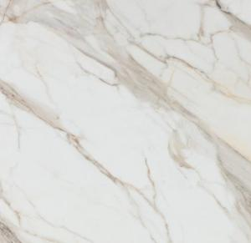 | A22GCTAG-WHE.N0X5P  22-CALACATTA GOLD WHITE-PL | Size: 120.00 X 120.00 CM  Series: CTAG  Color: WHITE | 2,064.96  m2 | 62.16  per m2
 | AGB12CTSEGRYZMLS5R  12-CITY STONE GRAY-L.S-RT:9MM | Size: 90.00 X 180.00 CM  Series: CTSE  Color: GRAY | 1,044.00  m2 | 49.39  per m2
 | AGB12CTSEGRYZMLS5R  12-CITY STONE GRAY-L.S-RT:9MM | Size: 60.00 X 120.00 CM  Series: CTSE  Color: GRAY | 436.32  m2 | 45.36  per m2
 | AGB12CTSEGRYZMLS5R  12-CITY STONE GRAY-L.S-RT:9MM | Size: 60.00 X 120.00 CM  Series: CTSE  Color: GRAY | 1,771.20  m2 | 45.36  per m2
 | A22GCTSE-BNE.M6X5R  22-CITY STONE BONE-MAT-LS-RT:9MM | Size: 120.00 X 120.00 CM  Series: CTSE  Color: BONE | 9,708.48  m2 | 43.51  per m2
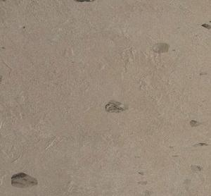 | A22GCTVP-BEE.MDX5R  22-CREATIVE CONCRETE P BEIGE-RT:9MM | Size: 120.00 X 120.00 CM  Series: CTVP  Color: BEIGE | 1,186.56  m2 | 62.16  per m2
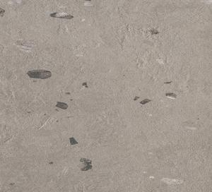 | A22GCTVP-DKG.MDX5R  22-CREATIVE CONCRTE P DRK-GRY-RT:9MM | Size: 120.00 X 120.00 CM  Series: CTVP  Color: DARK GREY | 1,324.80  m2 | 62.16  per m2
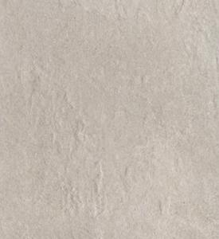 | A22GCTVP-GRY.M0X5R  22-CTVP GRY-RT-TH: 9MM | Size: 120.00 X 120.00 CM  Series: CTVP  Color: GRAY | 1,169.28  m2 | 62.16  per m2
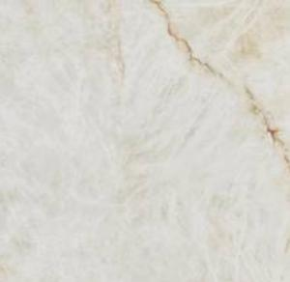 | A93GCYTR-WHE.M0X5R  93-CRYSTAL WHITE WHE-MATT-RT-TH:9MM | Size: 90.00 X 180.00 CM  Series: CYTR  Color: WHITE | 1,785.24  m2 | 68.88  per m2
 | A07RFCOT-IVO.M0X1U  07-FACTO CONCRETE IVORY-UR:13MM | Size: 41.60 X 41.60 CM  Series: FCOT  Color: IVORY | 1,275.34  m2 | 21.84  per m2
GRAY | A12GFLOC-GRY.M0X5R  12-FOLSOM CONCRETE GRAY-RT | Size: 60.00 X 120.00 CM  Series: FLOC  Color: GRAY | 665.28  m2 | 31.75  per m2
 | A93GBLIC-GRY.A6X5R  93-BALTICO GRAY LS R10-RT-TH:9MM | Size: 90.00 X 180.00 CM  Series: ICMR  Color: GRAY | 709.56  m2 | 49.39  per m2
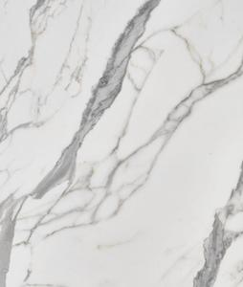 | A93GICMR-WHE.M0X5R  93-ICELAND WHITE WHITE MATI-RT:9MM | Size: 90.00 X 180.00 CM  Series: ICMR  Color: WHITE | 1,031.94  m2 | 49.39  per m2
 | A93GICMR-WHE.M0X5R  93-ICELAND WHITE WHITE MATT-RT:9MM | Size: 90.00 X 180.00 CM  Series: ICMR  Color: WHITE | 2,995.38  m2 | 49.39  per m2
 | A93GICMR-WHE.M0X5R  93-ICELAND WHITE WHITE MATT-RT:9MM | Size: 90.00 X 180.00 CM  Series: ICMR  Color: WHITE | 1,031.94  m2 | 49.39  per m2
 | A93GICMR-WHE.M0X5R  93-ICELAND WHITE WHITE MATT-RT:9MM | Size: 90.00 X 180.00 CM  Series: ICMR  Color: WHITE | 487.62  m2 | 49.39  per m2
 | A93GICMR -WHE.M0X5R  93-ICELAND WHITE WHITE MATT-RT:9MM | Size: 90.00 X 180.00 CM  Series: ICMR  Color: WHITE | 2,995.38  m2 | 49.39  per m2
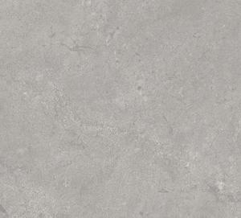 | A22GISBR-LIG.A6X5R  22-I SASSI BORGOGNA LIG-R10-LS-RT:9 | Size: 120.00 X 120.00 CM  Series: ISBR  Color: LIGHT GREY | 5,869.44  m2 | 62.16  per m2
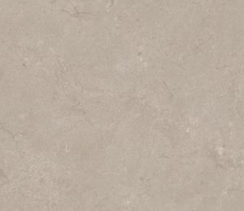 | A22GISBR-SND.A6X5R  22-I SASSI BORGOGNA SND-R10-LS-RT:9 | Size: 120.00 X 120.00 CM  Series: ISBR  Color: SAND | 6,048.00  m2 | 62.16  per m2
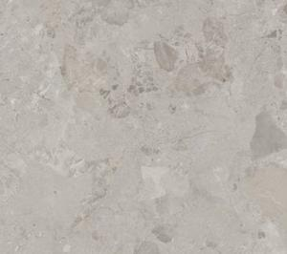 | A22GISMR-DIR.A6X5R  22-I SASSI MATERA DIR-R10-LS-RT:9MM | Size: 120.00 X 120.00 CM  Series: ISMR  Color: DARK IVORY | 6,048.00  m2 | 62.16  per m2
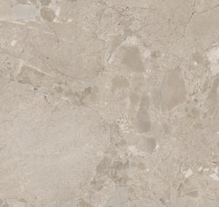 | A22GISMR-DRS.A6X5R  22-I SASSI MATERA DRS-R10-LS-RT:9MM | Size: 120.00 X 120.00 CM  Series: ISMR  Color: DARK SAND | 6,048.00  m2 | 62.16  per m2
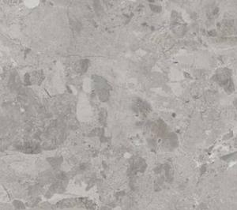 | A22GISMR-GRY.A6X5R  22-I SASSI MATERA GRY-R10-LS-RT:9MM | Size: 120.00 X 120.00 CM  Series: ISMR  Color: GRAY | 6,048.00  m2 | 62.16  per m2
IVORY | A06GLGBC-IVO.M0X0R  06-LONG BAY CEMENT IVORY-RT | Size: 60.00 X 60.00 CM  Series: LGBC  Color: IVORY | 339.84  m2 | 36.96  per m2
IVORY | A06GLGBC-IVO.M0X0R  06-LONG BAY CEMENT IVORY-RT | Size: 60.00 X 60.00 CM  Series: LGBC  Color: IVORY | 887.04  m2 | 36.96  per m2
WHITE | A 12GLTYC-WHE.M0X5R  12-LAFAYETIE CONCRETE WHITE-RT | Size: 60.00 X 120.00 CM  Series: LTYC  Color: WHITE | 546.48  m2 | 31.75  per m2
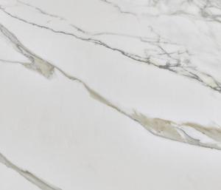 | A22GMBLT-WHE.N0X5P  22-MARBLE TREVISO WHITE-NPL-TH:9MM | Size: 120.00 X 120.00 CM  Series: MBLT  Color: WHITE | 7,407.36  m2 | 62.16  per m2
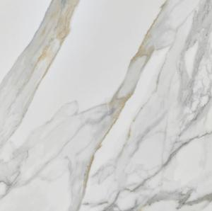 | A93GMBLT-WHE.N0X5P  93-MARBLE TREV ISO WHITE-HPL-TH:9MM | Size: 90.00 X 180.00 CM  Series: MBLT  Color: WHITE | 607.50  m2 | 49.39  per m2
 | A93GOPFC-WHE.A6X5R  93-0PIFICIO WHITE LS R10-RT-TH:9MM | Size: 90.00 X 180.00 CM  Series: OPFC  Color: WHITE | 720.90  m2 | 49.39  per m2
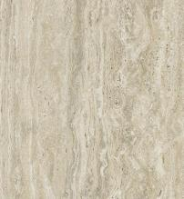 | A93GPNTO-BEE.N0X5P  93-PONTINO BEIGE-NPL-TH:9MM | Size: 90.00 X 180.00 CM  Series: PNTO  Color: BEIGE | 745.20  m2 | 49.39  per m2
 | A93GPNTO-BEE.N0X5P  93-PONTINO BEIGE-NPL-TH:9MM | Size: 90.00 X 180.00 CM  Series: PNTO  Color: BEIGE | 818.10  m2 | 49.39  per m2
 | A22GPSCR-WHE.A0X5R  22 PORTLAND 1 STONE VEIN WHE-R10-RT:9 | Size: 120.00 X 120.00 CM  Series: PSVE  Color: WHITE | 365.76  m2 | 43.51  per m2
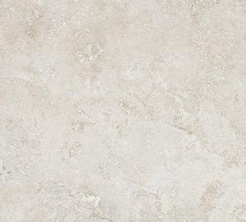 | A05GRLMB-LBE.A0X0R  05-RAPOLANO MARBLE LIGHT BEIGE R10-R | Size: 80.00 X 80.00 CM  Series: RLMB  Color: LIGHT BEIGE | 2,360.32  m2 | 40.32  per m2
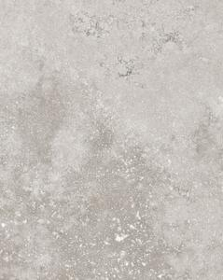 | A 12GRLMB-GRY.M0X5R  12-RAPOLANO MARBLE GRAY-RT | Size: 60.00 X 120.00 CM  Series: RLMB  Color: GRAY | 1,248.48  m2 | 31.75  per m2
 | A 12GRLMB-GRY.M0X5R  12-RAPOLANO MARBLE GRAY-RT | Size: 60.00 X 120.00 CM  Series: RLMB  Color: GRAY | 1,248.48  m2 | 31.75  per m2
 | A22GRPCT-WHE.M0X5R  22-RAPOLANO CROSSCUT WHITE-RT-TH: 9 | Size: 120.00 X 120.00 CM  Series: RPCT  Color: WHITE | 1,581.12  m2 | 49.39  per m2
LIGHT BEIGE | A06GRTTD-LBE.A6X0R  06-ROTTERDAM CONCRETE LBE-LS R10 RT | Size: 60.00 X 60.00 CM  Series: RTTD  Color: LIGHT BEIGE | 334.08  m2 | 36.96  per m2
WHITE | A06GSRSE-WHE.A6X0R  06-SILVER STONE WHITE -R10 LS-RT | Size: 60.00 X 60.00 CM  Series: SRSE  Color: WHITE | 110.88  m2 | 36.96  per m2
WHITE | A06GSRSE-WHE.A6X0R  06-SILVER STONE WHITE -R10 LS-RT | Size: 60.00 X 60.00 CM  Series: SRSE  Color: WHITE | 115.20  m2 | 36.96  per m2
WHITE | A06GSRSE-WHE.A6X0R  06-SILVER STONE WHITE -R10 LS-RT | Size: 60.00 X 60.00 CM  Series: SRSE  Color: WHITE | 141.12  m2 | 36.96  per m2
WHITE | A06GSRSE-WHE.A6X0R  06-SILVER STONE WHITE -R10 LS-RT | Size: 60.00 X 60.00 CM  Series: SRSE  Color: WHITE | 190.08  m2 | 36.96  per m2
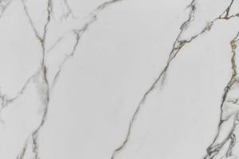 | A93GSTVO-WHE.N0X5P  93-STATUARIO VITRUVIO WHITE-NPL:9MM | Size: 90.00 X 180.00 CM  Series: STVO  Color: WHITE | 1,261.98  m2 | 49.39  per m2
 | A93GSTVO-WHE.N0X5P  93-STATUARIO VITRUVIO WHITE-NPL:9MM | Size: 90.00 X 180.00 CM  Series: STVO  Color: WHITE | 2,891.70  m2 | 49.39  per m2
 | A93GSTVO-WHE.N0X5P  93-STATUARIO VITRUVIO WHITE-NPL:9MM | Size: 90.00 X 180.00 CM  Series: STVO  Color: WHITE | 967.14  m2 | 49.39  per m2
 | A93GSTVO-WHE.N0X5P  93-STATUARIO VITRUVIO WHITE·NPL:9MM | Size: 90.00 X 180.00 CM  Series: STVO  Color: WHITE | 1,124.28  m2 | 49.39  per m2
 | A22GTVCR-GRY.M0X5R  22-TRAVERTINE CROSS CUT GRAY-RT | Size: 120.00 X 120.00 CM  Series: TVCR  Color: GRAY | 455.04  m2 | 43.51  per m2
 | A22GTVCR-IVO.M0X5R  22-TVCR IVO-RT-TH: 9MM | Size: 120.00 X 120.00 CM  Series: TVCR  Color: IVORY | 4,775.04  m2 | 62.16  per m2
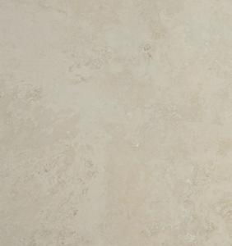 | A22GTVCR-IVO.M0X5R  22-TVCR IVO-RT-TH: 9MM | Size: 120.00 X 120.00 CM  Series: TVCR  Color: IVORY | 4,000.32  m2 | 62.16  per m2
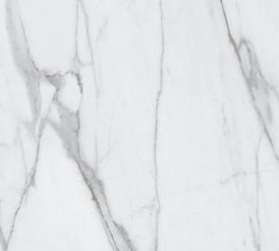 | A22GVSMB-WHE.N0X5P  22-VERSILIA MARBLE WHITE-PL | Size: 120.00 X 120.00 CM  Series: VSMB  Color: WHITE | 1,840.32  m2 | 62.16  per m2
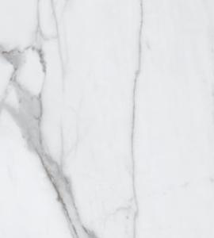 | A22GVSME-WHE.M0X5R  22-VERSILIA MARBLE WHITE-RT:9MM | Size: 120.00 X 120.00 CM  Series: VSME  Color: WHITE | 754.56  m2 | 43.51  per m2
 | A22GVSME-WHE.M0X5R  22-VERSILIA MARBLE WHITE-RT:9MM | Size: 120.00 X 120.00 CM  Series: VSME  Color: WHITE | 239.04  m2 | 43.51  per m2
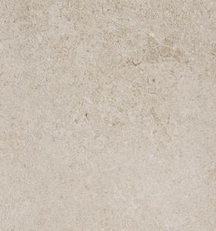 | A2B 12VYSTBEEMMLS5R  12-VALLEY STONE BEIGE-L.S-9MM-RT | Size: 60.00 X 120.00 CM  Series: VYST  Color: BEIGE | 352.80  m2 | 43.51  per m2
 | A2B12VYSTBEEMMLS5R  12-VALLEY STONE BEIGE-L.S-9MM-RT | Size: 60.00 X 120.00 CM  Series: VYST  Color: BEIGE | 584.64  m2 | 43.51  per m2
 | A22GZCRR-HWH.M0X5R  22-CARARA HYPER WHITE-MATT-RT:TH9MM | Size: 120.00 X 120.00 CM  Series: ZCRR  Color: HYPER WHITE | 4,694.40  m2 | 62.16  per m2
 | A14RZFUM-WH0.H0R  14-FUME WHITE-RT | Size: 30.00 X 60.00 CM  Series: ZFUM  Color: WHITE | 3,504.60  m2 | 21.84  per m2
TOTAL - 77 SKUs |  |  | 147,305.55 m2 | 7,243,811

