AI-Powered Network Intrusion Detection & Alert Dashboard with AI Model Comparison
A project submitted
in partial fulfillment of the requirements for the degree of
Master of Science in Cybersecurity

by
Cole M. Talarek (0871430)
Brian A. Styrcula (0989112)
Frank H. Belbusti (0886622)


School of Computer Science and Engineering
Sacred Heart University

Supervised by
Professor Sajal Bhatia

June 2026

Table of Contents
Abstract 3
Terms Used Table 4
Introduction to IDS and Project Objectives 5
Data Set Selection, Model Types, and Attack Severity Classification 6
Model Results, Challenges, and Shortcomings 7
Conclusions 8
References 9
Source Code 10

ABSTRACT
This capstone project presents the design and implementation of an AI-Powered Network Intrusion Detection and Alert Dashboard capable of identifying malicious network activity and visualizing threats in real time. The system combines supervised machine learning techniques with live network traffic monitoring to detect five network traffic categories: Benign traffic, DDoS attacks, Port Scanning, Brute Force attacks, and Web-based Attacks. Using the CICIDS2017 dataset, multiple machine learning models were evaluated, including Logistic Regression, Random Forest, and XGBoost. Random Forest was selected as the deployment model for the project due to its near-perfect performance, ease of integration, and lower implementation complexity. The detection engine was integrated with a Streamlit-based dashboard that provides real-time alerts, visual analytics, geolocation mapping, and threat summaries in an exportable report for ease of readability for upper management’s stakeholders. A controlled virtual lab environment using Kali Linux as the attacking host, DVWA as the vulnerable target host, and Scapy to listen to the network traffic between them were developed to demonstrate live attack detection. Results showed detection accuracy exceeding 99.98% while successfully identifying and visualizing real-world attack scenarios. The project demonstrates how artificial intelligence can enhance cybersecurity monitoring, improve incident response, and provide analysts with actionable threat intelligence in real time. This is especially relevant in today’s ever-evolving cybersecurity landscape for small businesses which often lack adequate defenses for their equipment. The project would be an ideal first line detection method for them and was developed with them in mind.

List of Terms
Table 1: Terms Used

Terms | Definition
IDS | Intrusion Detection System
Accuracy Score | The proportion of all classifications that were correct, whether positive or negative.
Precision Score | The proportion of all the model's positive classifications that are actually positive.
Recall Score | The proportion of all actual positives that were classified correctly as positives
F1 Score | Harmonic mean of precision and recall used to evaluate model performance
- Introduction to IDS and Project Objectives
Modern organizations face increasingly sophisticated cyber threats that frequently bypass traditional signature-based security controls. Intrusion Detection Systems (IDS) have historically relied on predefined rules and attack signatures, making them less effective against emerging or previously unseen threats. This project addresses these limitations through the development of an AI-powered network intrusion detection platform capable of identifying malicious activity using machine learning and presenting results through an interactive visualization dashboard.
The primary objectives of the project were to develop a machine learning-based detection engine, create a real-time network monitoring pipeline, build an analyst-friendly dashboard, build a basic export ready reporting module for detected attacks, and evaluate detection performance using industry-standard metrics. The complete system classifies network traffic into five categories: Benign traffic, DDoS attacks, Port Scanning, Brute Force attacks, and Web-based Attacks. The project combines predictive analytics with real-time situational awareness to improve cybersecurity monitoring and response capabilities.
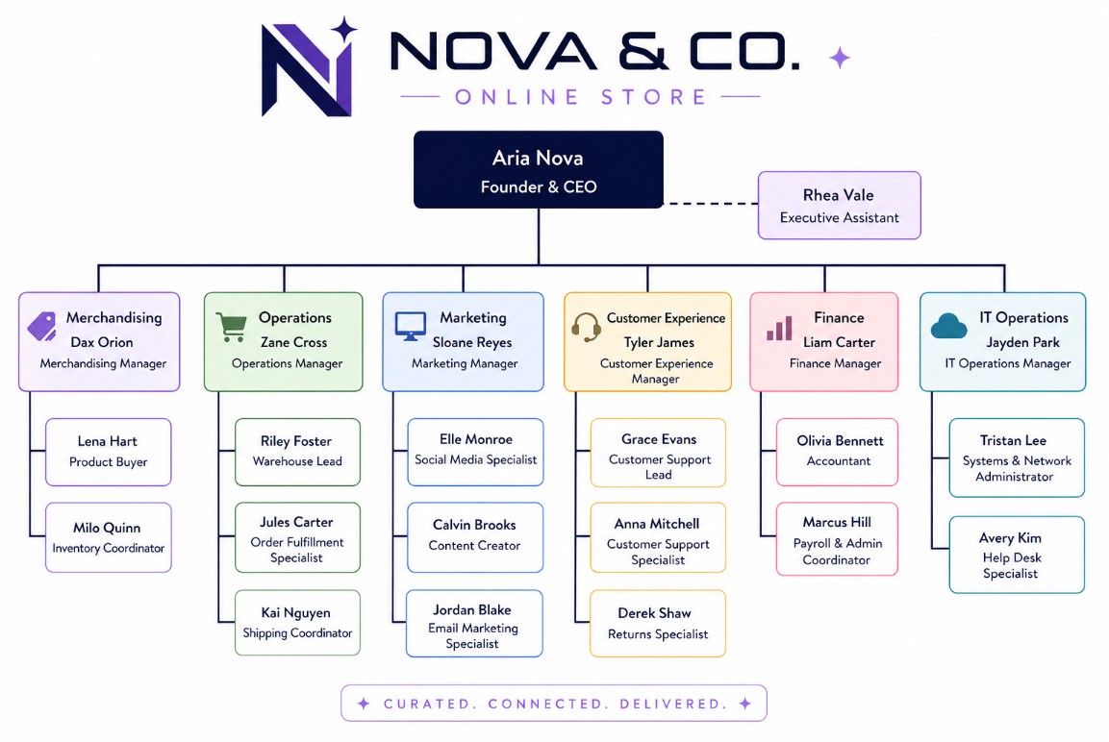
The project was designed with the plan that it would be able to be implemented and rolled out on relatively inexpensive hardware in a small business setting. Our problem ultimately boils down to, can this AI powered IDS function reliably and stably for a small business without significant monetary investment. Readability, low computer hardware requirements, and the ability to export information for managerial review were paramount. The dashboard itself uses simple graphs and logical layouts to allow even a novice analyst to understand the source of the attack, what type, and how severe it is without a significant and immediate deep dive. The initial project concept was built around a fictitious company named Nova & Co which would be the foundation of our core tenets as we designed the project and made decisions around initial attack severity classification.

- Data Set Selection, Model Types, and Attack Severity Classification
The CICIDS2017 dataset was selected because it is one of the most widely used benchmark datasets for intrusion detection research. The dataset contains realistic network traffic flows labeled as either benign or malicious activity. Each flow includes numerous numerical features describing connection behavior, packet counts, durations, throughput, and protocol characteristics. (REF) This dataset allows for ease of comparison against any similar models that may be on the market at present and allows for the model chosen to be based on a known quantity within the cybersecurity space. With consideration to standardization of our data and replication of our results under similar circumstances, CICIDS2017 was the best option for us. The ability for our fictitious company to iterate on this project so that it can continue to function as the landscape evolves was also a major consideration. Without a solid foundation for further development of the model with new attack type data, the project’s long-term stability becomes a significantly detrimental factor.
Three supervised learning models were evaluated:
• Logistic Regression – baseline classification model with low computational overhead. “…it predicts the probability that an input belongs to a specific class.” (REF)
• Random Forest – ensemble model using multiple decision trees for robust classification. “Ensemble learning methods are made up of a set of classifiers—e.g. decision trees—and their predictions are aggregated to identify the most popular result.” (REF)
• XGBoost – gradient boosting model optimized for high predictive accuracy. “The task of training the model amounts to finding the best parameters that best fit the training data (x) and labels (y).” (REF)
These models were selected to be trialed due to their differing requirements and potential in evaluating the data set. Logistic regression’s low computational requirements were its most prominent feature and a compounding factor in its selection when considering the specific business application we were aiming for. Random Forest was chosen due to its robust nature which would fit the need for a model that maintains longevity and quality without compromising stability. XGBoost was trialed due to its high accuracy and potential for a stronger model at the cost of higher computational requirements. Each model brings a unique way of classifying the data set such that the final application’s requirements and long term stability might be impacted which is ideal in this comparative analysis.
We settled on the following classifications for the attack types used in the CICIDS2017 dataset as listed in the following paragraphs. DoD/DDoS are classified as “Critical.” DDoS attacks prevent the company from making money, disrupt productivity, and creates a negative customer experience, which leads to loss of repeat business or word of mouth referrals. A small business is highly dependent on uptime for revenue and customer trust. As described in Fortinet’s DDoS overview (Fortinet), these attacks overwhelm servers or networks, making services unavailable. The data set includes DoS attack types across four different DoS based tools (slowloris, Slowhttptest, Hulk, and GoldenEye), which are instrumental in differentiating the spectrum of what DoS attacks can present as. For a small business, even short outages can directly halt sales, disrupt operations, and damage reputation. Unlike larger enterprises, small businesses often lack redundancy or mitigation infrastructure due to limited budgets, which justifies a critical classification.
Brute Force are classified as “Medium/High.” Repeat Offensive Operations may warrant higher alerts, the criteria of which depends on type, longevity, repeat sources (IPs, MACs, etc.) or repeat attack targets (same account, same username across systems, etc.). Brute force attacks involve repeated login attempts to gain unauthorized access. While a single attempt may not succeed, Fortinet’s definition criteria explain that persistence and automation increase the effectiveness of this type of attack over time. Fortinet’s emphasis on repeat behavior and targeting patterns aligns with real-world risks that small businesses face every day. (Fortinet) For small businesses, such as ours, that typically have fewer authentication safeguards (e.g., no MFA, poor password policies, etc.), escalation to High is justified when patterns indicate persistence or targeting of critical accounts, similar to a spearfishing scenario.
Port Scanning is classified as Low. Port scanning is a reconnaissance stage attack, and can be more easily remedied by firewall rules, and monitored for potential repeat offenders. Ease of prevention and no immediate loss of productivity or system compromise set the attack type classification for this attack type to low. Port scanning is identified by Fortinet as a reconnaissance technique, used to discover open ports and vulnerabilities rather than directly exploit them. Since it does not immediately impact systems or productivity, and can often be mitigated with basic firewall rules, the risk is indirect. (Fortinet) For a small business, this makes it appropriate to classify this attack type as low, while still monitoring for repeated scans that could precede more serious attacks on critical infrastructure.
Web Attacks are classified as “High/Critical.” Web attacks that can compromise multiple customers at once by injecting them with malicious outside code immediately presents multiple surfaces by which the company’s bottom line and reputation can be damaged. These types of attacks, even if limited to local XSS attacks, should be immediately identified and remedied. Web attacks such as Cross-Site Scripting (XSS) and Remote Code Execution (RCE) directly exploit application vulnerabilities: XSS attacks can inject malicious scripts which affect multiple users while RCE can allow full system compromise. These attacks scale quickly and can impact many customers simultaneously by stealing data, damaging trust, or enabling deeper breaches. For a small business, where web applications often drive revenue and customer interaction, this creates both financial and reputational risk.
- Model Results, Challenges, and Shortcomings
Model evaluation was performed using Accuracy, Precision, Recall, and F1 Score. The data was split 80% for training (teaching the model) and 20% for testing (checking it on traffic it had never seen). Results demonstrated that all three models achieved exceptionally high classification performance. Logistic Regression achieved 99.3283% accuracy and a 99.2379% F1 score. Random Forest achieved 99.9856% accuracy and F1 score, while XGBoost achieved the highest overall accuracy at 99.9946% and an F1 score of 99.9945%. Although XGBoost produced the best numerical results, the performance advantage over Random Forest was only 0.009%, making the difference negligible for practical deployment.

Random Forest | 99.99% | 99.99% | 99.99% | 99.99%
Logistic Regression | 99.33% | 99.28% | 99.33% | 99.24%
XGBoost | 99.99% | 99.99% | 99.99% | 99.99%

As a result, Random Forest was selected as the production model because it offered near-identical performance to XGBoost while remaining easier to deploy, explain, maintain, and integrate into the existing pipeline of the application as we developed it. The secondary goal of selecting a model that maintained small business as the primary end-user and servicer was also met. The Random Forest model’s qualities present the best compromise between F1 score and practicality.
Project challenges included
NEED MORE HERE
Additionally, while benchmark performance was extremely high for all models, future work should include testing against more diverse and evolving real-world traffic. The model and dashboard are only as good as the data that is fed into them as a foundation. Consideration for attack types not present in the CICIDS2017 dataset is a potentially limiting factor in how the current iteration of the model performs. As a result, the current model may not be able to detect certain intrusion types into the network it is currently monitoring. This is a limitation of any IDS though. It must be regularly updated, or the model itself must be able to differentiate and identify new emerging anomalous traffic patterns.
- Conclusions
This capstone project successfully demonstrated the integration of artificial intelligence, machine learning, and cybersecurity visualization into a unified intrusion detection platform. The system achieved near-perfect classification performance on the CICIDS2017 dataset while simultaneously supporting live attack monitoring and visualization. Through comparative analysis, Random Forest was selected as the deployment model due to its combination of accuracy, simplicity, and explainability. In its current form, the application would be an ideal compromise between affordability, dependability, and ease of deployment for a small business. The low computational requirements for this application to run allow for flexibility in how it’s deployed. A small business could use spare laptops or a dedicated virtual machine depending on how complex their environment is to deploy the application at various endpoints.
The completed solution provides security analysts with real-time visibility into network threats and supports rapid incident identification through automated classification and visual analytics. Future enhancements may include deep learning approaches, expanded attack coverage, automated response mechanisms, and deployment in larger enterprise environments. Overall, the project demonstrates the effectiveness of AI-driven intrusion detection systems in modern cybersecurity operations.
- References

- Source Code

