AI-Powered Network Intrusion Detection & Alert Dashboard with AI Model Comparison
A project submitted
in partial fulfillment of the requirements for the degree of
Master of Science in Cybersecurity

by
Cole M. Talarek (0871430)
Brian A. Styrcula (0989112)
Frank H. Belbusti (0886622)


School of Computer Science and Engineering
Sacred Heart University

Supervised by
Professor Sajal Bhatia

June 2026

Table of Contents
Abstract 3
Terms Used Table 4
Introduction to IDS and Project Objectives 5
Data Set Selection, Model Types, and Attack Severity Classification 6
Model Results, Challenges, and Shortcomings 7
Building the Dashboard, Challenges, and Shortcomings 8
Conclusions 10
References 12
Source Code 13

ABSTRACT
This capstone project presents the design and implementation of an AI-Powered Network Intrusion Detection and Alert Dashboard capable of identifying malicious network activity and visualizing threats in real time. The system combines supervised machine learning techniques with live network traffic monitoring to detect five network traffic categories: Benign traffic, DDoS attacks, Port Scanning, Brute Force attacks, and Web-based Attacks. Using the CICIDS2017 dataset, multiple machine learning models were evaluated, including Logistic Regression, Random Forest, and XGBoost. Random Forest was selected as the deployment model for the project due to its near-perfect performance, ease of integration, and lower implementation complexity. The detection engine was integrated with a Streamlit-based dashboard that provides real-time alerts, visual analytics, geolocation mapping, and threat summaries in an exportable report for ease of readability for upper management’s stakeholders. A controlled virtual lab environment using Kali Linux as the attacking host, Linux Mint as the vulnerable target host with Damn Vulnerable Web Application (DVWA) running, and Scapy to listen to the network traffic between them were developed to demonstrate live attack detection. Results showed detection accuracy exceeding 99.98% while successfully identifying and visualizing real-world attack scenarios. The project demonstrates how artificial intelligence can enhance cybersecurity monitoring, improve incident response, and provide analysts with actionable threat intelligence in real time. This is especially relevant in today’s ever-evolving cybersecurity landscape for small businesses which often lack adequate defenses for their equipment. The project would be an ideal first line detection method for them and was developed with them in mind.

List of Terms
Table 1: Terms Used

Terms | Definition
IDS | Intrusion Detection System
Accuracy Score | The proportion of all classifications that were correct, whether positive or negative.
Precision Score | The proportion of all the model's positive classifications that are actually positive.
Recall Score | The proportion of all actual positives that were classified correctly as positives
F1 Score | Harmonic mean of precision and recall used to evaluate model performance
- Introduction to IDS and Project Objectives
Modern organizations face increasingly sophisticated cyber threats that frequently bypass traditional signature-based security controls. Intrusion Detection Systems (IDS) have historically relied on predefined rules and attack signatures, making them less effective against emerging or previously unseen threats. This project addresses these limitations through the development of an AI-powered network intrusion detection platform capable of identifying malicious activity using machine learning and presenting results through an interactive visualization dashboard.
The primary objectives of the project were to develop a machine learning-based detection engine, create a real-time network monitoring pipeline, build an analyst-friendly dashboard, build a basic export ready reporting module for detected attacks, and evaluate detection performance using industry-standard metrics. The complete system classifies network traffic into five categories: Benign traffic, DDoS attacks, Port Scanning, Brute Force attacks, and Web-based Attacks. The project combines predictive analytics with real-time situational awareness to improve cybersecurity monitoring and response capabilities.
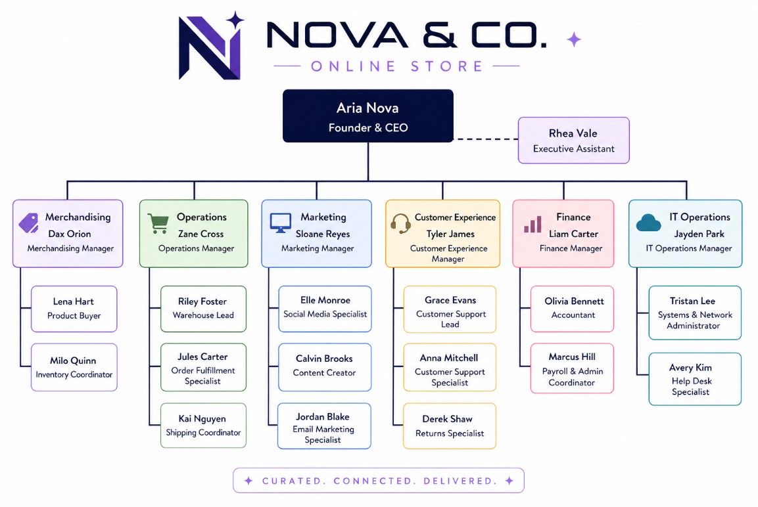
The project was designed with the plan that it would be able to be implemented and rolled out on relatively inexpensive hardware in a small business setting. Our problem ultimately boils down to, can this AI-powered IDS function reliably and stably for a small business without significant monetary investment. Readability, low computer hardware requirements, and the ability to export information for managerial review were paramount. The dashboard itself uses simple graphs and logical layouts to allow even a novice analyst to understand the source of the attack, what type, and how severe it is without a significant and immediate deep dive. The initial project concept was built around a fictitious company named Nova & Co which would be the foundation of our core tenets as we designed the project and made decisions around initial attack severity classification.

- Data Set Selection, Model Types, and Attack Severity Classification
The CICIDS2017 dataset was selected because it is one of the most widely used benchmark datasets for intrusion detection research. The dataset contains realistic network traffic flows labeled as either benign or malicious activity. Each flow includes numerous numerical features describing connection behavior, packet counts, durations, throughput, and protocol characteristics. (Sharafaldin et al., 2018) This dataset allows for ease of comparison against any similar models that may be on the market at present and allows for the model chosen to be based on a known quantity within the cybersecurity space. With consideration to standardization of our data and replication of our results under similar circumstances, CICIDS2017 was the best option for us. The ability for our fictitious company to iterate on this project so that it can continue to function as the landscape evolves was also a major consideration. Without a solid foundation for further development of the model with new attack type data, the project’s long-term stability becomes a significantly detrimental factor.
Three supervised learning models were evaluated:
• Logistic Regression – baseline classification model with low computational overhead. “…it predicts the probability that an input belongs to a specific class.” (IBM, 2024)
• Random Forest – ensemble model using multiple decision trees for robust classification. “Ensemble learning methods are made up of a set of classifiers—e.g. decision trees—and their predictions are aggregated to identify the most popular result.” Breiman, L. (2001). Random Forests. Machine Learning, 45(1), 5–32.
• XGBoost – gradient boosting model optimized for high predictive accuracy. “The task of training the model amounts to finding the best parameters that best fit the training data (x) and labels (y).” (Chen & Guestrin, 2016)
These models were selected to be trialed due to their differing requirements and potential in evaluating the data set. Logistic regression’s low computational requirements were its most prominent feature and a compounding factor in its selection when considering the specific business application we were aiming for. Random Forest was chosen due to its robust nature which would fit the need for a model that maintains longevity and quality without compromising stability. XGBoost was trialed due to its high accuracy and potential for a stronger model at the cost of higher computational requirements. Each model brings a unique way of classifying the data set such that the final application’s requirements and long term stability might be impacted which is ideal in this comparative analysis.
We settled on the following classifications for the attack types used in the CICIDS2017 dataset as listed in the following paragraphs. DoD/DDoS are classified as “Critical.” DDoS attacks prevent the company from making money, disrupt productivity, and creates a negative customer experience, which leads to loss of repeat business or word of mouth referrals. A small business is highly dependent on uptime for revenue and customer trust. As described in Fortinet’s DDoS overview (Fortinet, 2023), these attacks overwhelm servers or networks, making services unavailable. The data set includes DoS attack types across four different DoS based tools (slowloris, Slowhttptest, Hulk, and GoldenEye), which are instrumental in differentiating the spectrum of what DoS attacks can present as. For a small business, even short outages can directly halt sales, disrupt operations, and damage reputation. Unlike larger enterprises, small businesses often lack redundancy or mitigation infrastructure due to limited budgets, which justifies a critical classification.
Brute Force are classified as “Medium/High.” Repeat Offensive Operations may warrant higher alerts, the criteria of which depends on type, longevity, repeat sources (IPs, MACs, etc.) or repeat attack targets (same account, same username across systems, etc.). Brute force attacks involve repeated login attempts to gain unauthorized access. While a single attempt may not succeed, Fortinet’s definition criteria explain that persistence and automation increase the effectiveness of this type of attack over time. Fortinet’s emphasis on repeat behavior and targeting patterns aligns with real-world risks that small businesses face every day. (Fortinet, 2025a) For small businesses, such as ours, that typically have fewer authentication safeguards (e.g., no MFA, poor password policies, etc.), escalation to High is justified when patterns indicate persistence or targeting of critical accounts, similar to a spearfishing scenario.
Port Scanning is classified as Low. Port scanning is a reconnaissance stage attack, and can be more easily remedied by firewall rules, and monitored for potential repeat offenders. Ease of prevention and no immediate loss of productivity or system compromise set the attack type classification for this attack type to low. Port scanning is identified by Fortinet as a reconnaissance technique, used to discover open ports and vulnerabilities rather than directly exploit them. Since it does not immediately impact systems or productivity, and can often be mitigated with basic firewall rules, the risk is indirect. (Fortinet, 2024) For a small business, this makes it appropriate to classify this attack type as low, while still monitoring for repeated scans that could precede more serious attacks on critical infrastructure.
Web Attacks are classified as “High/Critical.” Web attacks that can compromise multiple customers at once by injecting them with malicious outside code immediately presents multiple surfaces by which the company’s bottom line and reputation can be damaged. These types of attacks, even if limited to local XSS attacks, should be immediately identified and remedied. Web attacks such as Cross-Site Scripting (XSS) and Remote Code Execution (RCE) directly exploit application vulnerabilities: XSS attacks can inject malicious scripts which affect multiple users while RCE can allow full system compromise. These attacks scale quickly and can impact many customers simultaneously by stealing data, damaging trust, or enabling deeper breaches. For a small business, where web applications often drive revenue and customer interaction, this creates both financial and reputational risk.
- Model Results, Challenges, and Shortcomings
Model evaluation was performed using Accuracy, Precision, Recall, and F1 Score. The data was split 80% for training (teaching the model) and 20% for testing (checking it on traffic it had never seen). Results demonstrated that all three models achieved exceptionally high classification performance. Logistic Regression achieved 99.3283% accuracy and a 99.2379% F1 score. Random Forest achieved 99.9856% accuracy and F1 score, while XGBoost achieved the highest overall accuracy at 99.9946% and an F1 score of 99.9945%. Although XGBoost produced the best numerical results, the performance advantage over Random Forest was only 0.009%, making the difference negligible for practical deployment.
Random Forest | 99.99% | 99.99% | 99.99% | 99.99%
Logistic Regression | 99.33% | 99.28% | 99.33% | 99.24%
XGBoost | 99.99% | 99.99% | 99.99% | 99.99%

As a result, Random Forest was selected as the production model because it offered near-identical performance to XGBoost while remaining easier to deploy, explain, maintain, and integrate into the existing pipeline of the application as we developed it. The secondary goal of selecting a model that maintained small business as the primary end-user and servicer was also met. The Random Forest model’s qualities present the best compromise between F1 score and practicality.
Project challenges included data preparation, computational requirements, and model evaluation. Before training could begin, the CICIDS2017 datasets had to be cleaned and standardized by removing duplicate records, handling infinite values, and eliminating missing data. Additionally, the project evolved from a simple binary classification problem (BENIGN vs DDoS) into a multi-class classification problem involving five traffic categories. This required combining multiple dataset files and developing a consistent attack categorization strategy. Training and evaluating multiple machine learning models also introduced additional computational overhead due to the large size of the dataset, which contained over one million traffic records. Finally, selecting a final deployment model required balancing raw predictive performance against practical considerations such as implementation complexity, maintainability, explainability, and integration with the dashboard and prediction pipeline.
Another challenge involved ensuring that the machine learning results could be effectively integrated into the dashboard component of the project. The prediction pipeline had to be designed to generate structured outputs containing timestamps, attack classifications, confidence scores, and severity ratings that could be consumed by the visualization layer. This required coordination between the machine learning, dashboard, and documentation portions of the project to ensure compatibility across all project components.
Additionally, while benchmark performance was extremely high for all models, future work should include testing against more diverse and evolving real-world traffic. The model and dashboard are only as good as the data that is fed into them as a foundation. Consideration for attack types not present in the CICIDS2017 dataset is a potentially limiting factor in how the current iteration of the model performs. As a result, the current model may not be able to detect certain intrusion types into the network it is currently monitoring. This is a limitation of any IDS though. It must be regularly updated, or the model itself must be able to differentiate and identify new emerging anomalous traffic patterns.
- Building the Dashboard, Challenges, and Shortcomings
The dashboard is the user-facing component of the AI Intrusion Detection System, which was built with Python using the Streamlit module. Streamlit can run on lower-level hardware such as a spare laptop or VM, and produces a clean interface quickly. Initially, the first prototype of the dashboard imported random mock data. This prototype was later transformed, so all values reflect real captured traffic.
The dashboard and its two supporting scripts rely on a focused set of Python modules and one JavaScript library for the map (summarized in Table 2). These fall into three groups: the dashboard app, the live detection engine that captures and classifies traffic, and the local server that connects them.

Table 2: Python modules and libraries used in the dashboard
Module / Library | Where Used | Purpose in the Dashboard
streamlit | Dashboard app | Provides the web application framework and renders the page layout, widgets, and all dashboard components.
streamlit.components.v1 | Dashboard app | Embeds the custom HTML and JavaScript live map inside the Streamlit page.
pandas | Dashboard app | Aggregates the alert records into the summary tables that the charts are built from.
plotly.express | Dashboard app | Generates the interactive bar, donut, and area charts.
json | Dashboard and detection engine | Reads and writes the alert log files shared between the capture engine and the dashboard.
os | All components | Builds file paths so each component locates its data files regardless of where it is run.
datetime, timedelta | Dashboard app | Formats timestamps and applies the rolling time window that limits which alerts are shown.
scapy (AsyncSniffer, IP, TCP) | Detection engine | Captures live network packets and parses their IP and TCP fields for classification.
collections (defaultdict, deque) | Detection engine | Buffers packets within short rolling windows so traffic can be grouped and classified.
threading | Detection engine | Runs packet capture asynchronously so sniffing and processing occur at the same time.
time | Detection engine | Times the rolling capture windows used during classification.
http.server | Local server | Handles the HTTP requests that deliver the live event feed to the dashboard.
socketserver | Local server | Hosts the lightweight local server that exposes the feed on the machine.
deck.gl (JavaScript, v8.9.36) | Browser (live map) | Renders the WebGL world map and the animated attack tracers in the browser.

Streamlit renders: the sidebar, the charts, and the page controls. The live map is the only exception since it was custom-made, using deck.gl embedded as a custom browser component (because deck.gl runs in the browser on WebGL rather than in Python). The sidebar has many different features: a multiselect attack-type filter, a confidence-threshold slider to suppress low-certainty detections, and a model summary panel.
The most important part of the dashboard is the live traffic map. Each detection fires an animated tracer from the apparent source to the protected target, fixed at the Sacred Heart University’s location. Because the lab uses internal IPs with no real geographic data, sources are projected onto world cities to give the map meaningful spatial context, mirroring how a live deployment would show external threats. Four indicators update continuously on the map: total threats, distinct attack types, attacking sources, and average confidence.
Under the map, three Plotly charts were implemented to summarize detections: a bar chart with counts by attack type, a donut chart with their proportional distribution, and an area chart with activity over time, all sharing one color scheme with the map. Every detection is logged with its time, source and target, classification, and confidence. Classifications map to the severity scheme defined earlier, letting an analyst separate a low-priority scan from a critical denial-of-service or web attack. A clear-log button and a refresh button support routine use.
The main engineering challenge was delivering this in real time without disrupting the analyst's view. Streamlit re-runs the entire script on every interaction, which would reload the map and reset its zoom and animation state. To avoid this, the map was separated from Streamlit's execution cycle. The detection engine writes structured alert records to a shared log as packets are classified, a lightweight local web server exposes that feed, and the embedded map polls it every few seconds, appending new attacks while preserving history. The map then updates smoothly instead of reloading on each change.
An exportable executive report is the last piece of the dashboard, built as a standalone HTML page that runs outside of Streamlit. It fetches the alert_history.json file from the same local server that feeds the live map, then parses the records and computes its summary statistics directly in the browser using JavaScript. These numbers populate a short-written summary, a set of key metrics, three charts, and a table of high-severity events, generated automatically with no separate backend code. The page can be printed or saved as a PDF, satisfying the project's goal of an export-ready report for management.
- Conclusions
This capstone project successfully demonstrated the integration of artificial intelligence, machine learning, and cybersecurity visualization into a unified intrusion detection platform. The system achieved near-perfect classification performance on the CICIDS2017 dataset while simultaneously supporting live attack monitoring and visualization. Through comparative analysis, Random Forest was selected as the deployment model due to its combination of accuracy, simplicity, and explainability. In its current form, the application would be an ideal compromise between affordability, dependability, and ease of deployment for a small business. The low computational requirements for this application to run allow for flexibility in how it’s deployed. A small business could use spare laptops or a dedicated virtual machine depending on how complex their environment is to deploy the application at various endpoints.
The completed solution provides security analysts with real-time visibility into network threats and supports rapid incident identification through automated classification and visual analytics. Future enhancements may include deep learning approaches, expanded attack coverage, automated response mechanisms, and deployment in larger enterprise environments. Overall, the project demonstrates the effectiveness of AI-driven intrusion detection systems in modern cybersecurity operations.

- References
Breiman, L. (2001). Random Forests. Machine Learning, 45(1), 5–32.
Chen, T., & Guestrin, C. (2016). XGBoost: A Scalable Tree Boosting System. Proceedings of the 22nd ACM SIGKDD International Conference on Knowledge Discovery and Data Mining.
Fortinet. (2023). What is a DDoS Attack? DDoS Meaning, Definition & Types. Fortinet. https://www.fortinet.com/resources/cyberglossary/ddos-attack
Fortinet. (2024). What is a Port Scan and How does it work? Fortinet. https://www.fortinet.com/resources/cyberglossary/what-is-port-scan
Fortinet. (2025a). What is Brute Force Attack? | Definition, Types & How It Works. Fortinet. https://www.fortinet.com/resources/cyberglossary/brute-force-attack
Fortinet. (2025b). What is Cross site scripting and How To Prevent it? Fortinet. https://www.fortinet.com/resources/cyberglossary/cross-site-scripting
Fortinet. (2025). What Is Remote Code Execution (RCE)? Attacks, Impact & Protection. Fortinet. https://www.fortinet.com/resources/cyberglossary/remote-code-execution
IBM. Logistic Regression. IBM Documentation.
Sharafaldin, I., Lashkari, A. H., & Ghorbani, A. A. (2018). Toward Generating a New Intrusion Detection Dataset and Intrusion Traffic Characterization. Proceedings of the 4th International Conference on Information Systems Security and Privacy (ICISSP), 108–116.

- Source Code
https://github.com/talarekc/AI-Intrusion-Detection

