DAY-2 ASSIGNMENT
InsuranceDB:
- CREATE DATABASE InsuranceDB;
USE InsuranceDB;
- Create table commands for all the tables with constraints, relationships etc.
CREATE TABLE Customers(
CustomerID INT PRIMARY KEY,
FirstName VARCHAR(50),
LastName VARCHAR(50),
DateOfBirth DATE,
Phone VARCHAR(20),
Email VARCHAR(50)
);

CREATE TABLE Policies(
PolicyID INT PRIMARY KEY,
PolicyName VARCHAR(50),
PolicyType VARCHAR(20),
PremiumAmount DECIMAL(10,2),
DurationYears VARCHAR(20)
);

CREATE TABLE Agents(
AgentID INT PRIMARY KEY,
AgentName VARCHAR(50),
Phone VARCHAR(20),
City VARCHAR(20)
);

CREATE TABLE PolicyAssignments(
AssignmentID INT PRIMARY KEY,
CustomerID INT,
PolicyID INT,
AgentID INT,
StartDate DATE,
EndDate DATE,
Constraint fk_customer_pa
FOREIGN KEY (CustomerID) REFERENCES Customers(CustomerID),
Constraint fk_policy_pa
FOREIGN KEY (PolicyID) REFERENCES Policies(PolicyID),
Constraint fk_agent_pa
FOREIGN KEY (AgentID) REFERENCES Agents(AgentID)
);

CREATE TABLE Claims(
ClaimID INT PRIMARY KEY,
AssignmentID INT,
ClaimDate DATE,
ClaimAmount DECIMAL(10,2),
ClaimStatus VARCHAR(10),
Constraint fk_pa_Claims
FOREIGN KEY (AssignmentID) REFERENCES PolicyAssignments(AssignmentID)
);

- Create table commands for all the tables with constraints, relationships etc.

INSERT INTO Customers (CustomerID, FirstName, LastName, DateOfBirth, Phone, Email)
VALUES
(1, 'Ravi', 'Kumar', '1990-05-12', '9876543210', 'ravi.kumar@example.com'),
(2, 'Priya', 'Sharma', '1988-11-22', '9876543211', 'priya.sharma@example.com'),
(3, 'Amit', 'Verma', '1995-03-15', '9876543212', 'amit.verma@example.com'),
(4, 'Sneha', 'Reddy', '1992-07-09', '9876543213', 'sneha.reddy@example.com');

INSERT INTO Customers (CustomerID, FirstName, LastName, DateOfBirth, Phone, Email)
VALUES
(5, 'Chaitanya', 'Talasila', '2005-04-15', '9876543210', 'chaitanya@example.com');

INSERT INTO Policies (PolicyID, PolicyName, PolicyType, PremiumAmount, DurationYears)
VALUES
(101, 'Health Secure', 'Health', 12000.00, '3 Years'),
(102, 'Life Shield', 'Life', 25000.00, '10 Years'),
(103, 'Motor Protect', 'Vehicle', 8000.00, '1 Year'),
(104, 'Senior Care', 'Health', 18000.00, '5 Years');

INSERT INTO Agents (AgentID, AgentName, Phone, City)
VALUES
(201, 'Anil Mehta', '9000011111', 'Hyderabad'),
(202, 'Kavya Rao', '9000011112', 'Mumbai'),
(203, 'Rohit Singh', '9000011113', 'Delhi');

INSERT INTO Agents (AgentID, AgentName, Phone, City)
VALUES
(204, 'Harshadh', '9000041111', 'Calicut');

INSERT INTO PolicyAssignments
(AssignmentID, CustomerID, PolicyID, AgentID, StartDate, EndDate)
VALUES
(301, 1, 101, 201, '2023-01-01', '2026-01-01'),
(302, 1, 102, 202, '2020-05-10', '2030-05-10'),
(303, 2, 103, 201, '2024-01-01', '2025-01-01'),
(304, 3, 104, 203, '2022-06-15', '2027-06-15'),
(305, 4, 101, 202, '2021-02-02', '2024-02-02');
SELECT * FROM PolicyAssignments;

INSERT INTO Claims
(ClaimID, AssignmentID, ClaimDate, ClaimAmount, ClaimStatus)
VALUES
(401, 301, '2024-03-12', 5000.00, 'Approved'),
(402, 303, '2024-04-15', 12000.00, 'Pending'),
(403, 305, '2023-10-10', 8000.00, 'Rejected'),
(404, 304, '2024-01-25', 15000.00, 'Approved'),
(405, 302, '2024-06-30', 30000.00, 'Pending');

- Select commands
-- 1. View all records Customers table.
SELECT * FROM Customers;

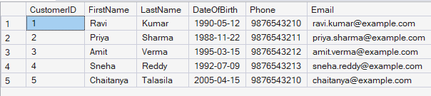

-- 2. View all records of PolicyAssignment table with CustomerId, PolicyId, StartDate and EndDate columns only.
SELECT CustomerId, PolicyId, StartDate, EndDate FROM PolicyAssignments;

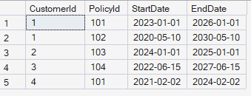

-- 3. Display all policies of Health type.
SELECT PolicyName FROM Policies;

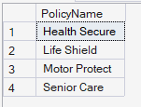

-- 4. Display policies having premium amount more than 10000 and DurationYears is 1.
SELECT PolicyName, PremiumAmount, DurationYears FROM Policies WHERE PremiumAmount>1000 and DurationYears ='1 Year';

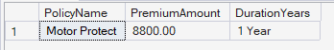

-- 5. Display unique city names from where agents belong to.
SELECT DISTINCT(city) FROM Agents;

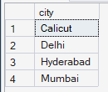

-- 6. List policies of type Life, Health, Motor using OR clause.
SELECT PolicyName FROM Policies WHERE PolicyType='Life' OR PolicyType='Health' OR PolicyType='Vehicle';

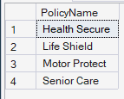

-- 7. List policies of type Life, Health, Motor using IN operator.
SELECT PolicyName FROM Policies WHERE PolicyType IN ('Life', 'Health', 'Vehicle');

-- 8. Display list of customers born after January 1st, 2001 and before December 31st, 2020 using >= and <= operators.
SELECT CustomerID, FirstName, LastName,DateOfBirth FROM Customers WHERE DateOfBirth>='2001-01-01' AND DateOfBirth<='2020-12-31';

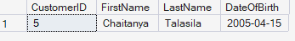

-- 9. Display list of customers born after January 1st, 2001 and before December 31st, 2020 using BETWEEN operator.
SELECT CustomerID, FirstName, LastName,DateOfBirth FROM Customers WHERE DateOfBirth BETWEEN '2001-01-01' AND '2020-12-31';

-- 10. Display claims data where claim status is Rejected.
SELECT * FROM Claims WHERE ClaimStatus='Rejected';

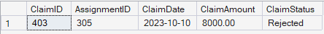

-- 11. Display records of Agents who stay in a city whose second letter is 'a'.
SELECT * FROM Agents WHERE city LIKE '_a%';

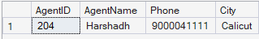

-- 12. Display highest and lowest ClaimAmount from Claims table.
SELECT MIN(ClaimAmount) as Lowest_claim, MAX(ClaimAmount) AS Highest_claim FROM Claims;

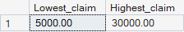

-- 13. Display latest claim record.
SELECT * FROM Claims ORDER BY ClaimDate DESC OFFSET 0 ROWS FETCH NEXT 1 ROWS ONLY;

-- 14. Increase premium amount by 10% for all health insurance policies.
UPDATE Policies SET PremiumAmount=1.1*PremiumAmount
SELECT * FROM Policies;

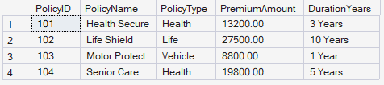

-- 15. Delete the record of PolicyAssignments whose EndDate is before today's date.
DELETE FROM Claims
WHERE AssignmentID IN (
SELECT AssignmentID
FROM PolicyAssignments
WHERE EndDate < GETDATE()
);
DELETE FROM PolicyAssignments WHERE EndDate<GetDate();
SELECT * FROM PolicyAssignments;

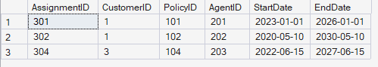

-- 16. Display number of claims rejected.
SELECT COUNT(*) FROM Claims WHERE ClaimStatus='Rejected';

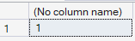

-- 17. Display PolicyId, PolicyName, PremiumAmount along with computed fields not in table -> 6% LocalTaxes, PremiumAmountWithTax and MonthlyPremiumAmount considering PremiumAmount is Annual.
SELECT PolicyId, PolicyName, PremiumAmount, (0.06 *PremiumAmount) AS LocalTaxes, ROUND(PremiumAmount+(0.06 *PremiumAmount),2) AS PremiumAmountWithTax,
ROUND((PremiumAmount + (PremiumAmount * 0.06)) / 12.0, 2) as MonthlyPremiumAmount FROM Policies;

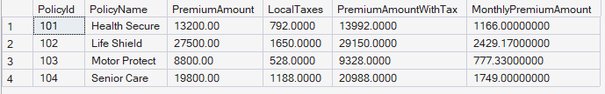

-- 18. Write a command to add Address and City Columns in the Customers table.
ALTER TABLE Customers
ADD Address VARCHAR(50), City VARCHAR(20)
SELECT * FROM Customers

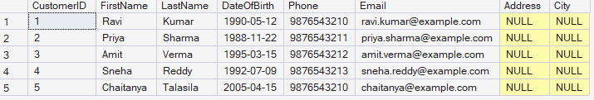

-- 19. Write a command to add a new column named DevOfId (DevelopmentOfficerId) in an existing Agents table.
ALTER TABLE Agents
ADD DevOfId INT;

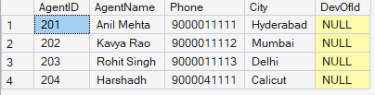

-- 20. Write command to make the above DevOfId as a recursive foreign key to AgentId as Parent.
ALTER TABLE Agents
ADD CONSTRAINT fk_agent_devof
FOREIGN KEY (DevOfId) REFERENCES Agents(AgentID);

- Queries using Joins, Group By, Having etc.

-- 1. List all Policies for a CustomerId 4.
SELECT a.CustomerID,c.PolicyName
FROM Customers a JOIN PolicyAssignments b
ON a.CustomerID=b.CustomerID
JOIN Policies c
ON c.PolicyID=B.PolicyID
WHERE a.customerid=4;

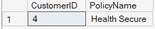

-- 2. View all customers with their policies.
SELECT a.CustomerID,c.PolicyName
FROM Customers a JOIN PolicyAssignments b
ON a.CustomerID=b.CustomerID
JOIN Policies c
ON c.PolicyID=B.PolicyID;

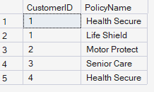

-- 3. View claims with customer name.
SELECT a.FirstName,a.LastName,c.ClaimID, c.ClaimDate, c.claimamount,c.claimstatus
FROM Customers a JOIN PolicyAssignments b
ON a.CustomerID=b.CustomerID
JOIN Claims c
ON b.AssignmentID=c.AssignmentID;

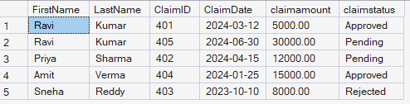

-- 4. Display FirstName, PolicyName, AgentName, StartDate and EndDate from their respective tables.
SELECT a.FirstName,c.PolicyName,d.AgentName,b.StartDate,b.EndDate
FROM Customers a JOIN PolicyAssignments b
ON a.CustomerID=b.CustomerID
JOIN Policies c
ON c.PolicyID=B.PolicyID
JOIN Agents d
ON d.AgentID=b.AgentID;

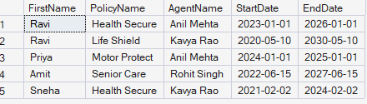

-- 5. Display claims report with FirstName, PolicyName, ClaimAmount, ClaimStatus, and ClaimDate from their respective tables.
SELECT a.FirstName,c.PolicyName,d.ClaimAmount,d.ClaimStatus,d.ClaimDate
FROM Customers a JOIN PolicyAssignments b
ON a.CustomerID=b.CustomerID
JOIN Policies c
ON c.PolicyID=B.PolicyID
JOIN Claims d
ON b.AssignmentID=d.AssignmentID;

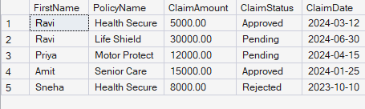

-- 6. Display records of Customers with or without Policies.
SELECT a.CustomerID,a.FirstName,a.LastName,b.AssignmentID,b.PolicyID
FROM Customers a LEFT JOIN PolicyAssignments b
ON a.CustomerID=b.CustomerID;

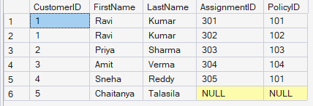

-- 7. Display all Customers with NO Claims.
SELECT a.CustomerID,a.FirstName,a.LastName
FROM Customers a LEFT JOIN PolicyAssignments b
ON a.CustomerID=b.CustomerID
WHERE b.AssignmentID IS NULL;

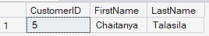

-- 8. Show CustomerName with Total Claim Amount per Customer.
SELECT a.customerid,a.FirstName,a.lastname,SUM(c.claimamount)
FROM Customers a JOIN PolicyAssignments b
ON a.CustomerID=b.CustomerID
JOIN Claims c
ON b.AssignmentID=c.AssignmentID
GROUP BY a.customerid,a.FirstName,a.lastname;

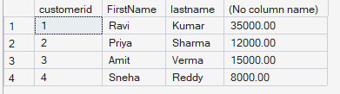
-- 9. Show names and total claim amount of Customers With Claim Amount > 50000 (Use HAVING Clause).
SELECT a.customerid,a.FirstName,a.lastname,SUM(c.claimamount)
FROM Customers a JOIN PolicyAssignments b
ON a.CustomerID=b.CustomerID
JOIN Claims c
ON b.AssignmentID=c.AssignmentID
GROUP BY a.customerid,a.FirstName,a.lastname
HAVING SUM(c.claimamount)>10000;

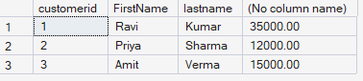

-- 10. Display list with Agent Wise Policy Count.
SELECT a.agentid,COUNT(*)
FROM agents a join policyassignments b
on a.agentid=b.agentid
GROUP BY a.agentid;
