01/12/2022 - JaganKumar Assignments

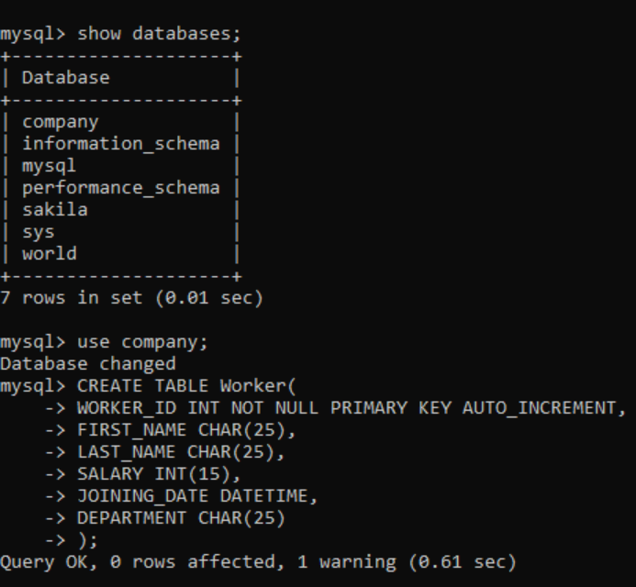

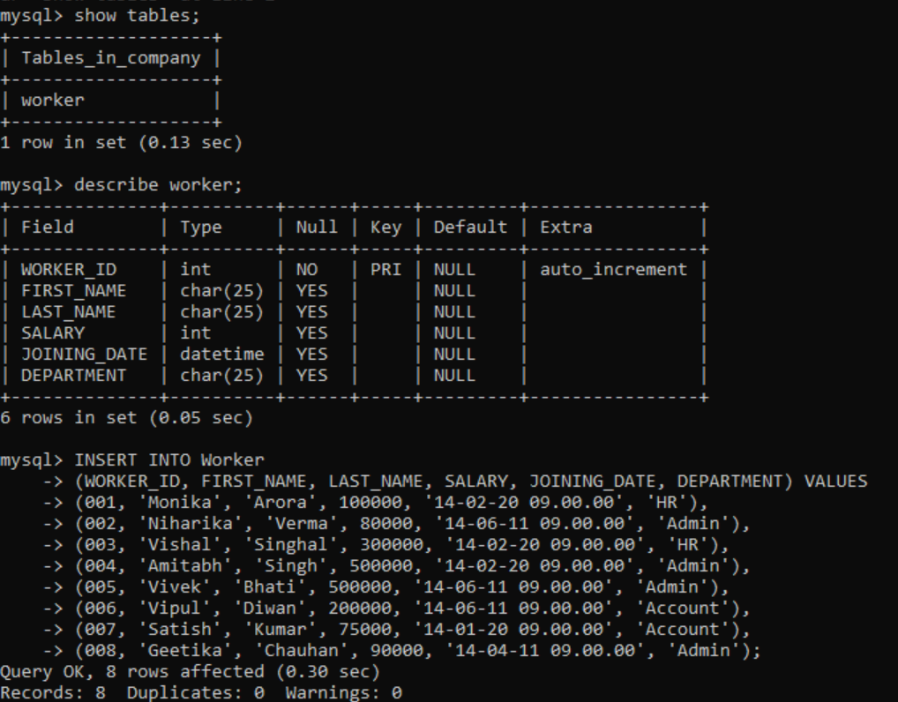

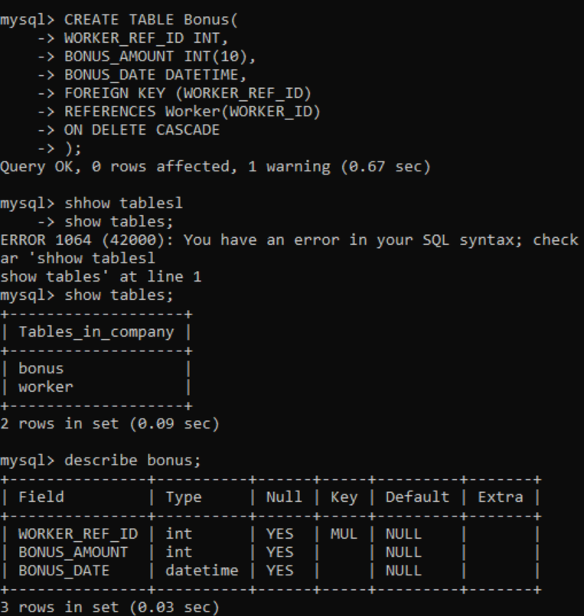

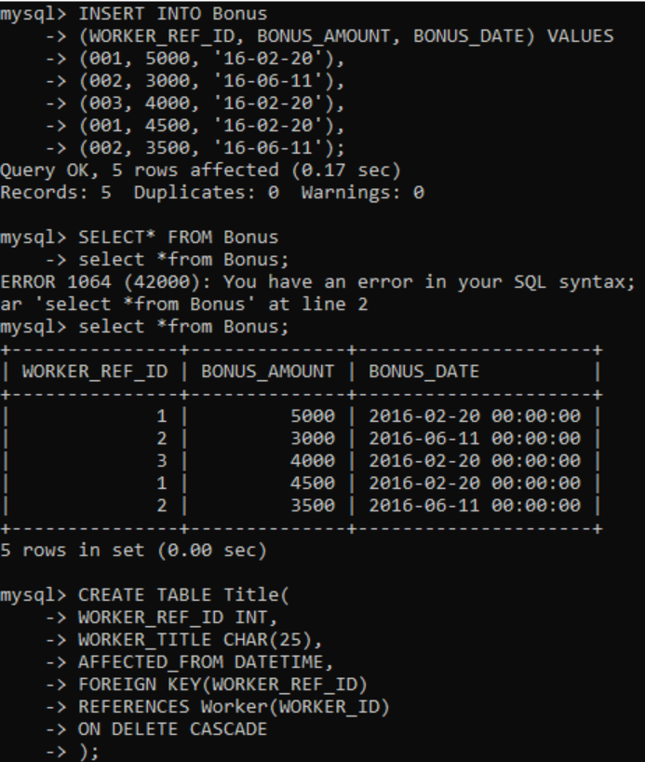

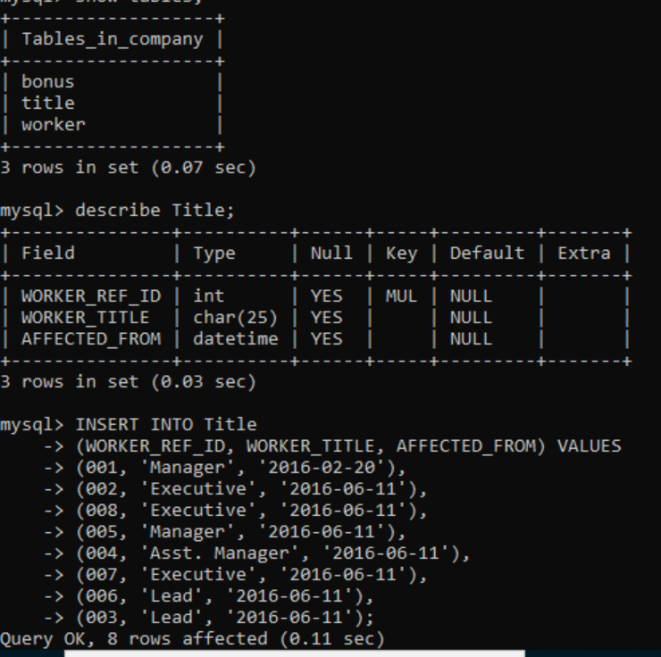

**Q-1. Write an SQL query to fetch “FIRST_NAME” from Worker table using the alias name as <WORKER_NAME>.**

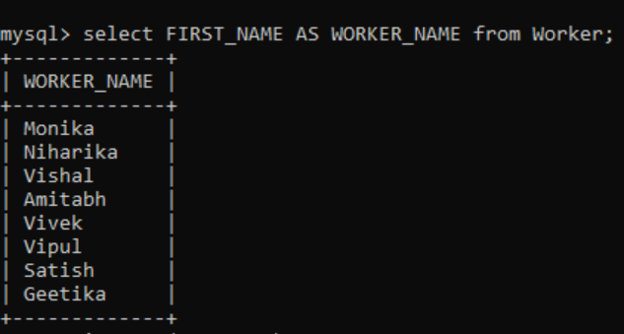

#### Q-2. Write an SQL query to fetch “FIRST_NAME” from Worker table in upper case.

#### 

#### Q-3. Write an SQL query to fetch unique values of DEPARTMENT from Worker table.

#### 

#### Q-4. Write an SQL query to print the first three characters of FIRST_NAME from Worker table.

#### 

#### Q-5. Write an SQL query to find the position of the alphabet (‘a’) in the first name column ‘Amitabh’ from Worker table.

#### 

#### Q-6. Write an SQL query to print the FIRST_NAME from Worker table after removing white spaces from the right side.

#### 

#### Q-7. Write an SQL query to print the DEPARTMENT from Worker table after removing white spaces from the left side.

#### 

#### Q-8. Write an SQL query that fetches the unique values of DEPARTMENT from Worker table and prints its length.

#### Q-9. Write an SQL query to print the FIRST_NAME from Worker table after replacing ‘a’ with ‘A’.

#### 

**Q-10. Write an SQL query to print the FIRST_NAME and LAST_NAME from Worker table into a single column COMPLETE_NAME. A space char should separate them.**

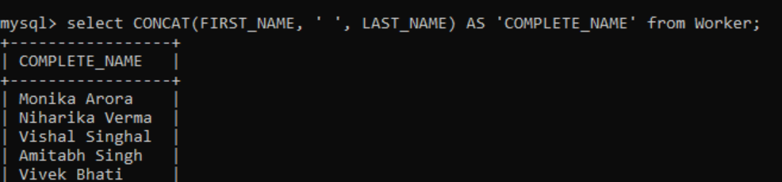

**Q-11. Write an SQL query to print all Worker details from the Worker table order by FIRST_NAME Ascending.**

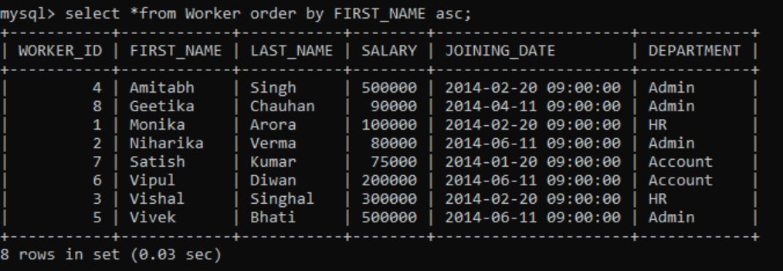

**Q-12. Write an SQL query to print all Worker details from the Worker table order by FIRST_NAME Ascending and DEPARTMENT Descending.**

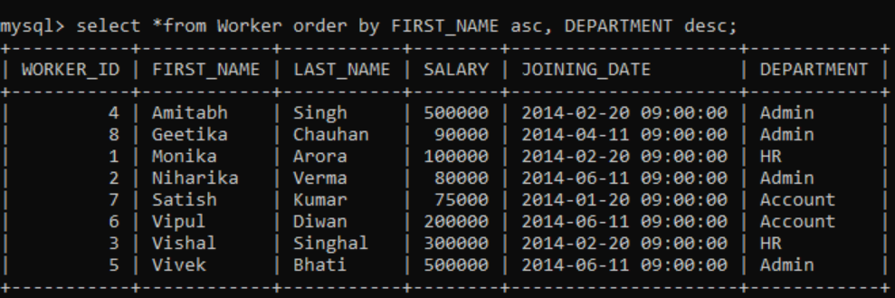

**Q-13. Write an SQL query to print details for Workers with the first name as “Vipul” and “Satish” from Worker table.**

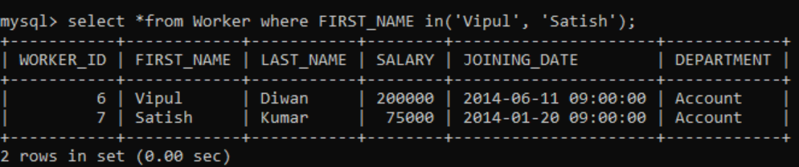

**Q-14. Write an SQL query to print details of workers excluding first names, “Vipul” and “Satish” from Worker table.**

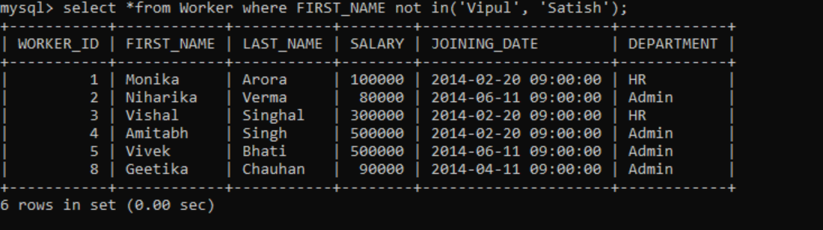

**Q-15.**

**Write an SQL query to print details of Workers with DEPARTMENT name as “Admin”.**

**Q-16. Write an SQL query to print details of the Workers whose FIRST_NAME contains ‘a’.**

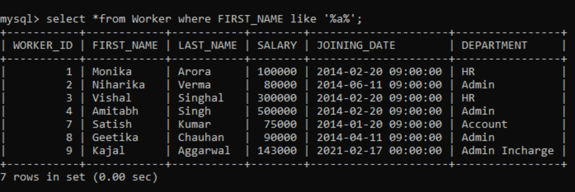

**Q-17. Write an SQL query to print details of the Workers whose FIRST_NAME ends with ‘a’.**

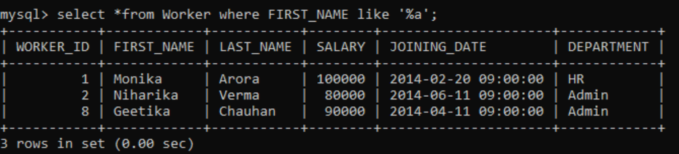

**Q-18. Write an SQL query to print details of the Workers whose FIRST_NAME ends with ‘h’ and contains six alphabets.**

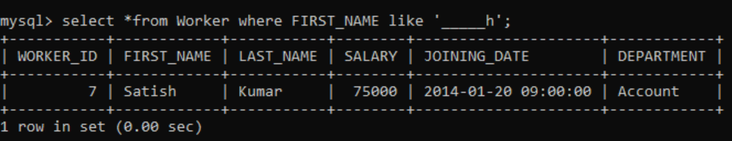

**Q-19. Write an SQL query to print details of the Workers whose SALARY lies between 100000 and 500000.**

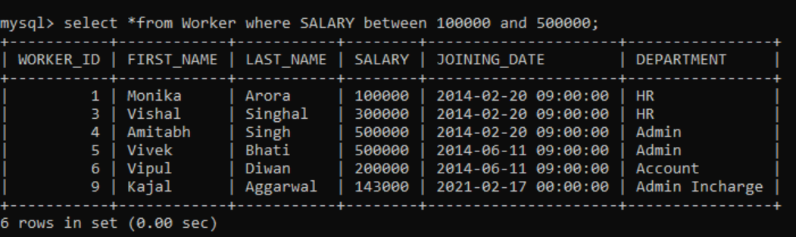

**Q-20. Write an SQL query to print details of the Workers who have joined in Feb’2014.**

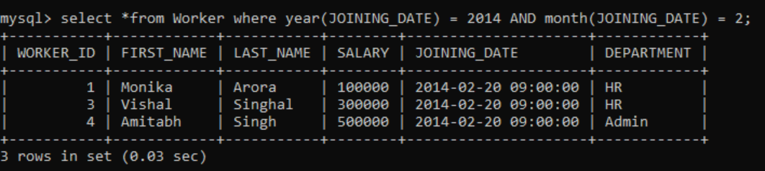

**Q-21. Write an SQL query to fetch the count of employees working in the department ‘Admin’.**

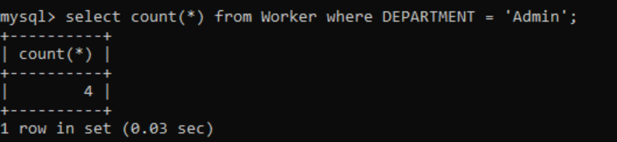

**Q-22. Write an SQL query to fetch worker names with salaries >= 50000 and <= 100000.**

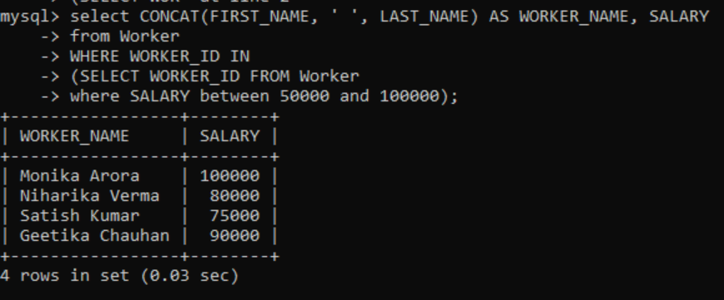

**Q-23. Write an SQL query to fetch the no. of workers for each department in the descending order.**

**Q-24. Write an SQL query to print details of the Workers who are also Managers.**

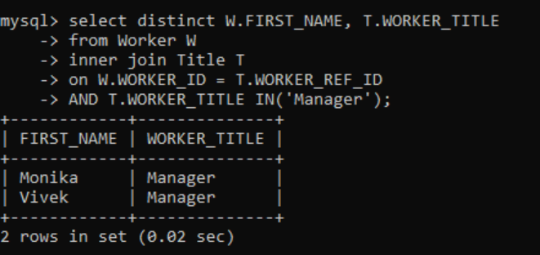

**Q-25. Write an SQL query to fetch duplicate records having matching data in some fields of a table.**

**Q-26. Write an SQL query to show only odd rows from a table.**

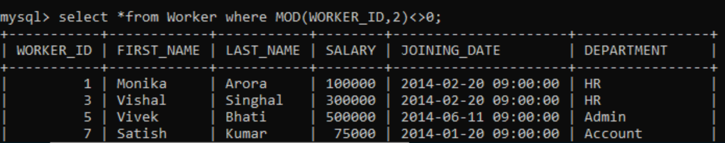

**Q-27. Write an SQL query to show only even rows from a table.**

**Q-28. Write an SQL query to clone a new table from another table.**

**Q-29. Write an SQL query to fetch intersecting records of two tables.**

**Q-30. Write an SQL query to show records from one table that another table does not have.**

**Q-31. Write an SQL query to show the current date and time.**

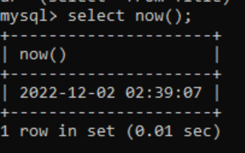

**Q-32. Write an SQL query to show the top n (say 10) records of a table.**

**Q-33. Write an SQL query to determine the nth (say n=5) highest salary from a table.**

**Q-34. Write an SQL query to determine the 5th highest salary without using TOP or limit method.**

**Q-35. Write an SQL query to fetch the list of employees with the same salary.**

**Q-36. Write an SQL query to show the second highest salary from a table.**

**Q-37. Write an SQL query to show one row twice in results from a table.**

**Q-38. Write an SQL query to fetch intersecting records of two tables.**

**Q-39. Write an SQL query to fetch the first 50% records from a table.**

**Q-40. Write an SQL query to fetch the departments that have less than five people in it.**

**Q-41. Write an SQL query to show all departments along with the number of people in there.**

**Q-42. Write an SQL query to show the last record from a table.**

**Q-43. Write an SQL query to fetch the first row of a table.**

**Q-44. Write an SQL query to fetch the last five records from a table.**

**Q-45. Write an SQL query to print the name of employees having the highest salary in each department.**

**Q-46. Write an SQL query to fetch three max salaries from a table.**

**Q-47. Write an SQL query to fetch three min salaries from a table.**

**Q-48. Write an SQL query to fetch nth max salaries from a table.**

**Q-49. Write an SQL query to fetch departments along with the total salaries paid for each of them.**

**Q-50. Write an SQL query to fetch the names of workers who earn the highest salary.**