Dossier → Team 8, Magnus Schlenger, Ivan Dyulgerov

Task 1:
- Duolingo style gamified learning app - quizzes and studying to go, gamified
-students can use their phones and an app to study “to go” (train, etc.)
-its also gamified so studying generally becomes more fun and maybe even slightly addicting
users and their goals: students can learn everywhere anytime on their phone and have more fun with it

- Course Survival Guide – “How to survive Module X”
-students who already finished classes can post tips on how to “survive” this particular class
-oftentimes its not clear what exactly is important for a certain class:
->maybe the “Übungsaufgaben” are most relevant for the exam and the actual lecture isnt as important or maybe the exam was mostly about reproducing knowledge from the lecture, etc
->maybe students dont know how to pass the “Praktikum”
users and their goals: students get to know whats important for a class before even starting it -> helps with planning the class and what to focus on

- Ask Older Me - advice from higher semesters:
-students (especially first semesters) can ask questions that are stored in a large database/list
-then other students (especially higher semesters) can answer these questions in different ways
-answers and questions can both be upvoted or downvoted and maybe categorized so its easy to find certain topics
-kind of like a huge chat with all the uni students but way clearer and easier to navigate
- better than a huge telegram chat where you scroll for hours to find some important information
- a little bit like more reddit rather than telegram
users and their goals: students can get advice from other students in a more organized and clear way

- Concept Battles – explanations compete, users vote which is clearer
-students can post explanations for different concepts and all the other students can upvote or downvote depending on which one actually helped them
- maybe students can even upload entire explanation videos, tasks, etc.
-ideally students who post detailed or good explanations are rewarded in some way (app coins for different kind of benefits, money, exam points (if the prof collaborates))
users and their goals: students can learn in a more intuitive and “student friendly” way from other students and maybe students can be rewarded for delivering good explanations

Task 2:
Target Users:
- Students, who want to share additional information while doing their homeworks. Students can raise their questions and receive answers from other students. Users can up-/downvote every single answer in order to bring the most correct answer on the top of the rest. This way students can not only see all the answers but also the number of votes of each reply.
- Common people that want to discuss daily problems or cases.
- Football fans who would like to vote which team is going to the final.
- Cinema fans who wants to discuss their favorite series.
Goal: Introducing an app that involves students to cooperate and go through the difficulties and uncertainty. This information will be stored as database.

Task 3: First Prototypes
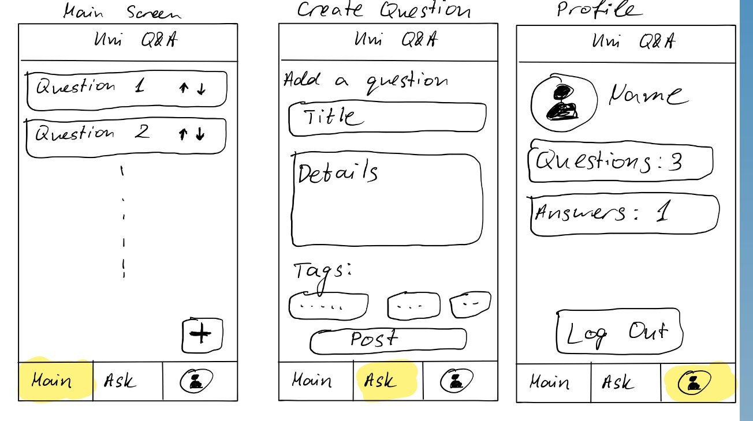
We wanted to keep the design simplistic and intuitive because of that we decided to go with 3 screens. The main one presents all questions in the form of feed where everyone can add his question and wait for replies. Second screen shows “Add a question” tab where people can easily reach within just 1 click in the navigation bar on the bottom. There users can find some text fields where they can provide more information like title and description of their question. Adding a tags is also a good option which will help other people to browse quickly and find all the questions which are related to searched tags. The last section aims to provide profile view and information about the user account. On the screen are visible: Avatar, Name, number of from user added questions and answers. On the bottom is situated “Log Out”.

Some random people we asked were very exited from our idea and suggested us a lot of useful features we can add later to our design.

Task 4: Finalized Design
