

**Talat Zahra 52734**

Digital signal processing project

AI +DSP RELATED PROJECT

# Smart Voice Activity Detection (VAD) Demo Synthetic Audio

**clc; clear; close all;**

# Step 1: Generate synthetic audio (speech-like signal)

**fs = 8000; % Sampling frequency (8 kHz) t = 0:1/fs:2; % 2 seconds duration**

**audio = 0.6*sin(2*pi*300*t) + 0.4*sin(2*pi*600*t); % sum of two sinusoids**

**(simulated speech)**

**audio = audio(:); % column vector audio = audio / max(abs(audio)); % normalize amplitude**

# Step 2: Frame the signal

**frame_duration = 0.02; % 20 ms frames**

**frame_len = round(fs * frame_duration); frame_shift = round(frame_len / 2); % 50% overlap**

**num_frames = floor((length(audio) - frame_len) / frame_shift) + 1;**

**frames = zeros(frame_len, num_frames);**

**for i = 1:num_frames**

**idx = (i-1)*frame_shift + 1 : (i-1)*frame_shift + frame_len;**

**frames(:,i) = audio(idx); end**

# Step 3: Compute short-time energy and zerocrossing rate

**energy = sum(frames.^2); % Energy per frame zcr = sum(abs(diff(sign(frames))) > 0); % Zero-crossing rate per frame**

# Step 4: Voice Activity Detection (VAD)

**energy_thresh = 0.01; % Energy threshold zcr_thresh = 20; % Zero-crossing threshold vad = (energy > energy_thresh) & (zcr < zcr_thresh);**

# Step 5: Plot results

**time_audio = (0:length(audio)-1) / fs; figure('Name','Voice Activity Detection Demo','NumberTitle','off');**

**subplot(3,1,1); plot(time_audio, audio); title('Synthetic Speech Signal'); xlabel('Time (seconds)'); ylabel('Amplitude'); grid on;**

**subplot(3,1,2); stem(vad, 'filled');**

**title('VAD Output (1 = Speech, 0 = Silence)');**

**xlabel('Frame Number'); ylabel('VAD Decision'); ylim([-0.1 1.1]); grid on;**

**subplot(3,1,3);**

**plot(energy, 'r', 'LineWidth', 1.5);**

**hold on;**

**plot(zcr, 'g', 'LineWidth', 1.5); legend('Short-Time Energy','Zero-Crossing Rate'); title('Energy and Zero-Crossing Rate per Frame');**

**xlabel('Frame Number');**

**grid on;**

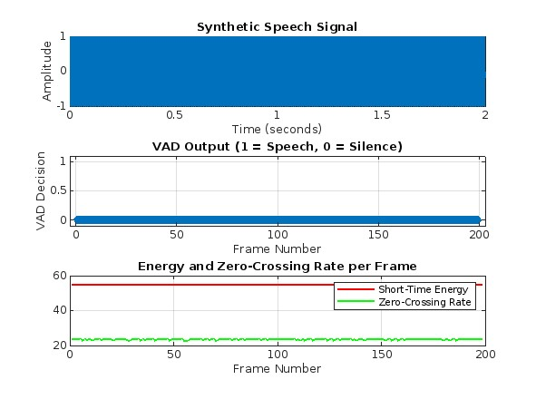

CODE SIMULATION MATLAB

|  |
| --- |
| %% Smart Voice Activity Detection (VAD) Demo - Synthetic Audio  clc; clear; close all;  %% Step 1: Generate synthetic audio (speech-like signal)  fs = 8000; % Sampling frequency (8 kHz)  t = 0:1/fs:2; % 2 seconds duration  audio = 0.6*sin(2*pi*300*t) + 0.4*sin(2*pi*600*t); % sum of two sinusoids (simulated speech)  audio = audio(:); % column vector  audio = audio / max(abs(audio)); % normalize amplitude  %% Step 2: Frame the signal  frame_duration = 0.02; % 20 ms frames  frame_len = round(fs * frame_duration);  frame_shift = round(frame_len / 2); % 50% overlap  num_frames = floor((length(audio) - frame_len) / frame_shift) + 1;  frames = zeros(frame_len, num_frames);  for i = 1:num_frames  idx = (i-1)*frame_shift + 1 : (i-1)*frame_shift + frame_len;  frames(:,i) = audio(idx);  end  %% Step 3: Compute short-time energy and zero-crossing rate  energy = sum(frames.^2); % Energy per frame  zcr = sum(abs(diff(sign(frames))) > 0); % Zero-crossing rate per frame  %% Step 4: Voice Activity Detection (VAD)  energy_thresh = 0.01; % Energy threshold  zcr_thresh = 20; % Zero-crossing threshold  vad = (energy > energy_thresh) & (zcr < zcr_thresh);  %% Step 5: Plot results  time_audio = (0:length(audio)-1) / fs;  figure('Name','Voice Activity Detection Demo','NumberTitle','off');  subplot(3,1,1);  plot(time_audio, audio);  title('Synthetic Speech Signal');  xlabel('Time (seconds)');  ylabel('Amplitude');  grid on;  subplot(3,1,2);  stem(vad, 'filled');  title('VAD Output (1 = Speech, 0 = Silence)');  xlabel('Frame Number');  ylabel('VAD Decision');  ylim([-0.1 1.1]);  grid on;  subplot(3,1,3);  plot(energy, 'r', 'LineWidth', 1.5);  hold on;  plot(zcr, 'g', 'LineWidth', 1.5);  legend('Short-Time Energy','Zero-Crossing Rate');  title('Energy and Zero-Crossing Rate per Frame');  xlabel('Frame Number');  grid on; |

OUTPUT

