TALAT ZAHRA 52734

LIVE CODE RUN WITH OUPUT

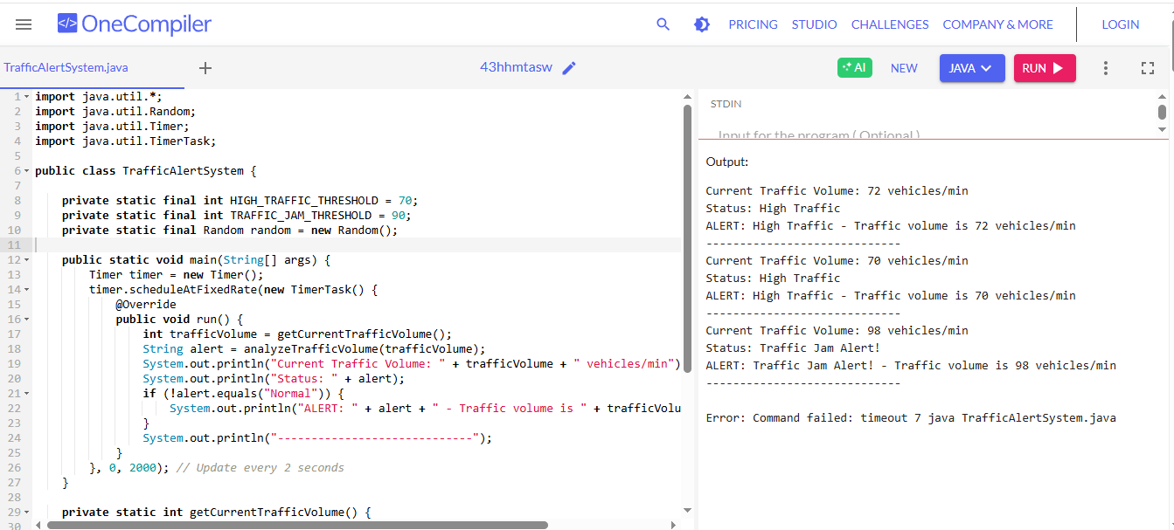

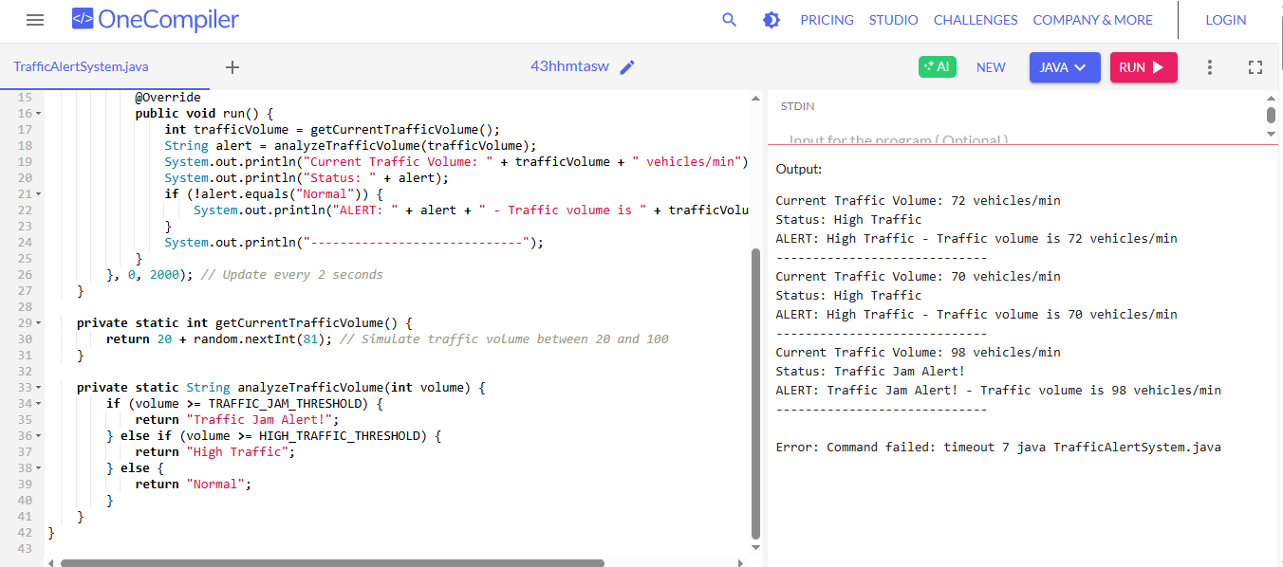

CODE

import java.util.*;

import java.util.Random;

import java.util.Timer;

import java.util.TimerTask;

public class TrafficAlertSystem {

private static final int HIGH_TRAFFIC_THRESHOLD = 70;

private static final int TRAFFIC_JAM_THRESHOLD = 90;

private static final Random random = new Random();

public static void main(String[] args) {

Timer timer = new Timer();

timer.scheduleAtFixedRate(new TimerTask() {

@Override

public void run() {

int trafficVolume = getCurrentTrafficVolume();

String alert = analyzeTrafficVolume(trafficVolume);

System.out.println("Current Traffic Volume: " + trafficVolume + " vehicles/min");

System.out.println("Status: " + alert);

if (!alert.equals("Normal")) {

System.out.println("ALERT: " + alert + " - Traffic volume is " + trafficVolume + " vehicles/min");

}

System.out.println("-----------------------------");

}

}, 0, 2000); // Update every 2 seconds

}

private static int getCurrentTrafficVolume() {

return 20 + random.nextInt(81); // Simulate traffic volume between 20 and 100

}

private static String analyzeTrafficVolume(int volume) {

if (volume >= TRAFFIC_JAM_THRESHOLD) {

return "Traffic Jam Alert!";

} else if (volume >= HIGH_TRAFFIC_THRESHOLD) {

return "High Traffic";

} else {

return "Normal";

}

}

}