**Data Descrbtion:**

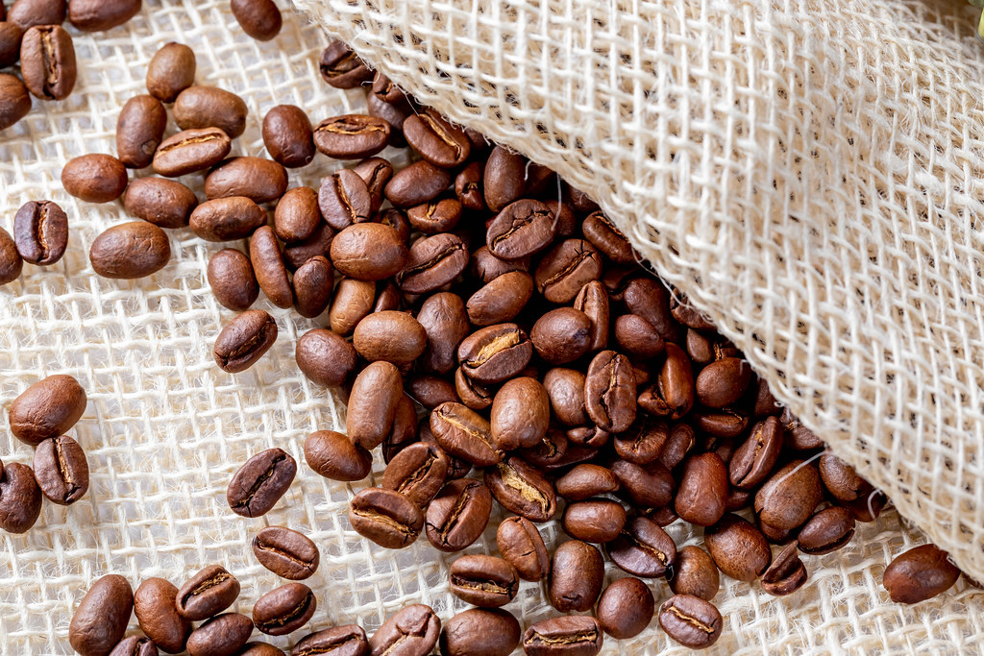

lava is the perfect fully responsive Ecommerce Webflow template for coffee shops and roasteries. showcase the delicious coffee you offer in your coffee shop.

From the personalities in which they exist to the communities that grow our coffee beans, we are committed to investing and creating opportunities to positively impact people's lives. Exchanging groups, helping at work, bringing activism into work, bringing activism into individuals - all this is an axe part of our identity as a sustainable company. As a publicly traded company, Starbucks believes in striking a balance. between business and social amenities

**Question / Need :**

Is LAVA so expensive?

Is drinking LAVA health?

How long can I stay in LAVA?

Is LAVA comfortable or not?

Are the staff and Services good ?

**Features:**

|  |  |
| --- | --- |
| **Field name** | **Describtion** |
| shop_name | coffee shop's name |
| rating | Coffe shop's rating |
| numbers_of_rating | number of ratings for each coffee shop |
| Price | how expensive is the coffee shop - 1 is inexpensive |
| shop_type | coffee shop's type. Either cafe or coffee shop |
| key_words | coffee shop's style |
| Address | coffee shop's address |

**Tools:**

**Technologies** :

python, SQL , Jupyter notebook, SQL, SQLite

**Libraries:**

( math , panda , Numpy , Matplotlib, SQLAlchemy)

**Presentation:**

PowerPoint