conversion in numberN

Artificial-Intelligence-Dietician

Mini Project submitted in partial fulfilment of the requirements for the Degree of

BACHELOR OF TECHNOLOGY
in
COMPUTER SCIENCE AND ENGINEERING
By
TALEBUL ISLAM 11904195 (58)
R. Mani Teja 11807450 (59)

Section : K18GT
Under the guidance of
AMANDEEP KAUR

School of Computer Science and Engineering
Lovely Professional University
Phagwara, Punjab (India)
APR 2020

ABSTRACT
As people across the globe are becoming more interested in watching their weight, eating more healthy food and avoiding junk food, a system that can measure calories and nutrition in every day meals can be very useful for maintaining our health. The online artificial dietician is a bot with artificial intelligence about human diets. It acts as a diet consultant similar to a real dietician. Dieticians are educated with nutrient value of foods. A dietician consults a person based on his schedule, body type, height and weight. The system too asks all this data from the user and processes it. It asks about how many hour the user works, his height, weight, age etc.
The system stores and processes this data and then calculates the nutrient value needed to fill up users needs. The system then shows an appropriate diet to the users and asks if user is ok with it, else it shows other alternate diets to fill up users needs. In today’s world, due to hectic schedule people cannot concentrate on their health. So there is need to suggest a diet plan, so they can maintain their health. We should take proper diet for our growth. AI dietician is an artificial intelligence dietician which provides proper diet plan to the user. The approach presented in this paper considers Height, Weight, BMI, Age, Gender and various diseases. A weighing machine is used to measure weight. The evaluation parameters are Height, Weight, BMI, Age, Gender and various diseases. The obtained result is in the form of diet plan.

Chapter -1
INTRODUCTION

To maintain health and to have our health in good condition, everyone should take a diet. This is very important for maintaining a good health condition. Now a day’s people are taking non healthy food and they got some severe diseases because of their careless behavior. These diseases are curable but health condition degrades. So every person should take proper diet for his/her own concern. People should follow dietary guidelines as well. This work exactly fulfills this requirement. This work provides a required diet plan to the user by considering different factors.
The system measures user’s BMI using his or her height and weight. It provides a proper diet plan to the individual considering age, gender, height, weight, disease. : The objective of this project is to provide an online bot which suggests diet plan based on user’s height, weight and eating habits.
The system measures a user’s body mass index using his/her height and weight. The system has been trained with large dataset of food varieties and their nutritional values. Once the system has the user’s body mass index, it needs to know eating habit of the user. The user has to provide information about the timings he eats. Timings for breakfast, lunch, snacks and dinner are entered by the user. Once the system has this data, it suggests the user a diet plan as per the user’s body mass index. If the user doesn’t like the diet plan the system modifies the diet plan keeping nutritional value the same. This is done to ensure that the user likes the diet suggested to him. Thus the need to travel to a dietician to know the diet plan can be removed. The users can get a diet plan based on their body mass index if they know their height and weight. No need to pay a visit to local dietician any more.
This system is developed using the Microsoft dot net framework with Microsoft SQL Server as the backend database. For developing this application Microsoft Visual Studio has to be used as the IDE.

Chapter-2
LITERATURE SURVEY
Husain et al. cancer is very severe disease. It is occurring frequently now days. Some systems are available in market which suggests diet for cancer but they are not sufficient. These systems only suggest one or two food items which help to secure from disease. This system provides a complete diet plan for cancer .cancer is a disease which is not curable. It needs kemo therapy which has side effects. Therefore the one and only solution to this is to take proper diet to prevent from getting such type of disease.
TALEBUL ISLAM. This work describes the diet plan for diabetic patients. This system is based on a virtual dietician concept. a chat bot is designed which works as a dietician. The history and view of chat bot is provided in this system. Diet plan for diabetic patients is given using this chat bot. this system is the interface between man and machine. chat bot concept provide interface that gives the diet plan for diabetic patients.
Barnett et al.This work provides diet plan for obese people.As obesity is a major health problem proper diet is very essential. To lose weight for obese people is a very difficult task. There are certain ranges of BMI which decides normal, underweight or overweight. The BMI above30 is refer as BMI for overweight people. This paper provides a system which manages weight and provides a good diet to lose weight. There is face to face consultation between dietician and a person. Because of this dieticians get clients automatically and clients get the proper advice without wastage of time for travelling to dietician.
Carl J. Brandt et al. Obesity is a major health problem . Each and everyone should take care of his/her health and should maintain a proper health condition. This system provides a diet plan to the user to lose weight. As today’s world is internet world and there is Gmail service available, this work gives a system which uses the emailed of the user. Based on email id of user the system sends the diet plan to him/her on their respective email ids.
Talapanty Shwetha et al. This work provides an intelligent agent which will give a diet plan to user. Eating habits of different person are different therefore their diet plan should be different. Lifestyle of each person is different. The different tensions are there for different professions. Because of this stress a proper diet is essential to follow. This work gives a proper diet which is different for each person. The user has to enter the information about his lifestyle and according to that, the diet plan will be displayed.

Chapter-3
MODULES AND REQUIREMENTS

Modules:
- Diet Data processing
- User nutrition counseling
- Efficient user handling

System Requirements:
Software Components:
- Operating System : Windows Xp, Windows 7(ultimate, enterprise)
- Anaconda
- IDE : Jupiter
Hardware Components:
- Processor : intel core i3
- Hard Disk : 5 GB
- Memory : 1GB RAM

Technologies :
- Python 3

Chapter-4
IMPLEMENTATION
Implementation steps of our work as follows:
- Measure height of the user using Ultrasonic sensor.
- Measure weight of the user using weighing machine.
- We should enter height in meter and weight in kg to calculate BMI.
- BMI is calculated as follows BMI= weight / (height)^2
- Enter Age and Gender of User.
- Enter the Disease if any.
- Choose Database according to the input factors given.
- Display database on mobile app

In Our Work to suggest diet plan to user. we measure his/her Height using Ultrasonic sensor and measured data will be automatically send to raspberry pi B3+ module. In G display we enter Height, Weight , Age ,Gender and Disease if any. according to the Tkinter programming the best Database will be selected and display on the Screen till date but we are developing an mobile app on which diet plan will be suggested .

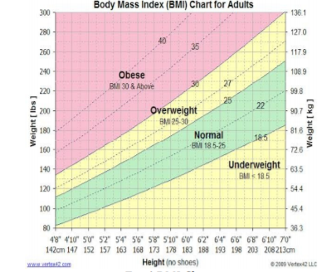

Representation of Ultrasonic sensor with wave forms:
The waveforms are Trigger, 8 adjacent clock pulses and time it takes to leave and return. The Ultrasonic module2cm - 400cm ranging accuracy and can reach to 3mm which can be used for object detection. It has ultrasonic transmitters, receiver and control circuit. The basic principle is using trigger for at least 10us high level signal and then sends eight 40 kHz cycle and checks if there is a pulse signal back. The pulse gets back through high level time duration, time distance can be calculated as follows.
Time Distance = (velocity of sound * high level time)/2

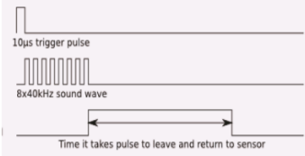
Chapter-5
EXISTING AND PROPOSED SYSTEMS

EXISTING SYSTEM:
In the previous system diet charts are usually generated using conditioning algorithms and data mining which hypes the use of database and purey depending on the database which leads to entering of data again and again and also it dossen’t focus on health condition Existing system takes in account the users height weight and gives a diet chart without taking his/her daily routine health conditions types of food they can eat into account which was a serious issue.AI domain gives a edge of generating a proper diet plan which lacks in other system as the domain is not the same.

DRAWBACKS:
- It doesn’t take users health condition (like diabetes or cardiac patients) into account.
- It does not asks user about his daily routine and food choices.
- Majority of system don’t use AI as their domain

PROPOSED SYSTEM:
The proposed system is a responsive website which contains the knowledge and data regarding the fitness of a person. We also referred data required to develop the website, from gym exercise book which makes the website a unique one. This website consist the user interface which will be publically displayed on the website i.e. the basic information regarding the fitness such as how to maintain good health by doing some workouts and by eating some food products which includes calories, proteins and carbohydrates etc.
ADVANTAGES:
- No need of consulting doctor for diet plans.
- This system provides full details of the nutrient constitution in body and if required more or not along with the plan by just answering to some queries.
- Saves money and very effective and give accurate results as it is coded with keeping diet chart in mind.
- There are alternative diet chart provided by the system if the user don't like any.

Chapter-6
RESULTS

The proposed work gives following results:
1) The system gives diet plan to the users on mobile based on BMI and other factors.
2) This result represents diet plan for obese people.
3) This result represents diet plan for people having pcos disease.
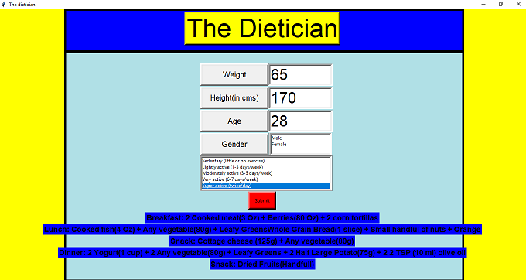

Conclusion & Future Scope:
This project Conclude that the designed system is useful for common people to maintain their health by taking proper diet. We can develop a system in which if the user is at a remote place, he/she can send details through GUI interface and system can send diet plan to user

Chapter-7
REFERENCES

1. Husain et al. ” Application of Data Mining Techniques in a Personalized Diet Recommendation System for Cancer Patients” IEEE Colloquium on Humanities , Science and Engineering Research Dec 2019.
2. Abbas Lokman and JasniZain.”An Architectural Design of Virtual Dietician (ViDi) for diabetic patients.”
3. Barnett et al. “An Integrative Health Platform for Supporting Weight Loss and Maintenance Behaviours.” IEEE Journal of Biomedical and Health Informatics, Vol.19, No.1, Jan 2015.
4. Carl J. Brandt et al.” E-dietician in General Practice” Second International Conference on eHealth, Telemedicine, and Social Medicine 2019.
5. TalapantyShwetha et al. “Artificial Intelligence Dietitian Using Android”. International Journal of Scientific Research in Computer Science, Engineering and Information Technology2017 IJSRCSEIT | Volume 2 | Issue 2.
6. HITESH PRUTHI et al.“ARTIFICIAL INTELLIGENCE DIETICIAN”. International Journal of Recent Trends in Engineering and Research.

