**LOVELY PROFESSIONAL**

**UNIVERSITY**

**Assignment**

**Operating system Lab**



**Department of Computer Science & Engineering**

Submitted By:- Project In Charge:-

Talebul Islam Priyanka mittal

Roll No:- 58 Section : gt (assistant professor)

Reg No :- 11904195

Github Link : - <https://github.com/talebulislam/Lab-Operating-System>

**2.Write a program to eliminate race condition using semaphores**

#include <stdio.h>

#include <stdlib.h>

#include <pthread.h> //compile and link with -pthread

#include <semaphore.h>

int global = 0;

sem_t mutex;

void *inc( void *ptr )

{

int i;

for(i = 0; i < 9000000; i++)

{

sem_wait(&mutex);

global++;

sem_post(&mutex);

}

}

void *dec( void *ptr )

{

int i;

for(i = 0; i < 9000000; i++)

{

sem_wait(&mutex);

global--;

sem_post(&mutex);

}

}

int main()

{

pthread_t thread1, thread2;

sem_init(&mutex, 0, 1);

pthread_create( &thread1, NULL, inc, NULL);

pthread_create( &thread2, NULL, dec, NULL);

pthread_join( thread1, NULL);

pthread_join( thread2, NULL);

sem_destroy(&mutex);

printf("Final global = %d\n", global);

exit(0);

}

Output : -

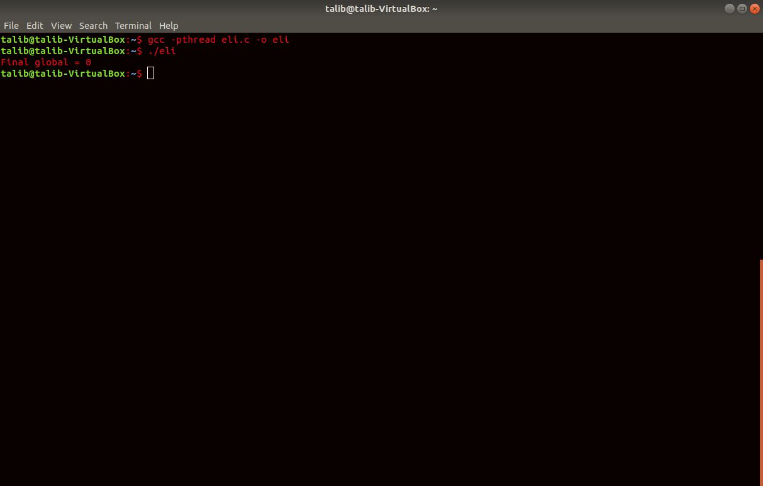

**4.Write a program to create a thread that calculates the average Marks of a student. The result is passed back to the main program For printing.**

#include <stdio.h>

#include <stdlib.h>

#include <pthread.h> //compile and link with -pthread

#include <semaphore.h>

int global = 0;

sem_t mutex;

void *inc( void *ptr )

{

int i;

for(i = 0; i < 9000000; i++)

{

sem_wait(&mutex);

global++;

sem_post(&mutex);

}

}

void *dec( void *ptr )

{

int i;

for(i = 0; i < 9000000; i++)

{

sem_wait(&mutex);

global--;

sem_post(&mutex);

}

}

int main()

{

pthread_t thread1, thread2;

sem_init(&mutex, 0, 1);

pthread_create( &thread1, NULL, inc, NULL);

pthread_create( &thread2, NULL, dec, NULL);

pthread_join( thread1, NULL);

pthread_join( thread2, NULL);

sem_destroy(&mutex);

printf("Final global = %d\n", global);

exit(0);

}

Output : -

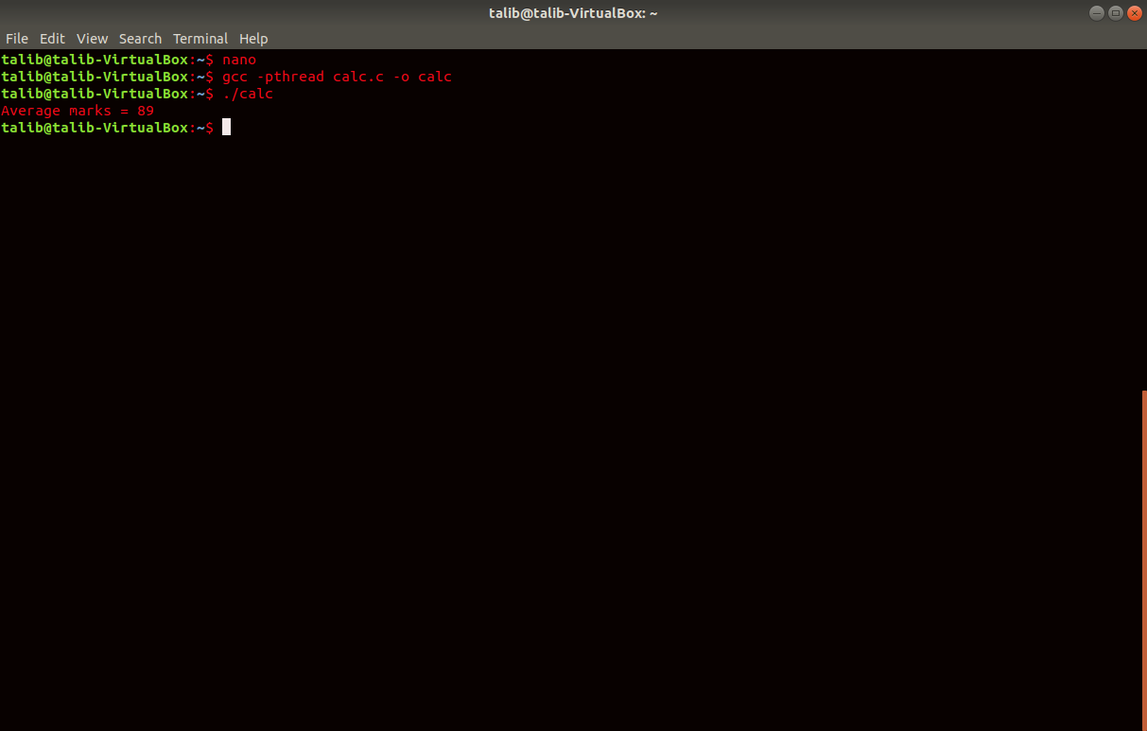

**6.Writeaprogram to generate the deadlock condition using semaphore.**

#include <stdio.h> // Input/Output

#include <unistd.h> // Time management (usleep)

#include <pthread.h> // Threads management

#include <sys/sem.h> // Semaphores management

#define PERMS 0660 // -rw permissions for group and user

int semId;

int initSem(int semId, int semNum, int initValue)

{

return semctl(semId, semNum, SETVAL, initValue);

}

/* An operation list is structured like this :

* { semphore index, operation, flags }

* The operation is an integer value interpreted like this :

* >= 0 : Rise the semaphore value by this value.

* This trigger the awakening of semaphores waiting for a rise.

* == 0 : Wait for the semaphore to be at value 0.

* < 0 : Substract abs(value) to the semaphore.

* If then the semaphore is negative, wait for a rise.

*/

// Try to take a resource, wait if not available

int P(int semId, int semNum)

{

// Operation list of 1 operation, taking resource, no flag

struct sembuf operationList[1];

operationList[0].sem_num = semNum;

operationList[0].sem_op = -1;

operationList[0].sem_flg = 0;

return semop(semId, operationList, 1);

}

// Release a resource

int V(int semId, int semNum)

{

// Operation list of 1 operation, releasing resource, no flag

struct sembuf operationList[1];

operationList[0].sem_num = semNum;

operationList[0].sem_op = 1;

operationList[0].sem_flg = 0;

return semop(semId, operationList, 1);

}

void* funcA(void* nothing)

{

printf("Thread A try to lock 0...\n");

P(semId, 0); // Take resource/semaphore 0 of semID

printf("Thread A locked 0.\n");

usleep(50*1000); // Wait 50 ms

printf("Thread A try to lock 1...\n");

P(semId, 1); // Take resource/semaphore 1 of semID

printf("Thread A locked 1.\n");

V(semId, 0); // Release resource/semaphore 0 of semID

V(semId, 1); // Release resource/semaphore 1 of semID

return NULL;

}

void* funcB(void* nothing)

{

printf("Thread B try to lock 1...\n");

P(semId, 1); // Take resource/semaphore 0 of semID

printf("Thread B locked 1.\n");

usleep(5*1000); // Wait 50 ms

printf("Thread B try to lock 0...\n");

P(semId, 0); // Take resource/semaphore 1 of semID

printf("Thread B locked 0.\n");

V(semId, 0); // Release resource/semaphore 0 of semID

V(semId, 1); // Release resource/semaphore 1 of semID

return NULL;

}

// Main function

int main(int argc, char* argv[])

{

int i; // Iterator

// We create a set of 2 semaphores

// ftok generates a key based on the program name and a char value

// This avoid to pick an arbitrary key already existing

semId = semget(ftok(argv[0], 'A'), 2, IPC_CREAT | PERMS);

// Set the semaphore at index 0 to value 1 (= available for use)

initSem(semId, 0, 1);

// Set the semaphore at index 1 to value 1 (= available for use)

initSem(semId, 1, 1);

pthread_t thread[2]; // Array of threads

pthread_create(&thread[0], NULL, funcA, NULL);

pthread_create(&thread[1], NULL, funcB, NULL);

// Wait until threads are all complete

for (i = 0 ; i < 2 ; i++)

{

pthread_join(thread[i], NULL);

}

printf("This is not printed in case of deadlock\n");

// Free the semaphores

semctl(semId, 0, IPC_RMID, 0);

semctl(semId, 1, IPC_RMID, 0);

return 0;

}

Output : -

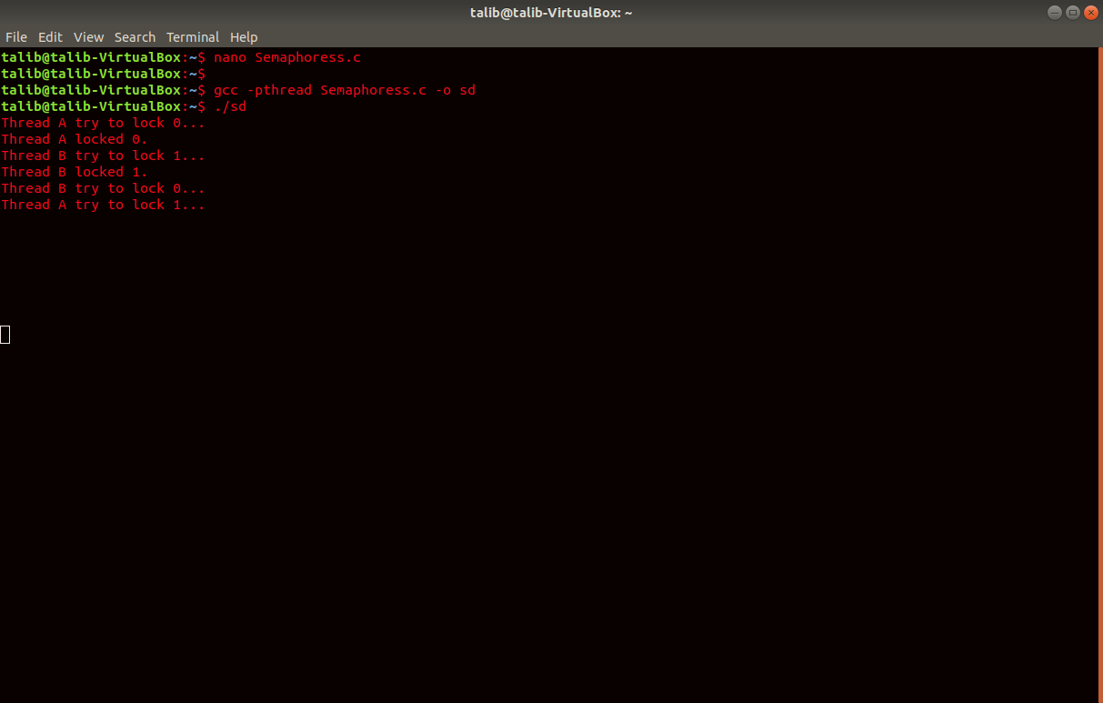

**8.Write a program using semaphore to avoid the race condition.**

With the help of dining philosopher problems

#include <stdio.h>

#include <unistd.h>

#include <pthread.h>

#define N_PHILOSOPHERS 5

#define LEFT (ph_num + N_PHILOSOPHERS - 1) % N_PHILOSOPHERS

#define RIGHT (ph_num + 1) % N_PHILOSOPHERS

pthread_mutex_t mutex;

pthread_cond_t condition[N_PHILOSOPHERS];

enum

{

THINKING, HUNGRY, EATING } state[N_PHILOSOPHERS];

int phil_num[N_PHILOSOPHERS];

void *philosophing (void *arg);

void pickup_forks(int ph_num);

void return_forks(int ph_num);

void test(int ph_num);

int main(int argc, char *argv[])

{

pthread_t ph_thread[N_PHILOSOPHERS];

pthread_mutex_init(&mutex, NULL);

for (int i = 0; i < N_PHILOSOPHERS; i++)

{

pthread_cond_init(&condition[i], NULL);

phil_num[i] = i;

}

for (int i = 0; i < N_PHILOSOPHERS; i++)

{

pthread_create(&ph_thread[i], NULL, philosophing, &phil_num[i]);

printf("Philosopher #%d sits on the table.\n", i + 1);

sleep(1);

}

for (int i = 0; i < N_PHILOSOPHERS; i++)

pthread_join(ph_thread[i], NULL);

pthread_mutex_destroy(&mutex);

for (int i = 0; i < N_PHILOSOPHERS; i++)

pthread_cond_destroy(&condition[i]);

return(0);

}

void *philosophing(void *arg)

{

while(1)

{

int *ph_num = arg;

printf("Philosopher #%d starts thinking.\n", *ph_num + 1);

sleep(2);

pickup_forks(*ph_num);

return_forks(*ph_num);

}

}

void pickup_forks(int ph_num)

{

pthread_mutex_lock(&mutex);

printf("Philosopher #%d is HUNGRY. She tries to grab her forks.\n", ph_num + 1);

state[ph_num] = HUNGRY;

test(ph_num);

while (state[ph_num] != EATING)

pthread_cond_wait(&condition[ph_num], &mutex);

pthread_mutex_unlock(&mutex);

}

void return_forks(int ph_num)

{

pthread_mutex_lock(&mutex);

printf("Philosopher #%d puts down chopsticks. Now she asks her neighbors if they are hungry.\n", ph_num + 1);

state[ph_num] = THINKING;

test(LEFT);

test(RIGHT);

pthread_mutex_unlock(&mutex);

}

void test(int ph_num)

{

if (state[ph_num] == HUNGRY && state[LEFT] != EATING && state[RIGHT] != EATING)

{

printf("Philosopher #%d starts EATING.\n", ph_num + 1);

state[ph_num] = EATING;

sleep(3);

pthread_cond_signal(&condition[ph_num]);

}

}

Output :-

