**AE2IIP Coursework**

Name: Tianlang Tan

Student ID: 20028268

1. **Task 1**
   1. **Effective filters**

|  |  |  |  |  |  |
| --- | --- | --- | --- | --- | --- |
| Noise | Mean filter | Gaussian filter | Median filter | Anisotropic filter | Bilateral filter |
| Gaussian | **21.47** | **22.17** | **21.58** | **21.37** | **22.18** |
| Uniform | **20.17** | **21.00** | **18.33** | **18.04** | **21.01** |
| S&P | **17.29** | **18.12** | **23.89** | **12.70** | **18.13** |

the SNR value is obtained from default parameter in the task1 specification sheet

1. Noise

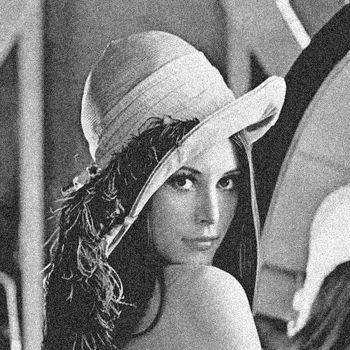

Figure 1: Gaussian noise

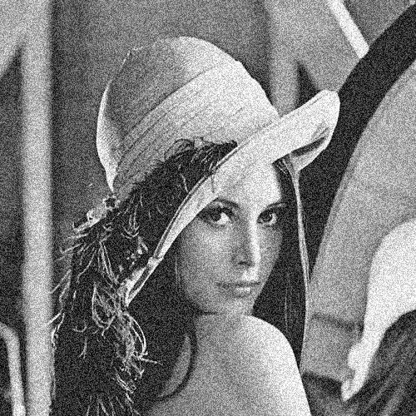

Figure 2: Uniform noise

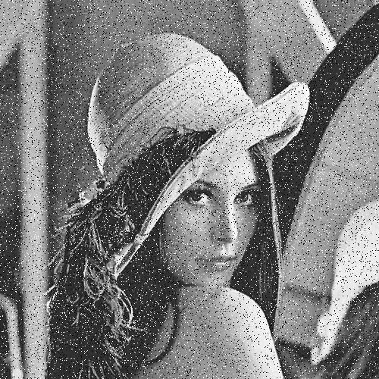

Figure 3: salt and pepper noise

1. Filter on Gaussian noise

Figure 4: mean filter

Figure 5: Gaussian filter

Figure 6: median filter

Figure 7: Anisotropic filter

Figure 8: Bilateral filter

1. Filter on Uniform noise

Figure 9: mean filter

Figure 10: Gaussian filter

Figure 11: median filter

Figure 12: Anisotropic filter

Figure 13: Bilateral filter

1. Filter on Salt & pepper noise

Figure 14: mean filter

Figure 15: Gaussian filter

Figure 16: median filter

Figure 17: Anisotropic filter

Figure 18: Bilateral filter

**Filter quality:**

Median filter is more effective to the salt & pepper noise. It shows the highest SNR value. Also, from the image visual quality, noise is greatly reduced by applying median filter.

For both uniform noise and Gaussian noise, using the default parameter in task1, Gaussian and bilateral filter have almost the same SNR value which is higher than other three filters. However, for Gaussian and bilateral filter, when the filter size are equal and σ of Gaussian filter is equal to σs of bilateral filter, if the σr is relatively small (the tuning result is between 0.2 - 1), bilateral filter can gain greater SNR value than Gaussian filter (the difference between two SNR values can reach to 2 by tuning parameter). There is no obvious difference between these two filters applied on the same image. Hence, from the image visual quality and SNRs, bilateral filter is more effective to uniform noise and Gaussian noise.

* 1. **Parameters**

1. the size of filter:

For mean, median and Anisotropic filter, as the size increases, the image becomes smoother. Because the previous 3 filters take neighbor pixels into consideration, as the size increase, the number of neighbor pixels increases. Hence, the result image will be smoother. Apply mean, median and Anisotropic filter on Gaussian noise image:

Figure 19: mean filter (left size is 3, right size is 15)

Figure 20: median filter (left size is 3, right size is 15)

Figure 21: Anisotropic filter (left size is 3, right size is 15)

For Gaussian filter, if σ is relatively small, as the filter size increases, no obvious effect can be observed. If σ is relatively large, as the filter size increase, the image become more blurred. Because when σ is relatively small, the Gaussian function is steeper so that most of the weights fall in the middle. However, when σ is relatively big, the Gaussian function widens and flattens so that the image is smoother. Apply Gaussian filter on Gaussian noise image:

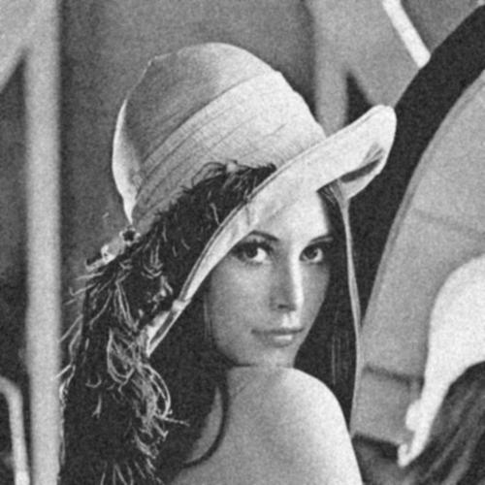

Gaussian filter σ = 1 (left size is 5, right size is 15)

Figure 22: Gaussian filter σ = 10 (left size is 5, right size is 15)

For bilateral filter, when σs is large, as filter size increases and σr remain the same, the image become more blurred. When σs is small, as filter size increases, no obvious effect can be observed. The reason is the same as the previous Gaussian filter. Apply bilateral filter on Gaussian noise image:

bilateral filter σs =1 (left size is 5, right size is 15)

Figure 23: bilateral filter σs =10 (left size is 5, right size is 15)

1. σ in Gaussian filter

Sigma determine the width of the Gaussian function. As the sigma increase, the image become smoother because the Gaussian function widens and flattens. Apply Gaussian filter on Gaussian noise image:

Figure 24: sigma (left size is 0.2, middle is 1, right size is 5)

1. the similarity function in anisotropic filter
2. σs, σr in bilateral filter

As σs increases, the bilateral filter is gradually closed to Gaussian convolution because the range Gaussian widens and flattens, which means that it becomes nearly the same over the intensity interval of the image. In other words, the image become blurred.

As σr increases, the larger features get smoothened.

Filter size：15

|  |  |  |  |  |
| --- | --- | --- | --- | --- |
| σr  σs | 0.1 | 1 | 10 | 100 |
| 1 |  |  |  |  |
| 3 |  |  |  |  |
| 10 |  |  |  |  |

1. **Task 2**

**2.1 Per-pixel level segmentation results**

|  |  |  |  |
| --- | --- | --- | --- |
|  | P | N | T |
| percentage | 81.66% | 95.41% | 93.60% |

**2.2 Explanation and justification**

The main idea of the algorithm: the preprocessing operation is to reduce the noise of the image and enhance the edge of the vessel for the edge detector to extract the edges. During the image processing, the vessels will be extracted, and noises are removed. The following figure is the main process of the algorithm

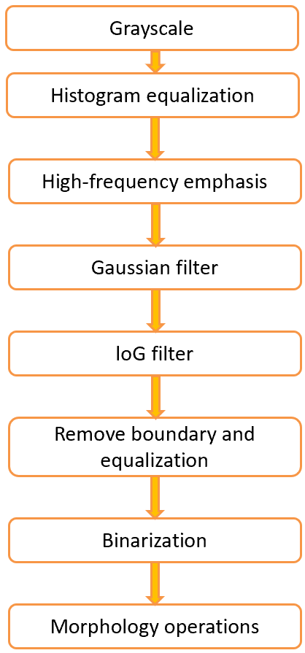

Figure 25: flow chart

1. The grayscale operation is to convert the image to grayscale for the following preprocessing

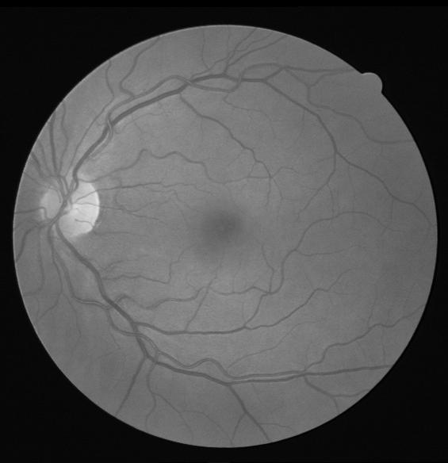

Figure 26: grayscale

1. The histogram equalization is used to increase the contrast of the image to enhance the blood vessels. This operation can enhance the edge of the vessels

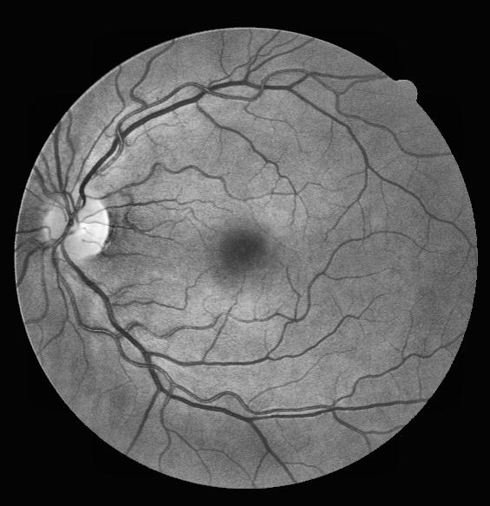

Figure 27: Histogram equalization

1. In high-frequency emphasis, high-pass Gaussian filters is implemented. This operation can also enhance the edge of the vessels.

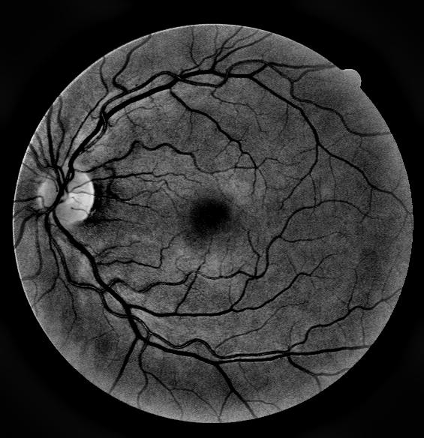

Figure 28: high-frequency emphasis

1. Gaussian filter is used to reduce the noise of the image. The filter size is 7 and σ is 0.9. This parameter combination can blur the noise meanwhile retain the blood vessels.

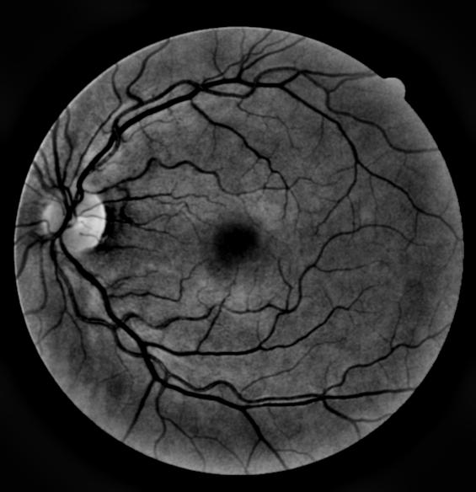

Figure 29: Gaussian filter

1. loG filter is used as an edge detector. This filter is chosen as it presents the best performance. loG filter can extract most of the blood vessels in the retina. The filter size is 1 and σ is 0.29. This parameter combination can catch most of the vessels including the small one meanwhile obtain relatively less noise.

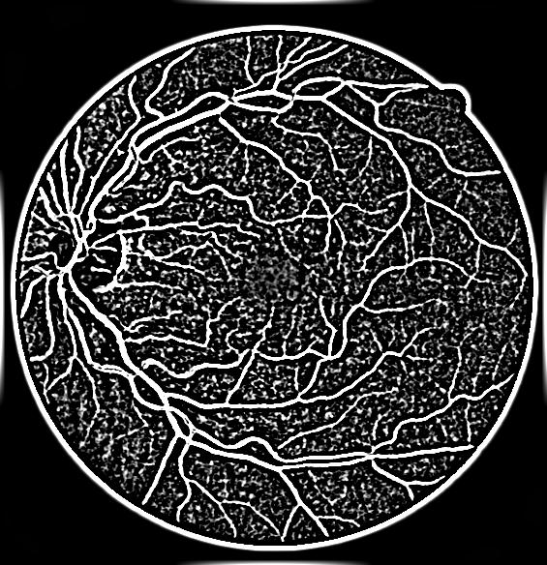

Figure 30: loG filter

1. Remove the outer boundary caused by loG filter. The boundary is removed by covering the mask on the image. After that, equalize the image again to increase the contrast.

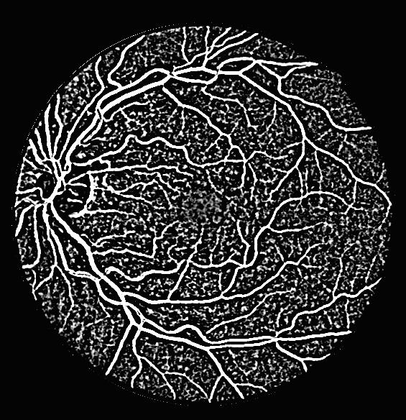

Figure 31: Remove boundary and equalization

1. The binarization process is to reduce the dark noise and preserve the blood vessels. The threshold of binarization is manually set as 0.55. If the threshold is greater, although there will be les noise, some of the small blood vessels will be lost.

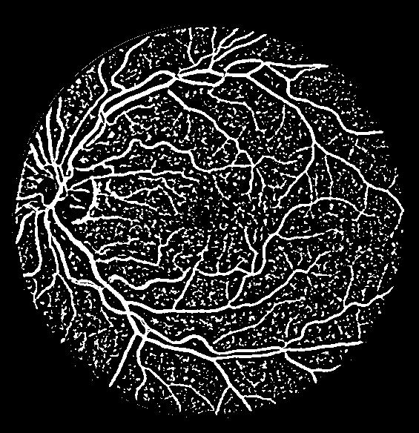

Figure 32: Binarization

1. The first morphology operation is to remove small connected component (less than 50 pixels). This operation can reduce a large amount of noise

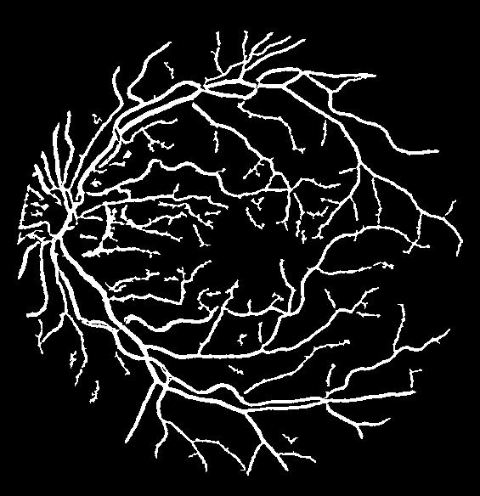

Figure 33: remove small connected component

1. The second morphology operation is close operation. This operation can fill in some small holes in the blood vessels. However, the close operation cannot close to much because dilation operation inside close operation will fill in the space between two blood vessels and combine them.

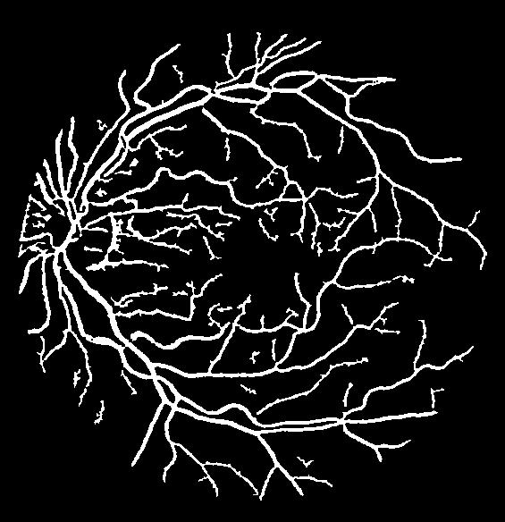

Figure 34: close operation

1. The third morphology operation is fill in small hole that can prevent the previous mentioned problem.

The main procedure is:

1. Fill all holes using imfill() function
2. Use logical operators to identify the hole pixels
3. Use bwareaopen() function on the holes image to remove small holes
4. Use logical operators to identify small holes
5. Use a logical operator to fill in the small holes in the original image

These operations can fill in the holes in the blood vessels with threshold that big holes between blood vessels can be preserved and small holes inside the blood vessels can be.

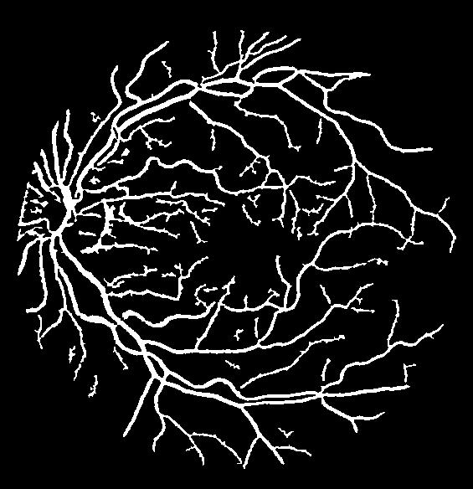

Figure 35: fill small holes

1. The final morphology operation is to remove small connected component again (less than 70 pixels)

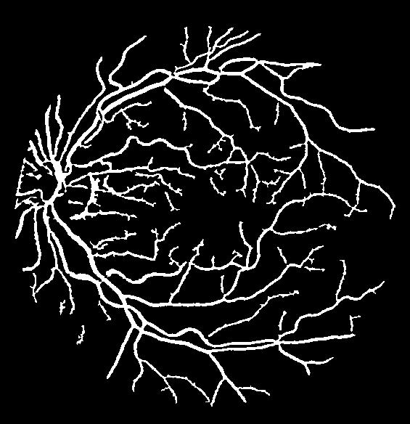

Figure 36: final image and label image

**2.3 Advantages and disadvantages**

This algorithm is compared with the other algorithm that the edge detector is sobel filter

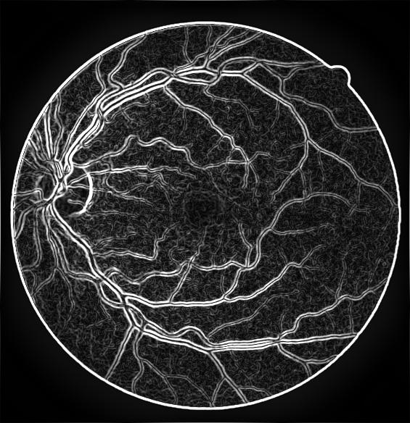 

Figure 37: sobel filter and loG filter

Although sobel filter can detect the main blood vessels and some of small vessels, it can only detect the edge of the blood vessel so that the vessels are hollow which is hard to fill in. Compared with sobel filter, loG filter can preserve more small blood vessels and most of the blood vessel is not hollow which is easier to fill in small holes.

The advantages of the algorithm:

1. Can preserve most of the blood vessels including small one blood vessels.
2. The location of all the main vessels are accurate.

The disadvantages of the algorithms:

1. To preserve more small blood vessels, more noises are included after applying loG filter. As a result, there are a few noises connected to the blood vessels and cannot be removed.
2. The location of the small vessels is less accurate than the big vessels due to the noise.
3. The optic disk cannot be removed by applying this algorithms