**AZURE APP CONFIGURATION:**

**Step 1**

Create app configuration store, search for app configuration and select app configuration.

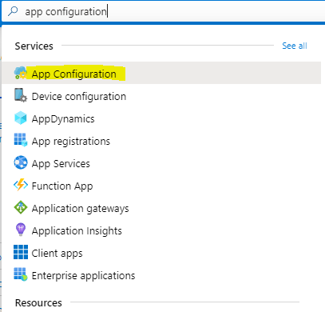

**Step 2**

Click on Add button, fill Resource name. subscription, resource group & location. Click on create button.

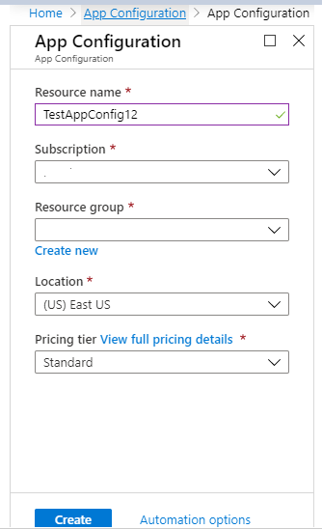

After click on create button your app configuration shown in list.



**Step 3**

Select configuration Explorer > create > Key-value and add following Key-value pairs

**Key Value**

TestApp:Settings:BackgroundColor blue

TestApp:Settings:FontSize 24

TestApp:Settings:FontColor Black

TestApp:Settings:Message Data from Azure App Configuration

Leave **Label** and **Content Type** empty for now. Select **Apply**.

**Step 4**

Go to settings and select Access keys. Copy primary connection string we’ll use it to read configuration from azure in asp.net core MVC application.

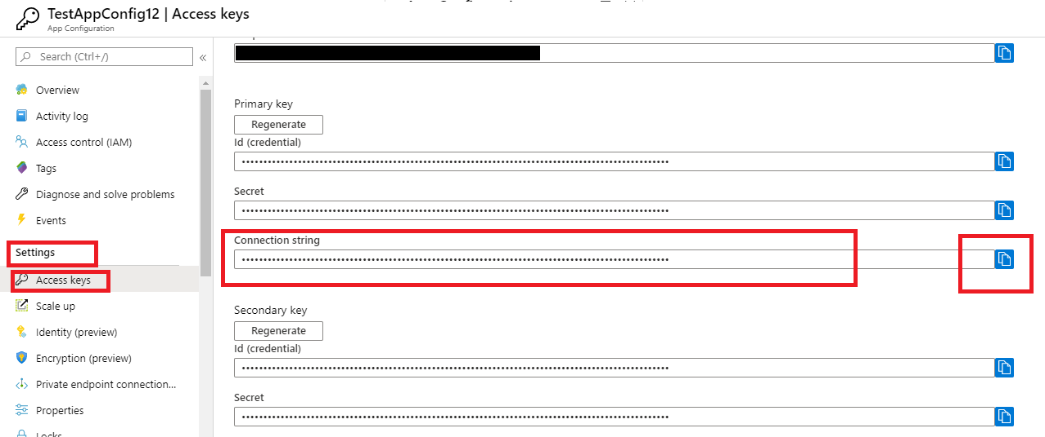

**Step 5**

Create asp.net core MVC application.

**Step 6**

Open the . csproj file. Add a UserSecretsId element as shown here. You can use the same GUID, or you can replace this value with your own. Save .csproj file

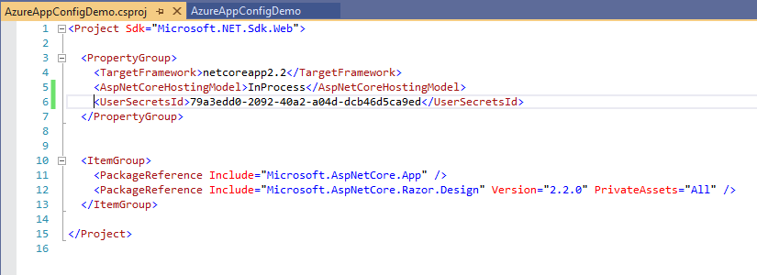

**Step 7**

Open package manager console and install below package and restore.

dotnet add package Microsoft.Azure.AppConfiguration.AspNetCore

dotnet restore

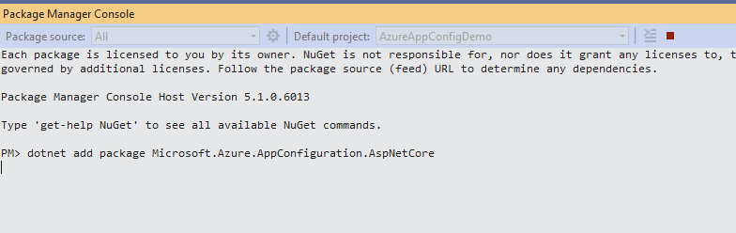

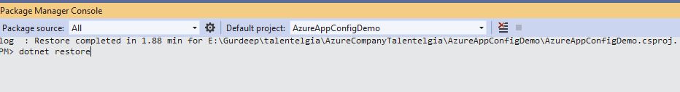

**Step 8**

Now we have to connect our application with azure app configuration. Run below command

dotnet user-secrets set ConnectionStrings:AppConfig <your_connection_string>

if above command gives error then give your connection string in double quotes.

**Step 9**

Update given code in program.cs file.

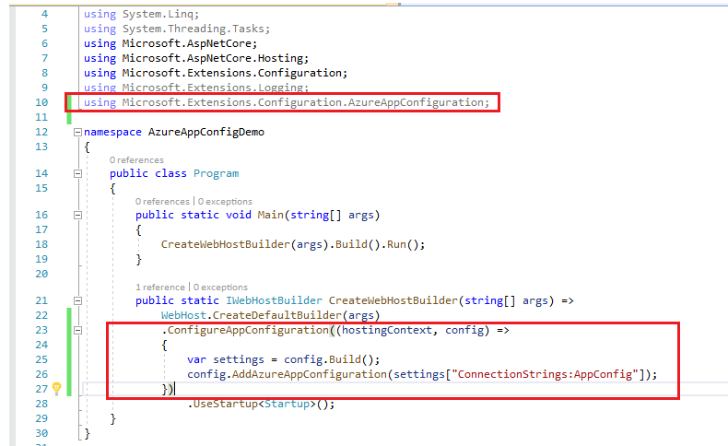

**Step 10**

Navigate to /Views/Home and open Index.cshtml. Replace its content with the following code:

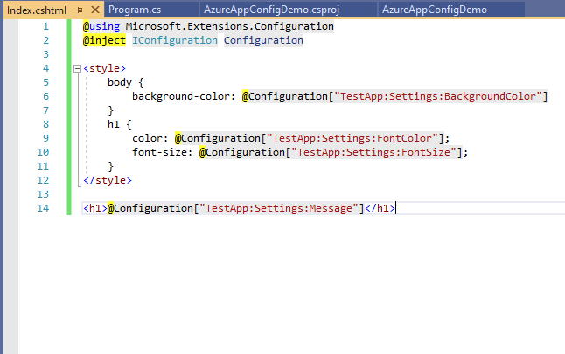

**Step 11**

Build and Run your application.

