**AZURE FUNCTIONS DEPLOYMENT:  
Step 1**

Right click on project and then click on publish option.

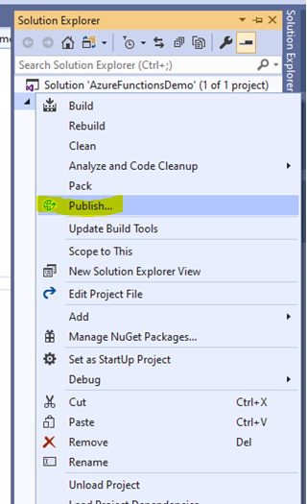

**Step 2**

There are two options for deployment one is create new and second one is select existing. In this we’ll select create new option and click on publish. We got below screen some of the option are prefilled and we have to create new “Resource Group”(3rd textbox).

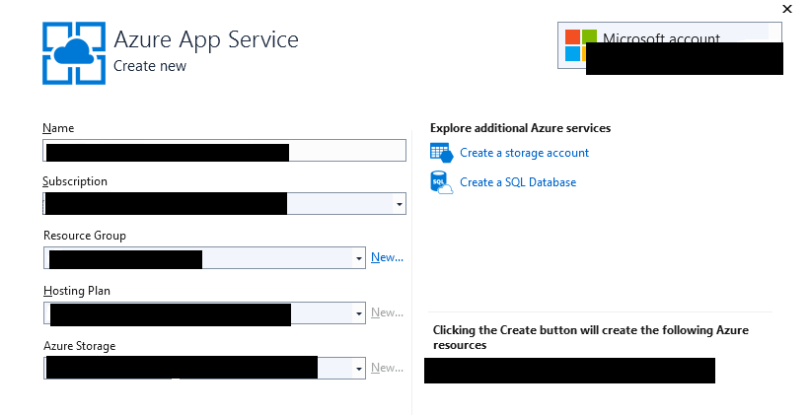

Step 3

Click on create button. It’ll create your azure app service on azure and deploy azure functions on azure portal.

Step 4

For check azure function is deployed or not. In search box write “azure function”. Click on azure function option your function app is visible there . click on function app it will open your function app where you’re able to see your triggered function.

