**AZURE LOGIC APPS:**

**In this demo we will capture new RSS feed and send RSS feed via mail to our users.  
Step 1**

Go to azure portal and search for logic apps then click on logic apps.

**Step 2**

Create new Logic app. Select subscription type and resource group. You can create new resource group also by clicking create new.

Give Logic app Name and select the location. Click on review + create button and then click on create button.

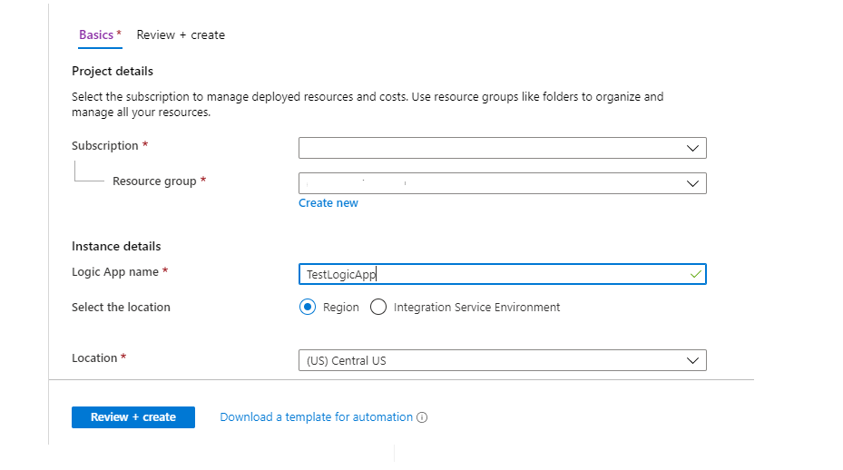

You got a message deployment is complete then click on Go to resource.



**Step 3**

There are multiple templates there, we need to use blank logic app template so select blank logic App template.

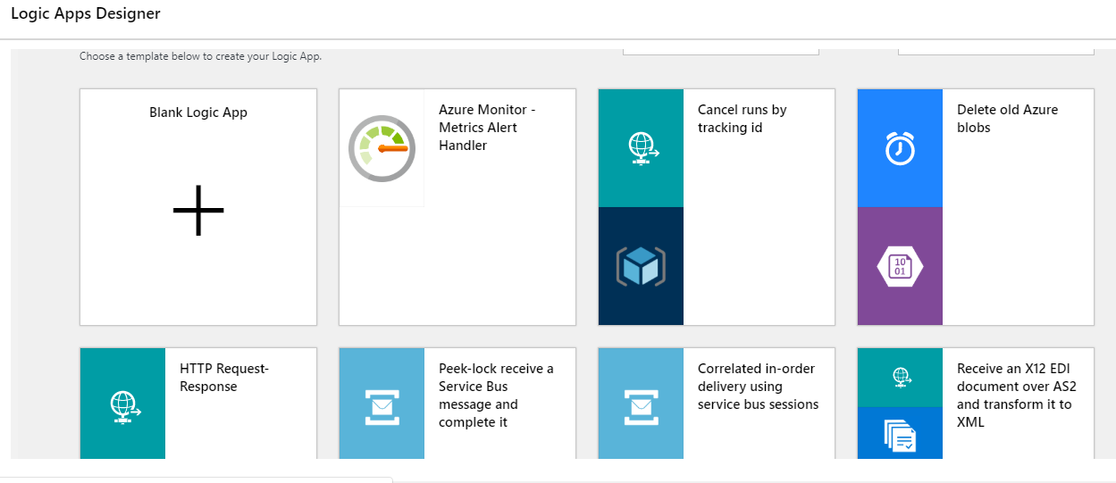

**Step 4**

Now we have to fetch new Rss feed and set initial event. Click on Rss option.

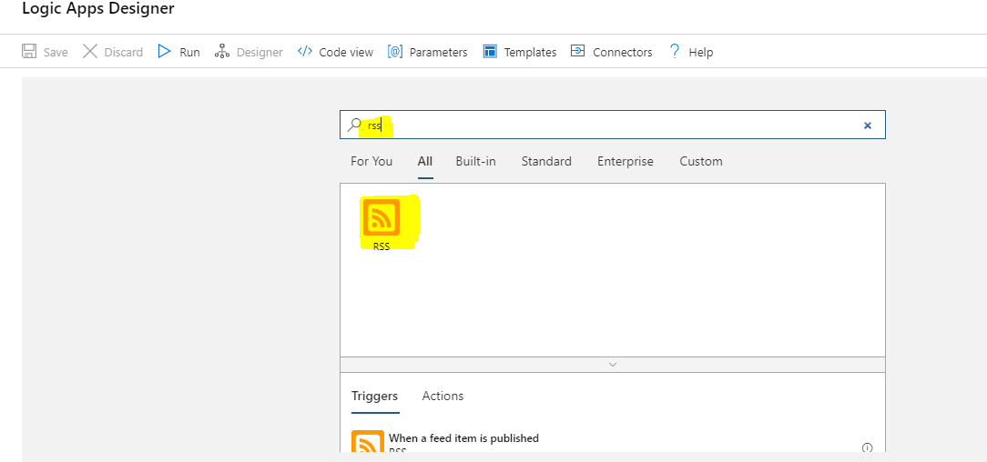

**Step 5**

Give Rss feed URL “http://feeds.reuters.com/reuters/topNews” Set interval to 1 and frequency in minute. Click on new step.

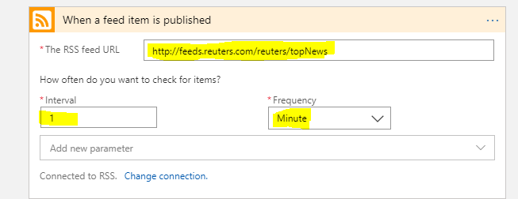

**Step 6**

Now we will setup an email account from which we will sent mail to users which contains new RSS feed. Search for gmail and select send email.

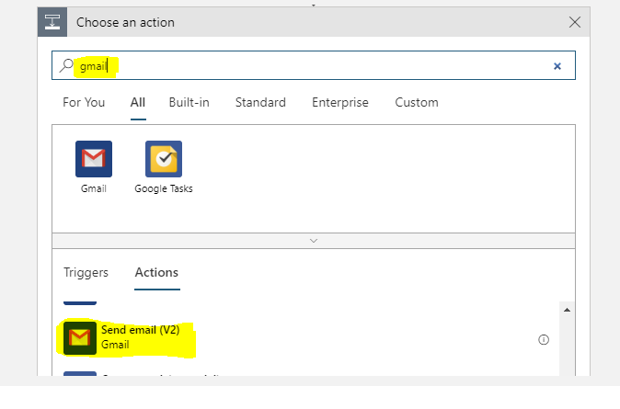

**Step 7**

Click on sign in button. 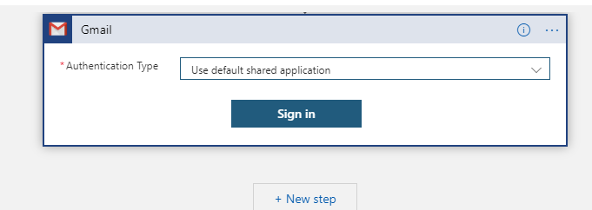

**Step 8**

After sign in create your email template and bind RSS feed option values in mail template. Please have a look given image. Click on save

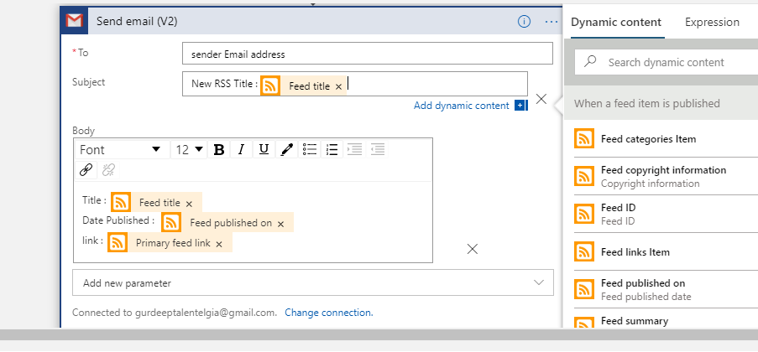

**Step 9**

Click on Run. Please have a look on email account.

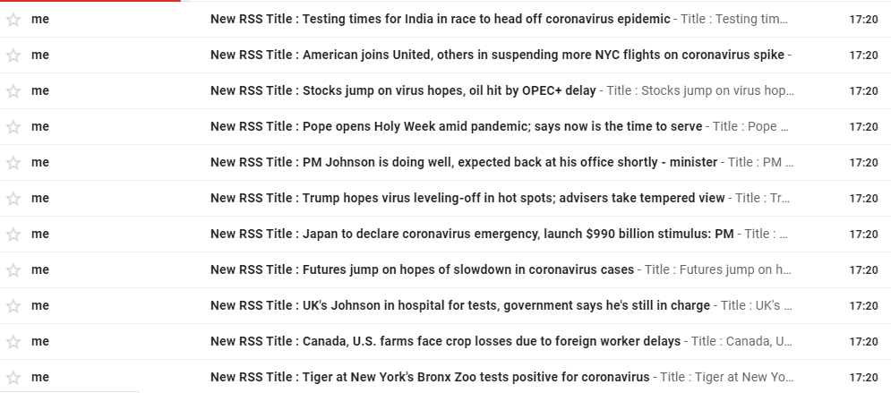

**Step 10**

For stop logic app, go to overview and click on disable button.