Biz Plan changes. –

Needs more Branding Throughout with some of our original business plan graphics
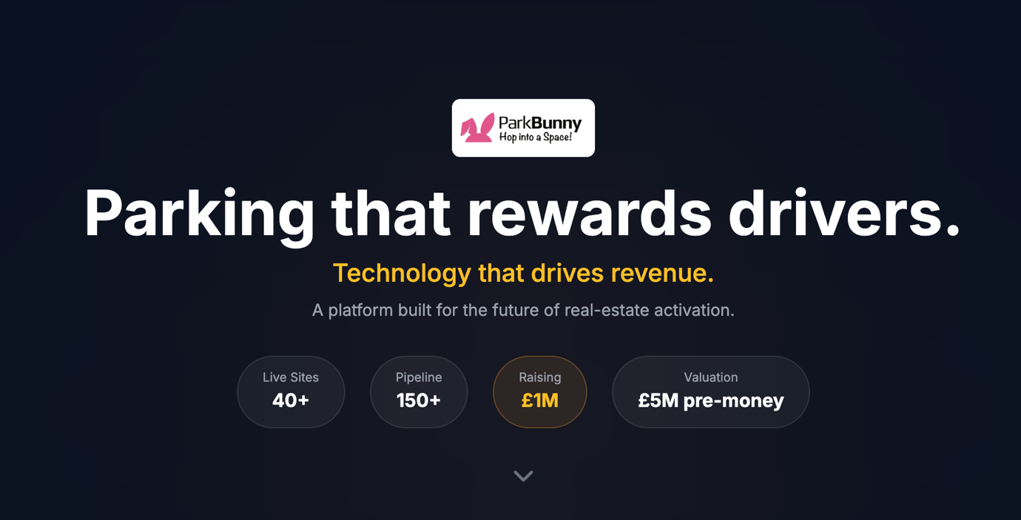
50 + sites
Raising £400k
£5m pre money valuation

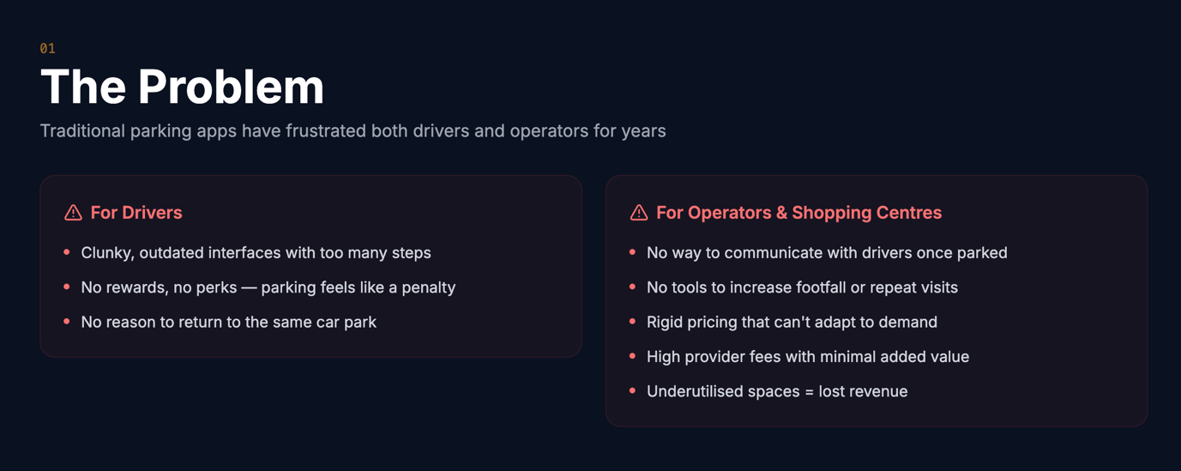

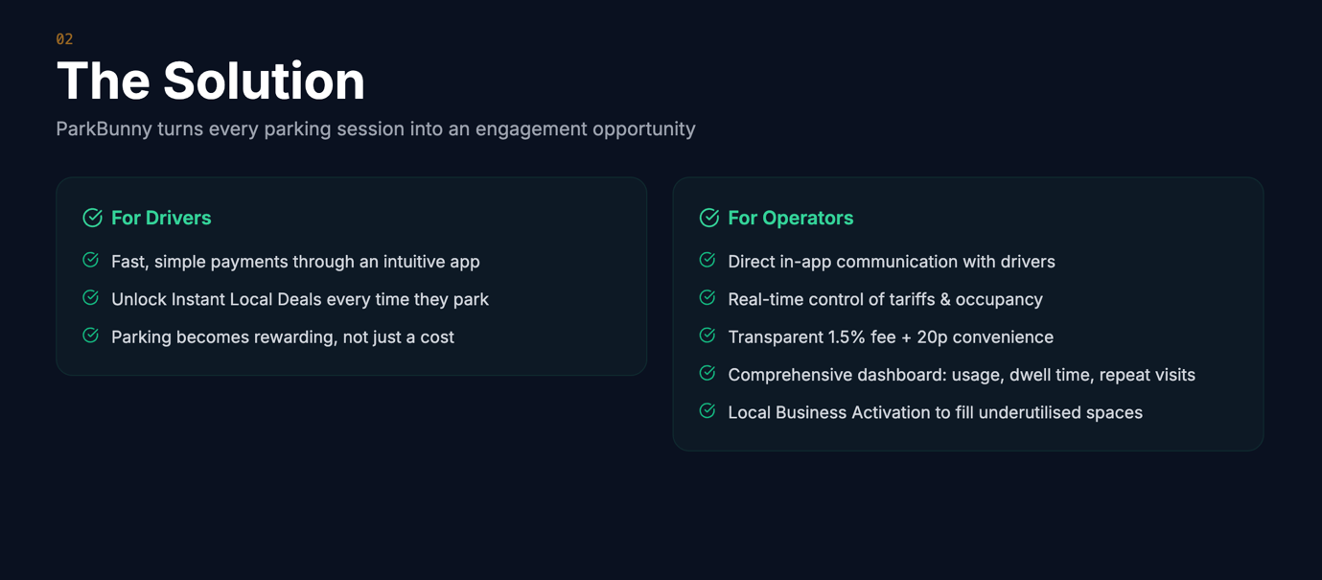
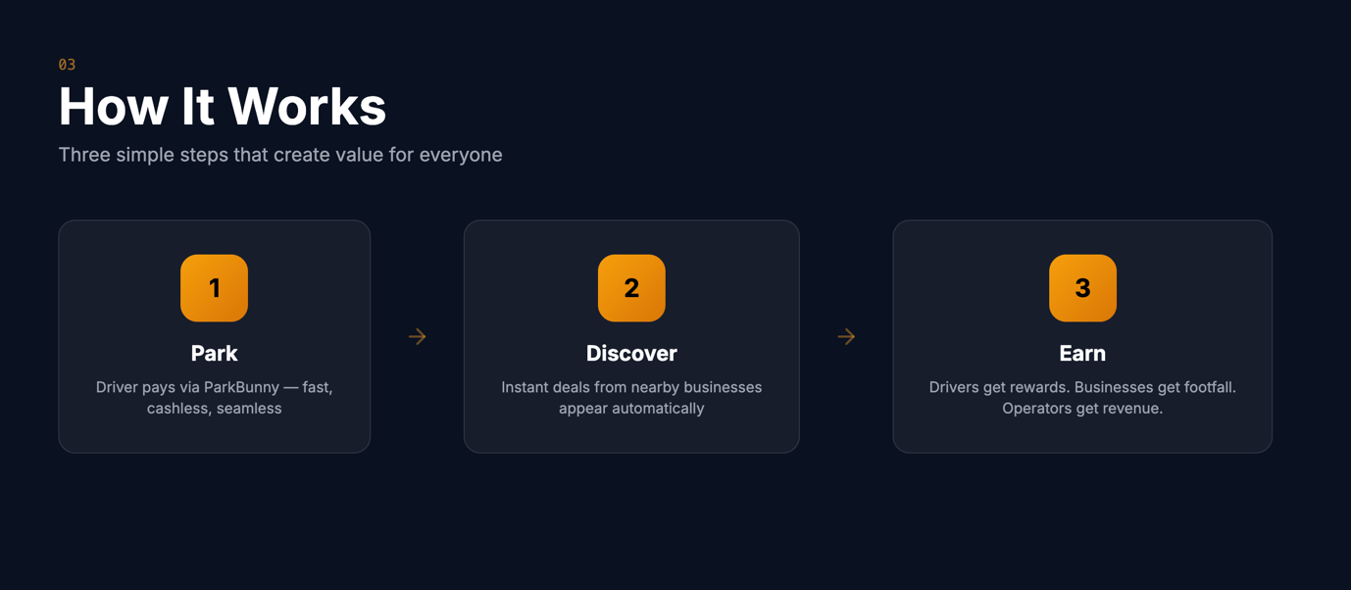

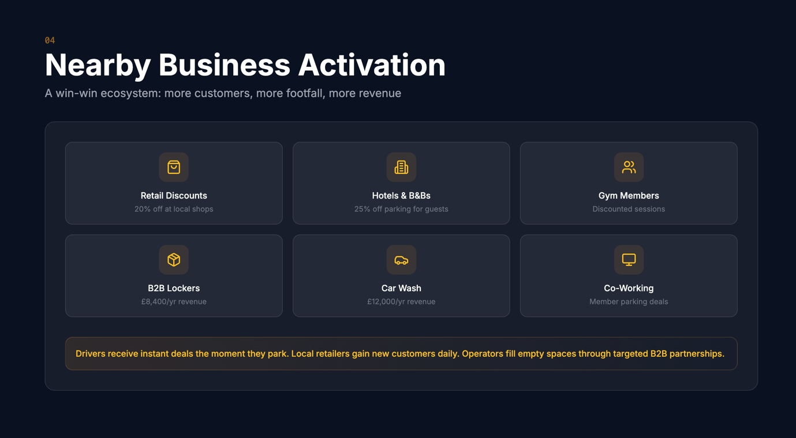

Supporting Independent retailers by offering hyperlocal discounts to drivers from local businesses ( prob needs re wording ) Food, retail, beauty and fitness rewards
Giving independent retailers the chance to turn a new customer into a regular customer
Ai driven hyperlocal outreach to Hotels, Gyms, offices etc offering discounted tariffs in return for promoting the car park to their guests, members and staff
Additional Revenue Streams for Car Park Owners – Last mile logistics lockers, digital signage, Self Service Car washes all revenue generators for under utilised areas of a car park
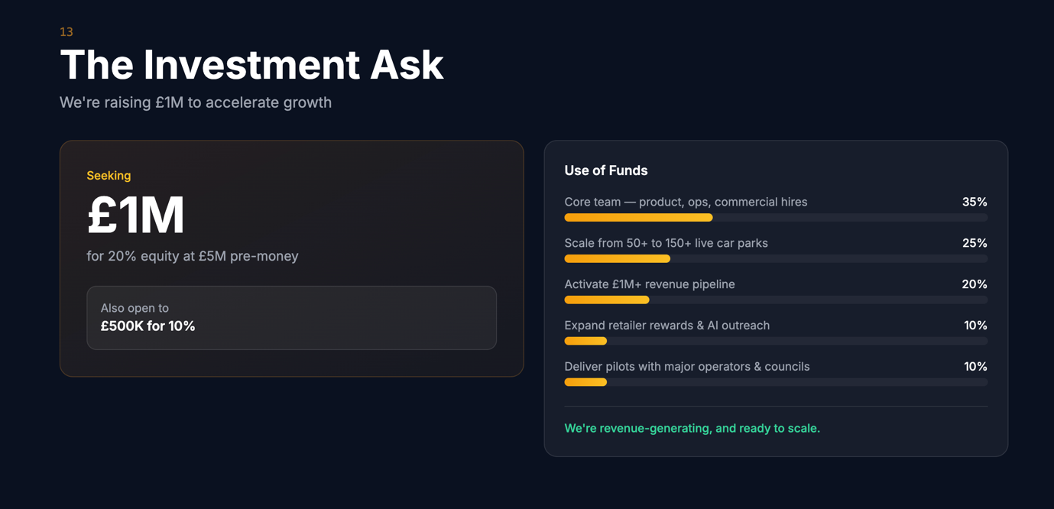

£400k at £4m pre money valuation
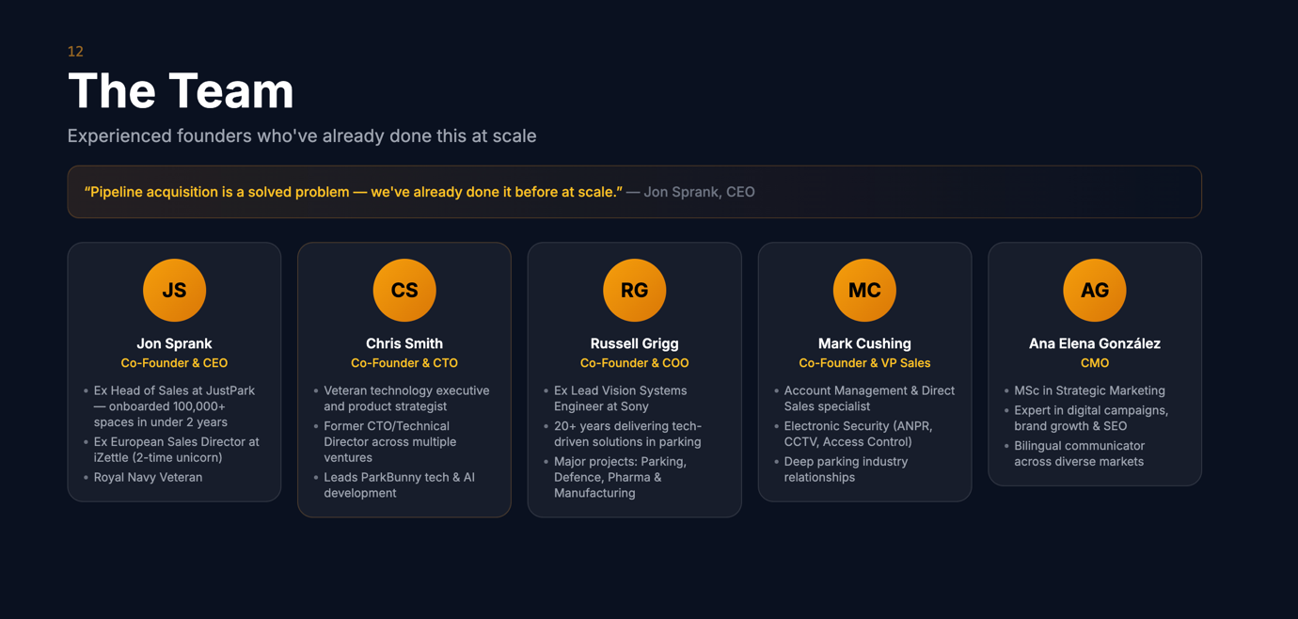
Headshots are on the deck I sent you over

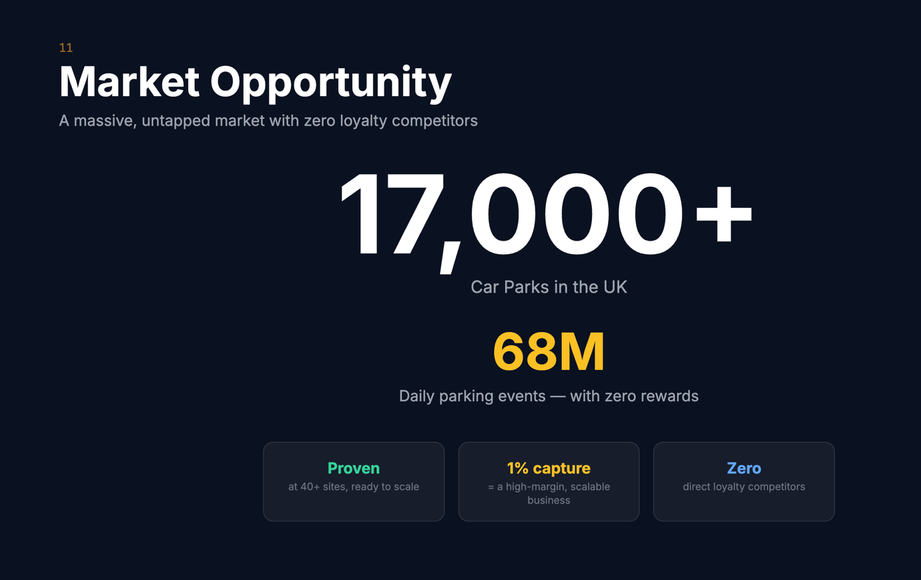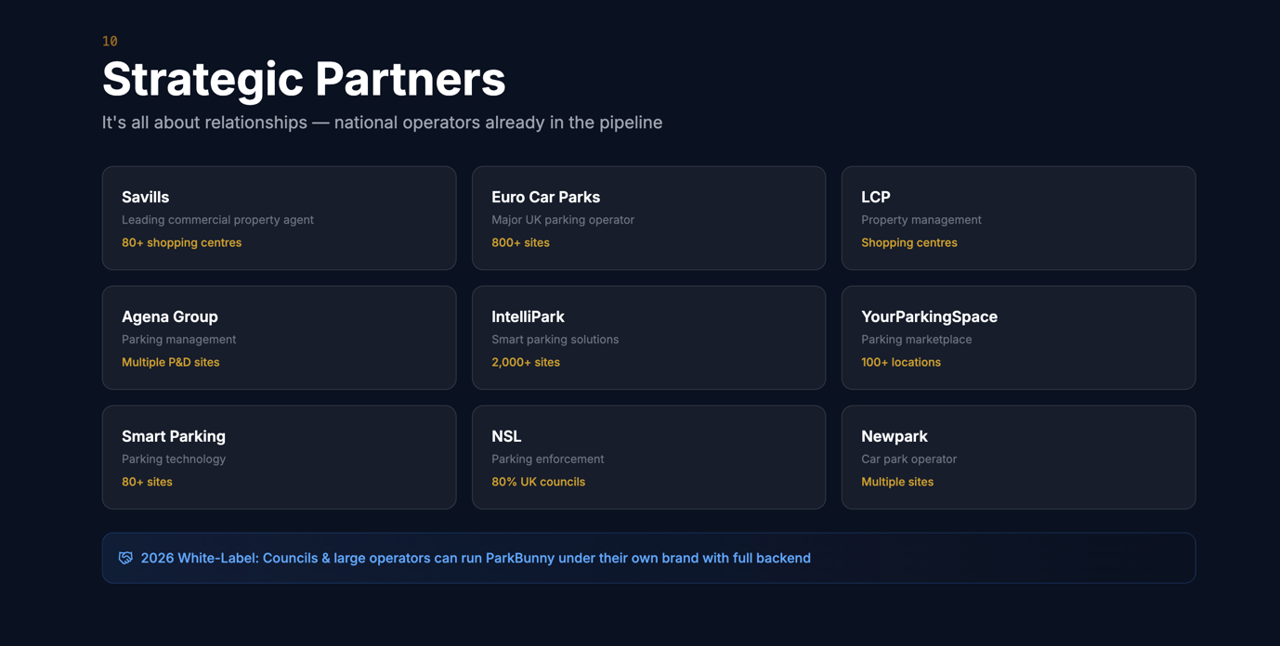
Remove Smart Parking
Remove YourParking Space
Add Intelli-Park
Add Anchor Group
Add ParkBee
Add Group Nexus
add wise Parking
Add Brittania Parking
Add brand logos
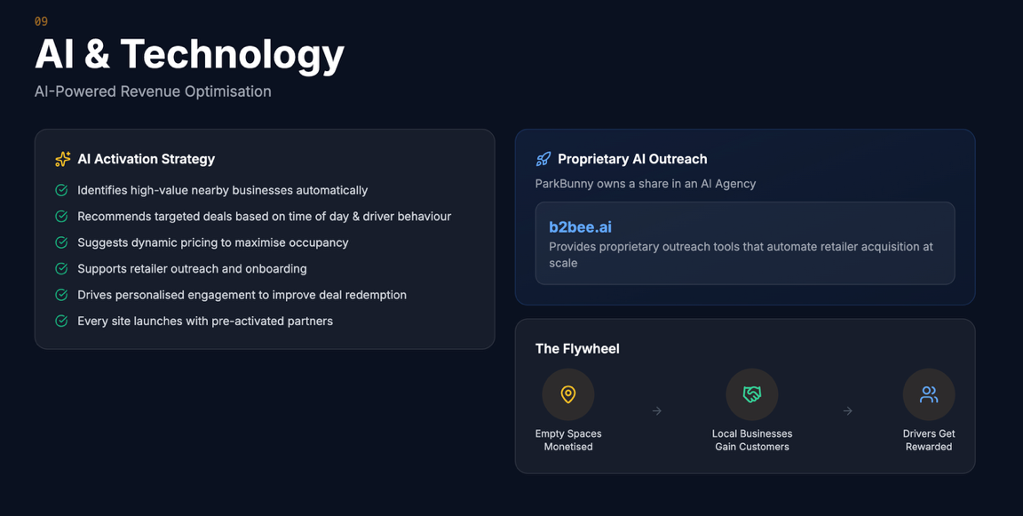
Add the reasoning behind why we are not hiring big teams we are using Ai for support lines / SDR functions and outreach keeping our costs down and efficeny high (re word this)
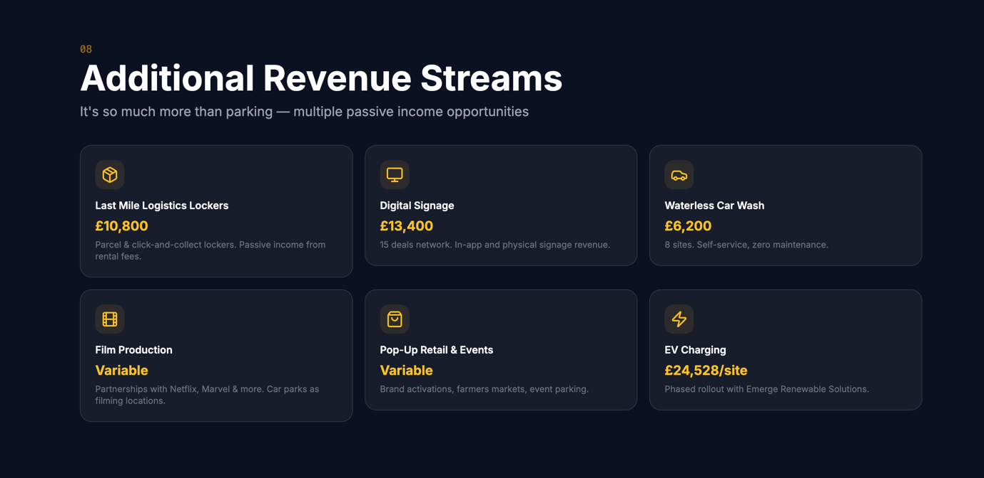
Remove added to the other slide

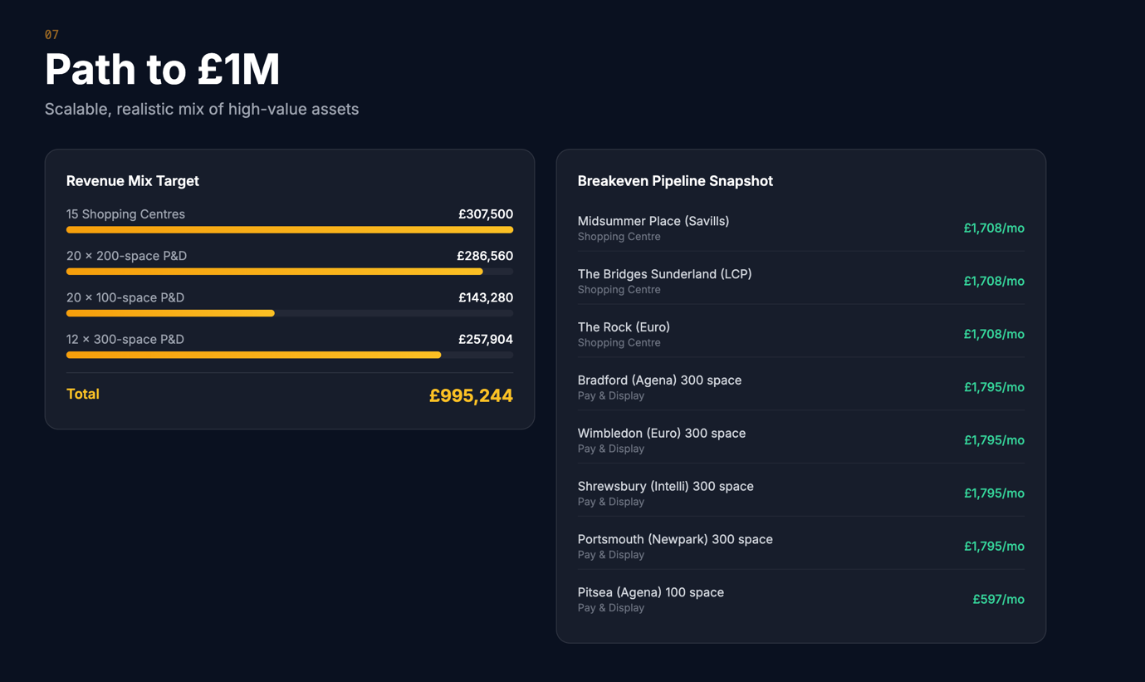
We need to re jig this slide – and add all our model into one slide and simplify
Break even April 2026 £18k per month run rate
How we scale to £1m - 150 space car park = £7k net revenue
£1m net revenue = 142 car parks our partners have over 10,000 sites of this size, executing on only 1,42 % of their portfolios will hit our target for 2026
Shopping centre would be 4x - 6x a 150 space car park in terms of revenue
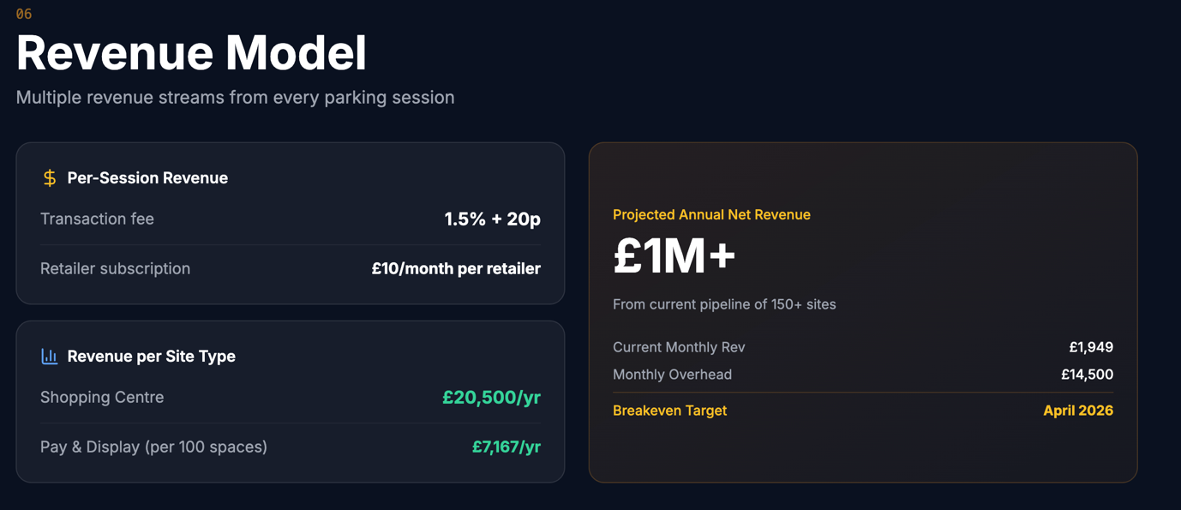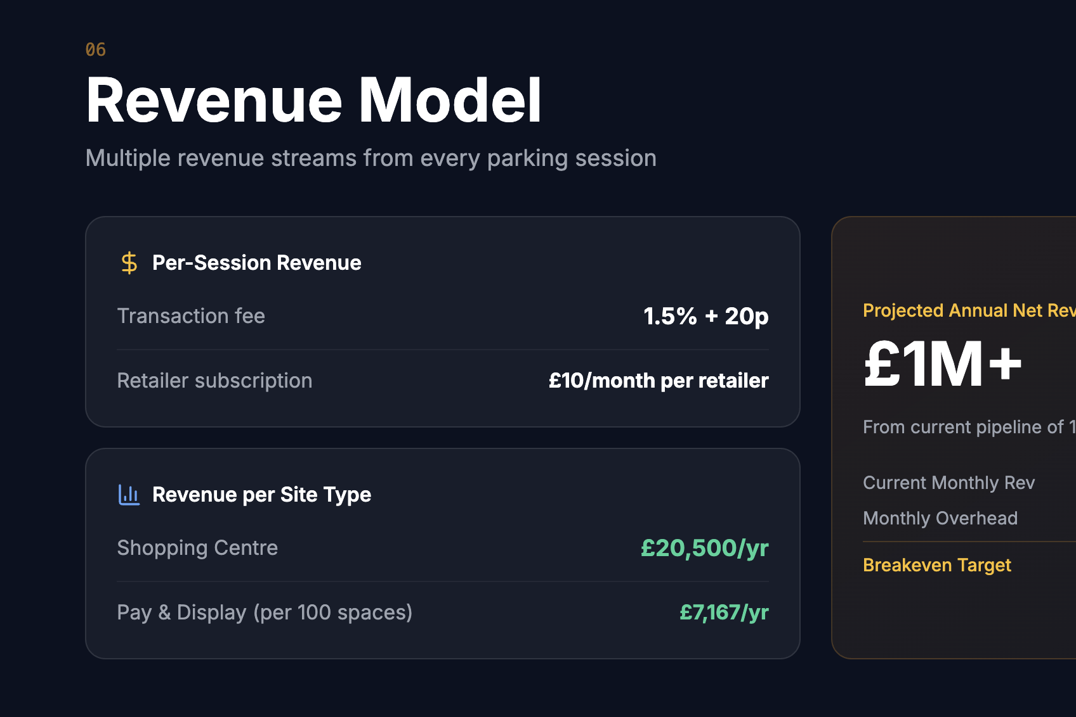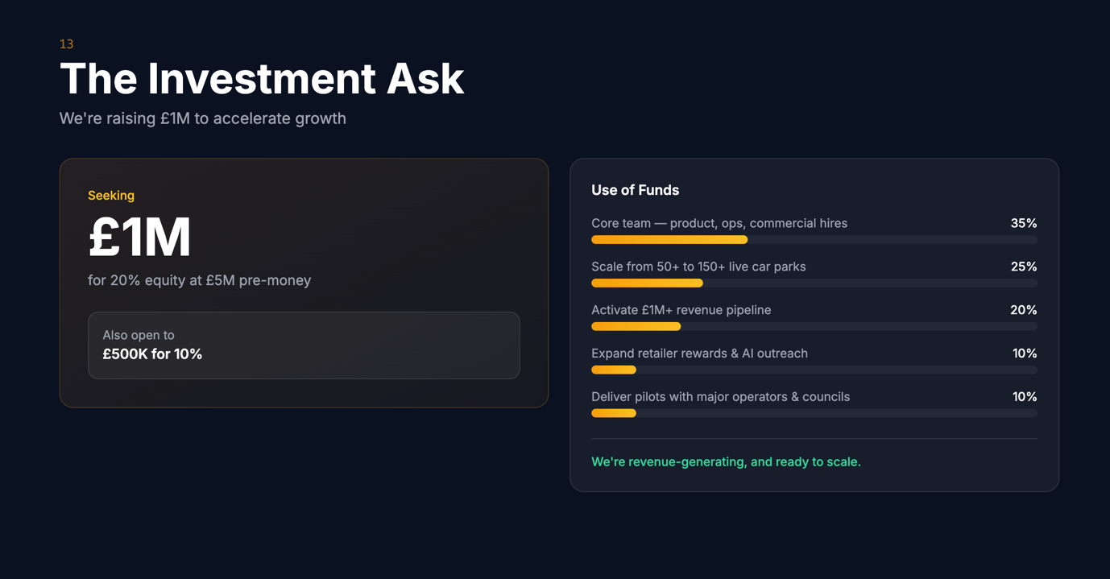

£400k at £5m pre money valuation

