Threat modeling fundamentals

Introduction

What is Threat Modeling?
Threat modeling is a structured approach to identifying, quantifying, and addressing security risks in a system. It’s a proactive security practice that helps organizations understand potential threats before they materialize into actual attacks.
Think of threat modeling as a security blueprint review. Just as architects review building plans for structural weaknesses, security professionals use threat modeling to identify security weaknesses in system designs.

Why Threat Modeling Matters
Key Insight:
Finding and fixing security issues during design is 100x cheaper than fixing them in production.
Threat modeling is essential because:
- Early Detection: Identifies vulnerabilities before code is written
- Cost Efficiency: Fixing design flaws is far cheaper than post-deployment patches
- Comprehensive View: Provides a holistic understanding of system security
- Risk Prioritization: Helps allocate security resources effectively
- Compliance: Meets regulatory requirements (PCI-DSS, HIPAA, GDPR)
- Security Culture: Builds security awareness across development teams

Real-World Relevance
Threat modeling is used across industries:
- Financial Services: Protecting customer financial data and transactions
- Healthcare: Securing patient records and medical devices
- E-commerce: Safeguarding payment information and user accounts
- IoT: Protecting connected devices from remote attacks
- Cloud Services: Securing multi-tenant environments and APIs
- Government: Protecting critical infrastructure and classified information

Learning Objectives
By the end of this guide, you will be able to:
- Explain core security concepts including the CIA Triad
- Differentiate between assets, threats, vulnerabilities, and risks
- Apply the STRIDE methodology to identify threats
- Use the DREAD system to prioritize risks
- Follow a structured 6 - step threat modeling process

Core Security Concepts

The CIA Triad
The CIA Triad is the foundation of information security, representing three core principles:
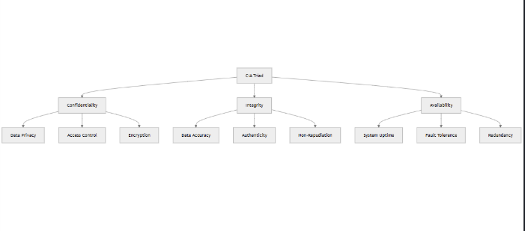

Confidentiality\
Definition:
Ensuring that information is accessible only to those authorized to access it.
Threats:
- Unauthorized data access
- Man-in-the-middle attacks
- Data breaches
- Social engineering
Controls:
- Encryption (at rest and in transit)
- Access control lists (ACLs)
- Multi-factor authentication (MFA)
- Data classification policies
Example:
A healthcare app must ensure that patient medical records are only viewable by authorized medical staff, not other patients or unauthorized third parties.

Integrity
Definition:
Ensuring that information is accurate, complete, and has not been tampered with.
Threats:
- Data tampering
- SQL injection
- Man-in-the-middle attacks
- Unauthorized modifications
Controls:
- Digital signatures
- Hash functions (SHA-256)
- Version control
- Input validation
- Database constraints
Example:
A banking application must ensure that transaction amounts cannot be modified during transmission or storage.

Availability
Definition:
Ensuring that information and resources are accessible to authorized users when needed.
Threats:
- Denial of Service (DoS) attacks
- Distributed Denial of Service (DDoS) attacks
- Hardware failures
- Natural disasters
- Ransomware
Controls:
- Load balancing
- Redundancy and failover systems
- DDoS protection services
- Regular backups
- Disaster recovery plans
Example:
An e-commerce website must remain accessible to customers 24/7, especially during peak shopping periods.

Assets, Threats, Vulnerabilities, and Risks
Understanding these four concepts is crucial for effective threat modeling:
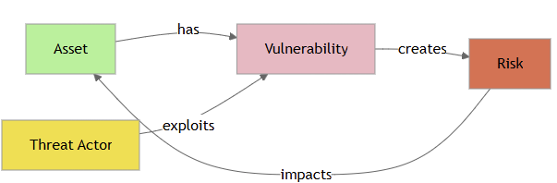

Assets
Definition:
Anything of value to the organization that needs protection.
Types of Assets:
Data: Customer information, financial records, intellectual property
Hardware: Servers, workstations, mobile devices, IoT sensors
Software: Applications, databases, operating systems
Services: APIs, cloud services, authentication systems
People: Employees, contractors, administrators
Reputation: Brand image, customer trust
Example Assets:
Asset Type | Example | Value
Data | Customer credit card numbers | Critical
Data | User email addresses | High
Hardware | Production database server | Critical
Software | Payment processing API | Critical
Reputation | Company brand | High

Threats
Definition:
Potential causes of unwanted incidents that may harm a system or organization.
Types of Threats:
Natural: Floods, fires, earthquakes
Human (Intentional): Hackers, malicious insiders, competitors
Human (Unintentional): Accidental deletion, misconfiguration
Technical: Hardware failures, software bugs, network outages
Threat Actors:
- Script kiddies (low skill)
- Hacktivists (politically motivated)
- Cybercriminals (financially motivated)
- Nation-states (highly sophisticated)
- Malicious insiders (privileged access)

Vulnerabilities
Definition:
Weaknesses in a system that can be exploited by threats.
Common Vulnerabilities:
- Unpatched software
- Weak passwords
- Missing encryption
- Insecure APIs
- SQL injection flaws
- Cross-site scripting (XSS)
- Misconfigured cloud storage
- Insufficient logging
Vulnerability Example:
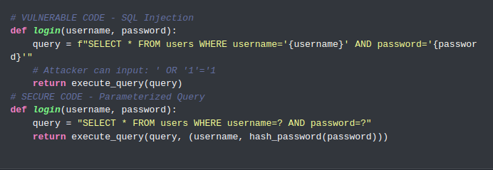

Risks
Definition:
The likelihood and impact of a threat exploiting a vulnerability.
Risk Formula:
Risk = Likelihood × Impact
Risk Levels:
Likelihood | Impact | Risk Level
High | High | Critical
High | Medium | High
Medium | High | High
Medium | Medium | Medium
Low | High | Medium
Low | Medium | Low
Low | Low | Low

Attack Surfaces and Attack Vectors

Attack Surface
Definition:
The sum of all possible points where an attacker could enter or extract data from a system.
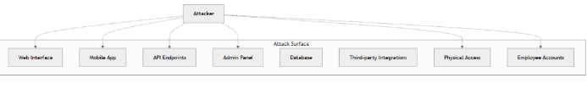
Components of Attack Surface:
Network: Open ports, network services, APIs
Application: User inputs, file uploads, authentication mechanisms
Human: Social engineering targets, privileged users
Physical: Building access, hardware devices
Reducing Attack Surface:
- Disable unnecessary services and ports
- Implement principle of least privilege
- Remove unused features and code
- Segment networks
- Use firewalls and access controls

Attack Vector
Definition:
The specific path or method used by an attacker to exploit a vulnerability.
Common Attack Vectors:
Phishing: Deceptive emails to steal credentials
SQL Injection: Malicious database queries
Cross-Site Scripting (XSS): Injecting malicious scripts
Malware: Viruses, trojans, ransomware
Man-in-the-Middle: Intercepting communications
Brute Force: Guessing passwords systematically
Zero-Day Exploits: Exploiting unknown vulnerabilities
Social Engineering: Manipulating people to divulge information
Attack Vector Example:
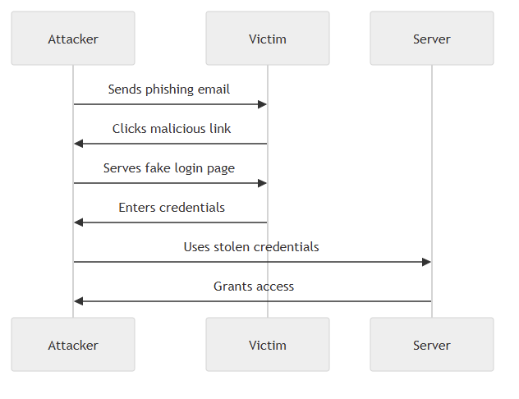

Trust Boundaries
Definition:
Lines drawn on system diagrams that separate different trust zones where data or control changes trust levels.
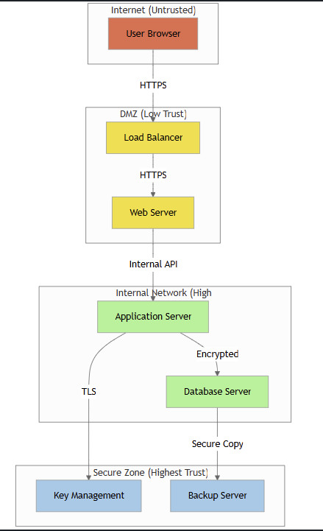

Why Trust Boundaries Matter:
- Data crossing boundaries requires validation and sanitization
- Authentication/authorization checks should occur at boundaries
- Encryption is often required when crossing boundaries
- Logging and monitoring should track boundary crossings
Trust Boundary Examples:
- User browser → Web server (Internet → DMZ)
- Web server → Application server (DMZ → Internal)
- Application → Database (Application layer → Data layer)
- Internal network → Cloud service (On-premise → Cloud)
- User context → Admin context (Privilege escalation boundary)
Key Takeaway: Every time data or control crosses a trust boundary, it represents a potential security risk that must be addressed with appropriate controls.

Threat Modeling Methodologies

STRIDE Methodology
STRIDE is a threat modeling framework developed by Microsoft that categorizes threats into six types. It’s one of the most widely used methodologies in the industry.
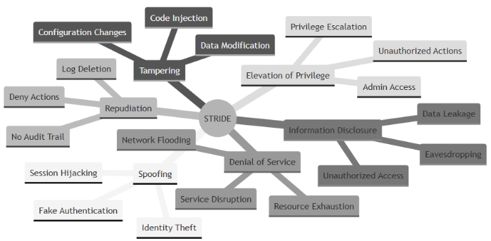

S - Spoofing Identity

Definition:
Pretending to be something or someone you’re not.
Examples:
- Impersonating another user by stealing credentials
- Forging email sender addresses
- IP address spoofing
- Session token theft
- Fake SSL certificates
Mitigation Strategies:
- Implement strong authentication (MFA)
- Use digital signatures
- Implement proper session management
- Use mutual TLS authentication
- Implement anti-spoofing measures (SPF, DKIM for email)
Real-World Example:
An attacker steals a user’s session cookie and uses it to impersonate the user on an e-commerce site, placing orders without authorization.

T - Tampering with Data
Definition:
Modifying data or code maliciously.
Examples:
- Altering data in transit (man-in-the-middle)
- Modifying database records
- Changing configuration files
- SQL injection attacks
- Modifying application binaries
Mitigation Strategies:
- Use encryption (TLS/SSL)
- Implement digital signatures
- Use hash functions for integrity checks
- Input validation and sanitization
- Implement audit logging
- Use database constraints and triggers
Real-World Example:
An attacker intercepts an online banking transaction and changes the recipient account number before it reaches the bank’s server.

R - Repudiation
Definition:
Denying that you performed an action without any way to prove otherwise.
Examples:
- User denies making a purchase
- Deleting or tampering with log files
- Claiming “I never received that email”
- Denying administrative actions
Mitigation Strategies:
- Implement comprehensive logging and auditing
- Use digital signatures for non-repudiation
- Implement secure time-stamping
- Store logs in tamper-proof locations
- Use blockchain for critical audit trails
- Implement log aggregation and backup
Real-World Example:
An employee deletes important files and claims they never had access to them, but there are no logs to prove what happened.

I - Information Disclosure
Definition:
Exposing information to unauthorized individuals.
Examples:
- Exposing database contents
- Leaking sensitive data in error messages
- Directory traversal attacks
- Unsecured API endpoints
- Exposed configuration files
- Memory dumps containing sensitive data
Mitigation Strategies:
- Encrypt sensitive data (at rest and in transit)
- Implement proper access controls
- Sanitize error messages
- Use secure coding practices
- Implement data classification
- Regular security audits and penetration testing
Real-World Example:
A web application displays detailed error messages that reveal database schema information, helping attackers craft SQL injection attacks.

D - Denial of Service
Definition:
Making a system or application unavailable to legitimate users.
Examples:
- DDoS attacks flooding network with traffic
- Resource exhaustion attacks
- Application-layer attacks (Slowloris)
- Ransomware locking systems
- Database connection pool exhaustion
Mitigation Strategies:
- Implement rate limiting
- Use DDoS protection services (Cloudflare, AWS Shield)
- Implement proper resource management
- Use auto-scaling
- Implement circuit breakers
- Set up monitoring and alerting
- Create incident response plans
Real-World Example:
An attacker floods an e-commerce website with requests during Black Friday, making it unavailable to legitimate customers and causing revenue loss.

E - Elevation of Privilege
Definition: Gaining higher-level permissions than authorized.
Examples:
- Exploiting buffer overflows to gain admin access
- SQL injection to bypass authentication
- Privilege escalation through misconfigurations
- Exploiting vulnerable sudo configurations
- Container escape attacks
Mitigation Strategies:
- Implement principle of least privilege
- Regular security patching
- Use role-based access control (RBAC)
- Input validation
- Secure coding practices
- Regular security assessments
- Implement proper permission boundaries
Real-World Example:
A regular user exploits a vulnerability in a web application to gain admin privileges and access sensitive customer data.

STRIDE Mapping Table
Component | Spoofing | Tampering | Repudiation | Info Disclosure | DoS | Elevation
External Entity | ✓ |  | ✓
Process | ✓ | ✓ | ✓ | ✓ | ✓ | ✓
Data Store |  | ✓ |  | ✓ | ✓
Data Flow |  | ✓ |  | ✓ | ✓

DREAD Rating System
DREAD is a quantitative risk assessment model that rates threats based on five factors. Each factor is scored from 1-10.
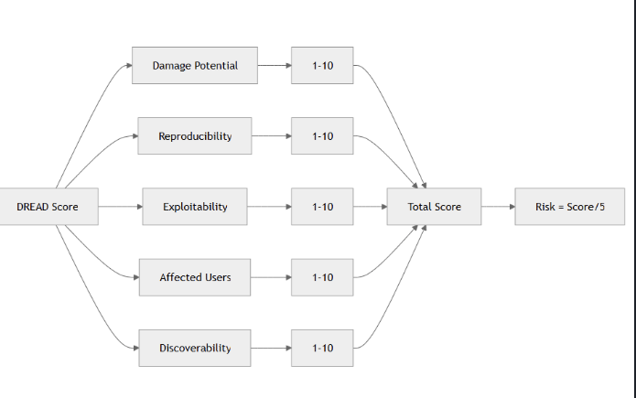

D - Damage Potential
Question: How much damage will be caused if the vulnerability is exploited?
Rating Scale:
- 10: Complete system compromise, data loss, or financial ruin
- 7-9: Significant data breach or major functionality loss
- 4-6: Limited data exposure or moderate impact
- 1-3: Minimal impact on system or data
Example:
- SQL injection exposing all customer records: 10
- XSS attack on a single page: 4

R - Reproducibility
Question: How easy is it to reproduce the attack?
Rating Scale:
- 10: Attack works every time, no special conditions needed
- 7-9: Attack works most of the time with minimal effort
- 4-6: Attack requires specific conditions or timing
- 1-3: Very difficult to reproduce, requires rare circumstances
Example:
- Missing authentication on API endpoint: 10
- Race condition that occurs occasionally: 3

E - Exploitability
Question: How easy is it to launch the attack?
Rating Scale:
- 10: Requires only a web browser, no special tools
- 7-9: Requires basic hacking tools (Burp Suite, SQLmap)
- 4-6: Requires advanced tools and moderate skill
- 1-3: Requires custom tools and expert-level skills
Example:
- Clicking a malicious link: 10
- Exploiting a zero-day vulnerability: 2

A - Affected Users
Question: How many users will be affected?
Rating Scale:
- 10: All users affected
- 7-9: Majority of users affected
- 4-6: Significant number of users affected
- 1-3: Very few users affected
Example:
- Authentication bypass affecting all users: 10
- Vulnerability in rarely-used admin feature: 2

D - Discoverability
Question: How easy is it to discover the vulnerability?
Rating Scale:
- 10: Vulnerability is obvious, visible in the browser
- 7-9: Can be found with automated scanning tools
- 4-6: Requires some investigation and analysis
- 1-3: Requires source code analysis or insider knowledge
Example:
- Exposed API keys in JavaScript: 10
- Logic flaw in complex business process: 3

DREAD Calculation Example
Vulnerability: Unencrypted password transmission
Factor | Score | Justification
Damage | 9 | Could compromise user accounts
Reproducibility | 10 | Happens on every login
Exploitability | 8 | Easy with network sniffing tools
Affected Users | 10 | All users affected
Discoverability | 9 | Visible in network traffic
TOTAL | 46
RISK LEVEL | 9.2/10 | CRITICAL
Risk Level Interpretation:
- 8.0-10.0: Critical (Fix immediately)
- 6.0-7.9: High (Fix within days)
- 4.0-5.9: Medium (Fix within weeks)
- 2.0-3.9: Low (Fix when possible)
- 0.0-1.9: Informational (Consider fixing)

PASTA Process
PASTA (Process for Attack Simulation and Threat Analysis) is a risk-centric, seven-stage threat modeling methodology.
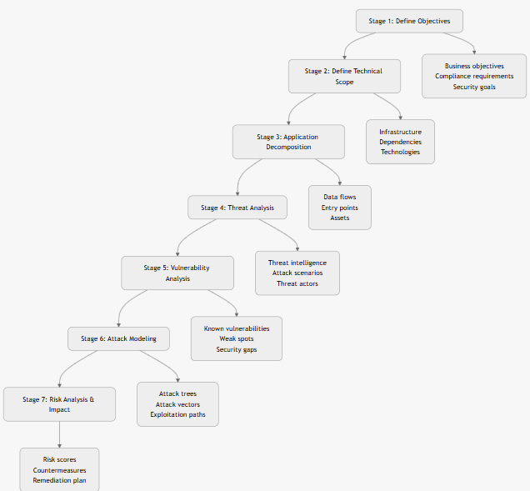

Stage 1: Define Objectives
Define business objectives and security requirements.
Activities:
- Identify business goals
- Define security and compliance requirements
- Determine impact tolerance
- Establish success criteria
Output: Security objectives document

Stage 2: Define Technical Scope
Define the technical scope of the analysis.
Activities:
- Inventory hardware and software
- Document network architecture
- Identify dependencies and integrations
- Define boundaries
Output: Technical scope document

Stage 3: Application Decomposition
Break down the application into components.
Activities:
- Create data flow diagrams (DFDs)
- Identify trust boundaries
- Document actors and roles
- Map data flows
Output: Detailed architecture diagrams

Stage 4: Threat Analysis
Analyze potential threats using intelligence sources.
Activities:
- Review threat intelligence feeds
- Identify relevant threat actors
- Analyze attack patterns
- Consider industry-specific threats
Output: Threat scenarios list

Stage 5: Vulnerability Analysis
Identify existing and potential vulnerabilities.
Activities:
- Review existing vulnerabilities (CVEs)
- Analyze code for weaknesses
- Review configurations
- Conduct security assessments
Output: Vulnerability assessment report

Stage 6: Attack Modeling
Model how attacks could be executed.
Activities:
- Create attack trees
- Map attack vectors
- Simulate attack scenarios
- Identify exploitation paths
Output: Attack simulation models

Stage 7: Risk Analysis and Impact
Analyze risks and prioritize remediation.
Activities:
- Calculate risk scores
- Prioritize threats
- Recommend countermeasures
- Create remediation roadmap
Output: Risk management plan

Operationally Critical Threat, Asset, and Vulnerability Evaluation (OCTAVE)
The OCTAVE threat model is a risk-based strategic assessment and planning technique for security. It is designed to help organizations big and small to understand and manage
their information security risks. Developed by Carnegie Mellon University’s Software Engineering Institute (SEI), OCTAVE is tailored for organizational risk management rather
than focusing solely on technical vulnerabilities. OCTAVE involves three different phases:
Build asset-based threat profiles:
Determine which assets are most important to the organization, such as databases, intellectual property, customer information, and critical infrastructure, and then establish
security requirements based on the identified threats to ensure the protection of critical assets.
Identify infrastructure vulnerabilities:
Review the organization’s technological infrastructure to identify vulnerabilities that could be exploited and then assess current security practices and policies to find gaps or
weaknesses.
Develop security strategy and plans:
Assess the risks to the organization by considering the impact and likelihood of identified threats and vulnerabilities. Formulate strategies to mitigate the identified risks, which
may include policy changes, technological solutions, and organizational practices.
Although OCTAVE is typically used for organizational risk assessment rather than direct penetration testing, its principles can be applied in a PenTest environment to help prioritize and structure the testing process.
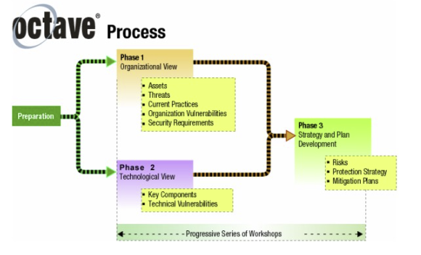

This flowchart represents the OCTAVE approach to information security risk evaluation, which is organized into three phases. The flowchart starts with a single box labeled
‘Preparation.’ Two arrows extend from ‘Preparation,’ leading to ‘Phase 1: Organizational View’ and ‘Phase 2: Technological View.’ Both Phase 1 and Phase 2 have arrows pointing to
‘Phase 3: Strategy and Plan Development,’ indicating that the outputs of the first two phases feed into the final phase.
The purpose of the flowchart is to illustrate how the organizational, technological, and analytical aspects of information security risk evaluation are structured into a three-
phased approach. The phases are as follows:
Phase 1: Organizational View – This phase focuses on organizational evaluation. The analysis team identifies critical information-related assets, determines current
protective measures, and creates asset-based threat profiles. Bullet points include the following:
* Assets.

* Threats.

* Current Practices.

* Organization Vulnerabilities.

* Security Requirements.
Phase 2: Technological View – This phase evaluates the organization’s information infrastructure. The analysis team identifies infrastructure vulnerabilities. Bullet points
include the following:
* Key Components.

* Technical Vulnerabilities.
Phase 3: Strategy and Plan Development – In this phase, the analysis team develops protection strategies and mitigation plans. Bullet points include the following:
* Risks.

* Protection Strategy.

* Mitigation Plans.

Attack Trees
Attack trees are a visual representation of attacks against a system, showing the goal at the top and various paths to achieve it below.
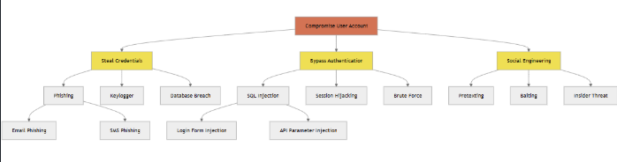

Components of Attack Trees
Root Node: The attacker’s ultimate goal
OR Nodes: Different ways to achieve a goal (any one path succeeds)
AND Nodes: Required steps that must all succeed
Leaf Nodes: Specific attack actions

Attack Tree Example: E-commerce Data Breach
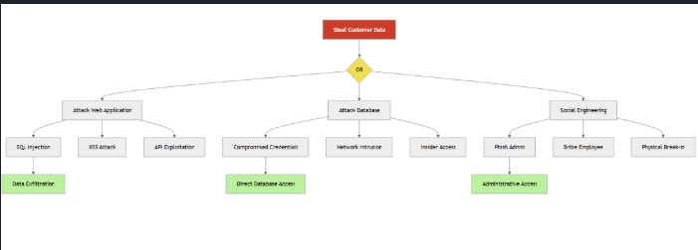

Using Attack Trees
Benefits:
- Visual representation of attack scenarios
- Helps identify multiple attack paths
- Facilitates risk analysis
- Supports security investment decisions
- Communicates threats to non-technical stakeholders
Steps to Create:
- Identify the attacker’s goal (root)
- Brainstorm ways to achieve that goal
- Break down each approach into sub-goals
- Continue until reaching atomic actions
- Assign likelihood and cost to each path
- Prioritize defenses based on analysis

Methodology Comparison
Choosing the right methodology depends on your project context, timeline, and goals.
Methodology | Best For | Complexity | Time Required | Output
STRIDE | General purpose, design phase | Low-Medium | 2-4 hours | Threat categories
DREAD | Risk prioritization | Low | 1-2 hours | Quantitative scores
PASTA | Comprehensive analysis | High | 2-3 days | Complete risk assessment
OCTAVE | Organizational level risk assessments and governance | Medium–High | 1–2 days | Business-focused risk profile
Attack Trees | Visual communication, specific scenarios | Medium | 3-6 hours | Attack path diagrams

When to Use Each Methodology
Use STRIDE when:
- Starting a new project
- You need a systematic approach
- Working with developers
- Time is limited but coverage is important
- You want industry-standard methodology
Use DREAD when:
- You have multiple threats to prioritize
- You need to justify security investments
- Communicating with management
- You want quantifiable risk scores
- Resources are limited
Use PASTA when:
- Building critical systems
- Compliance requires comprehensive analysis
- You have time and resources
- Executive stakeholders need detailed reports
- Risk-centric approach is needed
Use Attack Trees when:
- Analyzing specific attack scenarios
- Communicating with non-technical stakeholders
- Identifying optimal defense strategies
- Evaluating security investments
- Teaching security concepts
Use OCTAVE especially OCTAVE Allegro when:
- Aligning security priorities with business leaders and executives
- Performing enterprise-wide, department-level, or information-centric risk assessments
- Letting business or non-security teams own and drive the risk process
- Meeting compliance requirements for formal risk assessment (ISO 27001, NIST CSF, SOC 2, HIPAA, PCI DSS, etc.)
- Operating with small or overstretched security teams

Combined Approach
Many organizations combine methodologies:
- STRIDE to identify threats systematically
- Attack Trees to visualize critical attack paths
- DREAD to prioritize remediation efforts
- PASTA for periodic comprehensive reviews
- OCTAVE Allegro for enterprise-wide, business-owned risk assessments and compliance
Best Practice:
Start with STRIDE for breadth, use Attack Trees for depth on critical assets, and DREAD for prioritization.

The Threat Modeling Process
The threat modeling process is a structured six-step methodology for identifying, evaluating, and mitigating security risks across the lifecycle of a system or application. Each step builds understanding of what you are protecting, how attackers could interact with it, and which controls most effectively reduce risk.
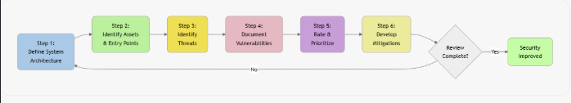
Step 1 – Define System Architecture and Scope
The process begins by establishing what needs to be protected through a clear definition of the system architecture and scope. This involves documenting assumptions, constraints, and business requirements, as well as producing architecture diagrams such as Data Flow Diagrams (DFDs) that illustrate system components, data flows, and trust boundaries. Explicitly stating what is in scope and out of scope ensures that the analysis focuses on the correct elements.
Step 2 – Identify Assets and Entry Points
The next step is to identify and classify all valuable assets based on their confidentiality, integrity, and availability needs. These include sensitive data, authentication mechanisms, APIs, infrastructure components, and administrative interfaces. In parallel, all entry points such as login pages, APIs, file upload endpoints, and admin panels are cataloged to determine where attackers could interact with the system.
Step 3 – Identify Threats
With assets and entry points understood, threats are identified using structured methodologies such as STRIDE. Each data flow, component, and data store is examined for potential risks including spoofing, tampering, repudiation, information disclosure, denial of service, and elevation of privilege. Threat scenarios and attacker personas help ensure a complete and realistic understanding of how the system could be attacked.
Step 4 – Document Vulnerabilities
This step focuses on identifying weaknesses that may enable the identified threats. Vulnerabilities are discovered through code reviews, configuration audits, dependency analysis, and automated scanning tools. Each vulnerability is documented and mapped to its corresponding threats, assets, and affected system areas to maintain traceability and clarity.
Step 5 – Rate and Prioritize Risks
All threats and vulnerabilities are then evaluated and prioritized using risk-scoring methods such as DREAD or CVSS. This analysis considers both impact and likelihood, resulting in a ranked list of risks that guides remediation efforts. The final output includes a remediation backlog, risk matrix, and an executive summary highlighting the most critical risks.
Step 6 – Develop and Implement Mitigation Strategies
The final step is to define and apply mitigation strategies to reduce or eliminate the prioritized risks. These strategies may include preventive controls (e.g., input validation, authentication hardening), detective controls (logging and monitoring), corrective actions (patching, rate limiting), and compensating controls when ideal solutions are not feasible. Each mitigation is verified through testing to ensure it effectively addresses the associated risks.

Iterative Process
Threat modeling is not a one-time activity:
When to Update Threat Models:
- New features or functionality
- Architecture changes
- New threat intelligence
- After security incidents
- Compliance requirements change
- Annually at minimum
Key Takeaway: Threat modeling is a living process that should evolve with your system and the threat landscape.

