Fall 2015 - CPSC 1302 – Computer Science II

ASSIGNMENT 3-Part1: Design and implement a Java program of your own choosing, provided the program uses inheritance, illustrates method overriding, and illustrates the use of the super keyword within the constructors and other public methods of the subclasses.
Lab (Do one of the following problems) Feel free to do both for feedback, but only one should be turned in for grading :-)
For either Problem G and Problem M, your program must use inheritance, and multiple (two or more) classes that extend a given superclass. Your program would eventually have to illustrate (or take advantage of) method overriding, the use of the super keyword within the constructors and within other public methods of the subclasses.
Problem G - Games:
In your own words, describe a game that could be implemented by a program that satisfies the above requirements.
- Superclass: Board Games.
- Subclasses: Monopoly and Candy Land.
- Inheritance: Monopoly = setNameOfPlayers, setNumberOfPlayers(int), getNameOfPlayers, & getNameOfPlayers.
Candy Land= setColorOfPiece, setPlayers(int), getColorOfPiece & getPlayers(int).
- Monopoly--->Super.toString return “Name: “ + NameOfPlayers+ “Number of Players: ”+ NumberOfPlayers;
- Candy Land--->Super.toString return “Color of candy piece: “ + ColorOfPiece+ “Number of Players: ”+ Players;

Problem M - Modeling and Simulation:
In your own words, describe a modeling and simulation problem that could be implemented by a program that satisfies the above requirements.

Phase 1 -- Analysis and Design Phase:

- Draw a UML class diagram for a program that would solve the above problem. Be sure to use the correct types of arrows and boxes for your UML diagram. (Hints: Nouns from your problem statements should be used to name your classes.)
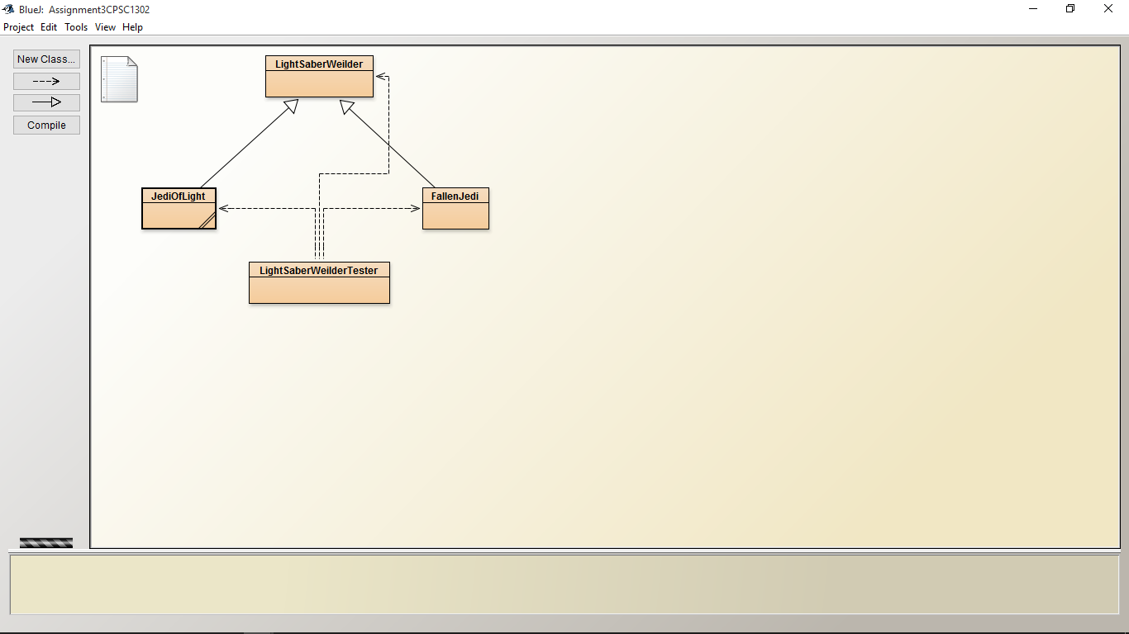
Phase 2: Coding
- Implement a Java program that solves the above problem.(Here you may have to go back and redo Phase 1, should the process of coding reveal optimizations that you could make to your classes or class diagram.)

- For each method and each class, provide a full Javadoc documentation. Be sure to consider using the following Javadoc tags (where appropriate)--@author, @version, @param @return, @precondition, @postcondition

- Run the Documentation tool in BlueJ to generate the Javadoc HTML for your project. The HTML files should be created automatically inside a folder called 'doc' that you should see next to the rest of your project files.

Deliverables:
(10 points) Your BlueJ folder, zipped or gzipped, and this document with your answers typed below. Full documentation included in the form of HTML files, and Java code matching the diagram of Phase 1!
(1 points) What is your problem statement?: This program extends to subclasses from a super class called LightSaberWeilder. It then lists my favorite jedi from both dark and light side of the force.
(0.5 point) What is the name of your superclass?: ____LightSaberWeilder___________________
(1 points) What are the names of your subclasses?: ________JediOfLight and FallenJedi_______________
(0.5 point) What method(s) did you override?: ________setEra_______________
(1 points) Paste your UML class diagram below

(1 points) Does each method of each class have full, accurate Javadoc? Y/N-Yes
(1 points) Does each class have a set() method and a get() method for each instance variable? Y/N-Yes
(1 points) Does each class, except perhaps for a driver, have a toString() method. Y/N-Yes
(1 points) Does each subclass have a default constructor and a custom constructor. Was a call to super() used in the constructors to initialize superclass variables. Y/N-Yes
(1 points) Is at least one superclass method overridden. Does the overriding method perform a computation that is different than that which we see in the superclass? Y/N-Yes
(1 points) Is the overridden method used in the program to perform an action that is relevant to the control flow of the program. Y/N-Yes

