Fall 2015 - CPSC 1302 – Computer Science II

ASSIGNMENT 3-Part2: Short Answer Questions.
This assignment is due by 11:59 p.m. EST on Friday, October 30, 2015. Late submissions will be graded as described in the syllabus. Assignments submitted at or after 12:01 a.m. EST, Tuesday, November 03, will not be accepted. Please start working on your assignment early.
Please work individually.
Short Answer Questions: Learning more about protected variables, method overriding, the Object class, final classes, final methods, abstract classes, and shadow variables.

Q1)(1 point) Why is the protected visibility modifier a better choice in an inheritance hierarchy? (See Chapter 8 of the text)
One-sentence answer:
- A protected visibility modifier is a better choice because it provides the best possible encapsulation that permits inheritance.

Q2)(1 point) Suppose we create a subclass from a class that has a method called someMethod(). If we override someMethod() in the subclass, is it possible to access the superclass's version of someMethod? If so, how? (See Chapter 8 of the text)
One-sentence answer:
- To access the super class’s someMethod() you use the super.someMethod() method to access it

Q3)(1 point) What is the relevance of the Object class to the Java programming language. (See Chapter 8 of the text)
One-sentence answer:
- All classes are derived from the Object class.

Q4)(1 point) Explain how a subclass can access its parent classes private instance variables and methods. (See Chapter 8 of the text)
One-sentence answer:
- They can be used indirectly, they cannot be referenced by name.

Q5)(1 point) A programmer tries to create a subclass of String called MyString. When the programmer compiles her new class, the compiler produces the following message:
MyString.java:1: cannot inherit from final java.lang.String
public class MyString extends String {
^
1 error

What is the cause of this error.
One-sentence answer:
- Cannot use String as a subclass because it is a reference to a object

Q6)(1 point) Draw a hierarchy of Animals (i.e., UML class diagram). The hierarchy should include the following entities: Animal, Reptile, Mammal, Bear, Human, Iguana, and Dolphin.
Your diagram:
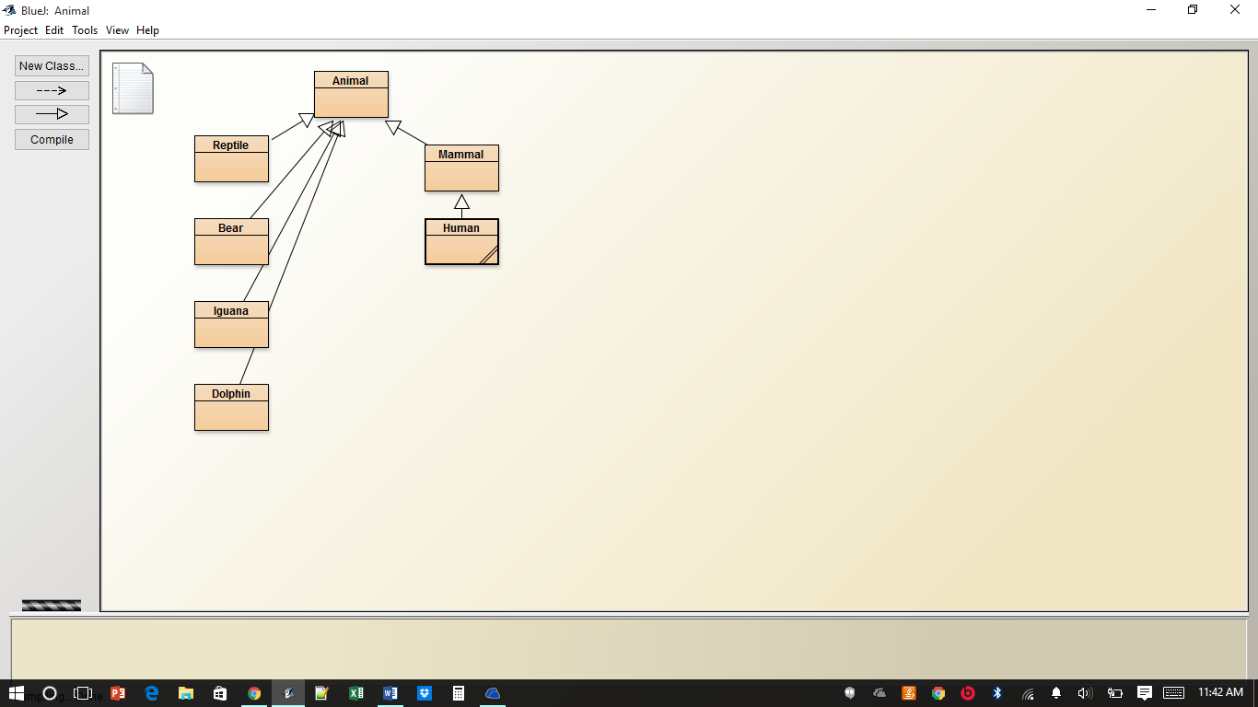
Q7)(1 point) Consider a software system that will implement the following classes: Student, Professor, StaffMember, ContractWorker. List some common attributes of these classes. What would be a good abstract class from which these classes may be extended via inheritance?
Student Attributes: - height, and shoe size,
Professor Attributes: salary, experience,
StaffMember Attributes: experience, previous place of work
ContactWorkerStudent Attributes: gpa, references
A good abstract class would be: Foreign Employes
Q8)(1 point) Explain what it means for a child class to override a parent class. Why might this be useful?
Two-sentence answer:
Method overriding is a key element in object oriented design. It allows two objects that are related by inheritance to use the same naming conventions.

Q9)(1 point) What does it mean for a class to be declared as final? What does it mean for a method to be declared as final?
One-sentence answer:
- It ensures that a derived class uses a particular definition of a method.

Q10)(1 point) What is a shadow variable?
One-sentence answer:
- A variable of the same name declared in a childs class.
Deliverables:
(10 points) This document with your answers included below each of the above questions.

