Software Project Management Execution Phase

For

The Untamed World
Prepared by
Section Name: A
Student Name | Reg No
Farah Hameed | 21-SE-030
Muhammad Danial Shahzad | 21-SE-065
Muhammad Haffis | 21-SE-080

Submitted To:
Ma’am Farwah Aizaz

DEPARTMENT OF COMPUTER SCIENCE
BS SOFTWARE ENGINEERING PROGRAM
HITEC UNIVERSITY TAXILA

Table of Contents
1. Execution Phase Using Jira 1
1.1 Introduction 1
1.2 Project Configuration on Jira 1
1.3 Epic Overview 1
1.4 Sprint Management 2
1.5 Sub-tasks and Dependencies 6
1.6 Jira Board 10
1.7 Collaboration and Communication 11
1.8 Analytics 11
1.9 Conclusion 12

1. Execution Phase Using Jira
Project Name: The Untamed World
Phase: Execution Phase
Tool Used: Jira
Report Date: 2025-01-26
Prepared By: Farah Hameed

Introduction
During the execution phase of "The Untamed World", Jira was used as the primary project management tool to track tasks, manage sprints, and monitor progress. This report provides an overview of how Jira was utilized, including screenshots of key workflows, and boards.

Project Configuration on Jira
The project follows a Scrum methodology with a sprint duration ranging from 2 to 4 weeks, allowing for agile and iterative development. The team consists of three members: Farah Hameed, Muhammad Haffis, and Muhammad Danial Shahzad, each bringing their unique skills and expertise to the project. This structure enables effective collaboration, quick adaptation to changes, and continuous delivery of project milestones within the defined sprint cycles. The team's efforts are focused on achieving key objectives and delivering high-quality results in each sprint.

Epic Overview
The Epic Board serves as a strategic tool for organizing and managing the major deliverables of "The Untamed World", ensuring the project remains on track and meets its objectives. By breaking the project into specific epics, such as Design and Prototyping, Development, and Testing, the team can focus on one phase at a time while maintaining visibility across the entire project lifecycle. It also provides a clear roadmap, helping the team stay focused on key deliverables and ensuring each phase is thoroughly planned and executed. For example, during the Design and Prototyping epic, the team can focus on developing visual concepts and testing early designs, while in the Development phase, they can concentrate on coding, integrating features, and ensuring functionality. The Testing and Deployment epics ensure that quality assurance processes and proper launch procedures are followed before the final release. Additionally, the Documentation epic ensures that all processes, code, and user manuals are well-documented for future reference and maintenance. Project Initiation and planning, Design and Prototyping epics have been done. One issue of Development has been done too and one issue of it is in under review and one is in completion phase. One issue of Testing is in progress phase and all other epics awaiting and need to be done.
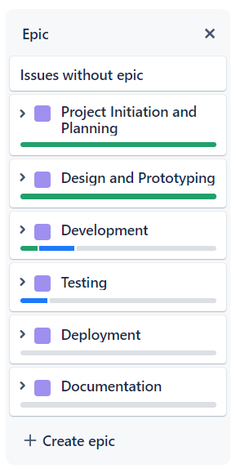

Sprint Management
The Sprint 1 Board highlights the Project Planning and Setup phase, with the primary story UWD-8 focusing on ensuring the project's viability. The tasks included conducting a feasibility analysis, creating a project charter, and preparing a proposal document. All tasks have been completed, as shown in the Finalized and Done column, demonstrating a successful start to the project.
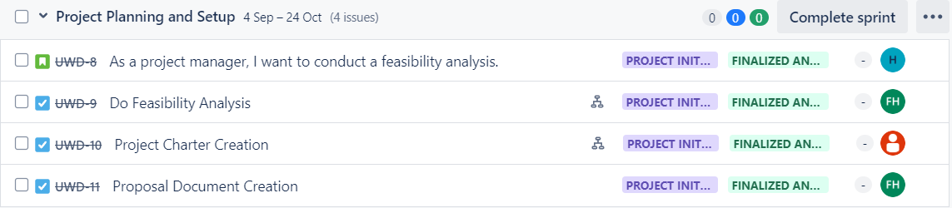
The Sprint 2 Board highlights the Requirement Gathering phase, with tasks like UWD-13 (Create SRS), UWD-14 (Define Functional and Non-Functional Requirements), and UWD-18 (Create Architectural Design). All tasks have been completed, as shown in the Finalized and Done column, ensuring that all game requirements were thoroughly documented and planned before moving into development. This structured approach helped the team align with project goals and set the stage for a successful development phase.
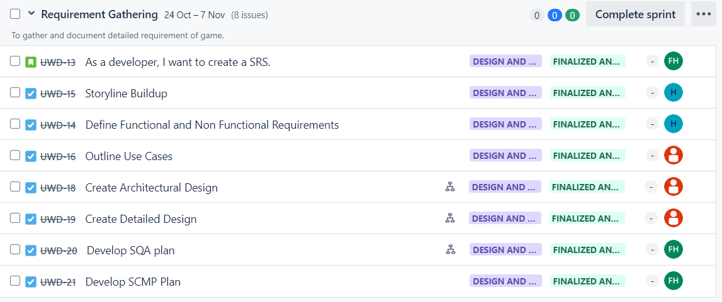
The Sprint 3 Board highlights the Prototyping phase, with the primary goal of creating a functional prototype. The story UWD-22 focuses on delivering a working model of the game, while UWD-23 involves the actual development of the prototype. Both tasks have been completed, ensuring that the team could visualize and refine the game's core features before moving into full-scale development. This approach helped the team validate ideas early and reduce risks in later stages.
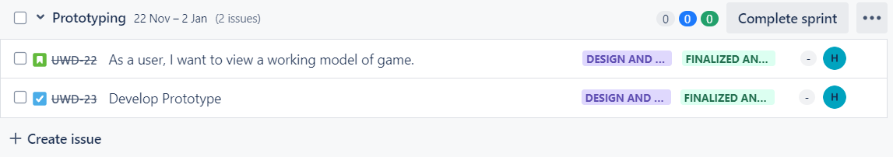
The Sprint 4 Board provides a clear view of the Base Game Development phase, with tasks spread across different stages of completion. Tasks like Integrate GUI Component, Game Storyline Integration, and Integration Testing are still in the To Do column, awaiting initiation. Basic Animation Implementation has been moved to the Review and Tested column, showing that task has been completed and is under review. Unit Testing is currently in the In Progress column, indicating active work on this task. This distribution helps the team prioritize and manage their workload effectively, ensuring steady progress toward sprint goals.
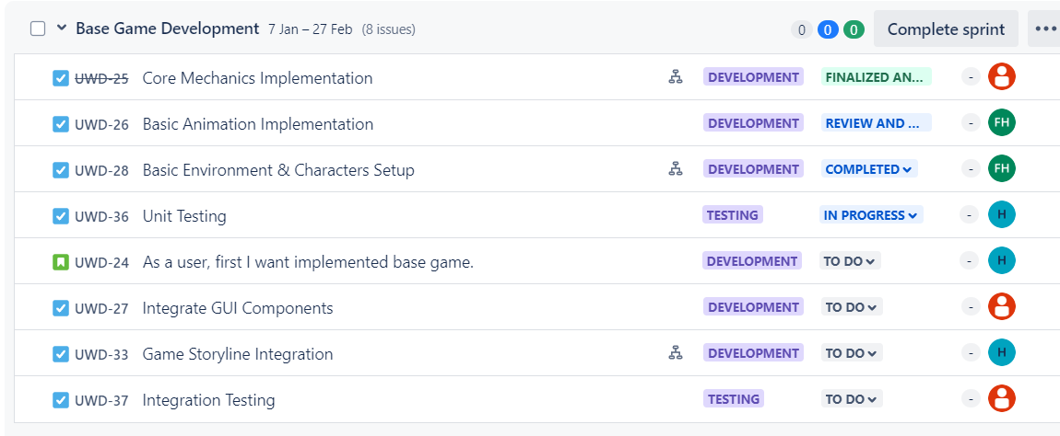
The Sprint 5 Board highlights the Expanded Functionality and Polishing phase, with tasks focused on adding advanced mechanics and finalizing the game. All tasks are currently in the To Do column, indicating that the team is preparing to address these features. As the sprint progresses, tasks will move to In Progress and Done, ensuring a structured and organized workflow. This sprint is critical for enhancing the gameplay experience and ensuring the game is fully functional and polished before release.
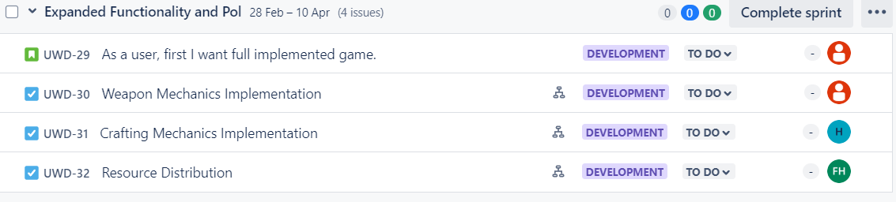
Sprint 6 and 7 Boards from Jira, covering the Testing and Fixing and Final Adjustments phases of "The Untamed World." Sprint 6 includes UWD-47 (Regular Testing with Bug Fixes), and Sprint 7 includes UWD-34 (Detailing and Post Processing). Both tasks are currently in the To Do column, indicating that the team is preparing to begin these critical phases. These sprints will focus on testing, bug fixes, and final polishing to ensure the game is ready for release.
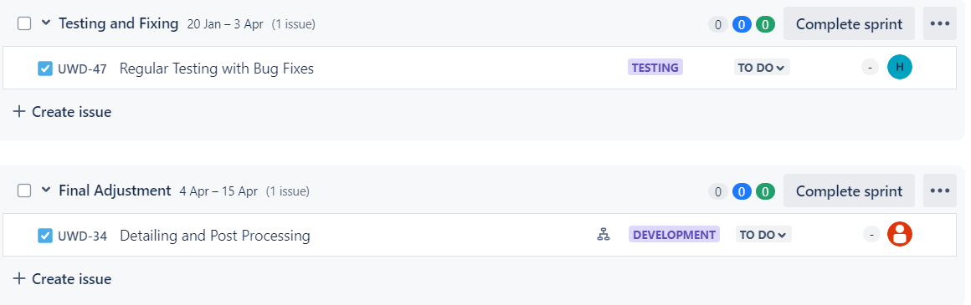
The Sprint 8 Board highlights the Testing and Fixing Bugs phase, where the team will conduct comprehensive testing to ensure the game is free of issues and performs well. All tasks are currently in the To Do column, indicating that the team is preparing to begin this critical phase. This sprint is essential for delivering a polished and high-quality game to the players.
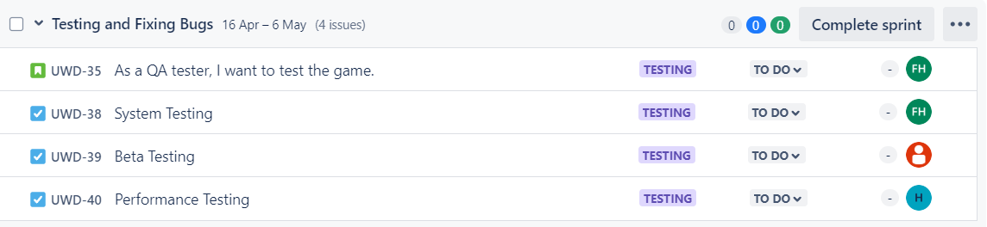
The Sprint 9 Board highlights the Documentation and Packaging phase, where the team will finalize all necessary documentation and prepare the game for release. All tasks are currently in the To Do column, indicating that the team is preparing to begin this final phase. This sprint is crucial for ensuring that all documentation is complete and the game is ready for distribution.
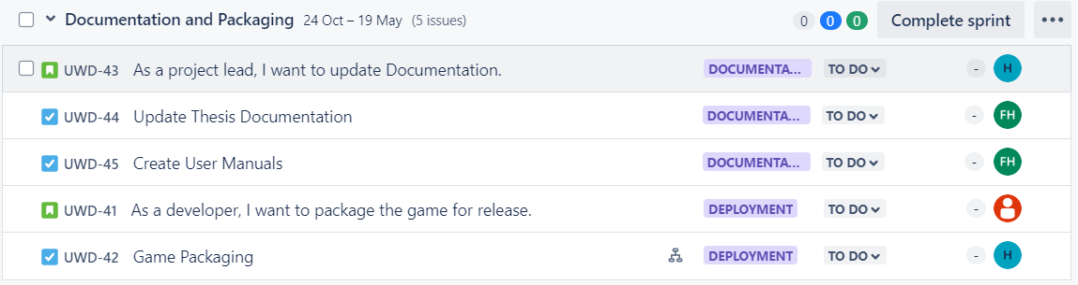

Sub-tasks and Dependencies
The below all screenshots provide a detailed breakdown of all subtasks and task dependencies for The Untamed World. These screenshots offer a comprehensive view of how each task is interconnected, highlighting the logical flow and relationships between various project components. By mapping out subtasks and dependencies, the team ensures that all deliverables are completed in the correct sequence, minimizing risks and avoiding delays. This visual representation aids in identifying critical paths, managing resources effectively, and maintaining clear communication among team members throughout the project lifecycle.
For Feasibility Analysis Task:
The following screenshot highlights the subtasks and dependencies related to the feasibility analysis. The Business Case (CBA) is a key subtask that must be completed before the project charter can be created. This dependency ensures that the project initiation or charter is based on a comprehensive feasibility study, reducing risks and setting a strong foundation for the project.
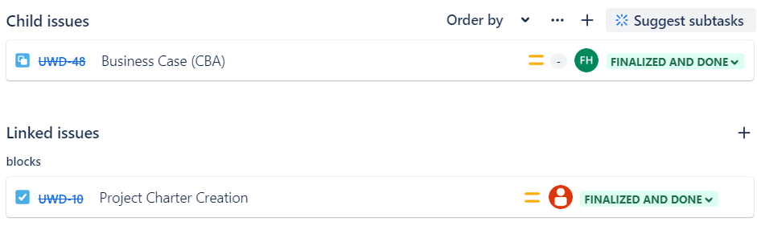
For Project Charter Creation Task:
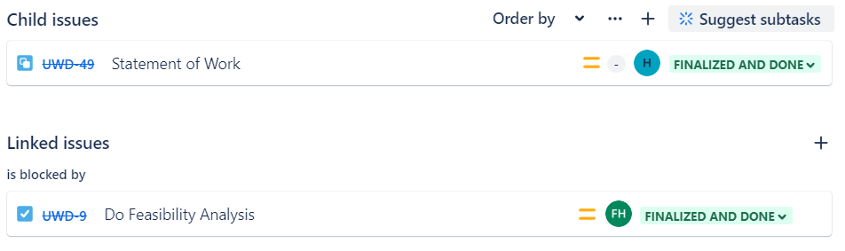
For Architectural Design Task:
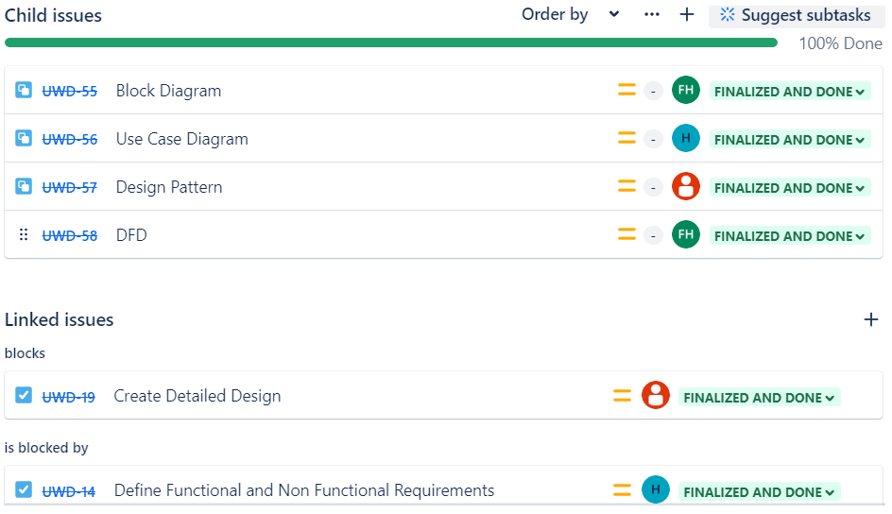
For Detailed Design Task:
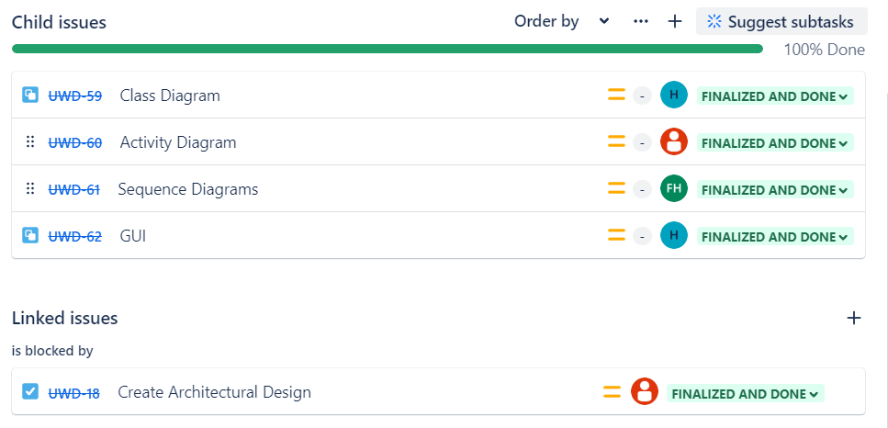
For Storyline Integration Task:
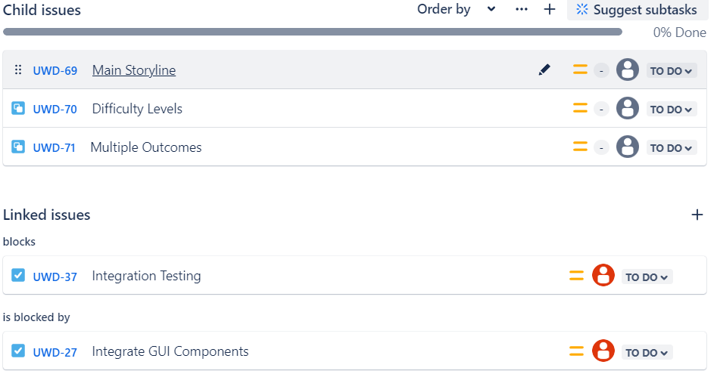
For Weapons Mechanics Implementation Task:
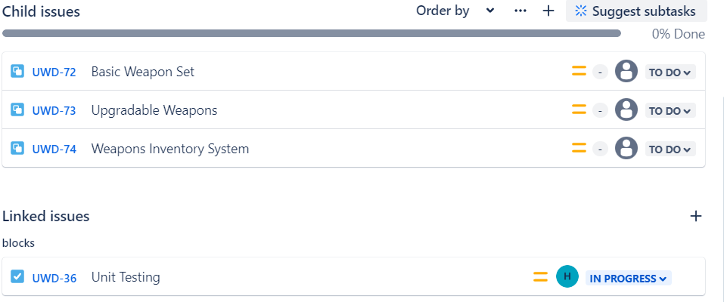
For Crafting Mechanics Implementation Task:
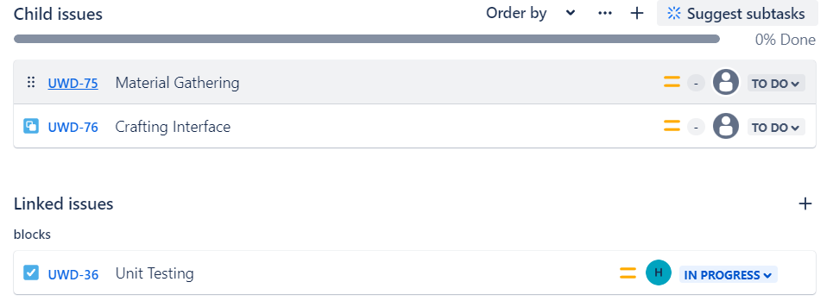
For Detailing and Post Processing Task:
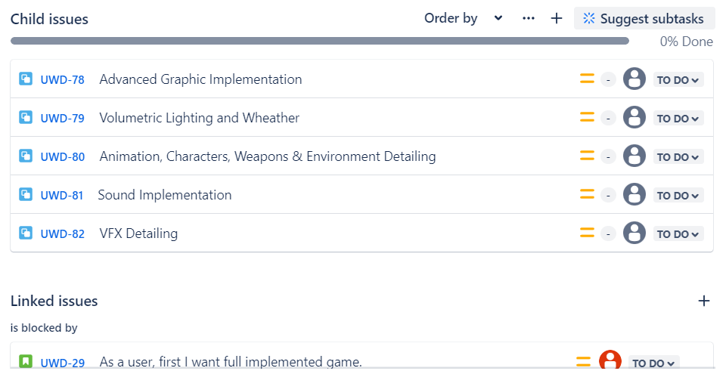
For Game Packaging Task:
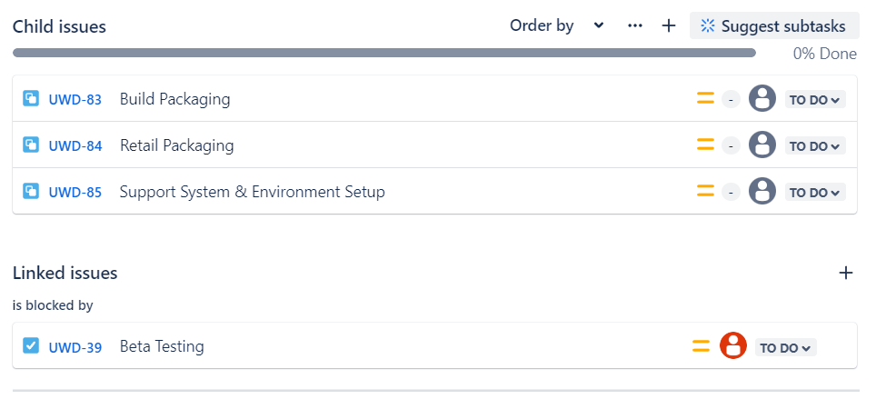

Jira Board
The below screenshot highlights the Jira board configuration for managing sprints during the execution phase. The board is divided into multiple columns representing different task statuses: "To Do," "In Progress," "Completed," "Review and Tested," and "Finalized and Done." Tasks are grouped and tracked across various sprints, ensuring efficient planning and execution within defined timeframes. Each card on the board corresponds to a specific task, with details such as the task ID (e.g., UWD-24), priority tags (e.g., "Development," "Testing," "Project Initiation and Planning"), the number of comments or subtasks, and the team members assigned. This provides a clear, collaborative workspace for the team. For instance, tasks like "As a user, first I want implemented base game" and "Integrate GUI Components" are in the "To Do" column, awaiting development. Tasks in the "In Progress" column, such as "Unit Testing," show ongoing work, while those in "Completed" and "Review and Tested" reflect milestones achieved and reviewed, ensuring quality. The "Finalized and Done" column includes tasks that have been fully completed, such as "Project Charter Creation" and "Proposal Document Creation," reflecting the team's adherence to project timelines and deliverables. By leveraging sprints, the team ensured agile progress, breaking the project into manageable sections to meet milestones efficiently while maintaining focus and alignment on project goals.
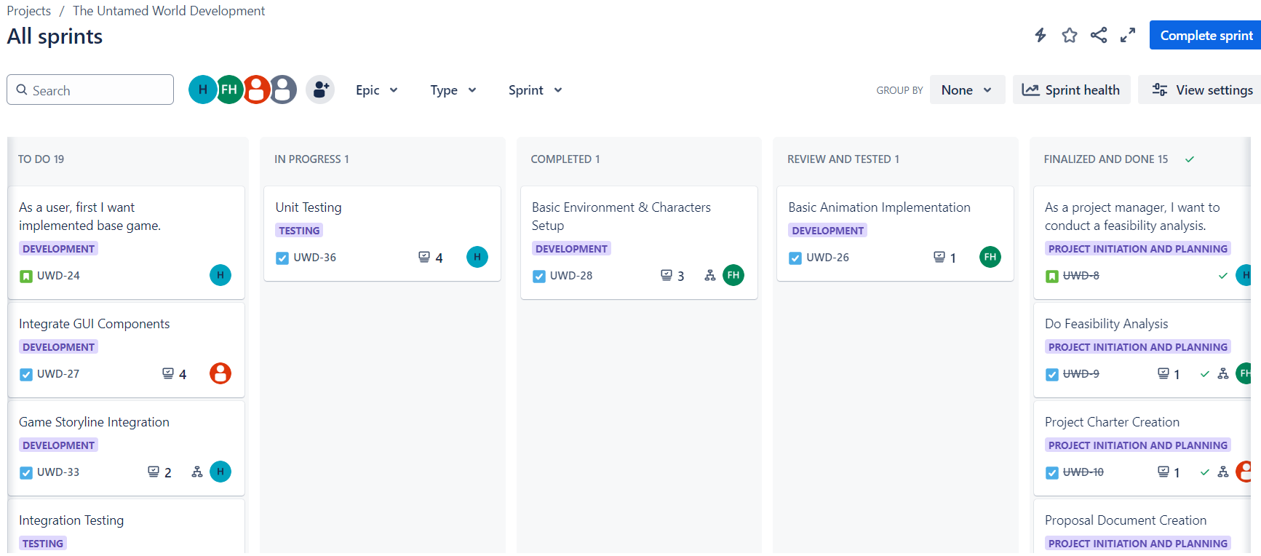

Collaboration and Communication
Team members used comments to provide updates, ask questions, and share feedback on tasks and mentioned other members in comments to notify them of updates or requests.
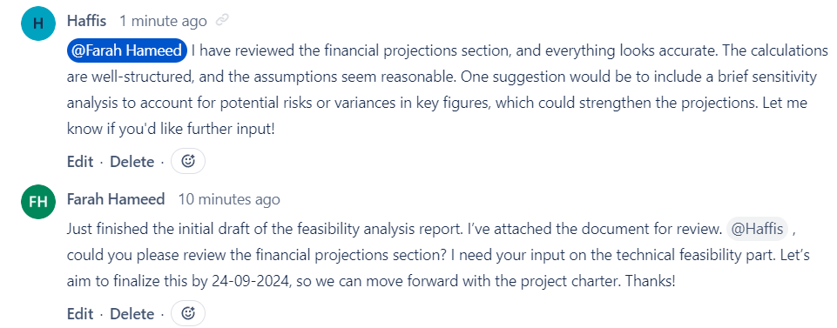

Analytics
The "Status Overview" chart provides a snapshot of the current progress of the project's issues, categorizing a total of 81 tasks across various statuses. The majority of tasks, 52 in total, are in the "To Do" stage, indicating planned items yet to be started. A significant portion, 26 tasks, have been successfully completed and marked as "Finalized and Done." One task is currently in the review and testing phase, awaiting validation, while another task has been completed but might still require final approval. Additionally, one task is actively being worked on, reflecting the team's ongoing efforts. This visual representation aids in identifying project progress, helping prioritize pending tasks and ensuring efficient execution during development.
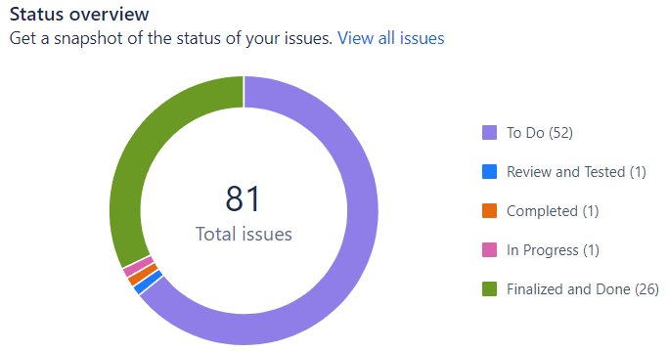
The team workload distribution shows task assignments among three team members. Haffis, the project manager, has the highest workload at 35%, while "21-se-065" and Farah Hameed each handle 33% of the tasks. This distribution reflects a slightly higher share of responsibilities for the manager, aligning with their leadership role. The chart facilitates effective monitoring and suggests reassignments if needed to balance workloads across the team.
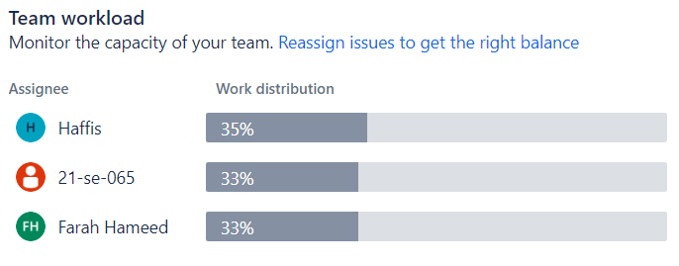

Conclusion
Jira proved to be an invaluable tool for managing the execution phase of "The Untamed World." It provided a clear structure for task management, progress tracking, and team collaboration. By leveraging Jira's features, the team was able to stay organized, meet deadlines, and deliver a high-quality product. Moving forward, we will continue to refine our Jira workflows to address challenges and improve efficiency.

________________________________________________
___________________________________________

