COMPUTER ORGANIZATION AND ASSEMBLY LANGUAGE

TOPIC: CONDITION JUMPS

NAME:
MUHAMMAD TALHA
SECTION:
4/A
ROLL#:
241890

INSTRUCTOR:
Ms ROMANA MAROOF

EXAMPLE #1
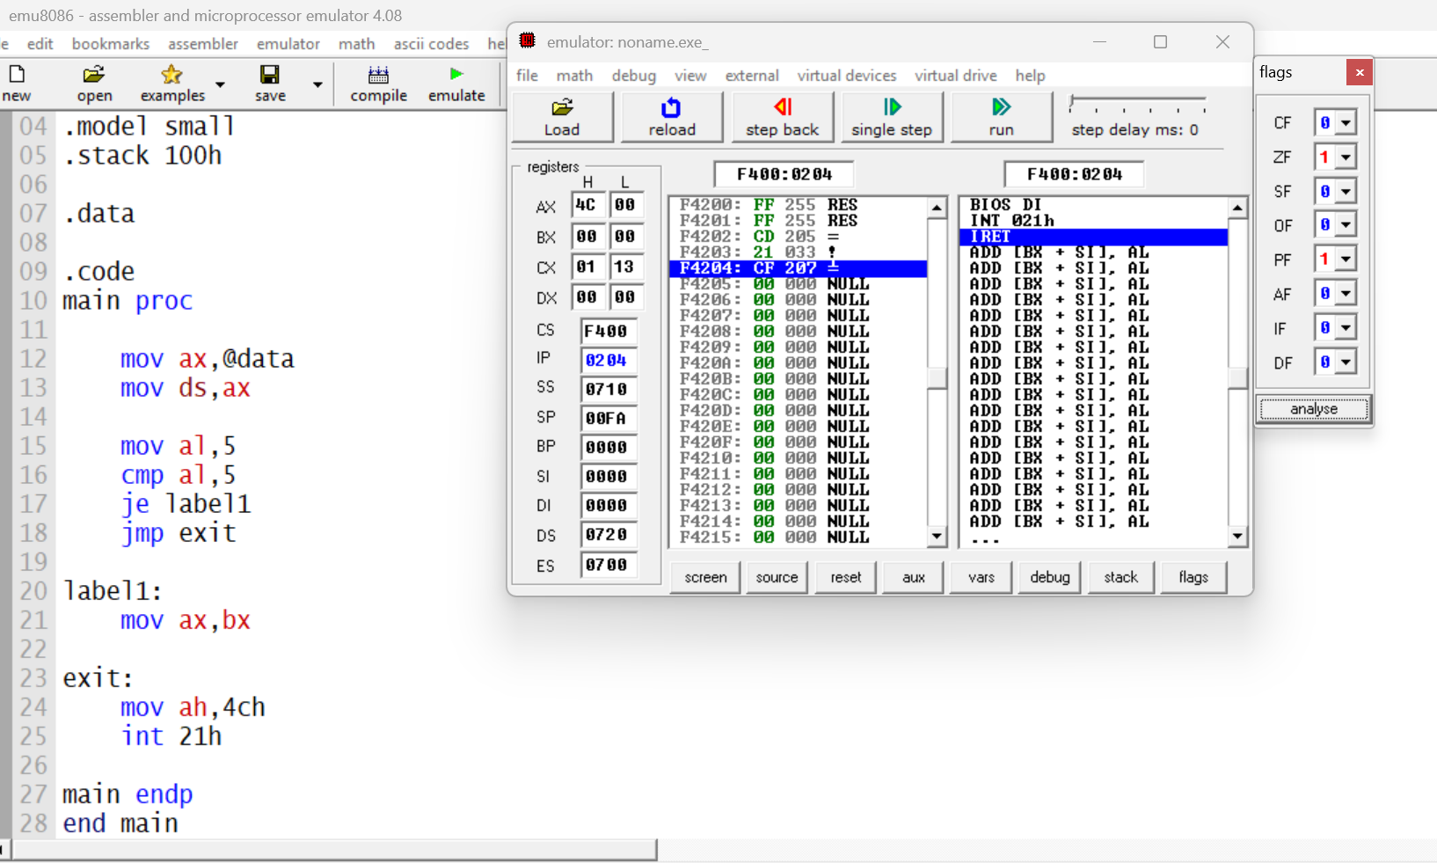
OUTPUT:

EXPLAINATION:
- mov ax,@data: loads data segment address into ax; flags: none
- mov ds,ax: initializes ds with data segment; flags: none
- mov al,5: stores 5 in al register; flags: none
- cmp al,5 compares al with 5; flags affected: zf, sf, cf, of, pf, af
- je label1: jumps to label1 if zf = 1; flags: none
- jmp exit unconditional jump to exit; flags: none
- label1: target label for jump; flags: none
- mov ax,bx: copies value of bx into ax; flags: none
- exit: program exit label; flags: none
- mov ah,4ch: loads program terminate function into ah; flags: none
- int 21h: calls dos interrupt to terminate program; flags may change

LAB EXAMPLE 2:
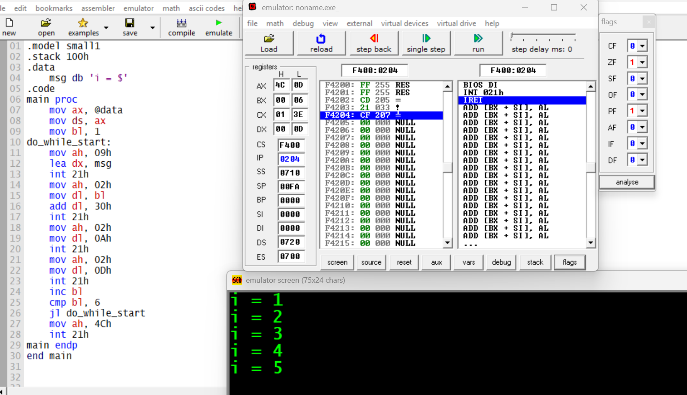
RESULTS:

EXPLAINATION:
- msg db 'i = $' - Defines a string message ending with $
- mov ax, @data - Moves data segment address to AX
- mov ds, ax - Initializes DS register with data segment
- mov bl, 1 - Initializes counter BL to 1
- do_while_start: - Label marking start of loop
- mov ah, 09h - Sets function 09h for string output
- lea dx, msg - Loads address of msg into DX
- int 21h - Calls DOS interrupt to display string
- mov ah, 02h - Sets function 02h for character output
- mov dl, bl - Moves current counter value to DL
- add dl, 30h - Converts number to ASCII character
- int 21h - Calls DOS interrupt to display character
- mov ah, 02h - Sets function 02h for character output
- mov dl, 0Ah - Loads line feed character (new line)
- int 21h - Calls DOS interrupt to display character
- mov ah, 02h - Sets function 02h for character output
- mov dl, 0Dh - Loads carriage return character
- int 21h - Calls DOS interrupt to display character
- inc bl - Increments counter BL by 1
- cmp bl, 6 - Compares BL with 6
- jl do_while_start - Jumps back if BL is less than 6

FLAG CHANGES FOR KEY INSTRUCTIONS:
cmp bl, 6 - Sets ZF=1 if equal, SF=1 if negative, CF=1 if borrow
jl do_while_start - Jumps if SF ≠ OF (checks if BL < 6)
inc bl - Affects ZF, SF, OF, AF but NOT CF
add dl, 30h - Affects CF, OF, ZF, SF, AF, PF

LAB EXAMPLE 3
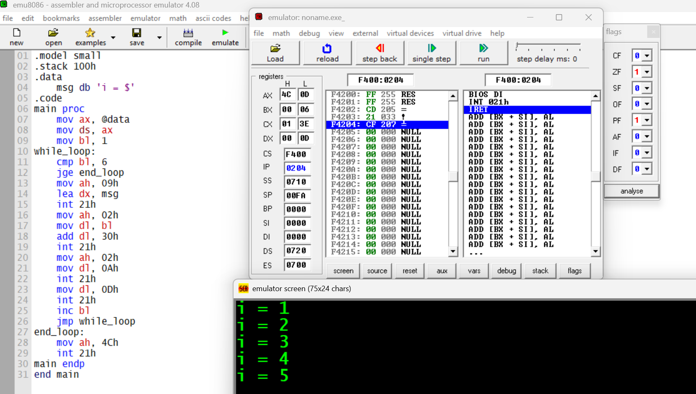
RESULTS:

EXPLAINATION:
- mov bl, 1 - Sets counter to 1
- while_loop: - Loop start label
- cmp bl, 6 - Compares counter with 6
- jge end_loop - Exits if counter >= 6
- mov ah, 09h - Sets string output function
- lea dx, msg - Loads message address
- int 21h - Displays message
- mov ah, 02h - Sets character output function
- mov dl, bl - Moves counter to DL
- add dl, 30h - Converts to ASCII
- int 21h - Displays number
- mov ah, 02h - Sets character output function
- mov dl, 0Ah - Loads line feed
- int 21h - Prints new line
- mov dl, 0Dh - Loads carriage return
- int 21h - Prints carriage return
- inc bl - Increments counter
- jmp while_loop - Jumps back to condition
- end_loop: - Exit point label
- mov ah, 4Ch - Sets exit function
- int 21h - Exits program

FLAG CHANGES FOR KEY INSTRUCTIONS:

- cmp bl, 6- ZF=1 if equal, SF=1 if negative, CF=1 if borrow
- jge end_loop - Jumps if SF=OF (checks if BL >= 6)
- inc bl` Affects ZF, SF, OF, AF but NOT CF
- add dl, 30h - Affects CF, OF, ZF, SF, AF, PF

LAB EXERCISE#1:
Counting from 1 to 10 (Using LOOP Instruction)
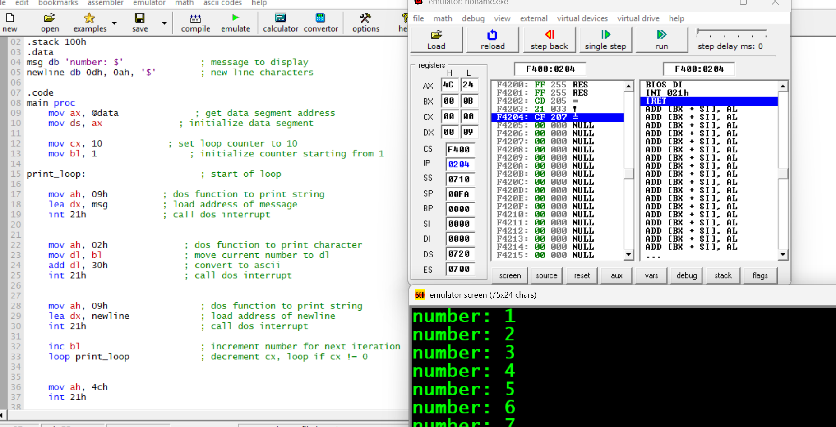
RESULTS:

EXPLAINATION:
Flag changes for Exercise 1:

add dl, 30h- Affects CF, OF, ZF, SF, AF, PF
inc bl`- Affects ZF, SF, OF, AF but NOT CF
loop print_loop` - Affects no flags (CX decremented internally, flags unchanged)

LAB EXERCISE 2
Factorial Calculation (5!) Using LOOPE
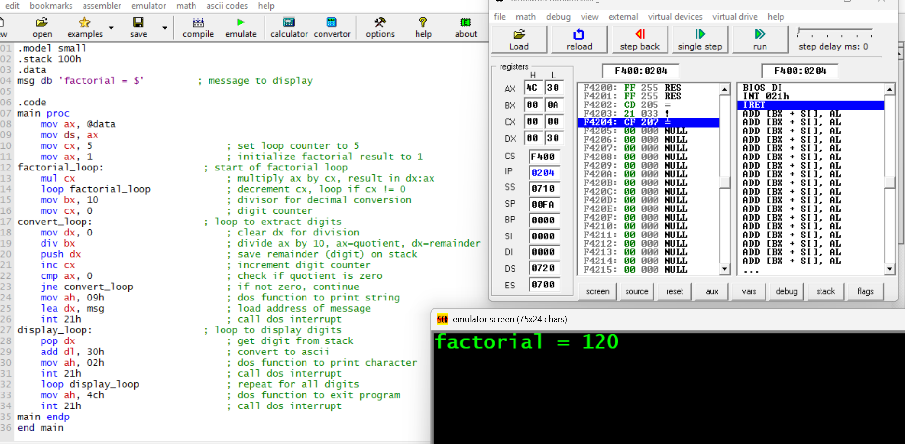
RESULTS:

FLAGS:
- mul cx - Affects CF and OF (set if upper half non-zero)
- loop factorial_loop - Affects no flags
- div bx - Affects all flags (undefined state)
- cmp ax, 0 - Sets ZF=1 if ax=0, SF=0, CF=0
- jne convert_loop - Jumps if ZF=0
- inc cx - Affects ZF, SF, OF, AF but NOT CF
- add dl, 30h - Affects CF, OF, ZF, SF, AF, PF
- loop display_loop - Affects no flags

