COMPUTER NETWORK LAB

LAB 7

NAME:
MUHAMMAD TALHA
SECTION:
4/A
ROLL NUMBER:
241890

INSTRUCTOR:
Mr. MUHAMMAD BILAL

TASK#1
TOPOLOGY:
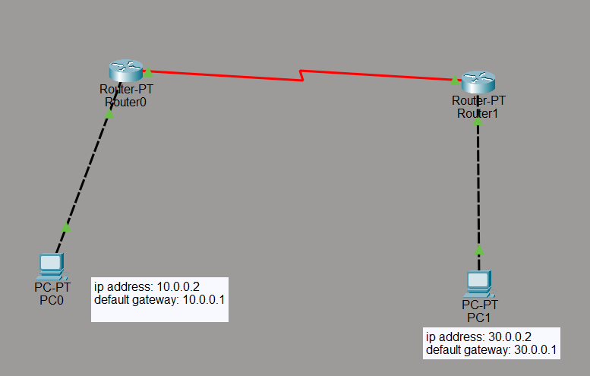
ROUTING ROURTER 0:
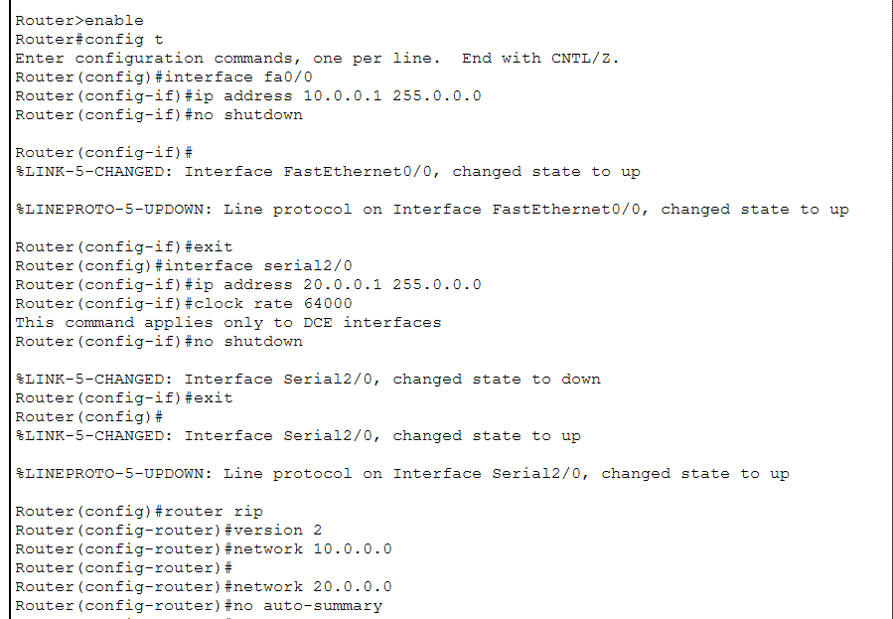

ROUTING ROURTER 1:
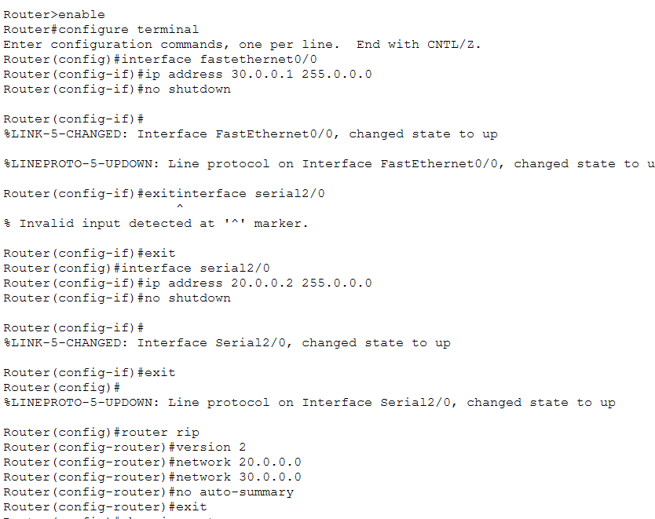
VERIFYING ROUTING:
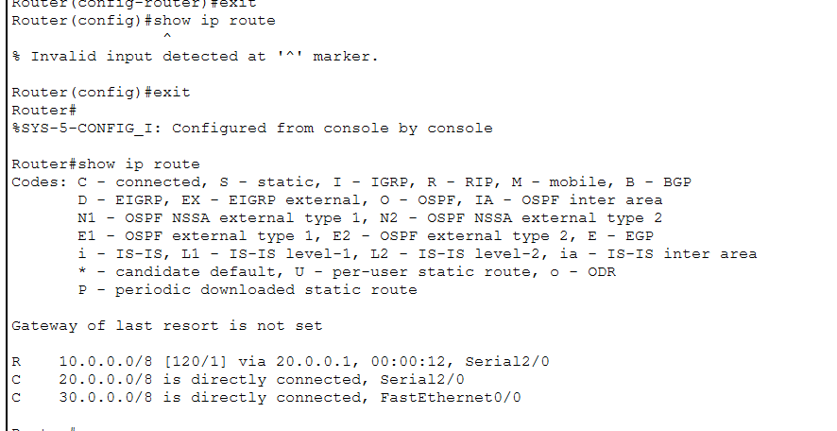

TEST THE NETWORK:
FROM PC0->PC1
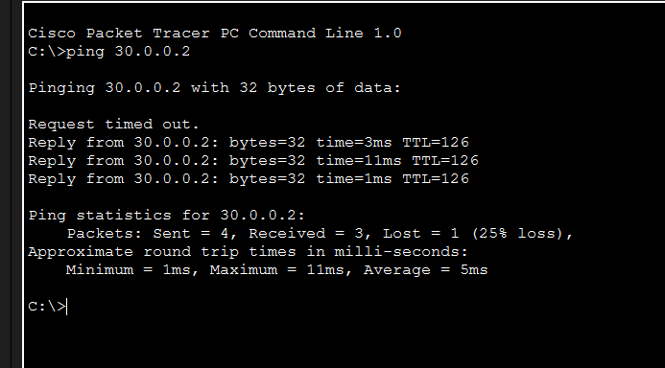

LAB TASK #2
TOPOLOGY:
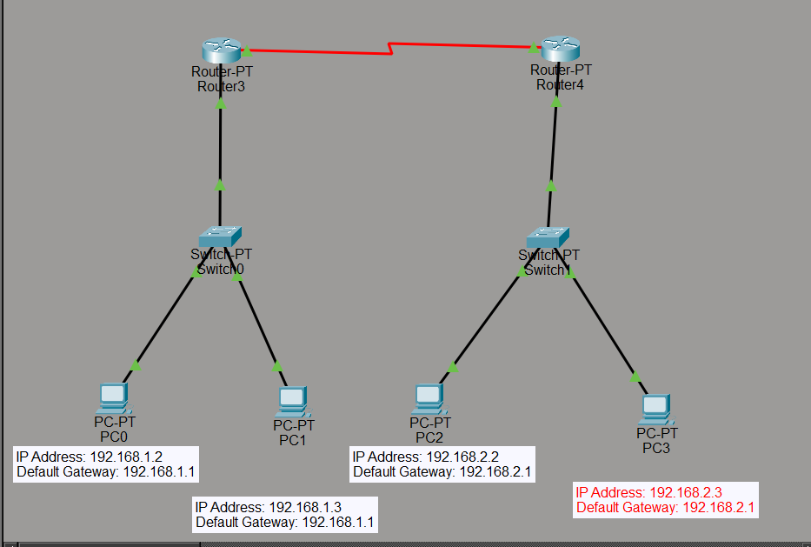

ROUTING ROUTER 3
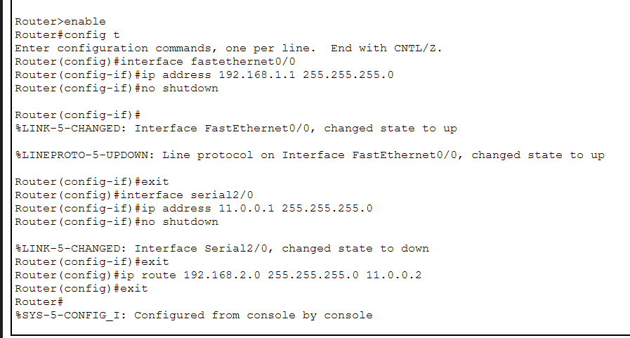
ROUTING ROUTER 4:
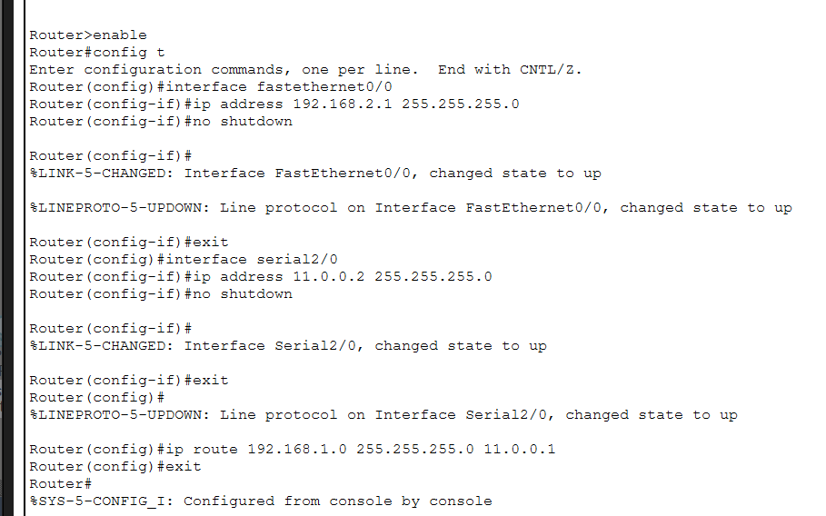

VERIFYING ROURES ROUTER 4:
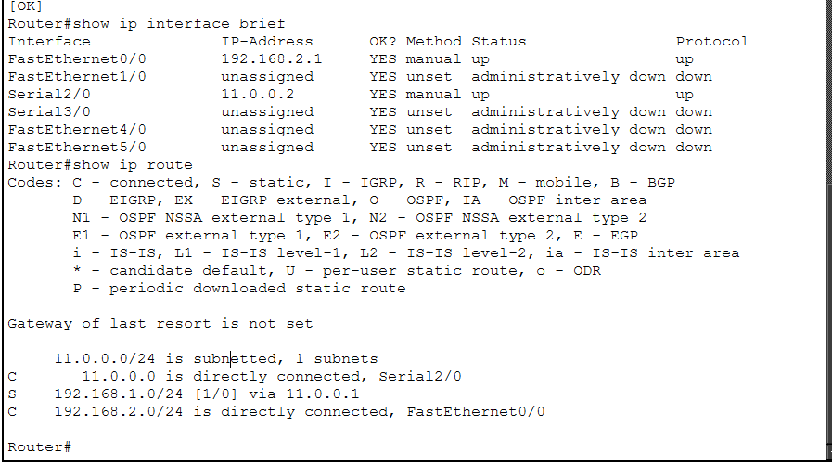
PC0-PC4:
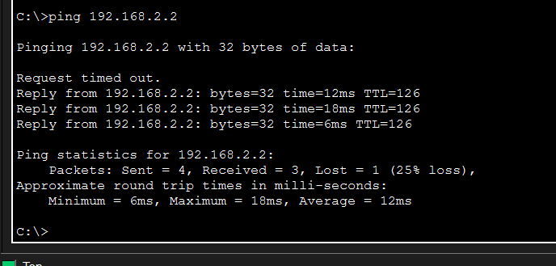

LAB TASK#3
TOPOLOGY
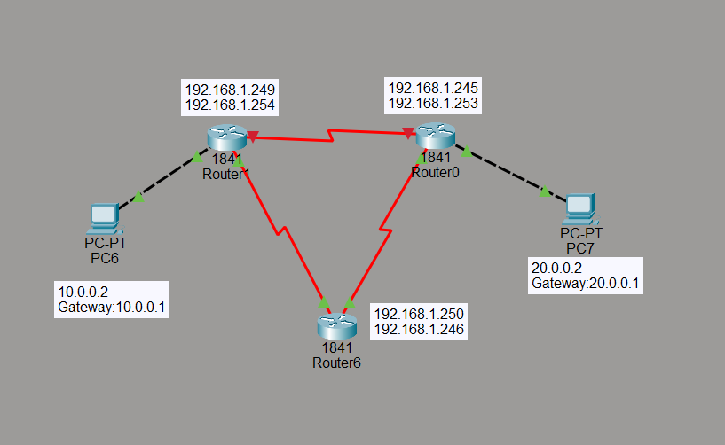
PING FROM PC6 TO PC 7:
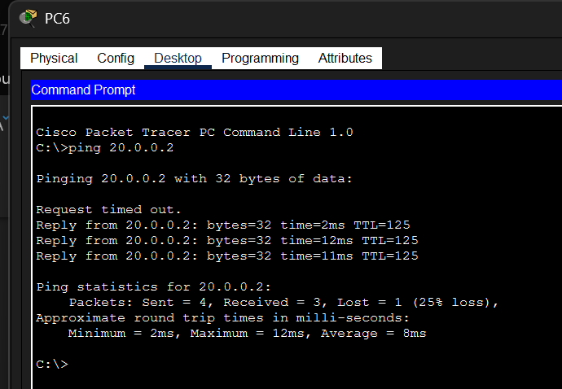
ROUTERS EXPLAINATION:
- Router0: Connects to the 20.0.0.0/8 network via FastEthernet0/1 (20.0.1.30). Has a PC (PC7) with IP 20.0.0.2. Connected to Router6 via Serial0/0/0 (192.168.1.245).
- Router1: Connects to the 10.0.0.0/8 network via FastEthernet0/1 (10.0.0.1). Has a PC (PC6) with IP 10.0.0.2. Connected to Router6 via Serial0/0/0 (192.168.1.249).
- Router6: Acts as a central hub. Connected to Router0 via Serial0/0/1 (192.168.1.246) and to Router1 via Serial0/0/0 (192.168.1.250). No active LAN connections.
WORLING:
- Router6 acts as the backbone. It connects both Router0 and Router1 through serial links, allowing communication between the two separate networks.
- Router0 serves the 20.0.0.0/8 network. It routes traffic between PC7 (20.0.0.2) and other networks via its serial connection to Router6.
- Router1 serves the 10.0.0.0/8 network. It routes traffic between PC6 (10.0.0.2) and other networks via its serial connection to Router6.
- PC6 and PC7 can communicate. Traffic from PC6 (10.0.0.2) goes to Router1 -> Router6 -> Router0 -> PC7 (20.0.0.2), and vice versa.
- All three routers form a point-to-point serial network using the 192.168.1.240/30 subnet range to pass data between the 10.0.0.0/8 and 20.0.0.0/8 networks.

