COMPUTER NETWORK LAB 3/4

TOPIC:
VLAN and interVLAN Routing in

NAME:
MUHAMMAD TALHA
ROLL#:
241890
SECTION:
4/A

INSTRUCTOR:
Mr. MUHAMMAD BILAL

LAB TASK#1
TOPOLOGY:
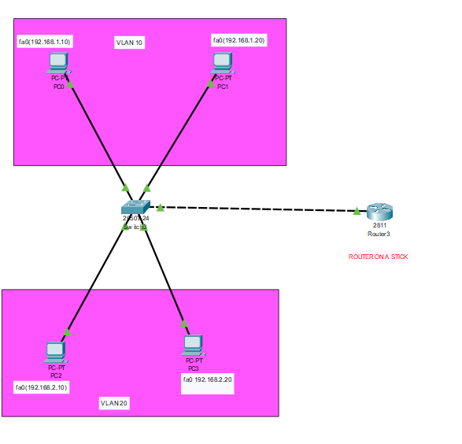
STEPS:
- VLAN IN SWITCH
- First, I created two VLANs on the switch.
  - VLAN 10 =>SALES
  - VLAN 20 =>IT
CODE:
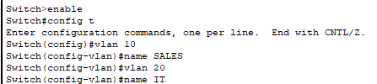
- Assign Ports to VLANs
- Then I assigned ports to VLANs.
fa0/1 and fa0/2 =>VLAN 10
fa0/3 and fa0/4 =>VLAN 20
CODE:
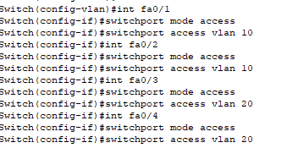
- Step 3: Assign IP Address to PCs
Then I gave IP addresses to PCs.
VLAN 10:
- PC1 =>192.168.1.10
- PC2 =>192.168.1.20
- Default Gateway =>192.168.1.1
VLAN 20:
- PC3 =>192.168.2.10
- PC4 =>192.168.2.20
- Default Gateway =>192.168.2.1
After this, same VLAN PCs can ping each other, but different VLANs cannot.
- Configure Router (Router-on-a-Stick)
To allow communication between VLANs, I configured the router.
First, I enabled the main interface.
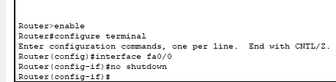
For vlan 10 and vlan 20
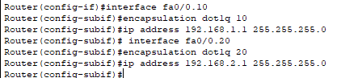

Step 5: Testing
Now I tested:
Ping PC2 from PC1 =>Success
Ping PC3 from PC1 =>Success
Before configuration:
Pc1=>pc2
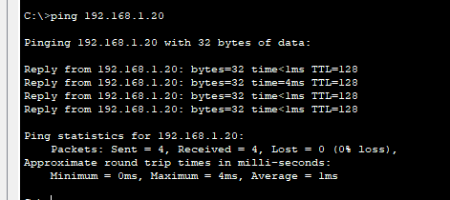
Pc1=>pc3
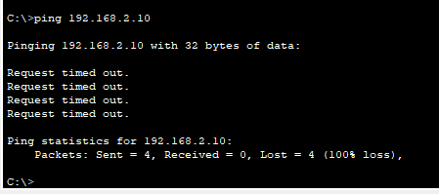
AFTER CONFIGURATION:
Pc1=>pc4
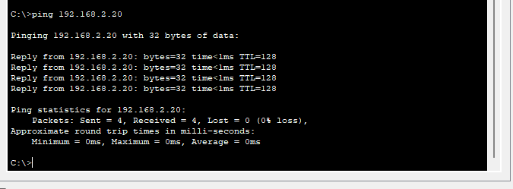

LAB TASK #3
Topology:
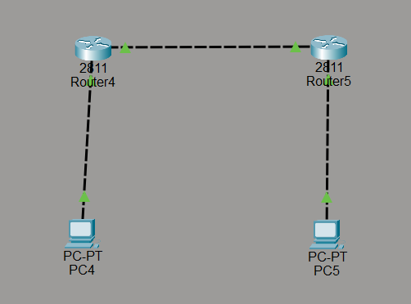
Results:
Router r5:
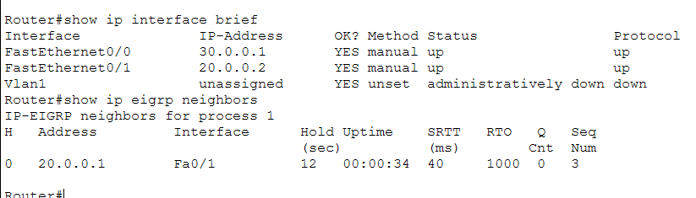
Router r4:
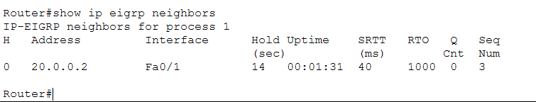
Steps:
- Configure r1 interfaces, assign ips to fa0/0 and fa0/1, then no shutdown
- Configure r2 interfaces, assign ips to fa0/0 and fa0/1, then no shutdown
- Ensure router link uses same subnet, r1 = 20.0.0.1, r2 = 20.0.0.2
- Configure pc1, ip 10.0.0.2 mask 255.0.0.0 gateway 10.0.0.1
- Configure pc2, ip 30.0.0.2 mask 255.0.0.0 gateway 30.0.0.1
- Enable eigrp on r1, router eigrp 1 + network 10.0.0.0 + network 20.0.0.0
- Enable eigrp on r2, router eigrp 1 + network 20.0.0.0 + network 30.0.0.0
- Disable auto-summary on both routers
- Verify neighbors using show ip eigrp neighbors
- Verify routes using show ip route eigrp
- Test connectivity by pinging pc1 and pc2
PC CONNECTIVITY:
