Pearls AQI Predictor
A Serverless MLOps System for 3-Day
Air Quality Forecasting in Lahore
Project Report
Submitted as part of the
Pearls Data Science Internship Program

Prepared by: Muhammad Talha
September 2026
Repository: github.com/talha-64/AQI_Predictor
Live Dashboard: aqipredictor-10p.streamlit.app

Contents
1. Executive Summary 3
2. Introduction & Problem Statement 3
3. Objectives 3
4. System Architecture 4
5. Data Sources 4
6. Exploratory Data Analysis - Key Findings 5
7. Feature Engineering 5
8. Model Development & Methodology 6
9. Model Performance & Evaluation 6
10. MLOps Pipeline & Automation 7
11. Model Explainability (SHAP) 8
12. Interactive Dashboard 10
14. Conclusion & Future Work 11
15. References & Links 12

1. Executive Summary
This report documents the design, implementation, and deployment of the Pearls AQI Predictor - an end-to-end, fully serverless machine learning system that forecasts the Air Quality Index (AQI) for Lahore, Pakistan, three days in advance. The system was built to satisfy a Data Science internship project brief requiring automated data collection, feature engineering, model training, and a real-time prediction dashboard, using a 100% serverless technology stack.
The final system ingests live pollutant and weather data hourly, engineers a validated feature set of over 50 signals, trains three chained LightGBM regression models (one per forecast horizon), blends each prediction with a persistence baseline, and serves the result through a live, publicly accessible Streamlit dashboard. The entire pipeline - feature collection, model retraining, and inference - runs autonomously via GitHub Actions, with redundant external scheduling through cron-job.org to guarantee reliability.
On the most recent evaluation, the system achieves an R² of 0.883 for the 24-hour forecast, 0.713 for 48 hours, and 0.656 for 72 hours - all of which improve on a naive persistence baseline, which itself is a genuinely strong benchmark given the high autocorrelation of AQI in Lahore.

2. Introduction & Problem Statement
Lahore consistently ranks among the most polluted cities in the world, with air quality deteriorating sharply during the October–February smog season. Reliable short-term AQI forecasting gives residents, schools, and public health authorities the lead time needed to plan outdoor activity, issue advisories, and reduce exposure during hazardous periods.
The assigned project brief required building a complete, production-style ML system - not just a trained model - covering the full lifecycle: automated feature pipelines, a feature store, model training and registry, CI/CD automation, and a live-serving dashboard, using a 100% serverless architecture with no infrastructure to provision or maintain.

3. Objectives
- Forecast Lahore's AQI for the next 3 days (24h / 48h / 72h horizons) using historical pollutant and weather data.
- Build a fully automated feature pipeline that fetches and engineers new data every hour with no manual intervention.
- Build a fully automated retraining pipeline that keeps the model current as new data accumulates.
- Use a managed Feature Store and Model Registry (Hopsworks) rather than ad-hoc file storage.
- Provide model explainability via SHAP.
- Implement hazardous-AQI alerting for public health relevance.
- Deploy a live, interactive dashboard accessible to any user without setup.

4. System Architecture
The system is organized around a Feature Store / Model Registry pattern, with all state living in Hopsworks and all orchestration handled by GitHub Actions (backed up by an external cron trigger). No servers are provisioned or maintained at any point - every component runs on free-tier serverless infrastructure.
At a high level:
Hourly cycle: 02_feature_pipeline.py fetches the latest pollution and weather readings, engineers the full feature row, and writes it to the aqi_hourly_fg Feature Group. 04_batch_inference.py then loads the latest registered models, generates the 3-day forecast, writes it to the aqi_predictions_fg Feature Group, and publishes a lightweight JSON/CSV snapshot back into the repository for the dashboard to read.
Daily cycle: 03_training_pipeline.py reads the full historical feature set, retrains all three horizon models, evaluates them against a persistence baseline, and registers new versions in the Hopsworks Model Registry.
One-time setup: 01_backfill.py seeds the Feature Store with roughly 5 years of historical pollution and weather data before the automated cycles take over.

5. Data Sources
Source | Data Provided | Access
OpenWeather Air Pollution API | PM2.5, PM10, CO, NO, NO₂, O₃, SO₂, NH₃ (current + historical) | API key required
Open-Meteo Weather API | Temperature, humidity, wind speed/direction, pressure, precipitation, cloud cover (historical archive + forecast) | No API key required
Open-Meteo is used for both historical backfill and live forecast lead features, ensuring the weather inputs at training time and inference time come from the same provider - avoiding a train/serve distribution mismatch.

6. Exploratory Data Analysis - Key Findings
An extensive EDA (notebooks/EDA.ipynb) over the full 5-year historical dataset directly motivated the feature engineering decisions.
Strong seasonality: the Oct–Feb smog season averages roughly 2× the AQI of the rest of the year, motivating an explicit is_smog_season flag.
High persistence: AQI 72 hours ahead still correlates with the current reading at r ≈ 0.65 - the empirical justification for blending every prediction with a persistence baseline rather than trusting the model alone at longer horizons.
Wind dominates dispersal: AQI drops sharply as wind speed increases; low-wind, high-pollution co-occurrence motivated a stagnation_index feature.
Rain clears pollution: a consistent negative relationship between rainfall and AQI motivated a rolling rain-accumulation feature.
Diurnal cycle: AQI varies systematically by hour of day, consistent with traffic and emission patterns, captured via cyclical time encoding.

7. Feature Engineering
7.1 Engineered Feature Set
- Exponential moving averages (12h / 72h / 168h spans) on PM2.5, PM10, EPA AQI, CO, and NO₂
- Autoregressive lags (24h / 48h / 72h / 168h) on EPA AQI
- Rolling volatility measures (24h / 72h standard deviation of AQI)
- Atmospheric stagnation index and pressure delta
- Cyclical hour-of-day encoding (sine/cosine)
- Smog-season indicator flag
- Rolling 72-hour rainfall accumulation
- Forward-looking weather lead features (24h/48h/72h) - shifted historical values during training, real forecast values at live inference time
7.2 Feature Pruning
Two rounds of validated pruning were applied before finalizing the feature set:
- Ablation testing: calendar day-of-year features (sin/cos of day-of-year) were found to act as a “which season does this look like” shortcut rather than encoding genuine AQI dynamics, and were removed.
- Collinearity analysis: AQI-family columns showed correlations of 0.79–0.98 with each other; the set was trimmed to one current value, one short EMA, one long EMA, and one volatility measure, letting the model concentrate signal rather than splitting importance across near-duplicate columns.

8. Model Development & Methodology
Development followed an iterative, evidence-driven process rather than fitting a single model and stopping:
- Established a naive persistence baseline (“tomorrow's AQI = today's AQI”) as the benchmark every model had to beat - a genuinely strong baseline given Lahore's high AQI autocorrelation.
- Trimmed and de-correlated the feature set (Section 7.2).
- Tested a delta-target reframing (predicting the change from current AQI rather than the absolute value).
- Chained the three horizon models so later horizons can use earlier predictions as input features.
- Swept the persistence-blend weight across a full 0–1 range to identify a stable, non-overfit operating point.
8.1 Final Model Architecture
Day 1 model: features -> prediction
Day 2 model: features + Day 1 prediction -> prediction
Day 3 model: features + Day 1 + Day 2 predictions -> prediction
Each horizon uses a LightGBM gradient-boosted regressor. The raw model output is then blended with simple persistence:
final_prediction = 0.4 x model_prediction + 0.6 x current_AQI
This weighting emerged from the full investigation summarized above, converging on 0.4 as a stable choice across all three horizons - favoring the model where it has genuine skill (short horizon) while leaning more on persistence as raw model skill degrades at longer horizons.

9. Model Performance & Evaluation
Performance is evaluated on a chronologically held-out test set (the most recent 20% of historical data), using Mean Absolute Error (MAE), Root Mean Squared Error (RMSE), and R².
Horizon | Blend Weight | MAE | RMSE | R²
Day 1 (24h) | 0.4 | 20.05 | 28.46 | 0.883
Day 2 (48h) | 0.4 | 31.93 | 44.79 | 0.713
Day 3 (72h) | 0.4 | 35.80 | 49.25 | 0.656

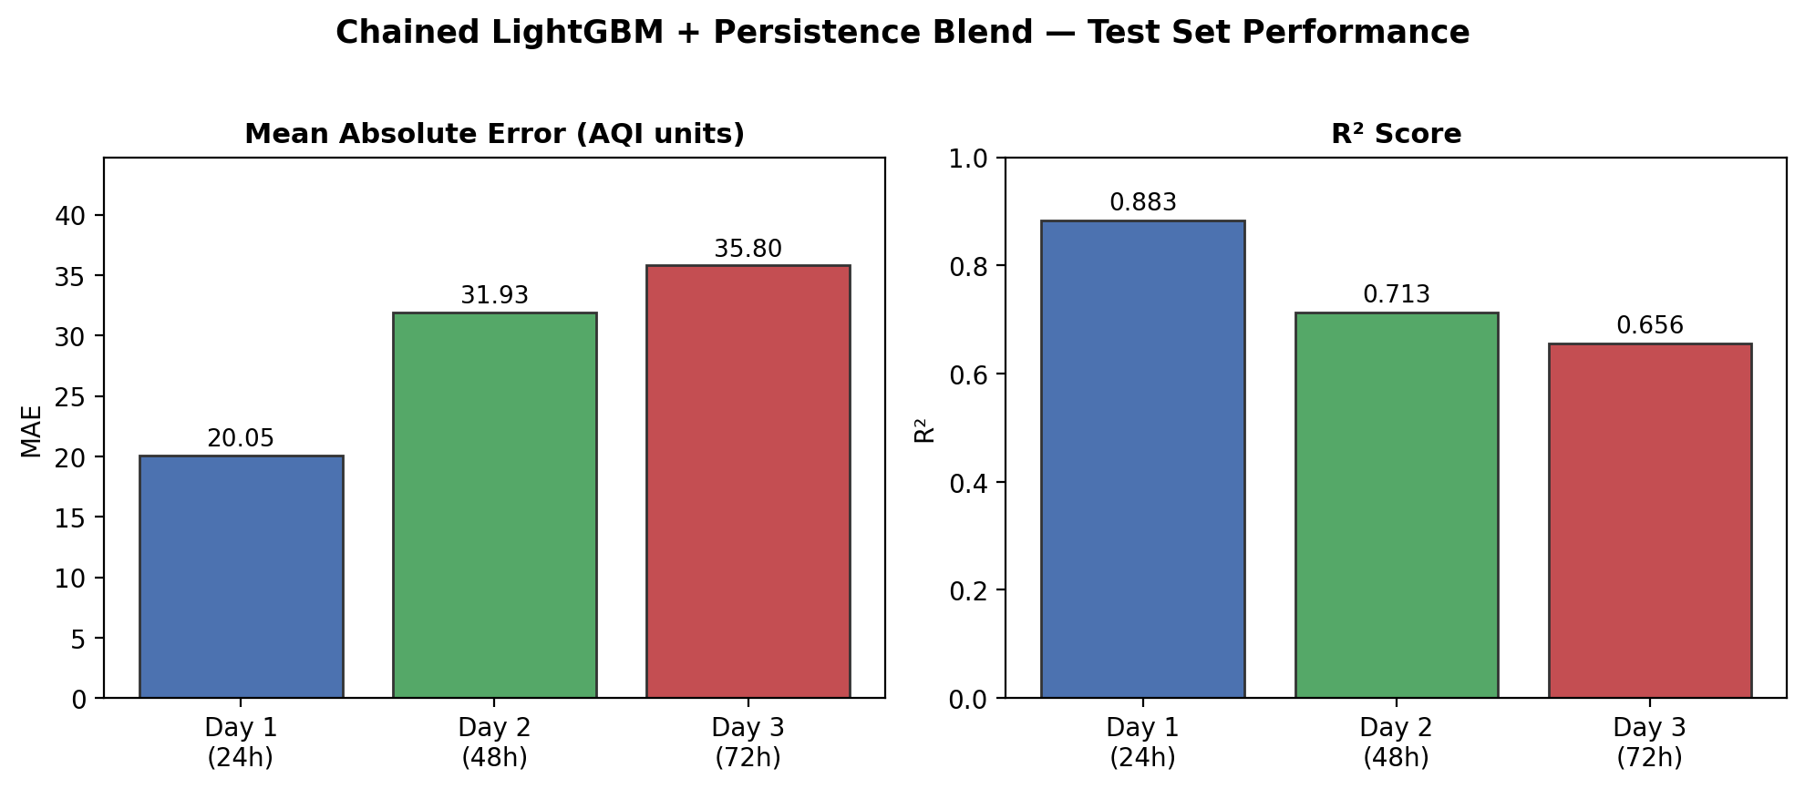
Figure 2: Test-set MAE and R² by forecast horizon. As expected, accuracy degrades with horizon length - a genuine reflection of atmospheric predictability limits, not a modeling shortfall.
These figures reflect the most recent automated retraining run; the daily_training_pipeline.yml workflow keeps the deployed model current as new data accumulates.

10. MLOps Pipeline & Automation
10.1 Pipeline Components
Script | Trigger | Responsibility
01_backfill.py | Manual, one-time | Seeds the Feature Store with ~5 years of historical data
02_feature_pipeline.py | Hourly | Fetches live data, engineers features, writes to Feature Store
03_training_pipeline.py | Daily (02:30 UTC) | Retrains all 3 models, evaluates, registers new versions
04_batch_inference.py | Hourly | Loads latest models, generates forecast, publishes results

10.2 Feature Store & Model Registry
Hopsworks Serverless provides both the Feature Store (aqi_hourly_fg for engineered features, aqi_predictions_fg for published forecasts) and the Model Registry (versioned per-horizon LightGBM models). 04_batch_inference.py always resolves the latest registered model version dynamically for each horizon, so a daily retrain is automatically picked up by the next inference run with no manual version management.
10.3 CI/CD & Scheduling
Two GitHub Actions workflows drive the automation: an hourly workflow running the feature and inference pipelines, and a daily workflow running the training pipeline. Because GitHub's native schedule trigger is documented as best-effort and was observed to intermittently skip runs, the hourly pipeline is additionally triggered via cron-job.org, which calls GitHub's REST API to dispatch the workflow independently of GitHub's own scheduler - providing redundancy against silently missed hourly runs.

11. Model Explainability (SHAP)
SHAP (SHapley Additive exPlanations) summary plots are regenerated automatically on every daily training run for each of the three horizon models, and committed to notebooks/SHAP/ in the repository. They identify which engineered features most influence each horizon's predictions, supporting model transparency and validating that the model is relying on meteorologically sensible signals (e.g. recent AQI history, stagnation index) rather than spurious correlations.
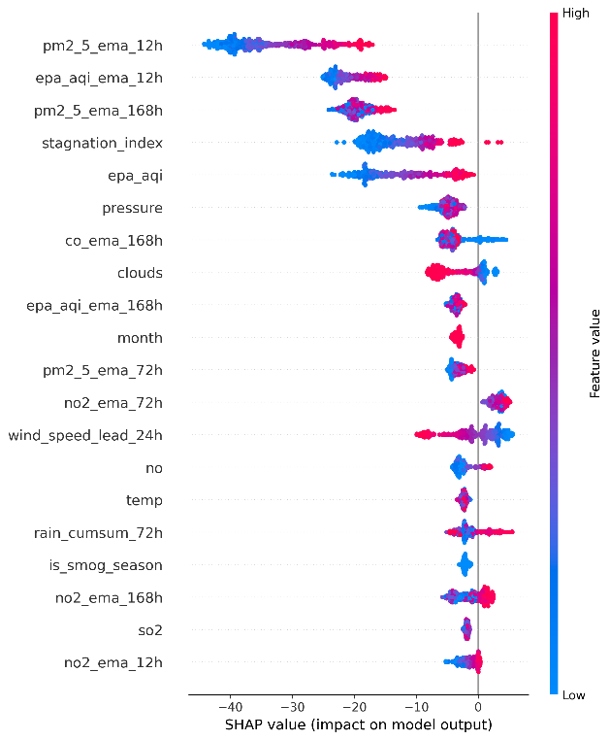
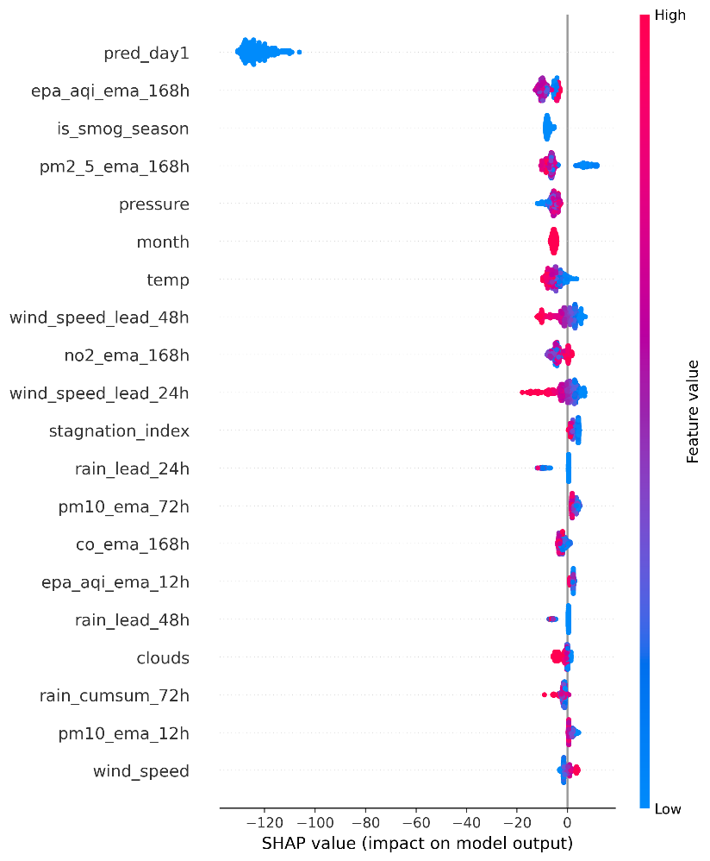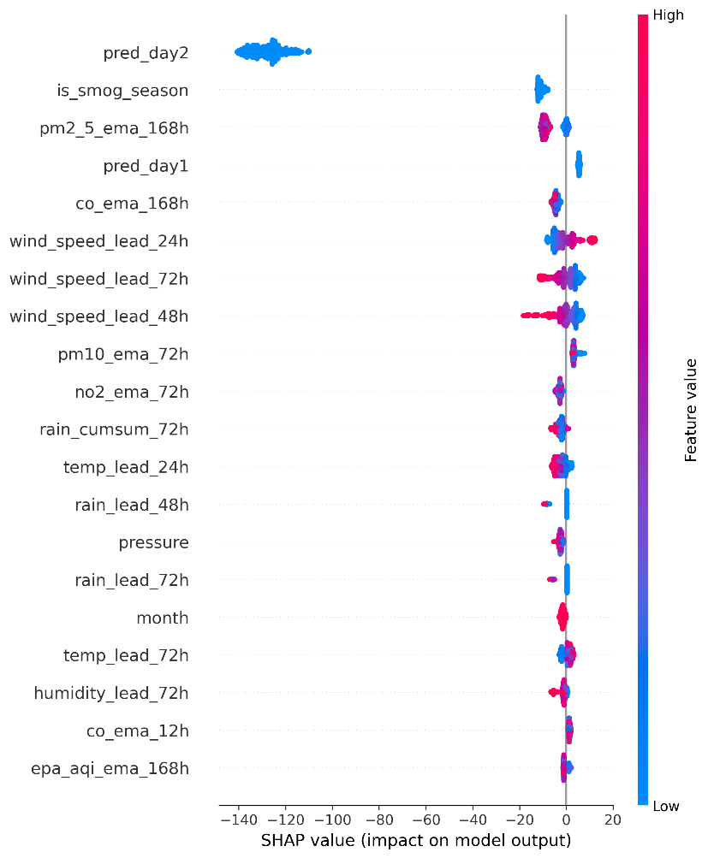

12. Interactive Dashboard
The Streamlit dashboard, deployed at aqipredictor-10p.streamlit.app, provides:
- Current AQI and 3-day forecast cards, color-coded by EPA AQI category
- A health advisory banner based on current conditions
- A 14-day AQI trend chart, localized to Pakistan Standard Time
- Horizon-by-horizon forecast breakdown and a model explainability tab
- Automatic hazardous-level alerting when any forecasted day crosses the “Unhealthy” threshold
The dashboard deliberately reads only from two small, repository-committed files (latest_predictions.json and recent_history.csv) rather than querying Hopsworks live on every page load - keeping it fast and avoiding load on the free-tier feature store regardless of concurrent visitors.
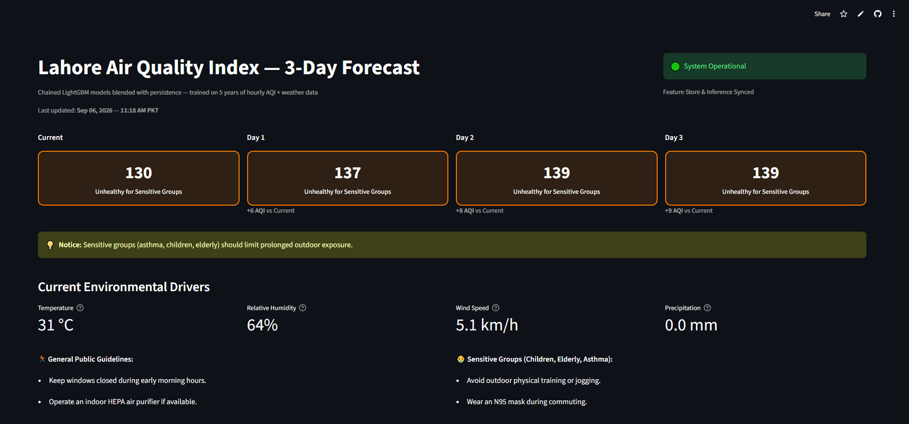13. Engineering Challenges & Solutions
Building and stabilizing the production pipeline surfaced several non-obvious infrastructure issues, documented here as they reflect substantial real-world debugging effort beyond initial model development:
- Hopsworks offline query service instability: the offline Arrow Flight/DuckDB query service intermittently failed with server-side crashes and materialization job failures. Resolved by routing all reads through the online store first, with a Hive/Spark fallback, avoiding dependency on the less reliable offline path.
- Strict schema dtype enforcement: the Feature Group schema was inferred as 32-bit float at backfill time; live inserts using pandas' default 64-bit floats were rejected. Resolved with explicit dtype casting on every insert, keeping timestamp_unix as a 64-bit integer per the schema's primary-key requirement.
- Timezone inconsistency across read backends: different Hopsworks read paths returned datetime columns with inconsistent timezone-awareness, causing sort/comparison failures. Resolved by normalizing every timestamp to timezone-naive UTC immediately after parsing, regardless of source.
- Model Registry version drift: inference initially pinned to a hardcoded model version, which would have silently served an increasingly stale model as daily retraining produced new versions with no error raised. Resolved by dynamically resolving the latest registered version on every inference run.
- Scheduler reliability: GitHub Actions' native schedule trigger was observed to silently skip runs, particularly after being manually disabled and re-enabled. Mitigated with a redundant external trigger via cron-job.org.
- Feature Store query cost on the free tier: An early dashboard design queried Hopsworks directly on every page load. Redesigned so the dashboard reads only small, pipeline-published local files, and the 14-day trend chart is maintained as an incrementally-updated rolling window rather than re-queried in full each hour.

14. Conclusion & Future Work
The Pearls AQI Predictor successfully delivers a complete, automated, serverless ML system meeting every requirement of the assigned project brief: automated feature and training pipelines, a managed feature store and model registry, CI/CD scheduling, SHAP explainability, hazardous-AQI alerting, and a live public dashboard. Beyond the initial model, significant engineering effort went into hardening the system against real production failure modes - infrastructure instability, schema mismatches, and scheduler unreliability - that only surface once a pipeline runs continuously rather than as a one-off notebook exercise.
Potential directions for future work:
- Incorporate neighboring monitoring stations or regional pollution-transport data to improve longer-horizon (48h/72h) accuracy.
- Experiment with deep learning architectures (e.g. temporal convolutional networks or transformers) as an additional candidate alongside LightGBM.
- Extend the system to additional cities, using the existing station-agnostic pipeline design with location as a categorical feature.
- Add automated data-drift and model-performance monitoring with alerting if live accuracy degrades below the persistence baseline.

15. References & Links
GitHub Repository: https://github.com/talha-64/AQI_Predictor
Live Dashboard: https://aqipredictor-10p.streamlit.app/
OpenWeather Air Pollution API: https://openweathermap.org/api/air-pollution
Open-Meteo API: https://open-meteo.com/
Hopsworks: https://www.hopsworks.ai/
LightGBM: https://lightgbm.readthedocs.io/
SHAP: https://shap.readthedocs.io/
Streamlit: https://streamlit.io/

