# Task 1

select distinct Region from country where LifeExpectancy<50;

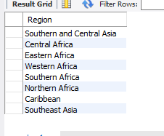

# Task 2

select Language from countrylanguage where isOfficial='F' and percentage between 50 and 80 ;

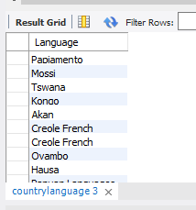

# Task 3

select Name from country where Name like('C_i%');

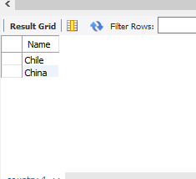

# Task 4

create table temp(select Code, LocalName from country where LocalName not like ('congo'));

select Code from temp where LocalName not like ('chile');

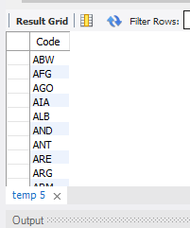

# Task 5

select Code, Language from country, countryLanguage where country.Code=countrylanguage.CountryCode and IndepYear like('198_');

