

**Introduction to Database System**

**Fall 2020**

# Lab Mid Paper

**Time Allowed: 2 hours**

|  |  |
| --- | --- |
| Name: | **Mumammad Talha Dar** |
| Registration No | **L1s19bscs0060** |
| Serial Number (of attendance sheet) |  |

|  |  |  |  |  |  |  |  |  |  |  |  |  |  |
| --- | --- | --- | --- | --- | --- | --- | --- | --- | --- | --- | --- | --- | --- |
|  | Q1 | Q2 | Q3 | Q4 | Q5 | Q6 | Q7 | Q8 | Q9 | Q10 | Q11 | Q12 | Total |
| Total | 15 | 5 | 5 | 5 | 5 | 5 | 5 | 5 | 5 | 5 | 5 | 5 | 70 |
| Obtained |  |  |  |  |  |  |  |  |  |  |  |  |  |

**Instructions:**

1. **This is closed Book/closed Notes Exam, no cheat sheet is allowed.**
2. **Understanding of question is part of paper**. Therefore, no queries will be entertained during examination.
3. **Bank schema, Chess schema** and SQL files are uploaded on LMS. Use database **Bank schema** to solve **Part 1** and **Chess** to solve **Part 2** of Paper.
4. You can use any method or approach to solve a query unless you are explicitly instructed to use specific approach.
5. Use proper indentation/formatting while writing queries.
6. SOME ONE is always with You, so be Relaxed. SOME ONE is always watching You, so be Honest. Keep Calm & stay Blessed.

# Part 1 (DDL)

**Note: Perform this question only on computer and submit MS Word file.**

**You need to write query (text form) + its output (screen shot with execution time)**

The Schema of **Bank System** is

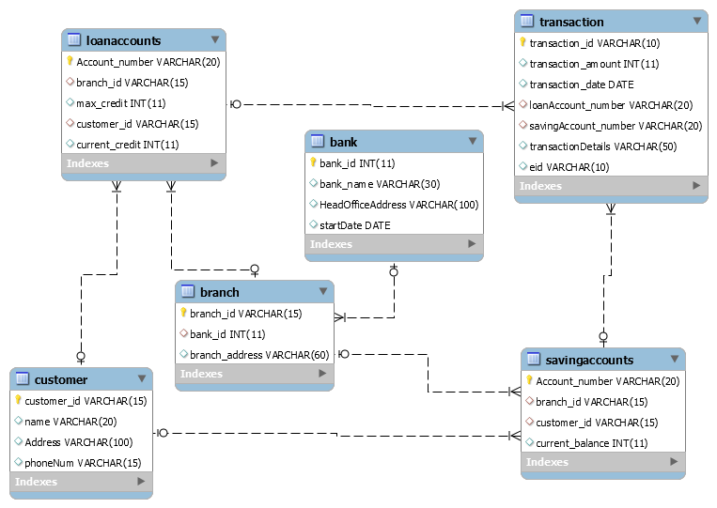

**Q1.** Create table **Employee** with following fields

1. eid varchar (10)
2. branch_id varchar (15)
3. name varchar (25)
4. address varchar (50)
5. age float

**Constraints.**

* **eid**in Employee, is prim/ary key
* **branch_id**in Employee, is foreign key from branch

create table employee(

eid varchar (10),

branch_id varchar (15),

name varchar (25),

address varchar (50),

age float

);

alter table employee add primary key(eid);

alter table employee add foreign key (branch_id) references branch(branch_id);

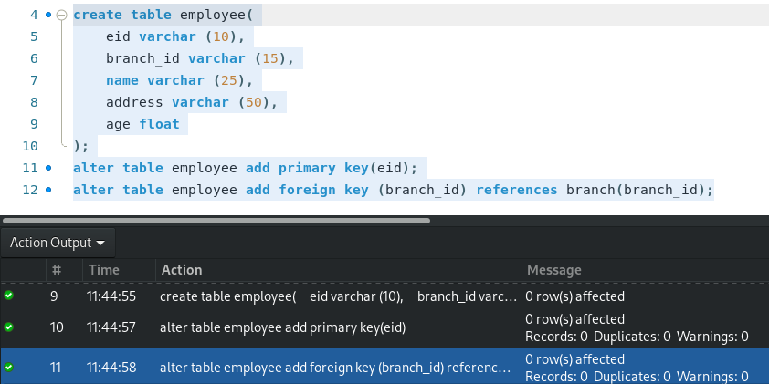

**Q2.** Now add column (**designation** varchar (25)) in Employee table.

alter table employee add column designation varchar(25);

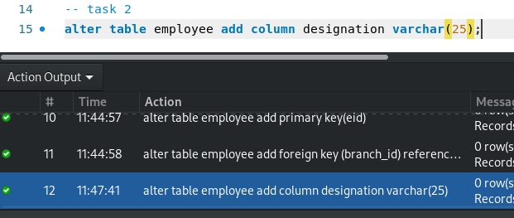

**Q3.** Requirements have been changed you are required to set **10000** as default value of **max_credit** in loanaccounts table.

alter table loanaccounts alter max_credit set default 1000;

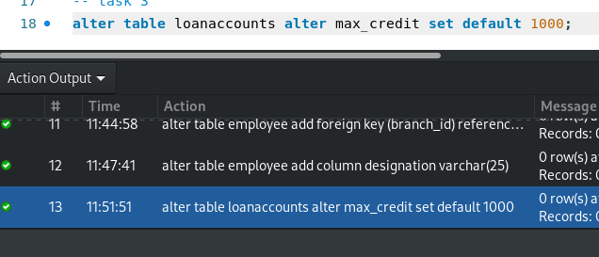

**Q4.** Change datatype of age in Employee to **Int** from float.

alter table employee modify column age int;

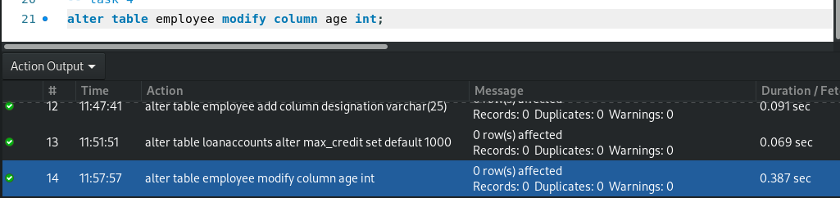

**Q5.** There is no relationship between Employee and Transaction table, so make a relation between these two tables using alter command. **Note** eid in transaction, should be foreign key from employee

alter table transaction add foreign key (eid) references employee(eid);

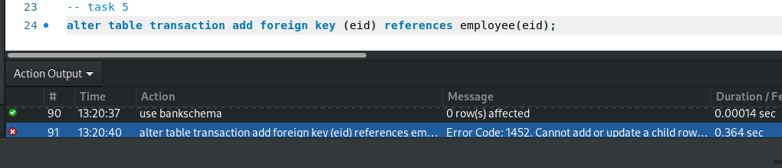

**Part 2 (DML)**

**For each of the following, write a SQL query that satisfies the given**

**requirements, You need to write query (text form) + its output table**

**(screen shot with execution time)**

**Q6.**  Show the details of those players whose names third letter is ‘S’.

select * from players where fname like ("__S%");

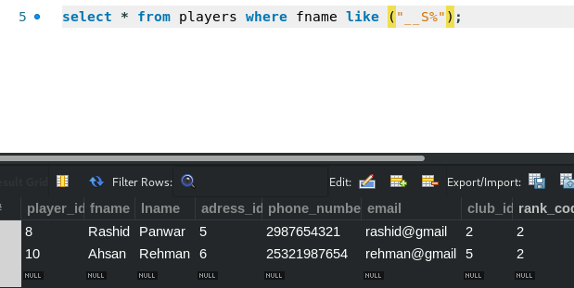

**Q7.** Show all data of sponsors other than ‘azhar’ and ’galib’.

select * from sponsors where sponsor_name not like ("galib") and sponsor_name not like ("azhar");

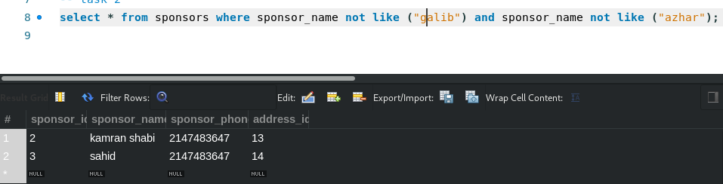

**Q8.**  Retrieve the first names of those players who participated in the tournament named as ‘awami’.

**(Do it with Joins)**

**select fname from players p inner join player_participated pp on p.player_id=pp.player_id inner join tornaments t on t.tornaments_id=pp.tornaments_id where t.tornament_name like ("awami");**

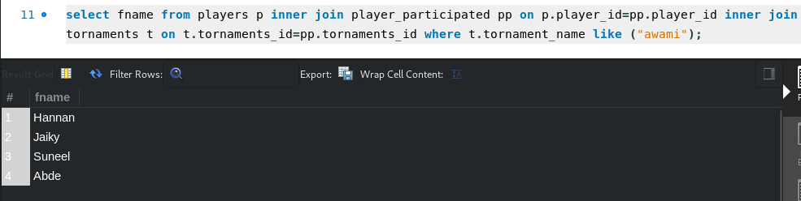

**Q9.** Print the detail of tournament organized by “alinawaz” or “shabana azmi”.

**(Do it with Inner/Nested query)**

**select * from tornaments t where t.organizer_id in (select t_o.organizer_id from tornament_organizer t_o where t_o.organizer_name like ("alinawaz") or t_o.organizer_name like("shabana azmi"));**

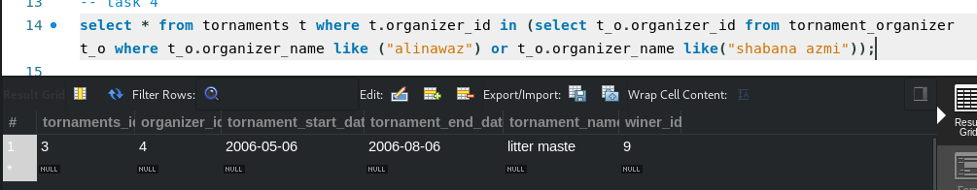

**Q10.** Print the name of player who have participated in more than one tournament.

**(Do it with Inner/Nested query)**

**select concat(p.fname,p.lname) from players p where p.player_id in(select pp.player_id from player_participated pp group by pp.player_id having count(pp.player_id)>1);**

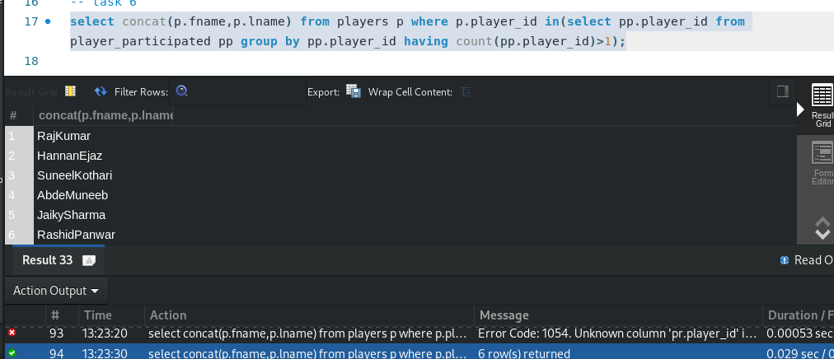

**Q11.** Print the number of the clubs which are located in Lahore or Faisalabad.

**(Do it with Inner/Nested query)**

**select count(cc.club_id) from chessclub cc where cc.adress_id in (select a.address_id from address a where a.city like ("Lahore") or a.city like ("Faisalabad"));**

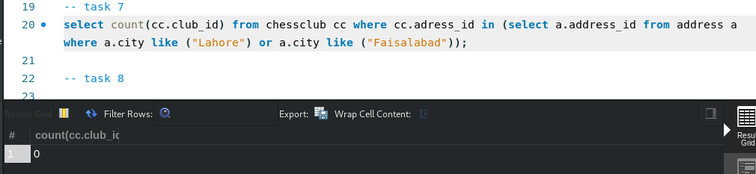

**Q12.** Show names of players who participated in tournament which was organized by organizer ‘Rahat fateh’ and tournament was organized in a club located in ‘lahore’.

select concat(p.fname, p.lname) from players p inner join player_participated pp on p.player_id = pp.player_id inner join tornaments t on pp.tornaments_id=t.tornaments_id inner join tornament_organizer t_o

on t.organizer_id=t_o.organizer_id inner join chessclub cc on t_o.club_id = cc.club_id

inner join address a on cc.adress_id=a.address_id where a.city like ("Lahore") and t_o.organizer_name like("Rahat fateh");

