# Task 1

select firstName, city from employees, offices where employees.officeCode=offices.officeCode;

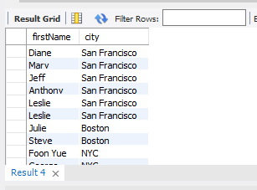

# Task 2

select country from employees, offices where employees.officeCode=offices.officeCode and jobTitle="vp sales" or jobTitle="vp marketing";

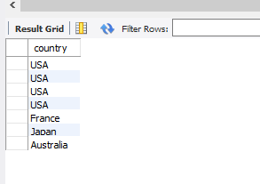

# Task 3

select * from orders where shippedDate like ('2003%');

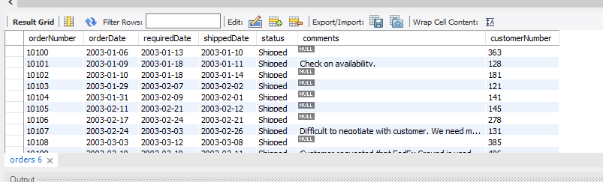

# Task 4

select customerName, phone from customers, payments where customers.customerNumber=payments.customerNumber and amount>=40000 and amount<=80000;

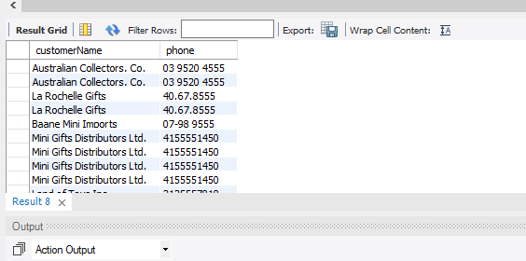

# Task 5

create table temp( select productName, productVendor from products where productVendor not like('min lin diecast'));

select * from temp where productVendor not like ('red start diecast');

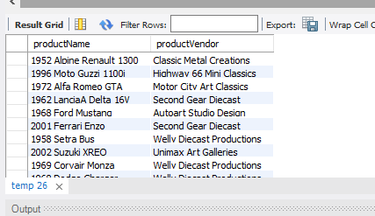

# Task 6

select city from offices where addressLine1 like('%Market%') or addressLine2 like('%Market%');

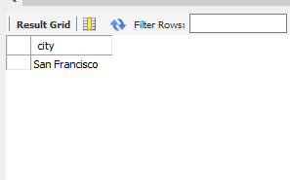

# Task 7

select * from customers where customerName like('__LL%');

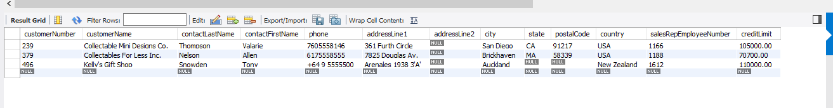

# Task 8

select distinct customerName,city,amount from customers, payments where customers.customerNumber=payments.customerNumber and amount>40000 and amount<50000 and city like('_an%');

