# Task 1

select * from employee;

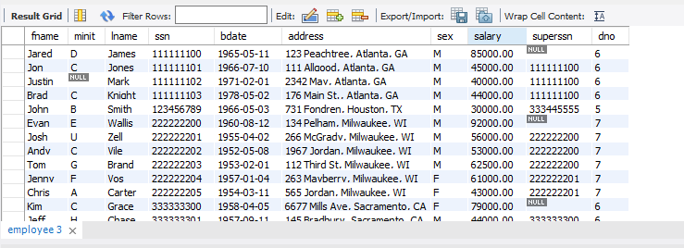

# Task 2

select fname, salary from employee where salary>40000;

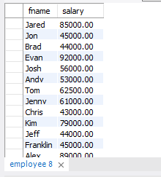

# task 3

select fname,superssn from employee where superssn is null;

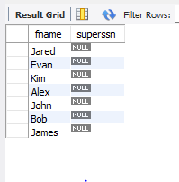

# task 4

select salary, dno, sex from employee where sex = 'F';

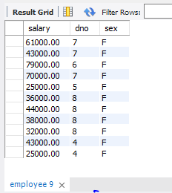

# task 5

select fname, salary from employee where salary > 40000 and salary <50000;

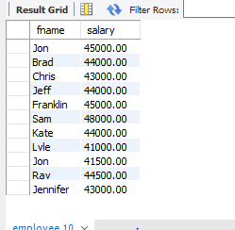

# task 6

select distinct fname,dno from employee where dno = 3;

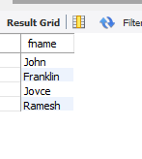

# task 7

select fname, salary from employee order by salary desc;

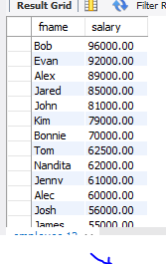

# task 8

insert into project values("Image Processing",4,"USA",6);

select * from project;

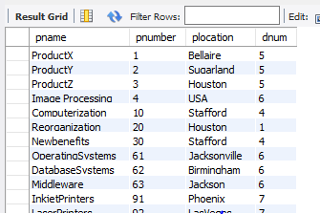

# task 9

update project set plocation="London" where pname="OperatingSystems";

select * from project;

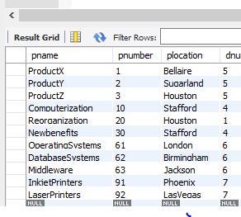

# task 10

delete from project where pname="Image Processing";

select * from project;

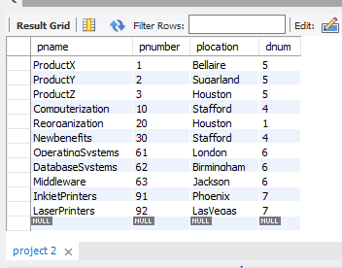

# task 11

select fname, lname, dno from employee where dno <> 7;

