# Task 1

create table Person(

PersonID int not null,

Name varchar(25),

Gender char,

Age int,

Email varchar(50),

primary key(PersonID));

insert into Person values (1, "Sarah", "F",10,"sarah@ucp.edu.pk"),(2, "Nagesh", "M",28,"nagesh@gmail.com"),(3, "Arifa", "F",29,"arifa@gmail.com"),(4, "Rehan", "M",74,"rehan@nust.edu.pk"),(5, "Makhdoom", "M",159,"makhdoom@ucp.edu.pk");

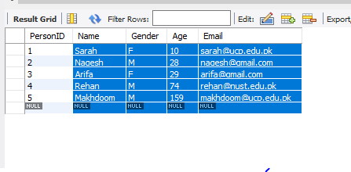

# Task 2

alter table Person drop column Age;

alter table Person add column City varchar(30);

update Person set City="Swat" where PersonID=1;

update Person set City="Lahore" where PersonID=2;

update Person set City="Karachi" where PersonID=3;

update Person set City="Islamabad" where PersonID=4;

update Person set City="Lahore" where PersonID=5;

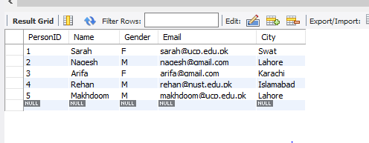

# Task 3

create table Contacts(

PhoneId int not null,

PersonID int,

Phone char(16),

primary key(PhoneId),

foreign key(PersonID) references Person(PersonID) on delete cascade);

insert into Contacts values (1,1,"+92-0333-1111111"),(2,4,"+92-0321-1234567"),(3,2,"+92-0321-7894561"),(4,5,"+92-0345-3453453"),(5,3,"+92-0313-1313131");

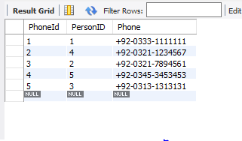

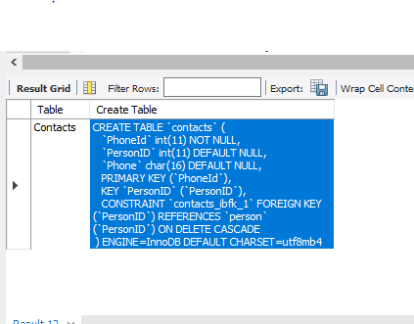

# Task 4

delete from Person where Name="Sarah";

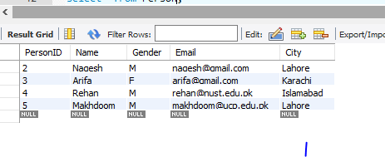

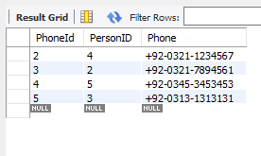

# Task 5

create table Officer(

OfficerID int not null,

Name varchar(25),

Age int,

Gender char,

primary key(OfficerID));

insert into Officer values (1,"Affer Raza",35,"M"),(2,"Sami Saqib",26,"F"),(3,"Rehan Khan",22,"M"),(4,"Zikriya",24,"M"),(5,"Mahwand Sultan",29,"M");

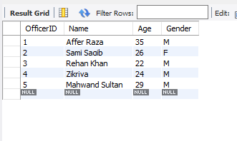

# Task 6

create table Preferences(

PreferenceID int not null,

Preference varchar(30),

primary key(PreferenceID));

# Task 7

alter table Preferences drop column Preference;

alter table Preferences add column OfficerID int; # before preferences

alter table Preferences add column Preference varchar(30);

insert into Preferences values (1,1,"Cricket"),(2,2,"Badminton"),(3,1,"Table Tennis");

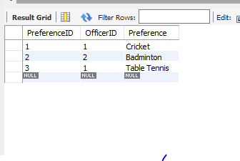

# Task 8

alter table Preferences add constraint foreign key (OfficerID) references Officer(OfficerID);

