CEE 5410/6410
HW 3–Linear Programs in the General Algebraic Modeling System (GAMS)

Choose to solve either the Reservoir Irrigation or the Network Shipping problem. Solve only 1 problem!!

Reservoir Operation Problem

A reservoir is designed to provide water for irrigation. The reservoir has a capacity of 9,000 acre-feet. Initial storage is 3,000 acre-feet of water. The size of the diversion canal and farmed area is very large relative to the amount of irrigation water available, so there is no upper limit on usable irrigation water. Any water above the reservoir capacity must be released to the river (spill). The ending storage must be equal to or greater than the beginning storage. The benefits per unit of water, and the estimated inflows to the reservoir in 3 months are given in Table 1. What is the diversion schedule that maximizes benefits?

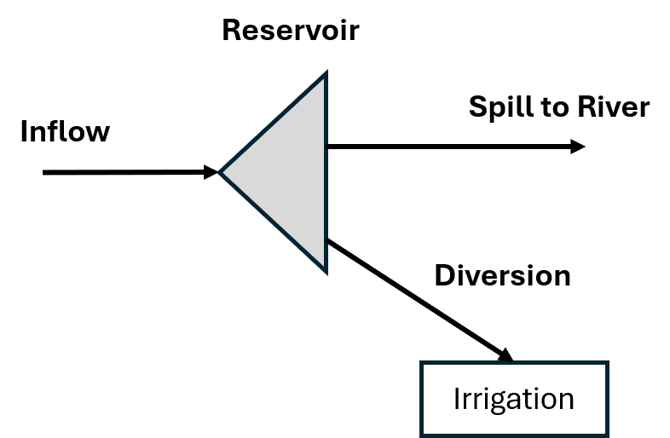

Figure 1: Schematic of Reservoir Irrigation Supply Problem

Table 1: Hydropower and Irrigation Problem Data

Month | Inflow (acre-feet) | Irrigation Benefits ($/acre-foot)
June | 5,000 | 150
July | 3,200 | 170
August | 2,000 | 425

Items to Address in 1-Page Report.

- Introduce the problem [10 points]

- Formulate the model in words and mathematical notation, including units of measurement for each parameter and variable.

  - Dimensions [5 points]
  - Decision variables [10 points]
  - Objective(s) [10 points]
  - Constraints [10 points]

- Solution - Delivery schedule, Objective Function value, Constraints that bind and that are slack [15 points]

- Explain why the optimal solution is optimal, new insights you took away about the problem, and concerns the company manager will have about the model formulation and solution [10 points]

HINTS:

- In GAMS, define a set for each dimension identified in Step Bi. One dimension is temporal and one dimension is spatial.

- Define a decision variable for each unknown value. The variables will have spatial and temporal dimensions.

- Define the objective function as the sum over all time periods of unit benefits multiplied by decision variable value. Note, only one set of decision variables contribute to the objective function.

- Define constraints for the Reservoir Mass Balance, reservoir capacity, and ending storage in each time step.

  - Reservoir Mass Balance is: Change in Storage = Sum of Inflows minus Sum of Outflows.

Network Shipping Problem
An automobile company must decide how to move cars from suppliers in Kansas City and Dallas to dealerships in New York, Minneapolis, Seattle, and San Francisco (Figure 1). Each supplier has a specified number of cars in stock and each dealership has an expected number of sales. Cost per car to ship from each supplier to dealer are also noted on Figure 1. Figure 2 shows the same network information in compact form because linear program solution algorithms do not need to know spatial position—only the nodes and cost to ship from 1 node to another.
What are the shipping volumes that will minimize cost?

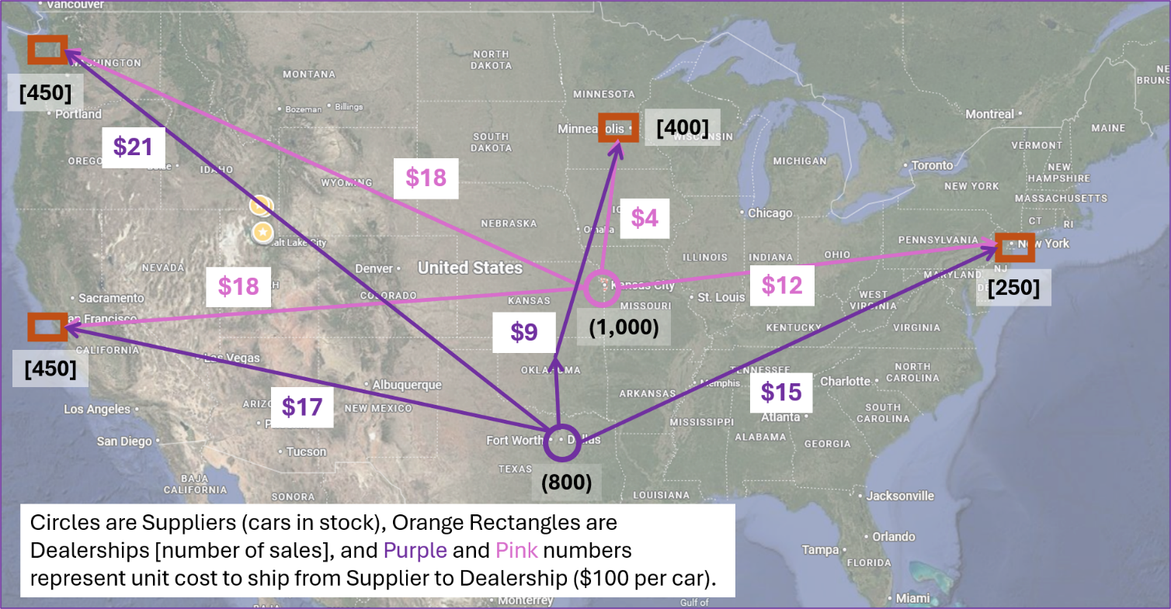
Figure 1. Network Shipping Program shown in Map form.
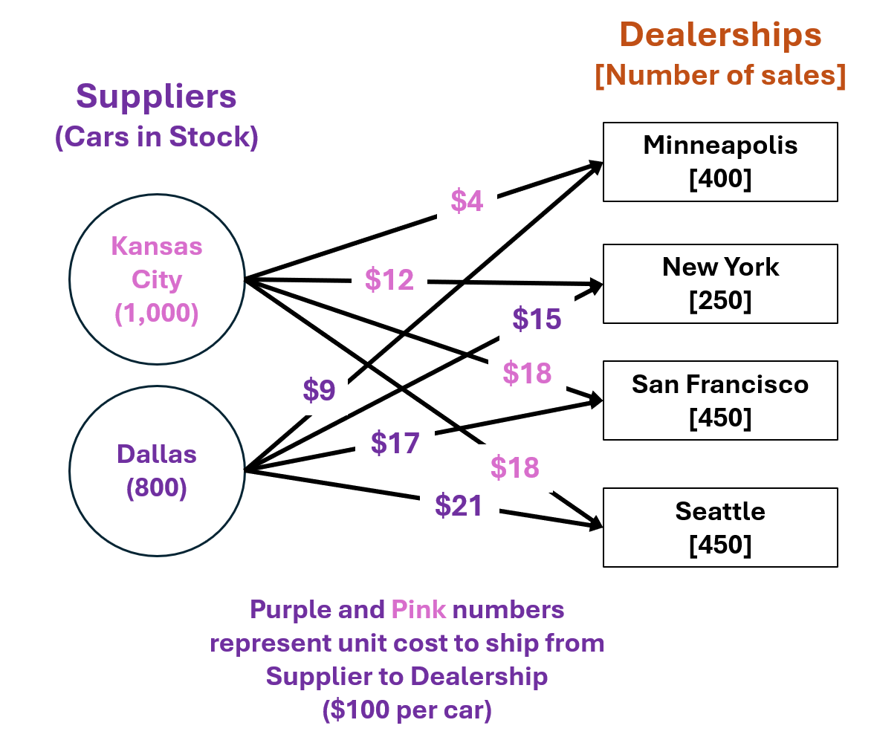
Figure 2. Network Shipping Program shown in Compact Form.

Items to Address in 1-Page Report.

- Introduce the problem [10 points]

- Formulate the model in words and mathematical notation, including units of measurement for each parameter and variable.

  - Dimensions [5 points]
  - Decision variables [10 points]
  - Objective(s) [10 points]
  - Constraints [10 points]

- Solution – Delivery schedule, Objective Function value, Constraints that bind and that are slack [15 points]

- Explain why the optimal solution is optimal, new insights you took away about the problem, and concerns the company manager will have about the model formulation and solution [10 points].

HINTS:

- In GAMS, define a set for each dimension identified in Step Bi. One dimension is suppliers and another dimension is dealerships.

- Define a decision variable for each unknown value. The variables will have supplier and dealership dimensions and represent all combinations of suppliers and dealerships.

- Define the objective function as the sum over all combinations of unit costs multiplied by the quantities.

- Define constraints for the number of cars that can be shipped from each supplier and the number of cars that need to be delivered to each dealership.

Category  (Max. Score) | No Evidence | Doesn’t Meet Standard | Nearly Meets Standard | Meets Standard | Exceeds Standard | Self- Score | Instructor Score
Title  (1) | Absent  0 | Evidence of two or less  0 | Evidence of three  0 | Evidence of four  1 | Title – can assess main point from title alone; Name, Instructors’ Names, Course, Date, Neatly finished 1
Introduction  (3) | Absent, no evidence  0 | There is no clear introduction or main topic.  1 | Introduction states the main topic but either:  - Does not give a full overview, Or:  - Too detailed, leading to annoying repetition later. 2 | The introduction states the main topic and previews the structure of the report.  2 | The introduction states the main topic and previews the structure of the report. Good overview of the problem and solution approach. Gives enough detail to motivate the reader to continue reading.  3
Organization and structural development of the idea: procedure, results, conclusions  (10) | No content provided.  0 | Paragraphs fail to develop the main idea. No section headers or guide to help the reader understand how material is organized.  1 – 5 | Organization of ideas not fully developed. Paragraphs lack supporting detail sentences. No transitions and/or ineffective section headers.  6 - 7 | Paragraph development present but not perfected. Each paragraph has sufficient supporting detail sentences. Few transitions.  8 | Writer demonstrates logic and sequencing of ideas through well-developed section headers, paragraphs, and transitions. The first sentence of each paragraph is the summary sentence.  9 - 10
Technical Correctness  (70) | Questions not addressed.  3 – 42% | The writer has no clue what they are talking about.  45 – 58% | Sketchy: left out required design points. Did not work on this as much as you should have, and it shows. Many important answers are incorrect.  61 – 79% | Discussion lacks adequate detail, but all the necessary points are covered and nearly all answers are correct.  82 – 88% | Provides what was explicitly asked for. The function of each piece is demonstrated to the reader in adequate, but not overwhelming, detail. Answers are correct and reasonable.  91 – 100%
Technical Correctness  (70) | - Problem description (10)
Technical Correctness  (70) | - Model Formulation – Dimensions (5), Decision Variables (10)
Technical Correctness  (70) | - Objective(s) (10), Constraints (10)
Technical Correctness  (70) | - Solution - Delivery schedule, Objective Function value, Constraints that bind and that are slack (15_
Technical Correctness  (70) | - Explain why the optimal solution is optimal, new insights you took away about the problem, and concerns the company manager will have about the model formulation and solution. (10)

Category  (Max. Score) | No Evidence | Doesn’t Meet Standard | Nearly Meets Standard | Meets Standard | Exceeds Standard | Self- Score | Instructor Score
Word Usage and Format  (7) | Not applicable | Numerous and distracting errors in punctuation, capitalization, spelling, sentence structure, word usage, significant figures, tables, and figures. Data vomited onto page(s). Unacceptable / unprofessional at the graduate level. 1 – 5 | Misspelled words, poor English grammar and word choice. Main body of report is either longer or significantly less than one page. Figures are too small and/or under-labeled, although they are usually of acceptable quality and focus. Tables incoherent or not cohesive. Bad font sizes. Too much or too little data in appendices. Could be improved by being more meticulous.  5 | Almost no errors in punctuation, capitalization, spelling, sentence structure, word usage, significant figures, and presentation of figures, tables, and appendices. Main body of report is one page or less  6 | Punctuation, capitalization, spelling, sentence structure, word usage, and significant figures all correct. Main body of report is one page or less. Clear, consistent fonts. Good word processing skills. Figures have adequate contrast. Informative figure and table titles and legends. Figures have appropriate axis tick spacing, labels, units, and legends. Table columns cohesive, labeled, and specify units. Document is stapled. Appendices, if provided, are separated by topic, and each have a title, discussion, and proper formatting and display of information 7
Conclusion  (4) | Absent  0 | Incomplete and/or not focused. 1 | The conclusion does not adequately restate the main results. 2 | The conclusion restates the main results. 3 | The conclusion restates the main results, and is an effective summary. 4
Use of AI  (3) | Absent  (Return without grade) |  |  | See Policy on Use in Syllabus  If used, list the AI tool], provide a short description of use, how use is within the course policy, and link to the transcript of student-AI interactions.  If not used, write “No AI was used in the analysis or write-up of this report.” 3
References  (2) | Absent  0 | Numerous errors, off-the-wall sources used. 0 | Some errors in citing format; more sources should be cited. 1 | Prior work cited with few errors.  2 | All prior work and data sources are cited in the correct format with no errors. 2
TOTAL (100)

