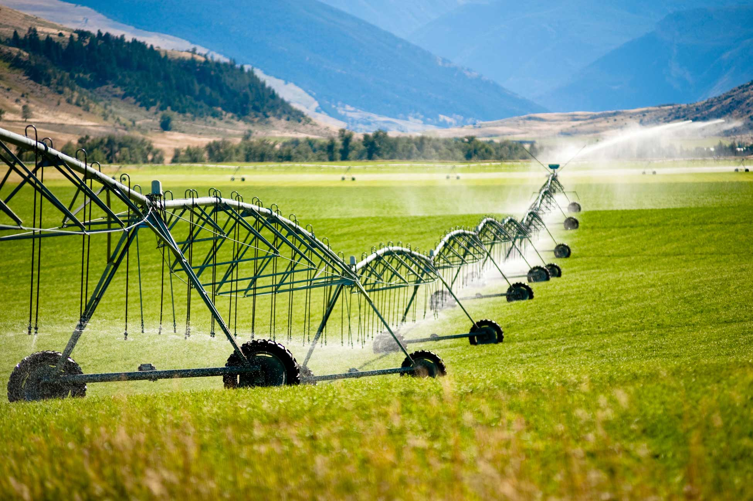

HW 5.
Mixed Integer Programming for
Water Irrigation Source Design
in GAMS

Talha Quddoos- A02469393
Dr. David E. Rosenberg
CEE 6410- Civil Engineering Systems Analysis in the Age of Uncertainty
October 20, 2026

Introduction
A farmer was planning to develop a water supply for irrigation. He had access to a river and was considering building a reservoir on the river and/or using a pump. For the reservoir, he had a choice to build a high-capacity reservoir or a low-capacity one. Under normal conditions, river inflow fluctuated twice a year (every six months), and so did the irrigation water demand. All proposed water sources had yearly capital costs; moreover, the pump had an additional cost associated with its operation. This report used a mixed integer programming approach to find the optimum water source design that maximizes the net benefit from the system.

Model Formulation
Table 1 and Table 2 summarize the available data. The given problem had 2-dimension sets (seasons and water sources), involved 2 direct decision variables (source choice, area to irrigate), and 4 associated decision variables (water release from the reservoir for irrigation, downstream water spill, water pumped for irrigation, and water storage value at the end of the season). Maximizing the total benefit (1) was the objective function.
$$Max Z(\$)=Benefit(\$) - Cost(\$ ) -- eq1$$
Subject to the following constraints.
- In each season, a reservoir could store up to the storage capacity of the dam (if constructed).
- In each season, the combined water flow of the dam and pump should be greater than the irrigation demand.
- Gravity release was only possible if dams were constructed. The farmer could select only one dam type at most.
- The water pump choice was binary. The farmer could select it alongside the dam of his choice.
The pump could only pump up to 396 acft of water/season.
- The pump could not pump more water than was available downstream (from ground drainage and dam spill).
- Reservoir storage at the end of the year should be equal to reservoir storage at the start of the year (assumption).
The problem was modelled in GAMS, and a mixed integer programming algorithm was used to solve it.

Conclusion and Recommendations
The GAMS model resulted in an optimized output of 380 acres of land cultivated with a combination of high-capacity dam and water pump construction, maximizing profits to $ 81,600. The reservoir released 20 acft in season1 and 780 acft in season 2, while the pump kept pumping all the available water, i.e 360acf both seasons. The model resulted in initial storage of 580 acft at the end of season 1, however, there was no water storage left at the end of the year. Based on the model computation, the spillway did not have any flow, so it could be left out of the project, where management can only focus on a high-capacity dam and the water pump. Moreover, the pump also worked less than the designed capacity due limited to water availability downstream. Any change in water drainage conditions would affect the water pump output.

Use of Artificial Intelligence (AI)
Claude AI was used to refresh and discuss the concepts https://claude.ai/share/62349eb6-2145-42f3-8172-057aa53ba361

Github
https://github.com/talha-q/CEE6410-Engineering-Systems

References
GAMS Development Corporation. General Algebraic Modeling System (GAMS) Release: 54.4.0 , Fairfax, VA, USA, 2026 .

Appendix
Table 1 Seasonal River Inflow and Irrigation Water Demand
Season,t | River Inflow, Qt (acft) | Irrigation Demand (acft/acre)
1 | 600 | 1
2 | 200 | 3

Table 2 Capacity of Available Alternatives and Associated Costs.
Facility | Capital ($/year) | Operating Cost ($/acft) | Capacity (acft)
High Dam | 10000 | 0 | 700
Low Dam | 6000 | 0 | 300
Water Pump | 8000 | 20 | 2.2acft/day

