CEE 6410
Prompt C.
Analytical Solution to an Optimization Problem

Learning Objectives:
- Apply the Lagrangian method to analytically solve a demonstrative non-linear water resources optimization problem
- Present your work in a variety of formats required of practicing engineers, including written reports

The Problem

A water manager must allocate river water to an urban area and wetland as shown in Figure 1. If there are 320 ac-ft of water available in the river, how much water should the manager allocate to urban users and to the wetland to maximize total benefits?

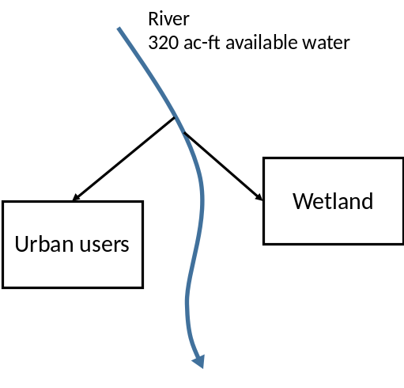
Figure 1. Schematic of water allocation decision problem
In your allocation decision, consider:
- Urban users are willing to pay $800 per acre-foot of supply (to avoid having to incur costs to truck in potable water),
- Wetland benefits derive from fees paid by hunters and fishermen for game and fish caught within the wetland. The number of game and fish produced in the wetland and available for catch is roughly proportional to the wetted surface area. Thus, assume the wetland benefits ($) from water allocated to the wetland (Q_{w}, ac-ft) can be described by the nonlinear function:

$$Wetland Benefits=2200 Q_{w}^{0.8}$$

Provide:
- A 1-sentence summary of the problem (5 pts)
- The Model Formulation in the format (15 pts)
  - Description of the dimensions of the problem.
  - Decision variables, Objective Function, and Constraints including definitions of parameters and variables and units of measurement.
- Analytical Solution using the Lagrangian Method (10 pts)
- Optimal Allocations and Total Benefits generated (5 pts).
- The additional benefits that would be generated if 10 more ac-ft of water were available in the river and who should be allocated the additional water (5 pts)

40 total points.

Category  (Max. Score) | No Evidence | Doesn’t Meet Standard | Nearly Meets Standard | Meets Standard | Exceeds Standard | Self- Score | Instructor Score
Title  (1) | Absent  0 | Evidence of two or less  0 | Evidence of three  0 | Evidence of four  1 | Title – can assess main point from title alone; Name, Instructors’ Names, Course, Date, Neatly finished 1
Introduction  (3) | Absent, no evidence  0 | There is no clear introduction or main topic.  1 | Introduction states the main topic but either:  - Does not give a full overview, Or:  - Too detailed, leading to annoying repetition later. 2 | The introduction states the main topic and previews the structure of the report.  2 | The introduction states the main topic and previews the structure of the report. Good overview of the problem and solution approach. Gives enough detail to motivate the reader to continue reading.  3
Organization and structural development of the idea  (10) | No content provided.  0 | Paragraphs fail to develop the main idea. No section headers or guide to help the reader understand how material is organized. 1 – 5 | Organization of ideas not fully developed. Paragraphs lack supporting detail sentences. No transitions and/or ineffective section headers.  6 - 7 | Paragraph development present but not perfected. Each paragraph has sufficient supporting detail sentences. Few transitions. 8 | Writer demonstrates logic and sequencing of intro, procedure, results, and conclusions through well-developed section headers, paragraphs, and transitions. The first sentence of each paragraph is the summary sentence. 9 - 10
Technical Correctness  (70) | Questions not addressed.  3 – 42% | The writer has no clue what they are talking about.  45 – 58% | Sketchy: left out required design points. Did not work on this as much as you should have, and it shows. Many important answers are incorrect.  61 – 79% | Discussion lacks adequate detail, but all the necessary points are covered and nearly all answers are correct.  82 – 88% | Provides what was explicitly asked for. The function of each piece is demonstrated to the reader in adequate, but not overwhelming, detail. Answers are correct and reasonable.  91 – 100%

Category  (Max. Score) | No Evidence | Doesn’t Meet Standard | Nearly Meets Standard | Meets Standard | Exceeds Standard | Self- Score | Instructor Score
Word Usage and Format  (10) | Not applicable | Numerous and distracting errors in punctuation, capitalization, spelling, sentence structure, word usage, significant figures, tables, and figures. Data vomited onto page(s). Unacceptable / unprofessional at the graduate level. 1 – 5 | Misspelled words, poor English grammar and word choice. Main body of report is either longer or significantly less than one page. Figures are too small and/or under-labeled, although they are usually of acceptable quality and focus. Tables incoherent or not cohesive. Bad font sizes. Too much or too little data in appendices. Could be improved by being more meticulous.  6 - 7 | Almost no errors in punctuation, capitalization, spelling, sentence structure, word usage, significant figures, and presentation of figures, tables, and appendices. Main body of report is one page or less  8 | Punctuation, capitalization, spelling, sentence structure, word usage, and significant figures all correct. Main body of report is one page or less. Clear, consistent fonts. Good word processing skills. Figures have adequate contrast. Informative figure and table titles and legends. Figures have appropriate axis tick spacing, labels, units, and legends. Table columns cohesive, labeled, and specify units. Document is stapled. Appendices, if provided, are separated by topic, and each have a title, discussion, and proper formatting and display of information 9 - 10
Conclusion  (4) | Absent  0 | Incomplete and/or not focused. 1 | The conclusion does not adequately restate the main results. 2 | The conclusion restates the main results. 3 | The conclusion restates the main results, and is an effective summary. 4
References  (0) | Absent  0 | Numerous errors, off-the-wall sources used. 0 | Some errors in citing format; more sources should be cited.  1 | Prior work cited with few errors.  2 | All prior work and data sources are cited in the correct format with no errors.  2 | NA | NA
TOTAL (98)

Instructor Feedback:

_________________________________________________________________________________________________________________________________________________

