**Lecture_07_Layout**

**Mobile Computing (MC)**

**__________________________________________________________________**



**Submitted to:**

**Sir Haq Nawaz**

**Submitted by:**

**Muhammad Talha Madni**

**Roll no: BSEF18A_018**

**Punjab University College of Information Technology,**

**PUCIT (Old Campus),**

**LAHORE**

**Project Build Successfully**

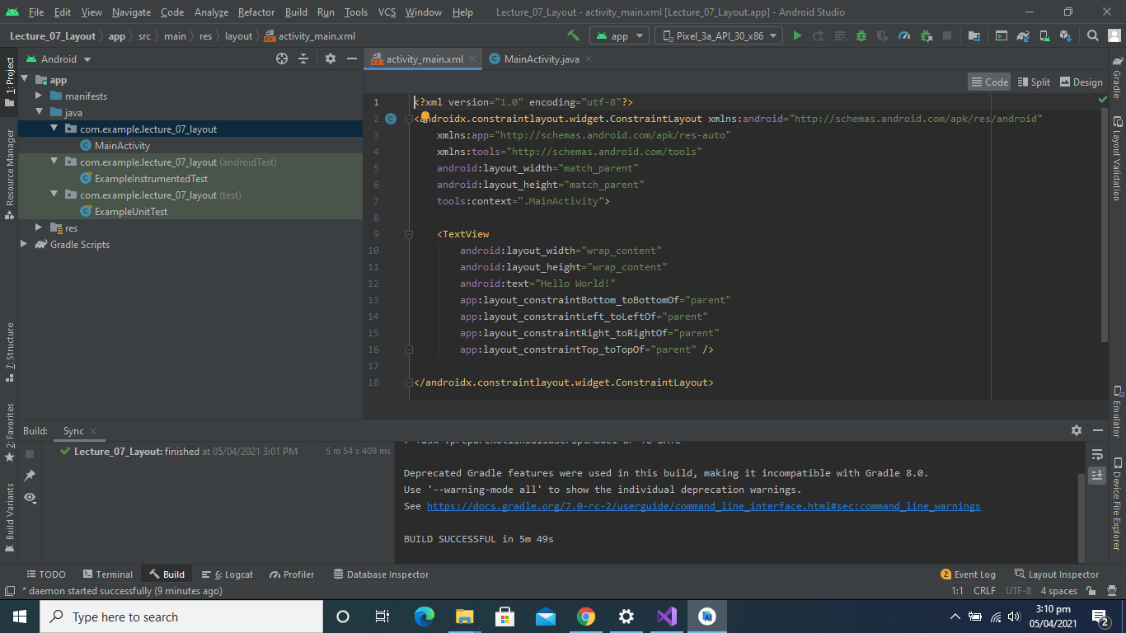

**New Layout Created**

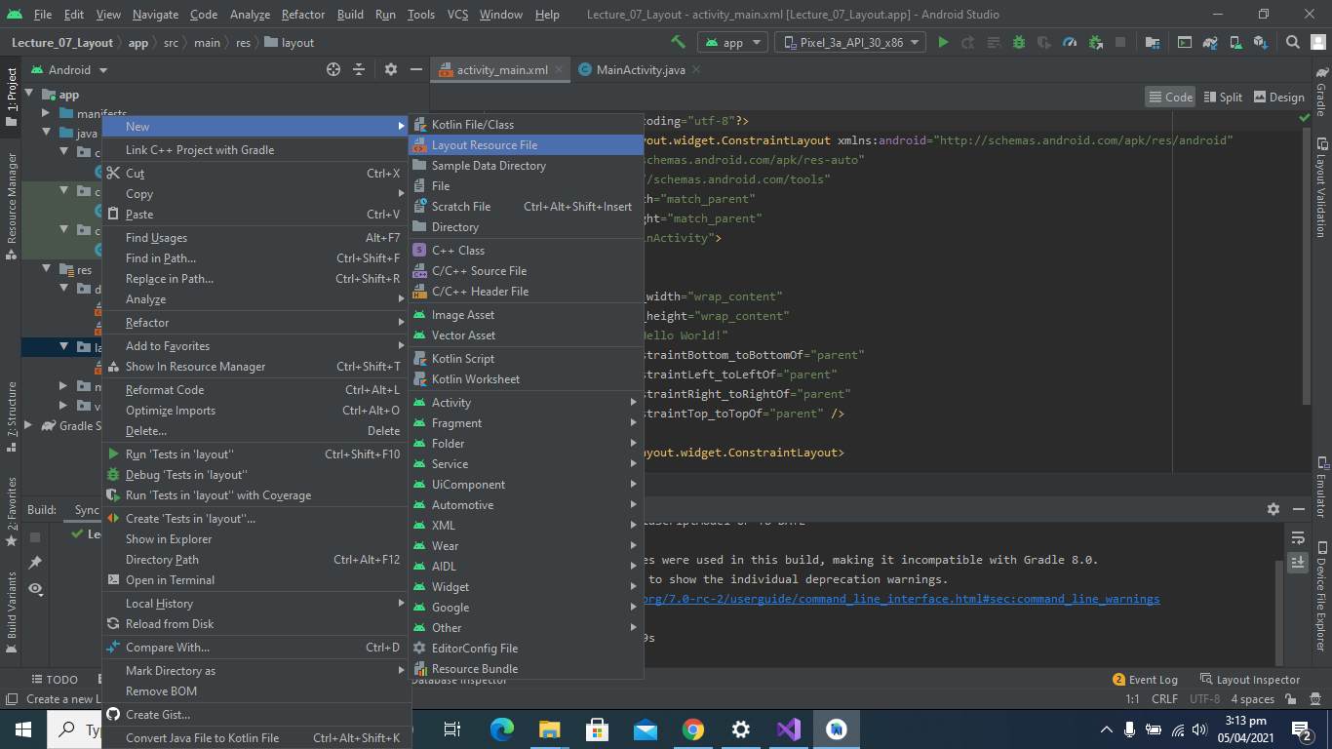

**Linear Layout Created**

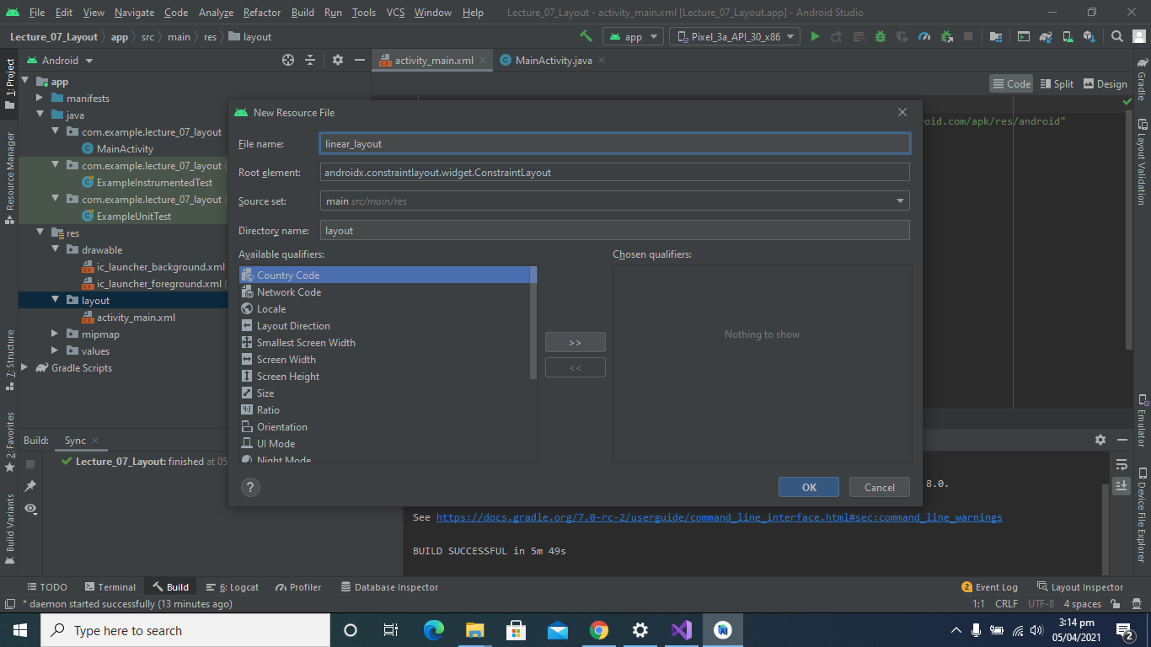

**Add Some Widgets in Linear Layout**

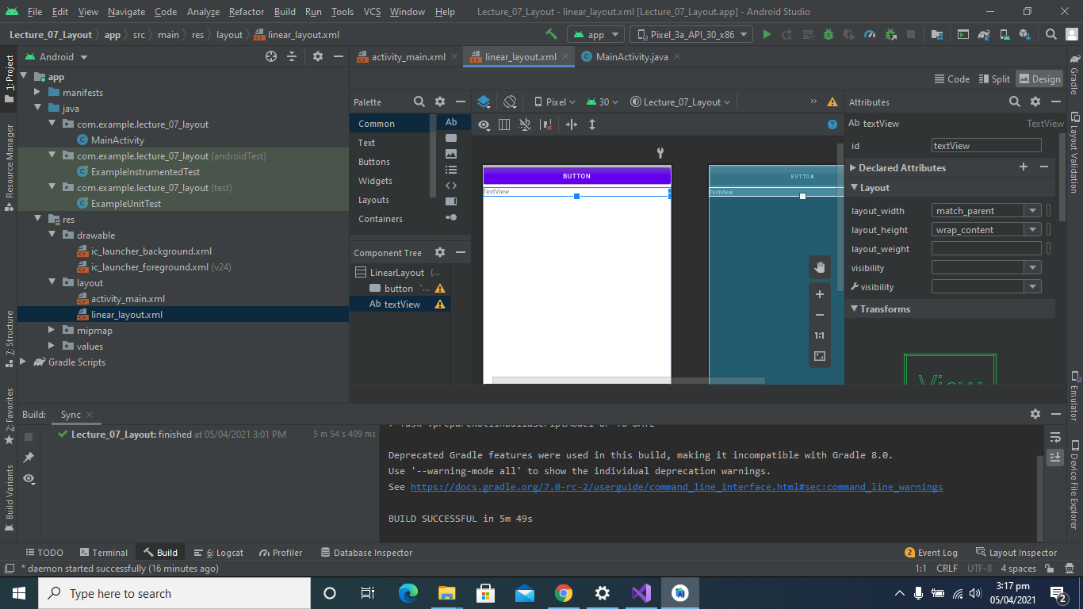

**Linear Layout Code Part**

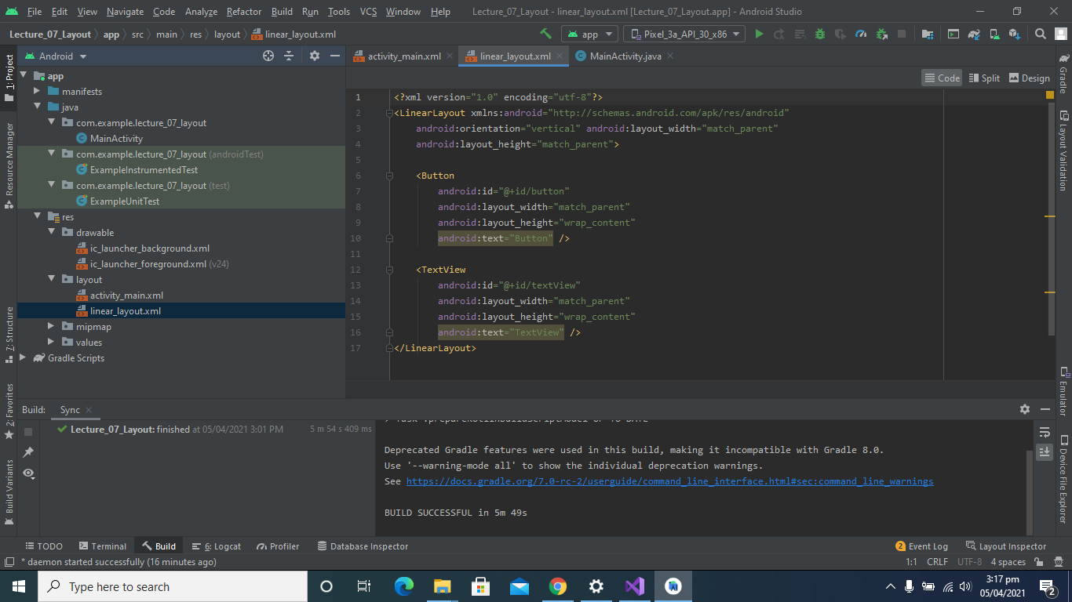

**Change content View to Linear Layout:**

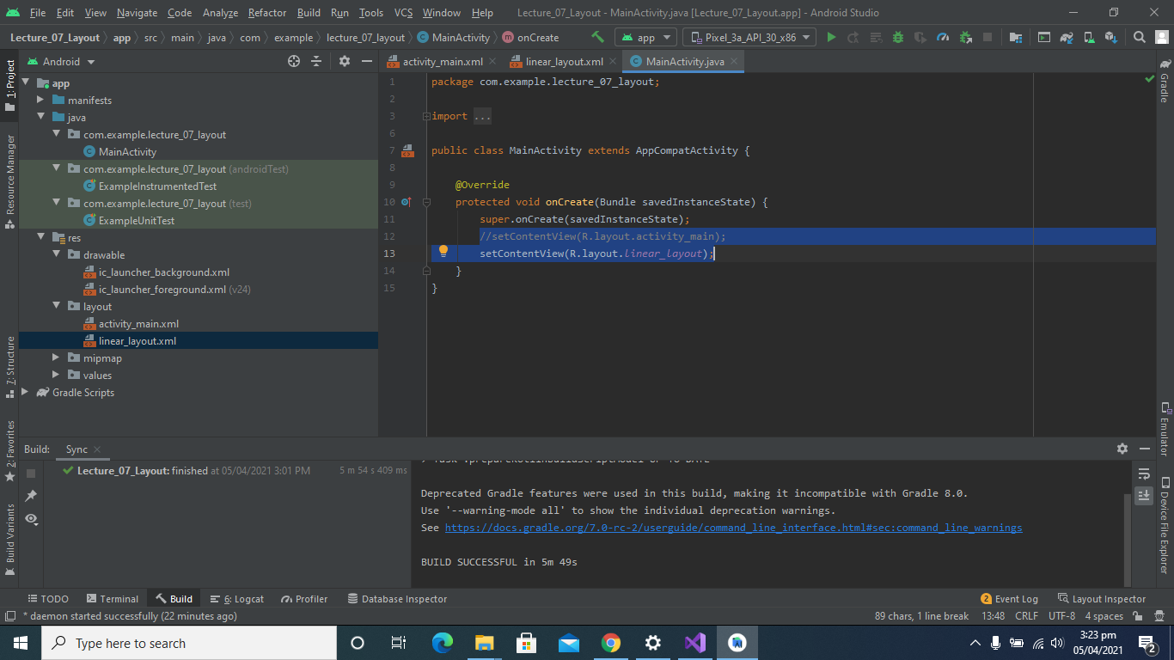

**After Running:**

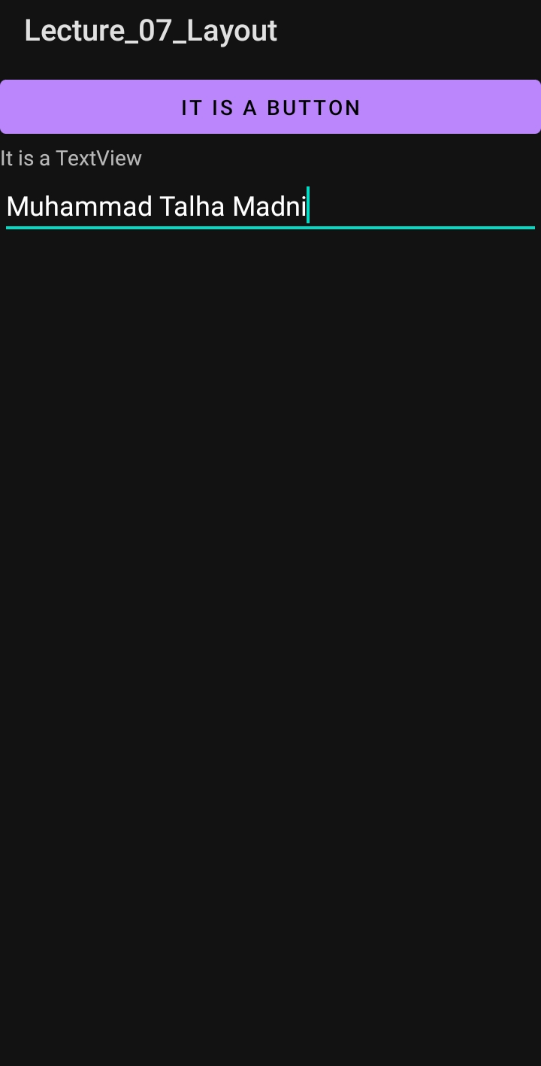

**Check Dependencies in Gradle**

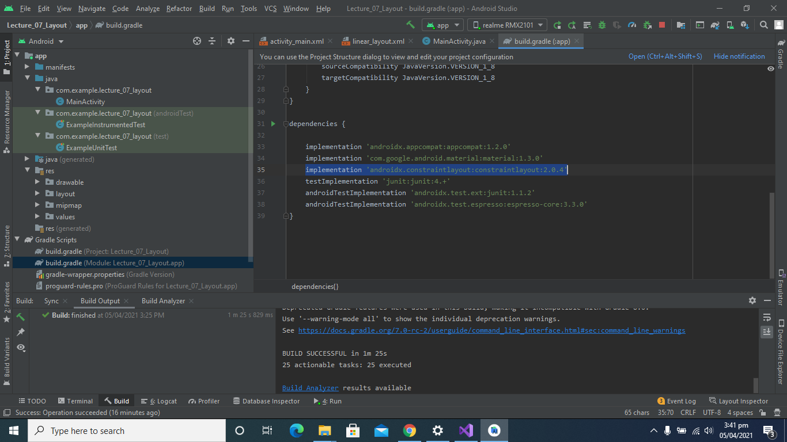

**Clear All Constraints:**

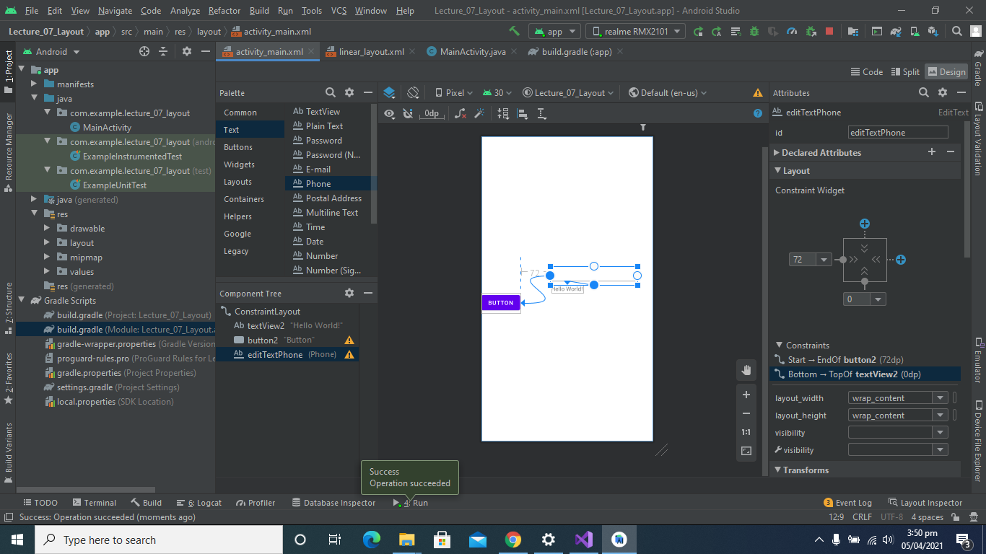

**After Running:**

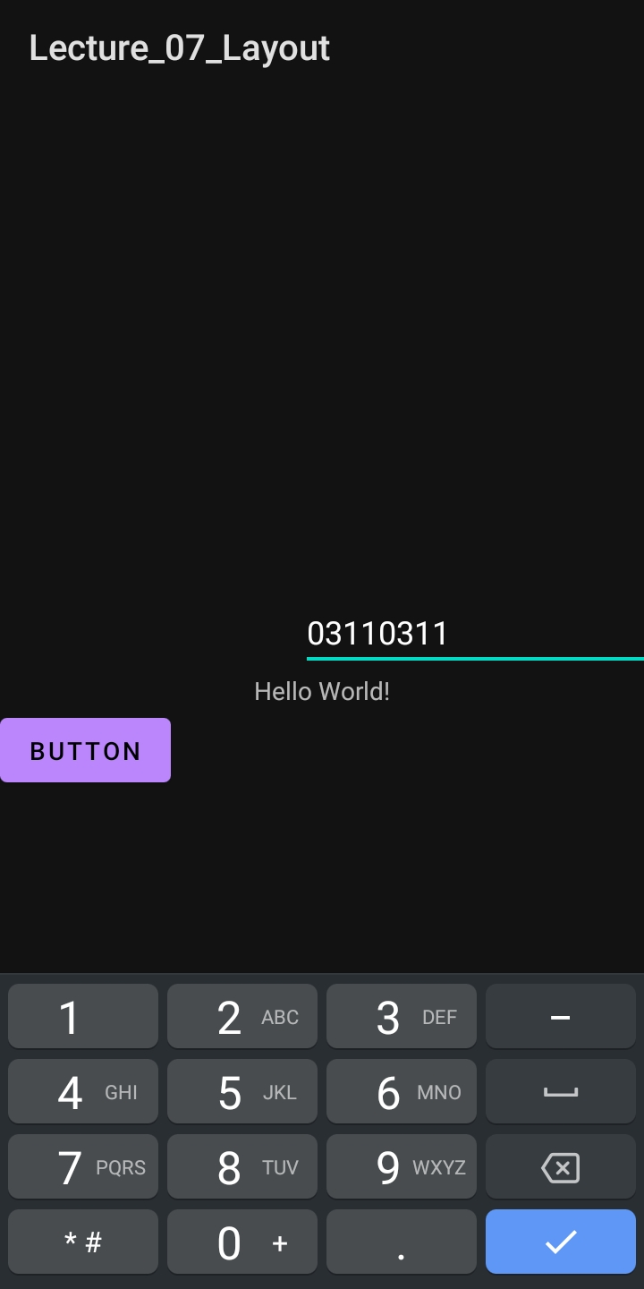

**Clear All Constraints:**

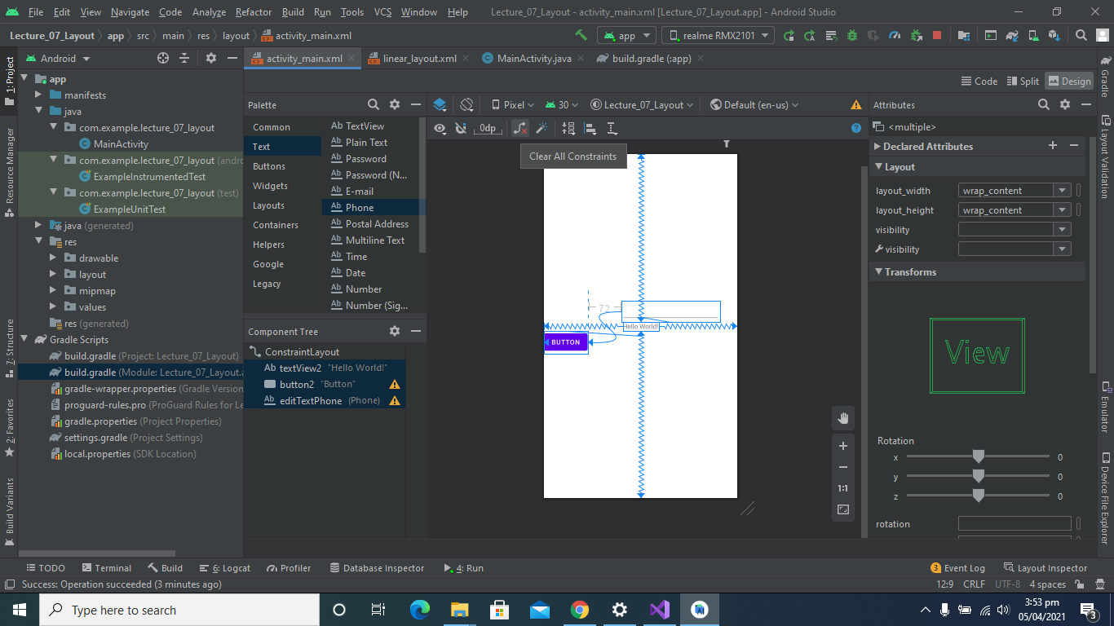

**After Removing Constraints:**

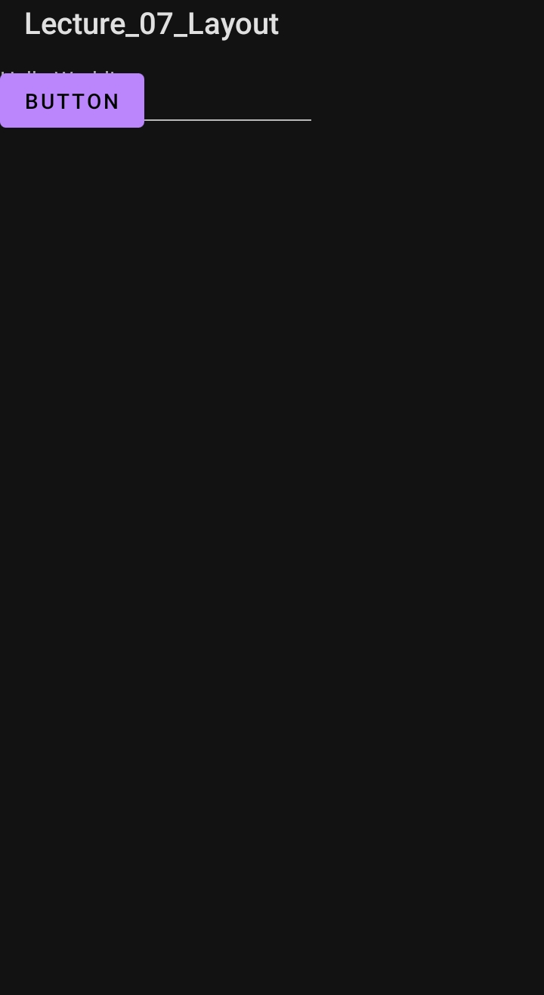

**Added Images**

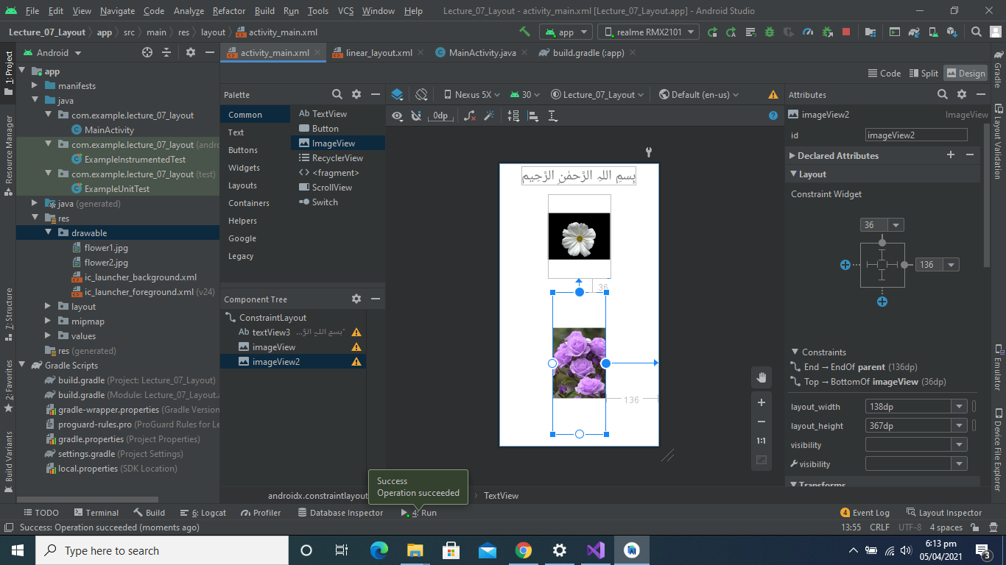

**After Running:**

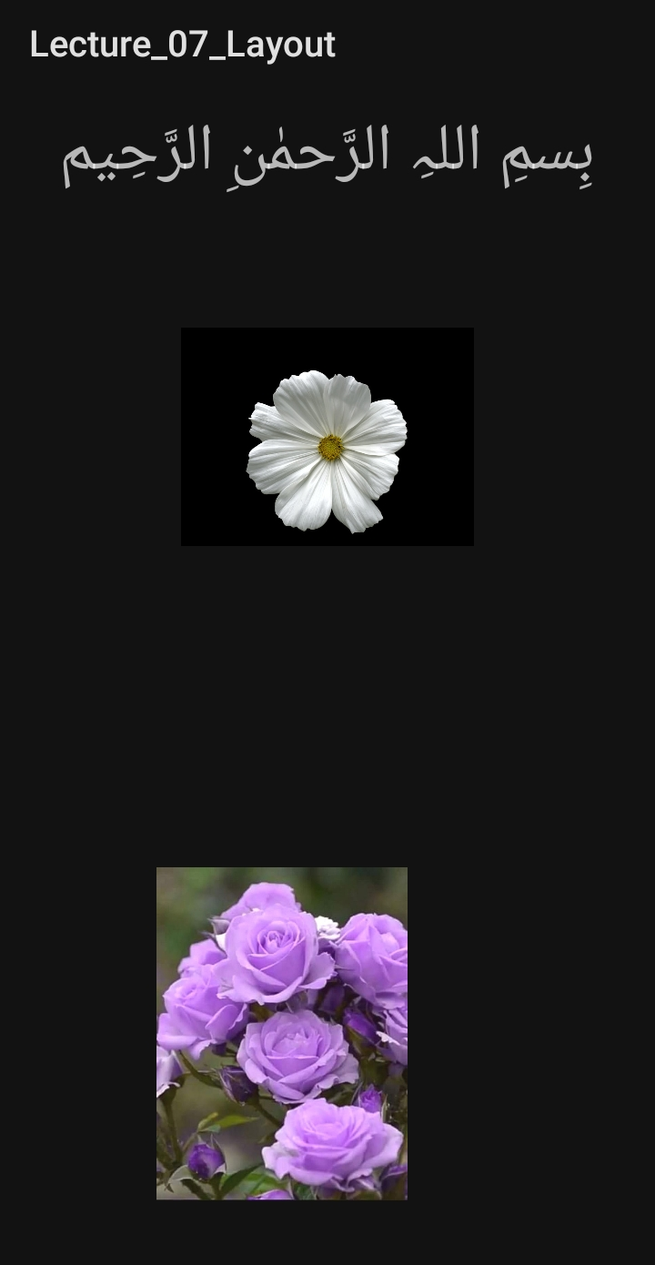

**Show All constraints**

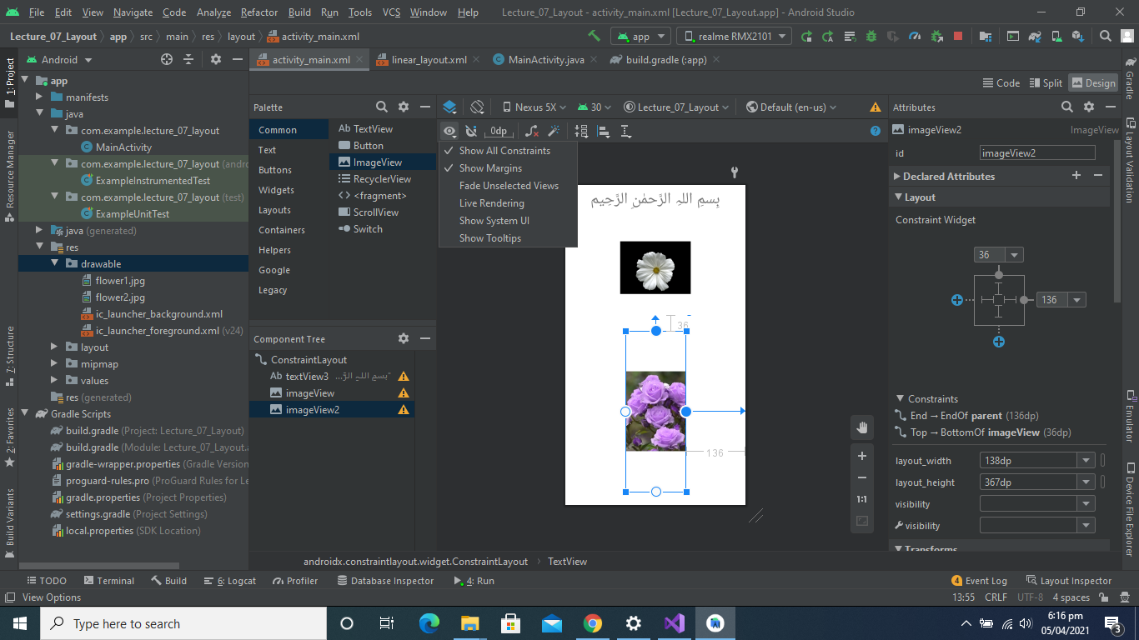

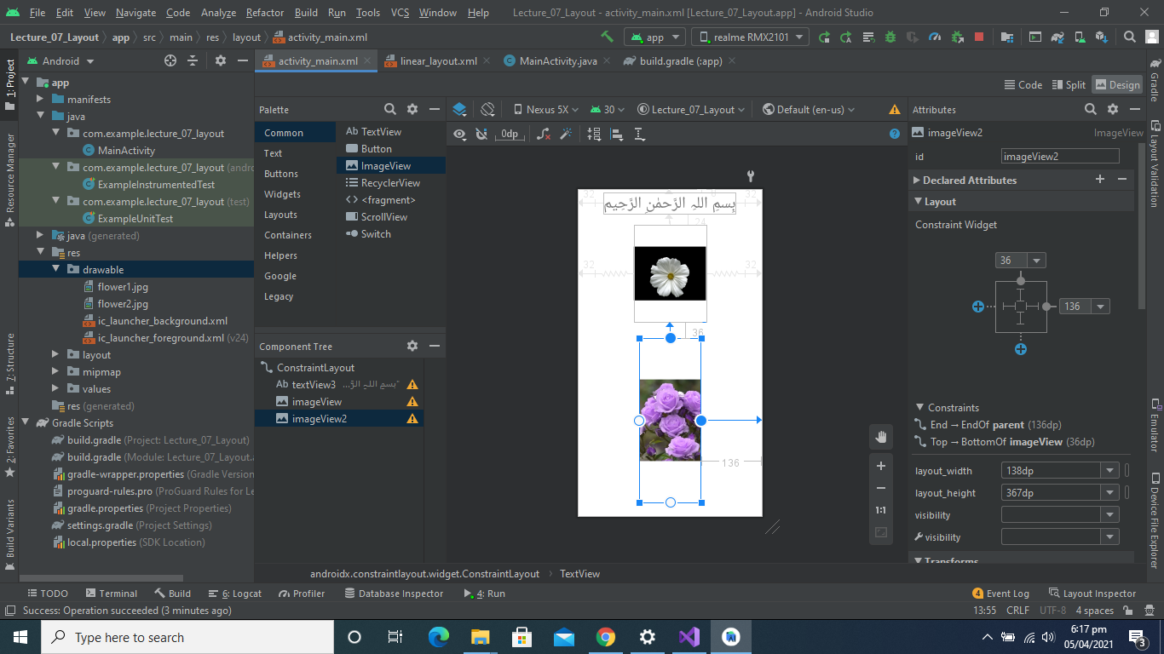

**Pack Buttons Horizontally Or Vertically**

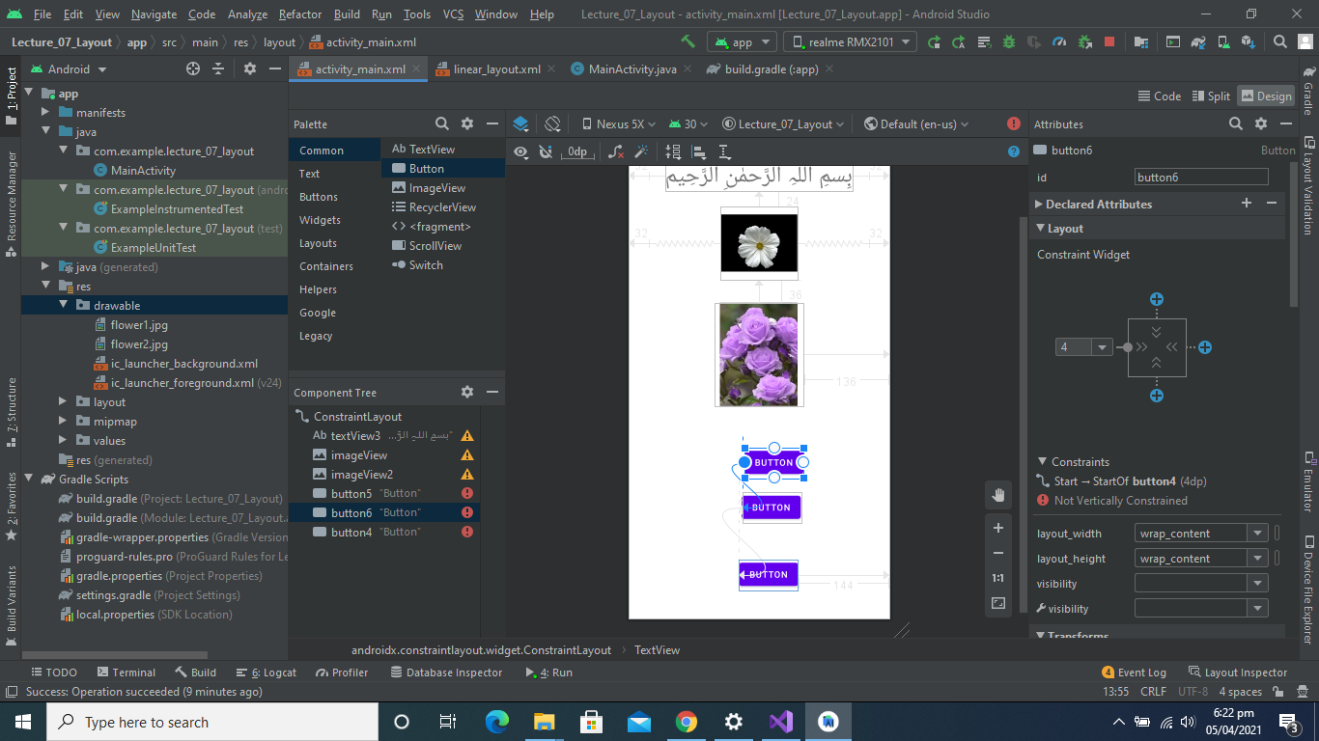

**Center Horizontally Buttons**

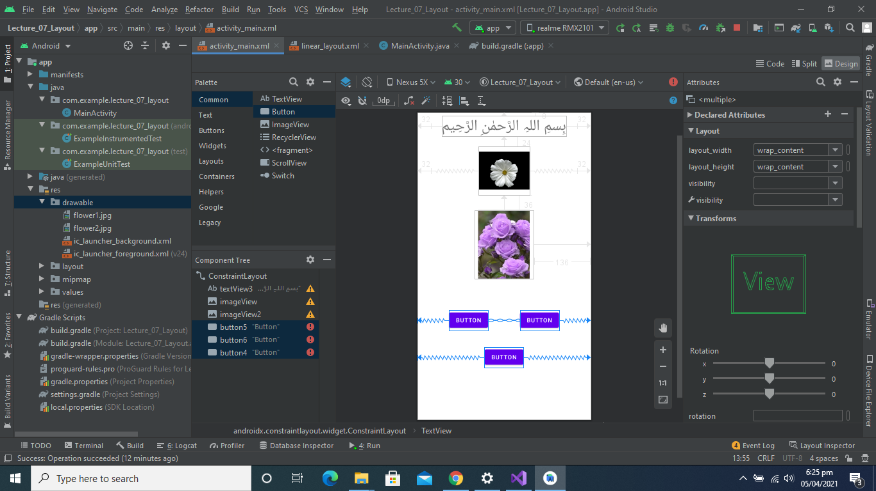

**Center Vertically Buttons**

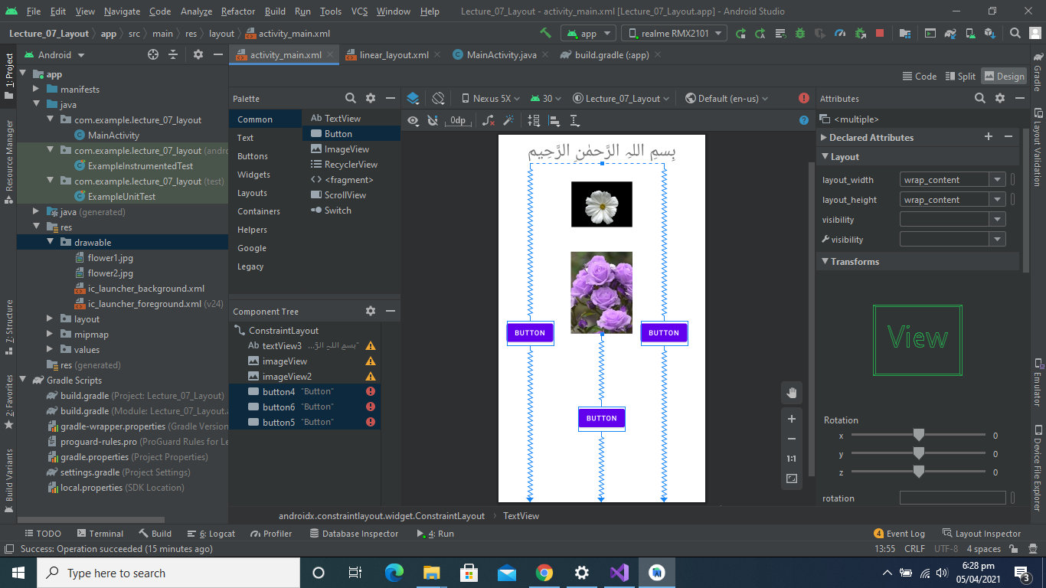

**Expand Buttons Horizontally and Vertically**

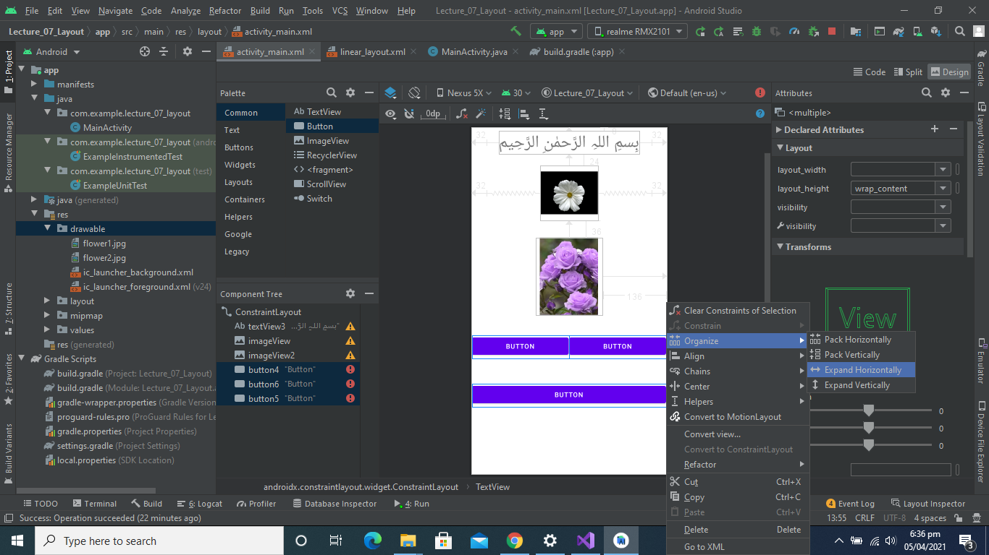

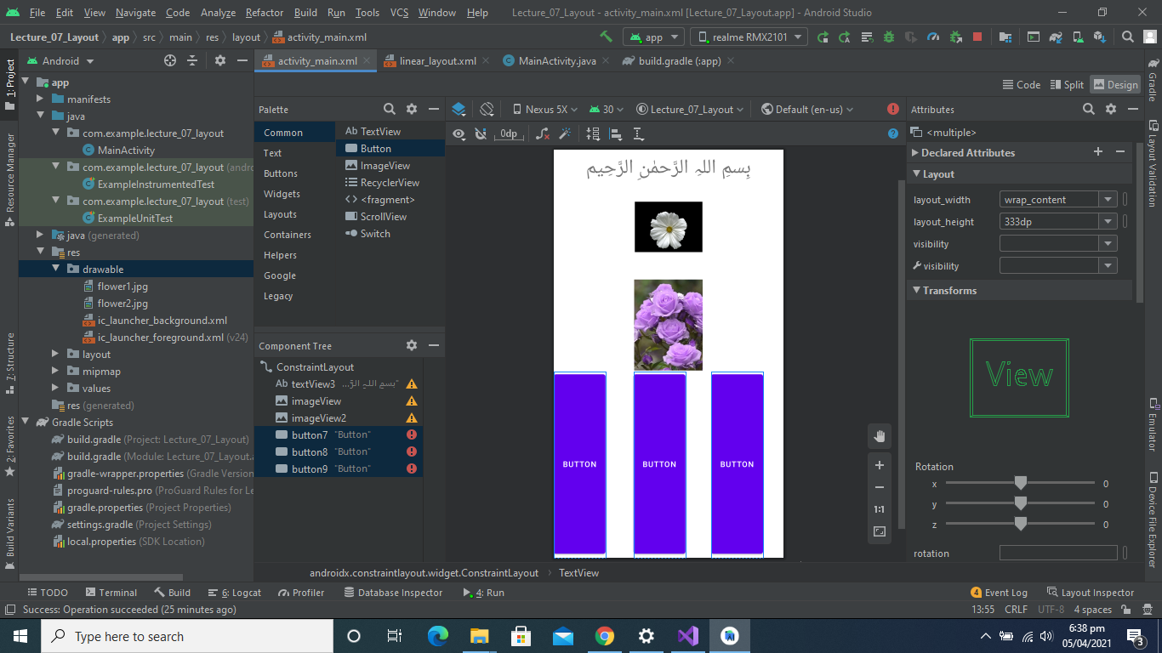

**Coding Section**

