**Lecture_08_Intent**

**Bsef18A018**

**Muhammad Talha Madni**

**Project Created:**

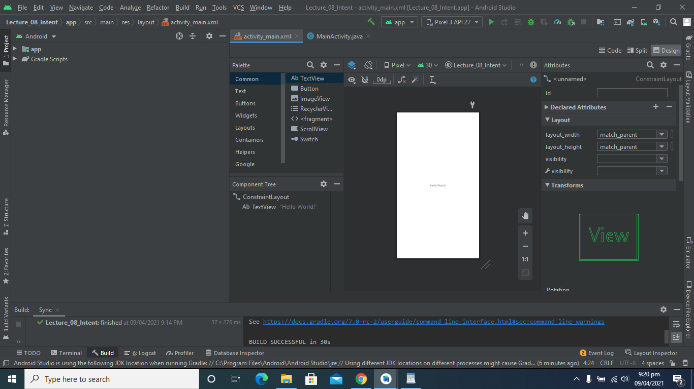

**Make Strings Instead of Text:**

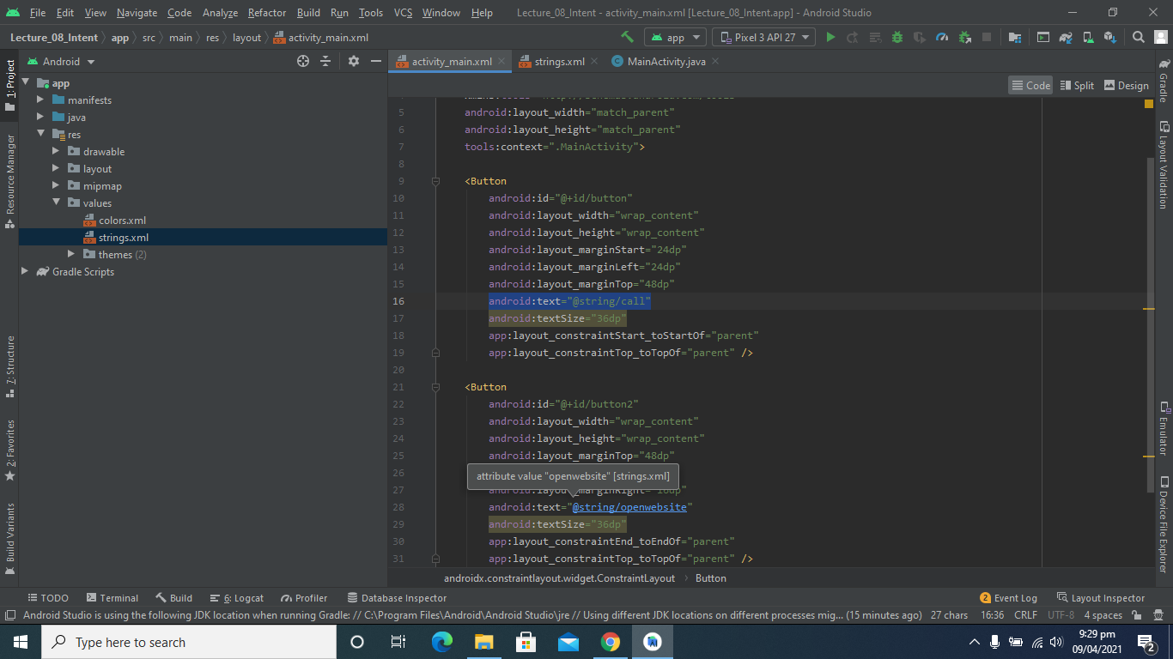

**Make Call and Website Buttons:**

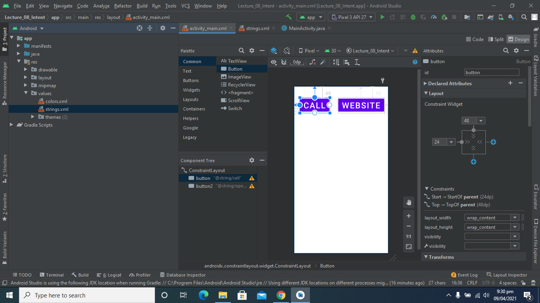

**Output:**

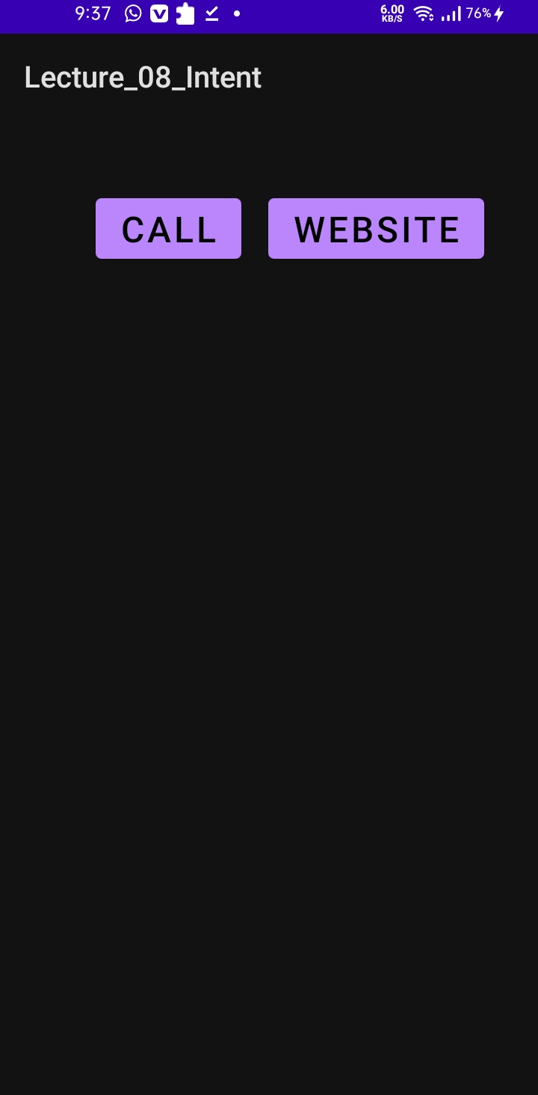

**Write Functions Definitions:**

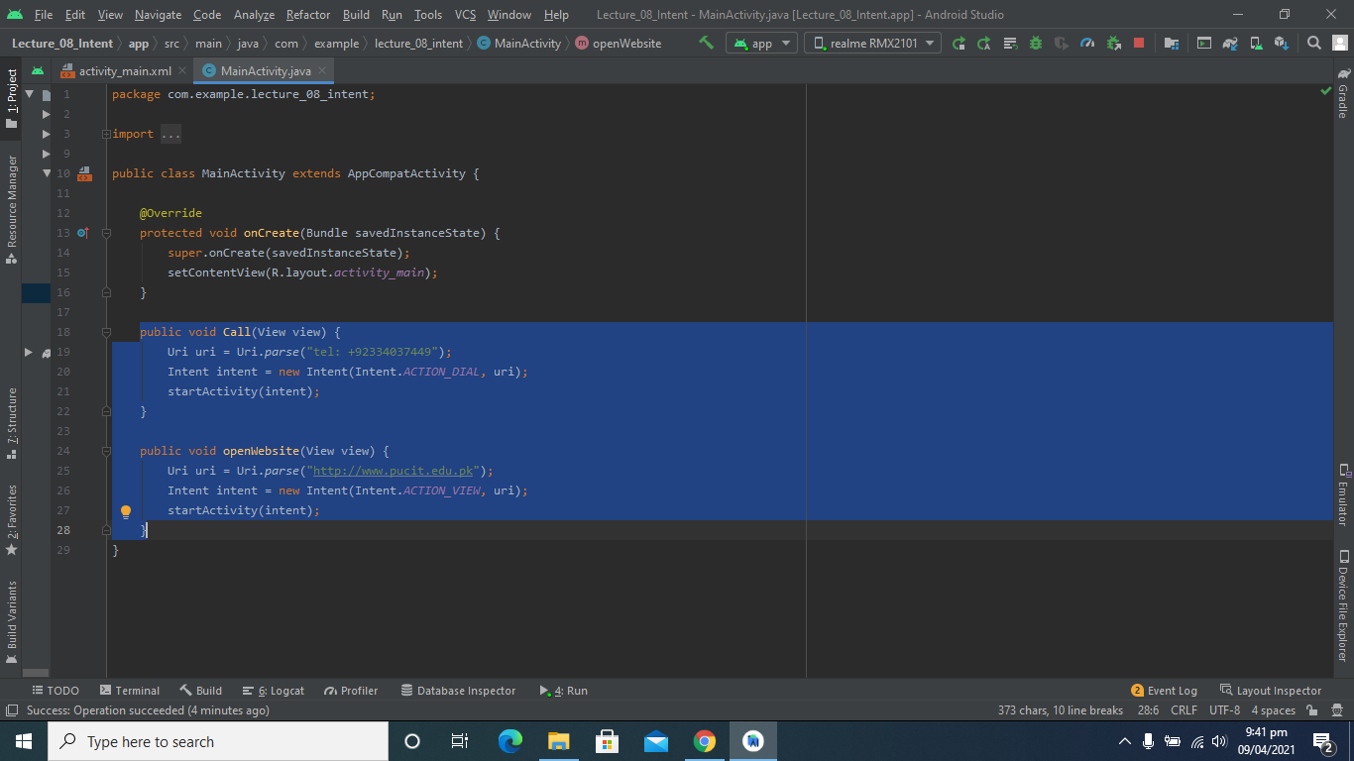

**Output Video Link:**

[Output Video](https://github.com/talha0606/MC_Progress/blob/master/lec08v01.mp4)

**New Activity Created:**

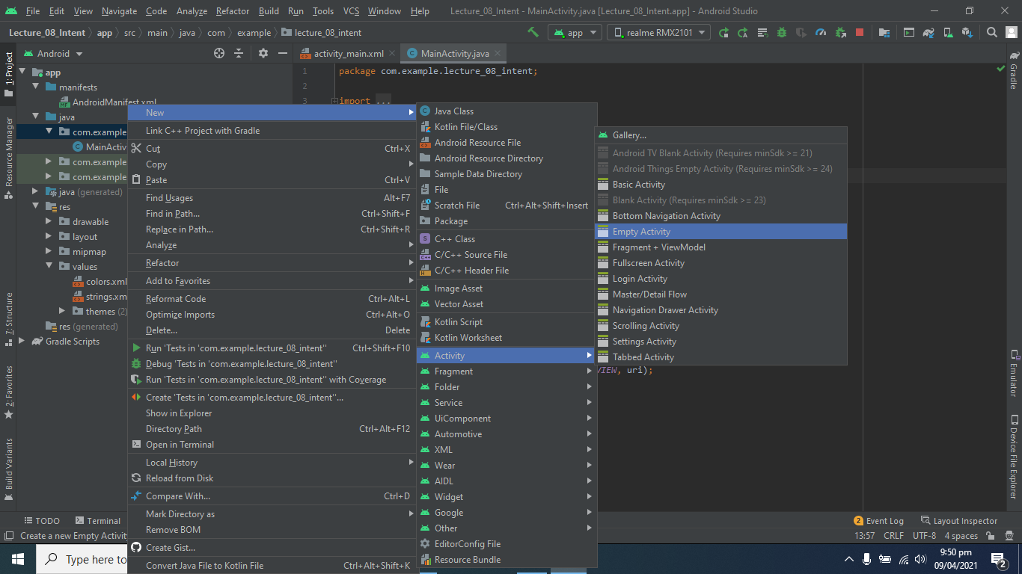

**Make button to move on another Activity:**

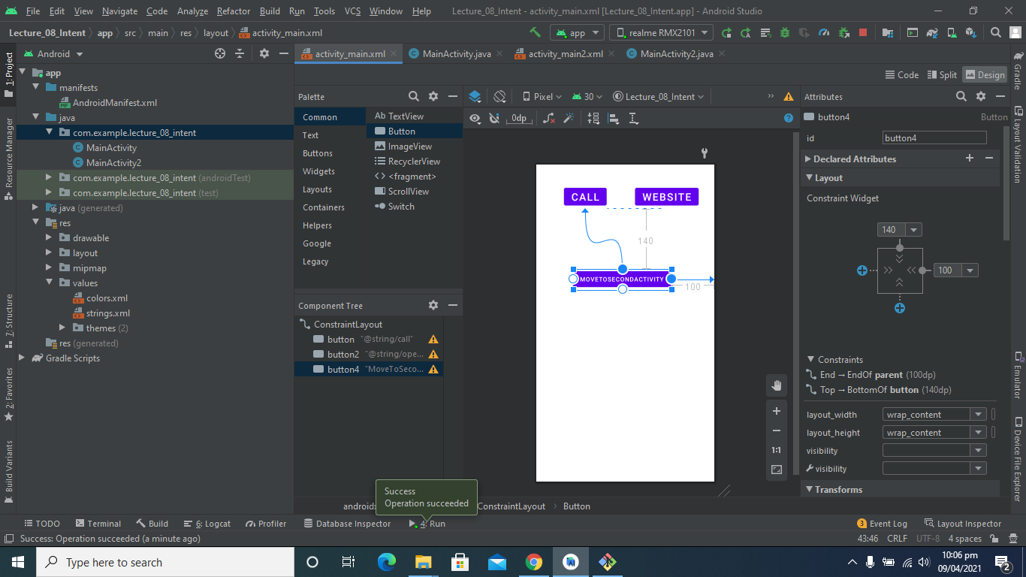

**Make button to move on another Activity:**

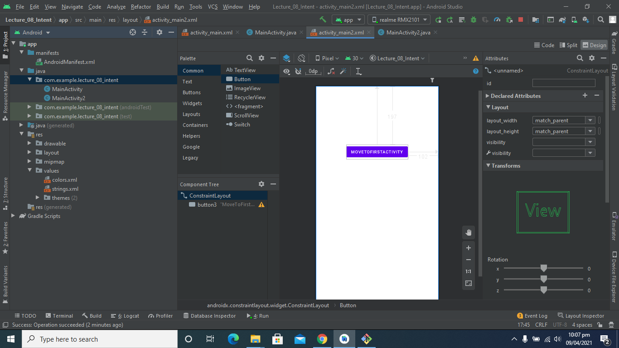

**Code to move on another Activity:**

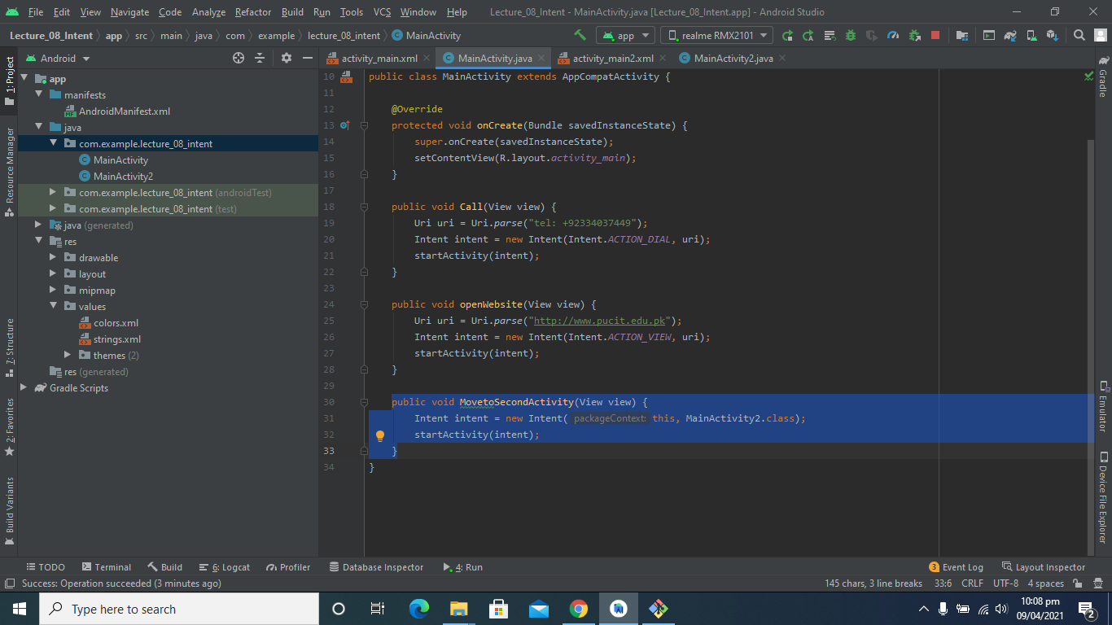

**Output Video Link:**

[**Video Link**](https://github.com/talha0606/MC_Progress/blob/master/lec08v02.mp4)